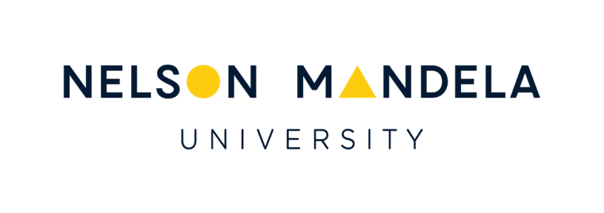

Transformed and Transformative Ocean Governance Conference
22-24 January 2020
Nelson Mandela University, South Africa

Details on Media Coverage

SABC TV Insert
The SABC conducted interviews with Lloyd Edwards (Raggy Charters), Dr Adnan Awad (International Ocean Institute Africa) and Dr Kimberley Peters (University of Liverpool), focusing on the pressures put on ocean resources by plastic pollution. Dr Awad and Dr Peters gave their opinions on the problems and solutions. This insert was broadcast on The Full View, Morning Live, and On Point. See the news insert at this link:
https://www.youtube.com/watch?v=-CSvfNBclog

Newspaper Articles
Mr Guy Rogers, Environment and Science Reporter for The Herald and Weekend Post newspapers, attended a number of conference sessions, and he published the following articles:
- “Sufficiency should underpin oceans management model” – The Herald, 23 January 2020
- ”Human health linked to state of oceans” – Weekend Post, 25 January 2020

Madibaz Radio Interview
Samantha Magwashu, a South African Agency for Science and Technology Advancement (SAASTA) intern based at the Nelson Mandela University’s Madibaz Radio station, interviewed CMR Director, Dr Bernadette Snow, and a few other conference delegates during the first day of the conference. The interviews were aired on 22 January.

SANCOR & WIOMSA Newsletters
The write-up of the conference that appears on the TTOGC webpage on the CMR’s website, was submitted to SANCOR and WIOMSA for inclusion in their first 2020 newsletters.

Nelson Mandela University News
The University’s Communication & Stakeholder Liaison Office published an article (“International conference on transformative ocean governance”) on the conference on the University’s website on 10 February. This article can be accessed at this link:
https://staff.mandela.ac.za/Bulletin/International-conference-on-transformative-ocean-g

