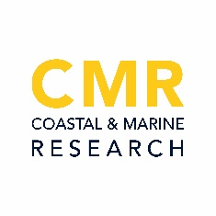
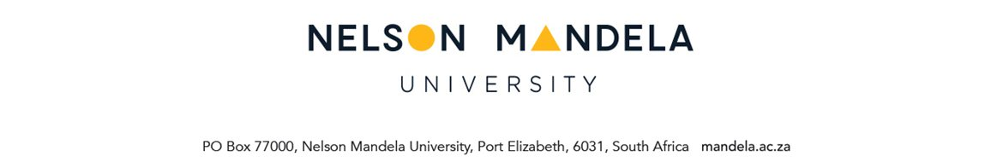

Institute for Coastal and Marine Research (CMR)
Membership Form

By completing and submitting this CMR membership form, it is acknowledged that the individual will be added to the confidential and secure CMR membership database and the CMR mailing list. The CMR mailing list will communicate quarterly CMR activity updates, opportunities and information for projects and exchanges, competitions run by the CMR, CMR vacancies, etc. The information provided below will be used for communication purposes and official reporting purposes on CMR membership and growth, only. Information will not be made publicly available and will not be shared with unauthorised persons.

PERSONAL DETAILS
Title:
Initials:
First Name:
Surname:

CONTACT DETAILS
Location (City):
Employer:
E-mail:

AFFILIATION
 | NMU | Department:
 |  | Position:
 | Other | Institution:
 |  | City/Town:
 |  | Position:

QUALIFICATION
Highest Qualification:
Institution:
Research Interest / Expertise:

HOW DID YOU FIND OUT ABOUT THE CMR?

Signature |  | Date

Please return submitted CMR membership form to CMR: cmr@mandela.ac.za

The Protection of Personal Information Act, 2013 (POPI Act) has been promulgated and implemented on 1 July 2020. All personal identifiable information provided by you shall be treated in accordance with this statute and used only for CMR communication by means of e-mail and administrative purposes, as indicated in the Nelson Mandela University Privacy Policy. I hereby provide consent for the use of all my personal identifiable information provided to the CMR and Nelson Mandela University for the aforesaid purposes.

