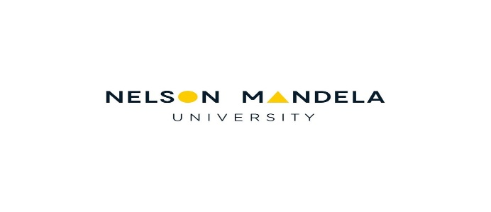

2020 Renewal

RECOMMENDATION FOR RENEWAL OF RESEARCH ASSOCIATE STATUS

Section A (TO BE COMPLETED BY RESEARCH ASSOCIATE)
TITLE | SURNAME | FIRST NAMES
Address | TELEPHONE NUMBERS
 | Home: | Cell:
 | Work:
 | Fax:
Code: | E-mail:

DATE………………………………… SIGNATURE………………..………………………………….

- Attach the following:
- Updated CV
- Biographical details form from HR website (please ensure that it is the most recent version)

- SUBMIT FORM AND SUPPORTING DOCUMENTS TO THE HEAD OF DEPARTMENT

Section B

RECOMMENDATION: DIRECTOR OF SCHOOL / HEAD OF DEPARTMENT/DIRECTOR CMR
………………………………………………………………………………………………………………………………………………………………………………………………………………………………………………………………………………………………………………………………………………………………
..............................................................................................................................................................................................................................................................................................................................

Kindly indicate the following:

- Nominee’s disciplinary field (e.g. physics, public medicine, inorganic chemistry etc.):

- Nominee’s research focus area/specialisation:

………………………… …………..……………………
SIGNATURE DATE

SUBMIT FORM AND SUPPORTING DOCUMENTS TO THE FREC FOR DECISION

Section C (To be completed by FREC secretary)

RECOMMENDATION BY FREC

RECOMMENDED:(√)
NOT RECOMMENDED:(√)

…………………………… ……………………………..…………………………..
DATE SIGNATURE

SUBMIT FORM + SUPPORTING DOCUMENTATION + EXTRACT OF FREC MINUTES TO MRS VISHA COOPASAMY (RSM OFFICE)

