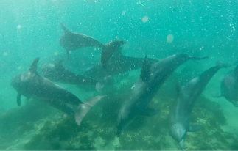
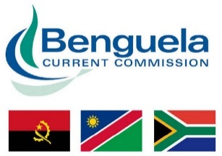

Angola, Namibia and South Africa
Revised and Additional EBSAs

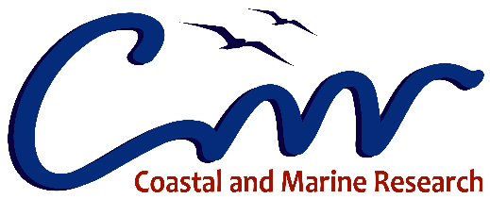
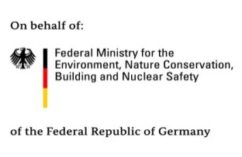
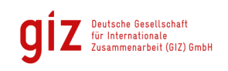
March 2019

Table of Contents
Table of Contents 2
National-level EBSAs 7
Angola 7
Revised EBSAs 7
Mussulo-Kwanza -Cabo Ledo Complex (Formerly Ramiros-Palmerinhas) 7
Revised EBSA Description 7
Motivation for Revisions 15
Research Needs 15
Future Process 16
New EBSAs 18
Chiloango Mangroves 18
Proposed EBSA Description 18
Motivation for Submission 26
Research Needs 26
Future Process 26
Ponta Padrao Mangroves and Turtle Beaches 27
Proposed EBSA Description 27
Motivation for Submission 36
Research Needs 36
Future Process 36
Longa Coastline 37
Proposed EBSA Description 37
Motivation for Submission 45
Research Needs 45
Future Process 45
Ombaca Canyon and Seamount Complex 46
Proposed EBSA Description 46
Motivation for Submission 52
Research Needs 53
Future Process 53
Bentiaba 54
Proposed EBSA Description 54
Motivation for Submission 62
Research Needs 62
Future Process 62
Namibia 63
Revised EBSAs 63
Namib Flyway 63
Revised EBSA Description 63
Motivation for Revisions 72
Research Needs 73
Future Process 73
Namibian Islands 75
Revised EBSA Description 75
Motivation for Revisions 85
Research Needs 85
Future Process 85
New EBSAs 87
Cape Fria 87
Proposed EBSA Description 87
Motivation for Submission 96
Research Needs 96
Future Process 97
Walvis Ridge Namibia 98
Proposed EBSA Description 98
Motivation for Submission 106
Research Needs 106
Future Process 107
South Africa 109
Revised EBSAs 109
Namaqua Fossil Forest 109
Revised EBSA Description 109
Motivation for Submission 115
Research Needs 115
Future Process 115
Childs Bank and Shelf Edge (Formerly Childs Bank) 117
Revised EBSA Description 117
Motivation for Submission 125
Research Needs 125
Future Process 125
Namaqua Coastal Area 128
Revised EBSA Description 128
Motivation for Submission 137
Research Needs 137
Future Process 137
Cape Canyon and Associated Islands, Bays and Lagoon (Formerly Cape Canyon and Surrounds) 139
Revised EBSA Description 139
Motivation for Submission 149
Research Needs 150
Future Process 150
Browns Bank 152
Revised EBSA Description 152
Motivation for Submission 159
Research Needs 159
Future Process 159
Agulhas Bank Nursery Area 161
Revised EBSA Description 161
Motivation for Submission 168
Research Needs 168
Future Process 168
Mallory Seamount, Trough and Slope Complex (Formerly Agulhas Slope and Seamounts) 170
Revised EBSA Description 170
Motivation for Submission 175
Research Needs 176
Future Process 176
Algoa to Amathole (Formerly Offshore of Port Elizabeth) 178
Revised EBSA Description 178
Motivation for Submission 187
Research Needs 188
Future Process 188
Protea Banks and Sardine Route 190
Revised EBSA Description 190
Motivation for Submission 197
Research Needs 197
Future Process 197
Natal Bight and uThukela River (Formerly Natal Bight) 200
Revised EBSA Description 200
Motivation for Submission 207
Research Needs 208
Future Process 208
New EBSAs 210
Protea Seamount Cluster 210
Proposed EBSA Description 210
Motivation for Submission 216
Research Needs 216
Future Process 216
Cape Point to Cape Agulhas 218
Proposed EBSA Description 218
Motivation for Submission 226
Research Needs 227
Future Process 227
Secret Reef 228
Proposed EBSA Description 228
Motivation for Submission 234
Research Needs 234
Future Process 234
Tsitsikamma-Robberg 235
Proposed EBSA Description 235
Motivation for Submission 241
Research Needs 241
Future Process 241
Transboundary EBSAs 242
Revised EBSAs 242
Namibe (Formerly Kunene-Tigres) 242
Revised EBSA Description 242
Motivation for Revisions 251
Research Needs 251
Future Process 251
Orange Seamount and Canyon Complex (formerly Orange Shelf Edge) 253
Revised EBSA Description 253
Motivation for Revisions 261
Research Needs 261
Future Process 261
Orange Cone 263
Revised EBSA Description 263
Motivation for Revisions 273
Research Needs 273
Future Process 273

National-level EBSAs

Angola

Revised EBSAs

Mussulo-Kwanza-Cabo Ledo Complex (Formerly Ramiros-Palmerinhas)

Revised EBSA Description

General Information

Summary
The Mussulo-Kwanza-Cabo Ledo Complex is largely a significant seaward extension of the existing inscribed Ramiros–Palmeirinhas Coastal Area EBSA, south of Luanda, Angola. This area includes two estuaries, small coastal islands, mangroves and sandy beaches. The coastal vegetation is dominated by low-growing saltmarsh species and other flora that inhabit intertidal flats, and the wetland areas are a proposed Ramsar site. It also contains an Important Bird Area for aquatic birds, especially migratory species, an important breeding site for threatened marine turtles and a nursery area for crabs, with a diversity of other species. It has since been shown that the adjacent inshore area is also an important nursery for horse mackerel, with the eggs and larvae getting exported offshore to -1300 m. Evidence from other systems indicates that canyons can play and important role in retention of fish spawning products, and thus the boundary of the EBSA was expanded to include the shelf-incising canyons that likely play a key role in this nursery function. The largest adjacent seamounts are included because they are also recognised habitat important for leatherback foraging. The canyons and seamounts thus also contribute to the rich diversity of the site and add to its vulnerability because these features are known to support fragile habitat-forming species. The important role of ecological processes associated with the rivers (nutrient and sediment delivery) that drives many attributes of the site was also not sufficiently recognised previously, and thus the EBSA boundary was also expanded southward to include the full extent of these processes based on a new habitat map. All features added to the EBSA were identified as priority areas in a systematic conservation plan for the region. The key attributes of this site of thus that it is of “special importance for life-history stages of species” and for “threatened, endangered or declining species and/or habitats”; it is also notable for its diversity, productivity and vulnerability.

Introduction of the area
The coastal Mussulo-Kwanza-Cabo Ledo Complex is located to the south of Luanda city, in the province of Luanda, in the northern portion of the Benguela Current Large Marine Ecosystem. It is a Type 2 EBSA (sensu Johnson et al. 2018) because it comprises a cluster of spatially fixed ecosystems and features but that are all connected by the same ecological processes and thus are evaluated as a single unit. The area extends from the coast to the lower slope, and includes two estuaries with mangroves, low-growing saltmarsh species, intertidal flats, sandy-, mixed- and rocky shores, lagoon habitat, the shelf and shelf edge, upper and lower slope, seamounts and shelf-incising canyons. It is an important site for bird aggregations and breeding turtles, and as nursery habitat for many species, including crabs and fish, notably for the horse mackerel. The site also includes representative portions of 13 threatened ecosystems, including two Critically Endangered and nine Endangered types. By implication, therefore, the site also includes some of the last remaining habitat for many threatened species. Information for the site, especially offshore, is relatively limited but some surveys have been completed.

With the accession of Angola to the Ramsar Convention on Wetlands, it was proposed to create and protect certain wetlands which have fundamental ecological functions for the regulation of water regimes and also serve as a habitat for flora and fauna especially for waterbirds. The 1,616 hectares area of Saco dos Flamingos (within the EBSA) has been proposed as a Ramsar site. The Kitabanga – Conservação de Tartarugas Marinhas project has been in place since 2003. Currently, it monitors about 12km in the beach of the Palmeirinhas. Nests densities recorded between 2011 and 2015 were as follows: 45 nests.km⁻¹ for the olive ridley turtle and 2.6 nests.km⁻¹ for the leatherback turtle (Morais, 2015). In 2006 there was a multidisciplinary sampling of estuaries in Angola, which included that of the Kwanza river in the southern region of the extended area (da Silva Neto, 2007). The project included biodiversity studies (birds, fish, invertebrates and vegetation) and hydrological processes. The results form part of the motivation for extending the EBSA southwards.

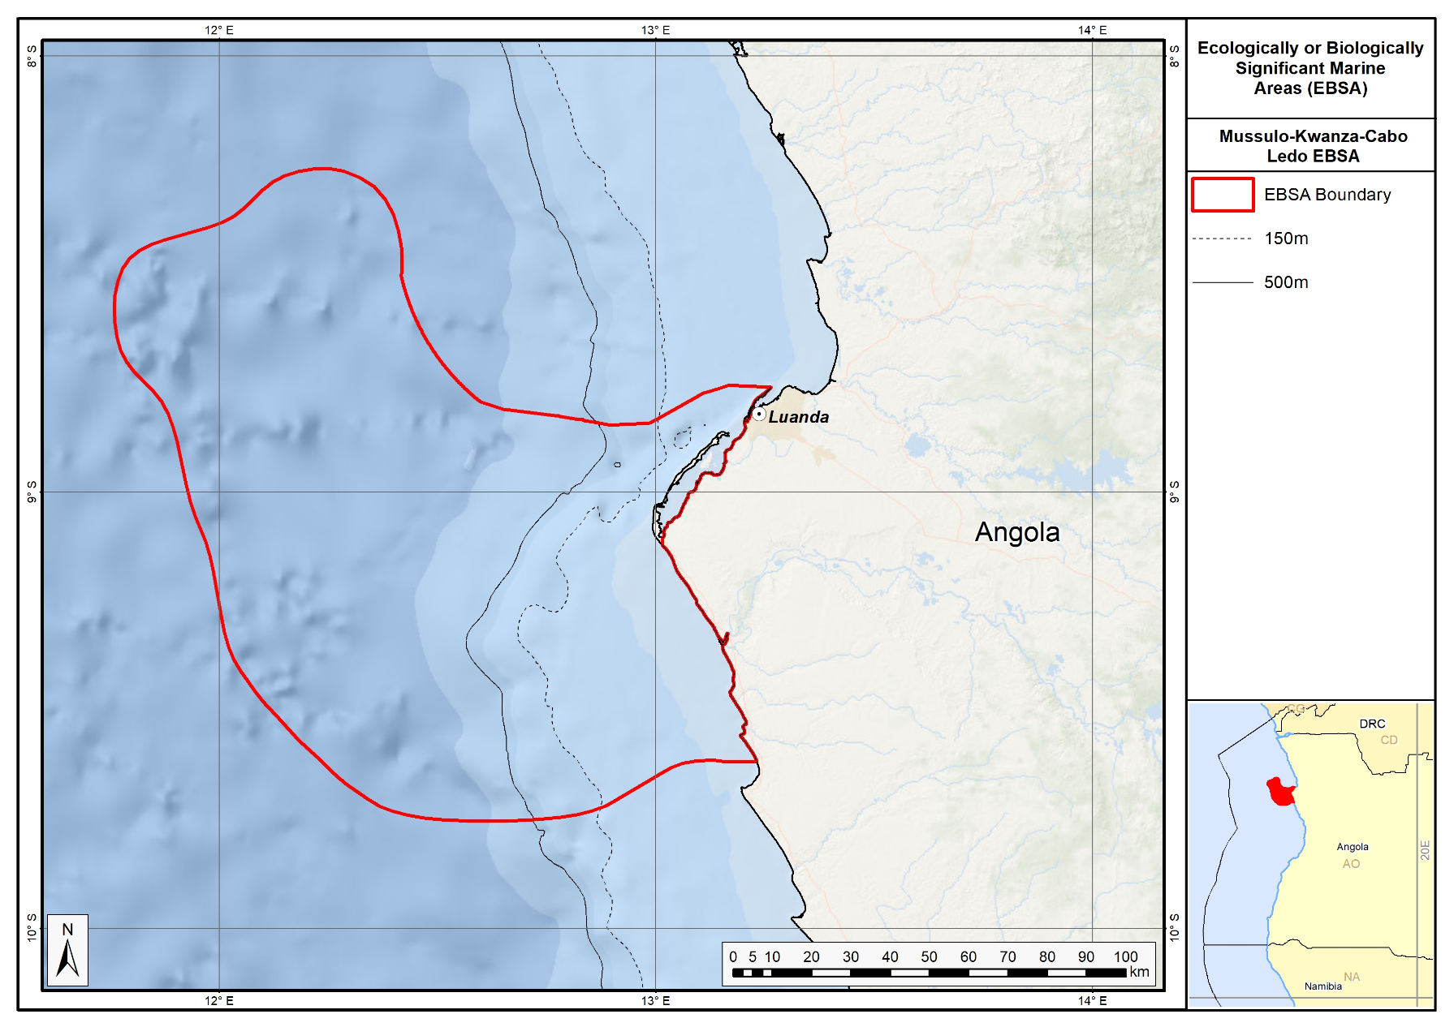

Proposed revised boundaries of the Mussulo-Kwanza-Cabo Ledo Complex EBSA.

Description of location
The coastal area encompasses the bays of Corimba, Luanda and Mussulo (including Saco dos Flamingos and Ilhéu dos Pássaros). The revised boundaries now include the mouth of the Kwanza River and ends north of Cabo Ledo. It has about 110 km of coastline and the furthest boundary is approximately 125 km offshore, including seamounts and shelf-incising canyons.

Feature description of the area
The coastal vegetation in the area is dominated by mangroves (Rhizophora mangle, Laguncularia racemosa and Avicenna germinans), with low-growing saltmarsh species of intertidal flats (Sesuvium portulacastrum, S. mesembritemoides and Salicornia sp.). The site is important for aquatic birds, with 61 congregatory waterbird species recorded, some of which occur in numbers which are at least nationally significant (BirdLife International, 2005). These include significant numbers of resident waterbirds as well as waders from the Palearctic while migrating south in the austral spring and returning in the late summer, for which the lagoon and intertidal flats are important foraging areas (Dean 2001). The threatened Cape gannet Morus capensis and Damara tern Sterna balaenarum are important non-breeding visitors to the inshore area (BirdLife International 2013). According to the IUCN Red List, these two species are classified as "Endangered" and "Vulnerable", respectively (http://www.iucnredlist.org/). The intertidal flats are an important nursery ground for crabs. Marine turtles, including the green Chelonia mydas (Endangered), leatherback Dermochelys coriacea (regionally Critically Endangered; globally Vulnerable) and olive ridley Lepidochelys olivacea (Vulnerable) occur in the area. Weir et al. (2007) surveyed the area and found that leatherback and olive ridley turtles were nesting on the beaches in the vicinity of the mangroves, with the nest density of the latter as high as 32 km⁻¹ at Palmeirinhas. In 2006, a multidisciplinary survey of the estuaries of Angola, including the Kwanza River estuary at the southern extent of the proposed area, was conducted (da Silva Neto, 2007). The project included studies of biodiversity (birds, fish, invertebrates, vegetation) and hydrological processes. Intertidal zones are important nurseries for crabs. The biological diversity in the area of the Kwanza bar reveals the presence of specimens of crustaceans such as shrimp (Penaeus sp.) and crab (Callinectes sp.). The ichthyofauna includes species that are ecologically adapted to the brackish environment, with emphasis on some species of the Clariidae and Mugilidae family. Also included are fish species of the families Soleidae, Lutjanidae, Lobotidae and Plynemidae (Holisticos, 2014). The inshore area is also an important nursery for horse mackerel, with the eggs and larvae getting exported offshore to -1300 m. Evidence from other systems indicates that seamounts and canyons can play and important role in retention of fish spawning products (Rojas & Landaeta, 2014), and thus the boundary of the EBSA was expanded to include the shelf-incising canyons that likely play a key role in this nursery function. The largest adjacent seamounts are also included, additionally because they are also recognised habitat important for leatherback foraging.

Although specific detailed biodiversity data on the offshore seamounts and canyons are lacking, these are significant features that are subject to fairly low levels of impact and hence are likely to be in good condition and support a representative range of biodiversity. These ecosystems also characteristically support fragile, habitat-forming species, such as sponges and corals, which add to the site’s vulnerability. Despite limited biodiversity information, 13 of the 23 ecosystem types represented in this EBSA are threatened, including two Critically Endangered and nine Endangered types. By implication, therefore, the site is also important for threatened species.

Feature conditions and future outlook of the proposed area
The Mussulo area is a confirmed Important Bird Area (BirdLife International 2013). The mangrove ecosystem of the area is not represented in mangrove communities elsewhere on the Angolan coast, and their botanical interest alone has been used to justify its conservation (Huntley 1974, UNEP 2007). The mangroves are threatened by the human occupation of coastal areas (BirdLife International 2005) and associated activities, which lead to damage, fragmentation and loss, with implications for their function as refuge, breeding or foraging areas for diverse species, including turtles, birds, fish and crustaceans. Other threats, particularly for the estuaries, include invasive alien plants, coastal erosion and artisanal fishing using set-nets and gill nets (da Silva Neto et al. 2007). Offshore pressures relate largely to fisheries. Revision of the EBSA boundary has largely excluded areas of direct impact, and therefore most of the EBSA area is in a Good (55 %) or Fair condition (32 %) (Holness et al., 2014). Nevertheless, the area is likely to be significantly impacted by activities directly adjacent to the EBSA (particularly from Luanda Bay), and this assessment of condition is likely to be highly optimistic. Further research for the area is recommended, particularly in terms of fully understanding the role of the canyons and seamounts in enhancing productivity and supporting species’ life-histories within this EBSA.

References
BirdLife International. 2005 BirdLife’s online World Bird Database: the site for bird conservation. Version 2. Cambridge, UK: BirdLife International. Available at http://www.birdlife.org. Accessed 11 April 2013
BirdLife International 2013. Marine e-Atlas: Delivering site networks for seabird conservation. Confirmed IBA site ‘Mussulo’. Available online: http://54.247.127.44/marineIBAs/default.html Accessed 11 April 2013
BirdLife International (2017) Important Bird Areas factsheet: Mussulo. Downloaded from http://www.birdlife.org on 05/12/2017
Dean, W. R. J. 2001. Angola. Pp. 71 – 91 in L. D. C. Fishpool and M. I. Evans, eds. Important Bird Areas in Africa and associated islands: Priority sites for conservation. Newbury and Cambridge. UK: Pices Publications and BirdLife International (BirdLife Conservation Series No. 11).
da Silva Neto, D., Boyd, A., Holtzhausen, H.,van Niekerk, L., Lamberth, S., Paterson, J., Bazika, B., Camarada, T., Pinto, M., Afonso, E., Cangajo, E., Estevão, V., Bornman, T.,Wooldridge, T., Deyzel, S., Buco, A., Jónico, V., Monteiro, F., Velasco, L., Fernandes, B. 2007. Baseline surveying of species and biodiversity in estuarine habitats. Final Integrated Report on BCLME Region. BCLME Project BEHP/BAC/03/04
FAO. 1994. Mangrove forest management guidelines (English) In: Food and Agricultural Organisation (FAO) Forestry Paper, no. 117 / FAO, Rome (Italy). Forest Resources Division, 339 p. http://archive.org/stream/mangroveforestma034845mbp/mangroveforestma034845mbp_djvu.txt (accessed 17 April 2013)
Holísticos. 2014. Caracterização Ambiental e Social para o Desenho da Sensibilidade Costeira entre Luanda e Namibe. Relatório Final, Dezembro de 2014.
Holness, S., Kirkman, S., Samaai, T., Wolf, T., Sink, K., Majiedt, P., Nsiangango, S., Kainge, P., Kilongo, K., Kathena, J., Harris, L., Lagabrielle, E., Kirchner, C., Chalmers, R., Lombard, M. 2014. Spatial Biodiversity Assessment and Spatial Management, including Marine Protected Areas. Final report for the Benguela Current Commission project BEH 09-01.
Huntley, B.J. 1974. Outlines of wildlife conservation in Angola. Journal of the Southern African Wildlife Management Association 4: 157–166
Johnson, D.E., Barrio Froján, C., Turner, P.J., Weaver, P., Gunn, V., Dunn, D.C., Halpin, P., Bax, N.J., Dunstan, P.K., 2018. Reviewing the EBSA process: Improving on success. Marine Policy 88, 75-85.
Morais, M., Torres, M., Martins, M. 2005. Análise da Biodiversidade Marinha e Costeira, e Identificação das Pressões de Origem Humana sobre os Ecossistemas Marinhos e Costeiros. Estudo Temático n.º2. Projecto 00011125, Estratégia e Plano de Acção Nacionais para a Biodiversidade (NBSAP). Ministério do Urbanismo e Ambiente, Junho de 2005.
Morais, M. 2015. Projecto Kitabanga – Conservação de tartarugas marinhas. Relatório final da temporada 2014/2015. Universidade Agostinho Neto / Faculdade de Ciências. Luanda.
Morais, Michel. 2016. Apresentação pública “Projecto Kitabanga - Estudo e Conservação de Tartarugas Marinhas”.
Morais, M. 2004. Informação para a selecção de zonas húmidas e sua classificação como sítios RAMSAR (RIS) em Angola. IUCN ROSA / MINUA. Luanda.
Morais, M., Torres, M.O.F., Martins, M.J. 2006. Biodiversidade Marinha e Costeira em Angola. Identificação e Análise de Pressões de Origem Antrópica. Ministério do Urbanismo e Ambiente. Luanda.
Morais, M., Velasco, L. Carvalho, E. 2006. Avaliação da condição e distribuição do manatim africano (Trichechus senegalensis) ao longo do rio Cuanza. Universidade Agostinho Neto e Ministério do Urbanismo e Ambiente. Luanda, Angola.
Powell, J. & Kouadio, A. 2008. Trichechus senegalensis. In: IUCN 2012. IUCN Red List of Threatened Species. Version 2012.2. www.iucnredlist.org. Downloaded on 11 April 2013.
Rojas, P.M., Landaeta, M.F. 2014. Fish larvae retention linked to abrupt bathymetry at Mejillones Bay (northern Chile) during coastal upwelling events. Lat. Am. J. Aquat. Res., 42(5): 989-1008.
Sarti Martinez, A.L. (Marine Turtle Specialist Group) 2000. Dermochelys coriacea. In: IUCN 2012. IUCN Red List of Threatened Species. Version 2012.2. www.iucnredlist.org. Downloaded on 15 April 2013.
Shumway, C.A. 1999. Forgotten Waters: Freshwater and Marine Ecosystems in Africa. Strategies for Biodiversity Conservation and Sustainable Development. http://pdf.usaid.gov/pdf_docs/PNACF449.pdf (accessed 17 April 2013).
UNEP. 2007. Mangroves of Western and Central Africa. UNEP-Regional Seas Programme/UNEPWCMC. http://www.unep-wcmc.org/resources/publications/UNEP_WCMC_bio_series/26.htm. (Accessed 11 April 2013)
Weir CR, Ron T, Morais M, Duarte ADC. 2007. Nesting and at-sea distribution of marine turtles in Angola, West Africa, 2000–2006: occurrence, threats and conservation implications. Oryx 41: 224-231

Other relevant website address or attached documents
Summary of habitat types and threat status for Mussulo-Kwanza -Cabo Ledo Complex. Data from Holness et al. (2014).
Threat Status | Ecosystem Type | Area km² | Area (%)
Critically Endangered | Luanda Inshore | 38.5 | 0%
 | Luanda Reflective Sandy Beach | 30.3 | 0%
Critically Endangered Total |  | 68.8 | 0%
Endangered | Bengo Shelf | 556.2 | 3%
 | Bengo Shelf Edge | 475.2 | 3%
 | Kwanza Inshore | 737.5 | 4%
 | Kwanza Intermediate Sandy Beach | 34.4 | 0%
 | Kwanza Mixed Shore | 28.8 | 0%
 | Kwanza Shelf | 1,868.1 | 11%
 | Kwanza Shelf Edge | 961.3 | 6%
 | Luanda Lagoon Coast | 151.4 | 1%
 | Luanda Mixed Shore | 0.8 | 0%
Endangered Total |  | 4,813.6 | 29%
Vulnerable | Kwanza Estuarine Shore | 1.2 | 0%
 | Luanda Sheltered Rocky Shore | 0.1 | 0%
Vulnerable Total |  | 1.3 | 0%
Least Threatened | Bengo Lagoon Coast | 0.4 | 0%
 | Bengo Mixed Shore | 0.0 | 0%
 | Bengo Upper Slope | 3,779.6 | 23%
 | Congo Lower Slope | 2,619.5 | 16%
 | Congo Seamount | 508.9 | 3%
 | Kwanza Lower Slope | 501.5 | 3%
 | Kwanza Reflective Sandy Beach | 40.9 | 0%
 | Kwanza Sheltered Rocky Shore | 8.1 | 0%
 | Kwanza Upper Slope | 4,212.2 | 25%
 | Luanda Intermediate Sandy Beach | 0.0 | 0%
Least Threatened Total |  | 11,671.0 | 70%
Grand Total |  | 16,554.8 | 100%

Assessment of the area against CBD EBSA criteria
C1: Uniqueness or rarity: Medium
Justification
The mangrove ecosystem of the area, which consists of Rhizophora mangle, Laguncularia racemosa and Avicenna germinans is not represented in mangrove communities elsewhere on the Angolan coast, and their botanical interest alone has been used to justify its conservation (UNEP 2007).
C2: Special importance for life-history stages of species: High
Justification
The Islands of Migratory Birds (Ilhéu dos Pássaros) is internationally recognized as an Important Bird Area – it is a vital feeding and refugee site for large numbers of migrating waterbirds (Birdlife International 2005, 2013). The beaches are used for breeding by globally Vulnerable leatherback turtles as well as Vulnerable olive ridley turtles, which have been found to have high nesting densities at Palmeirinhas by Weir et al. (2007). The densities of nests recorded in Palmeirinhas between 2011 and 2015 were 45 nests.km⁻¹ for the olive ridley turtle nests and 2.6 nests.km⁻¹ for the leatherback turtle (monitored beach 12 km). The area is reported to be an important nursery ground for crabs (Simão pers.comm.). Horse mackerel also spawn in the area, with the eggs and larvae transported offshore to about -1300 m. Other studies have suggested that canyons and seamounts can act to aid retention of these products (Rojas & Landaeta, 2014), which is proposed for the adjacent seamounts and shelf-incising canyons in this EBSA.

C3: Importance for threatened, endangered or declining species and/or habitats: High
Justification
The beaches are used for breeding by globally Vulnerable leatherback turtles as well as Vulnerable olive ridley turtles which have high nesting densities at Palmeirinhas (Weir et al. 2007). Threatened bird species Cape gannet Morus capensis and Damara tern Sterna balaenarum are important non-breeding visitors to the inshore area (Birdlife 2005, 2013). The West African manatee Trichechus senegalensis (IUCN Vulnerable) is also reported from this area (Kwanza River) (Morais et al., 2006; da Silva Neto et al. 2007), with the estuarine habitat being considered important for this threatened species (Morais et al., 2006; Powell and Kouadio, 2008).
The BCC spatial assessment (Holness et al., 2014) identified two Critically Endangered ecosystems (Luanda Inshore and Luanda Reflective Sandy Beach), nine Endangered ecosystems (Bengo Shelf, Bengo Shelf Edge, Kwanza Inshore, Kwanza Intermediate Sandy Beach, Kwanza Mixed Shore, Kwanza Shelf, Kwanza Shelf Edge, Luanda Lagoon Coast and Luanda Mixed Shore), and two Vulnerable types (Kwanza Estuarine Shore and Luanda Sheltered Rocky Shore). In the absence of more specific biodiversity information, it can be assumed that these threatened ecosystems support similarly threatened communities of species.

C4: Vulnerability, fragility, sensitivity, or slow recovery: Medium
Justification
The area is key for several relatively long-lived species that reproduce slowly and recover slowly from population declines, such as turtles and manatees (Sarti Martinez 2000, Powell and Kouadio 2008), not to mention mangroves. The mangroves, estuaries and associated low-growing saltmarsh and flat intertidal habitat are all sensitive to anthropogenic pressures such as traffic, pollution, deforestation, development and associated fragmentation, with implications for their function as refugia, breeding or foraging areas. Restoration of degraded mangroves is an extremely complex, costly, long-term process, and hence protection of intact mangroves is a far preferable option. The canyons and seamounts represented in the EBSA are also highly likely to support fragile habitat-forming species such as corals and sponges, as is characteristic of these features.

C5: Biological productivity: Medium
Justification
Mangroves are among the most productive terrestrial ecosystems (FAO 1994) and provide the highly productive coastal lagoons and tidal estuaries with which they are interlinked with essential organic nutrients; they are also critical breeding grounds and nurseries for larval and juvenile stages of important fisheries species (Shumway 1999). The seamounts and canyons may also play a role in enhancing local productivity.

C6: Biological diversity: Medium
Justification
The area contains 23 different habitat types (estuaries, lagoons, mangroves, saltmarshes, flat intertidal habitats, beaches and inshore areas), with associated diversity of species. At least 61 congregatory waterbird species use this area as well as non-breeding waterbird (BirdLife International 2005, 2013), several breeding sea turtle species (Weir et al. 2007), aquatic mammals such as the manatee (da Silva Neto et al. 2007), crabs, shrimps, sea snails and fishes. Field research has confirmed high diversity in this area, although this is still being included in reports.

C7: Naturalness: Medium
Justification
Much of the area is currently relatively pristine but coastal development (BirdLife International 2005) and vehicles in the coastal zone are having some impact in the area. It is also affected by effluent, e.g. from hospitality industry, bungalows, etc, and offshore pressures relate mostly to fisheries. Overall, however, the BCC spatial assessment showed that most of the EBSA area is in a Good (55 %) or Fair condition (32 %; Holness et al., 2014). Nevertheless, the area is likely to be significantly impacted by activities directly adjacent to the EBSA (particularly from Luanda Bay), and this assessment of condition is likely to be highly optimistic.

Status of submission
The Ramiros–Palmeirinhas EBSA was recognized as an area described as meeting EBSA criteria that were considered by the Conference of the Parties. The revised name, description and boundaries still need to be submitted to COP for approval.

COP Decision
dec-COP-12-DEC-22

End of proposed EBSA revised description

Motivation for Revisions
The EBSA description was updated by including the few additional studies available on the area. A summary table of the represented habitats and their threat status was also included as supplementary information. Evaluations of criteria did not change from those of the original Ramiros-Palmerinhas EBSA. The biggest change to the EBSA was a significant refinement of the EBSA delineation. This was done to more closely focus the EBSA on the key biodiversity features. The two biggest changes were an extension southward along the coast to fully include the Kwanza Estuary and an extension offshore to include important adjacent canyons and shelf ecosystems. Revised boundaries were extensively discussed in a series of stakeholder meetings.
The delineation process used a combination of Systematic Conservation Planning and multi-criteria analysis methods. The key features used in the analysis were:
- Irreplaceable and near irreplaceable (i.e. very high selection frequency) sites, as well as primary and secondary focus areas identified in the SCP undertaken for the BCLME by Holness et al. (2014).
- Threatened Benthic and Coastal Ecosystems. The analysis focussed on the inclusion of the most threatened ecosystem types found in the area. These types are highlighted in the table in the Other relevant website address or attached documents section. Key threatened ecosystem types were the endangered The BCC spatial assessment (Holness et al., 2014) identified two Critically Endangered ecosystems (Luanda Inshore and Luanda Reflective Sandy Beach), nine Endangered ecosystems (Bengo Shelf, Bengo Shelf Edge, Kwanza Inshore, Kwanza Intermediate Sandy Beach, Kwanza Mixed Shore, Kwanza Shelf, Kwanza Shelf Edge, Luanda Lagoon Coast and Luanda Mixed Shore), and two Vulnerable types (Kwanza Estuarine Shore and Luanda Sheltered Rocky Shore).
- Key physical features such as canyons and some small seamounts from the BCC spatial mapping project (Holness et al., 2014), GEBCO data, and global benthic geomorphology mapping (www.bluehabitats.org, Harris et al., 2014).
- Boundaries of Important Bird Areas (IBA) and proposed Ramsar sites were included.
- Areas of high relative naturalness identified by Holness et al. (2014) were prioritized.
- Some additional manual editing of the boundaries of the EBSA was undertaken to align with recognizable geographic features on the coast.
The multi-criteria analysis resulted a value surface. The cut-off value used to determine the extent of the EBSA was based on expert input and quantitative analysis of effective inclusion of the above features. This entailed taking an iterative parameter calibration-based approach whereby the spatial efficiency of the inclusion of the targeted features was evaluated. The approach aimed to identify a cut-off which most efficiently included prioritised features while minimizing the inclusion of impacted areas. The final boundaries shown in the map below were validated in an expert workshop.

Research Needs
Robust baseline data on the area remains sparse. Much further baseline research and ongoing monitoring is needed to ensure that the key features of the EBSA are well managed. Further research will be necessary to support the appropriate management. The increase of use for tourism purposes and the development / revitalization of urban areas have increased pressure on the system of the proposed area. There is no specific information on the behaviour, breeding period and number of individuals of some species including cetaceans, crustaceans, fish and molluscs. There are also no specific studies of water quality and sediment, bathymetry and others important data for environmental monitoring.

Future Process
It is currently unclear whether this EBSA will be the focus for status assessment and detailed management planning. Key immediate issues are expanding marine protection in Angola. The Ramsar designation of parts of the area need to be finalized and any required management interventions need to be implemented.

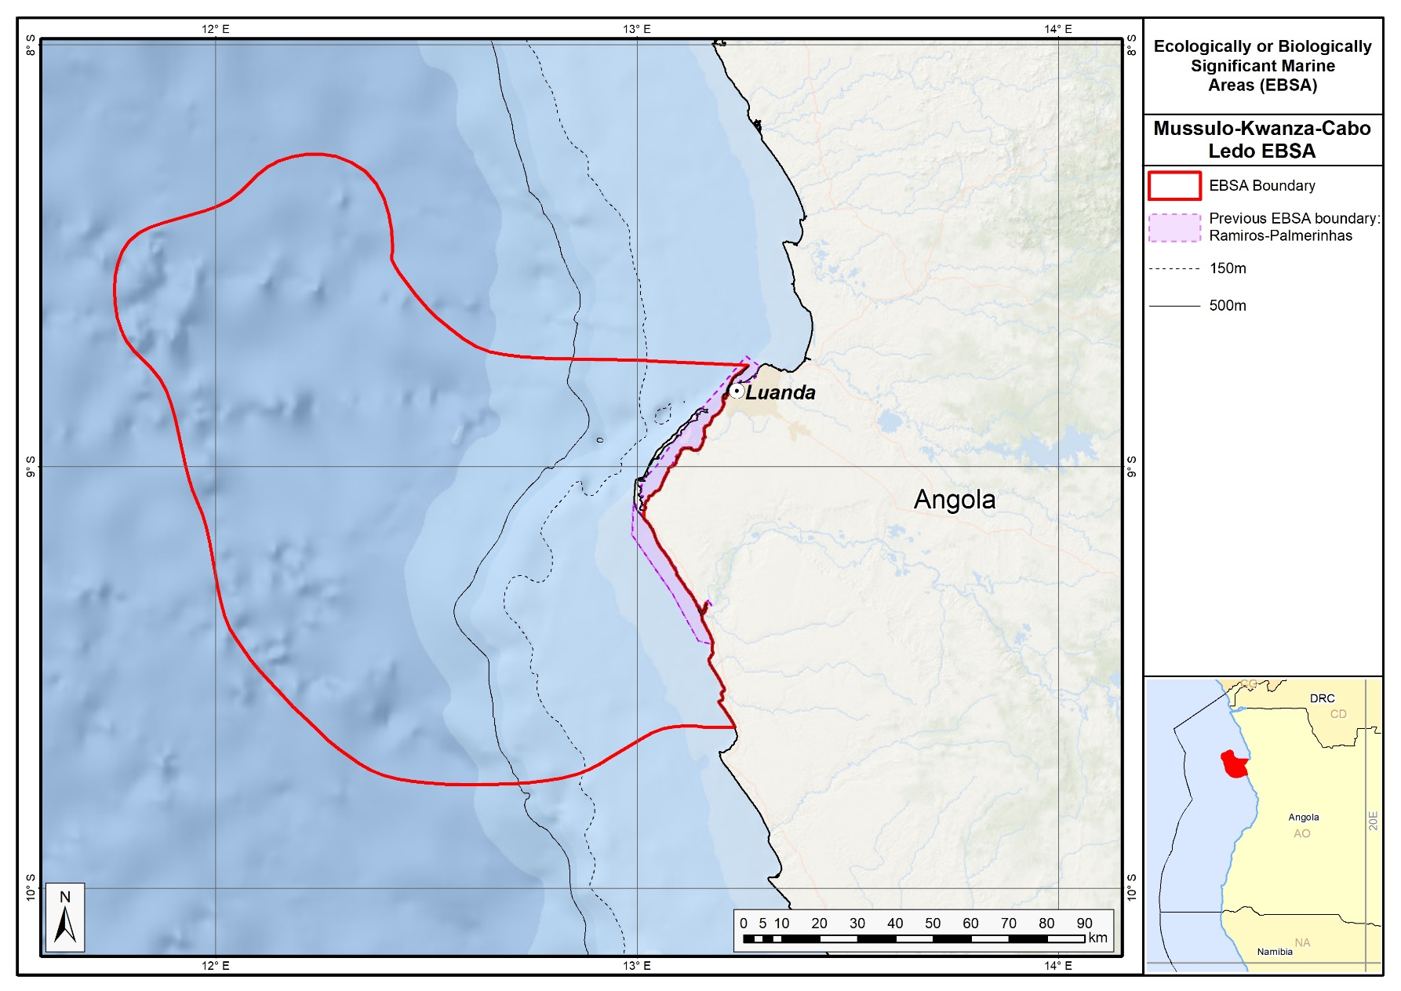

The proposed revised boundaries of the Mussulo-Kwanza -Cabo Ledo Complex EBSA in relation to the original boundaries of the Ramiros-Palmerinhas EBSA.

New EBSAs

Chiloango Mangroves

Proposed EBSA Description

Abstract
The Chiloango Estuary is in the Angolan province of Cabinda. The proposed EBSA is strongly coastal and includes the Chiloango Estuary and 6 km of coastline surrounding the estuary mouth. The mangroves and riverine forest are key features at this site; they are less noteworthy in a global context but are very significant in a local context. In fact, three of the four habitats represented in the area are threatened. Most importantly, this area supports many species whose growth and reproduction rates are slow, particularly globally threatened species such as olive ridley and leatherback turtles (that nest in the area) and manatees (that are resident in the area). The latter have been hunted throughout their range and, despite limited quantitative data, are showing extirpations in many places. Current anthropogenic pressure in the mangroves is also visible and worrying, with signs of advanced habitat degradation and destruction. The area is highly relevant in terms of the EBSA criteria: “Importance for threatened, endangered or declining species and/or habitats” and “Vulnerability, fragility, sensibility or slow recovery”.

Introduction
There are two estuaries in Cabinda: the Cabinda and Chiloango Estuaries in the north and south of the provice, respectively. At the boundary with the Republic of the Congo in the north, the Cabinda River reaches the sea through the Massabi Lagoon. The proposed EBSA, however, lies at the mouth of the Chiloango River in the south, which flows into the sea through the estuary (Giresse and Kouyoumontzakis, 1985). The river is approximately 168 km long, originating from springs in the Democratic Republic of Congo (DRC), and in some places forms the boundary that separates DRC from the province of Cabinda in Angola (Sonangol, 2012). It is a coastal EBSA that is a discrete site centred around the mangroves and its associated threatened species, and is thus a Type 1 EBSA (sensu Johnson et al. 2018).

The Chiloango Estuary EBSA comprises four biotypes: marine, estuarine, riverine forest, and wetland areas. There are approximately 130 hectares of wetland areas encompassing small lagoons, surrounded by Endangered mangroves. The mangroves and riverine forest associated with the river were fundamental in choosing this site as a proposed EBSA; although not globally significant, these mangroves are of key local significance. Consequently, the reason this EBSA was not included in the original set of EBSAs at the South Eastern Atlantic Workshop in 2013 (UNEP/CBD/RW/EBSA/SEA/1/4) is because this local knowledge was not available at that meeting and is better than the information included in international datasets (e.g., WCMC and the World Mangrove Atlas).

In the EBSA, the mangroves and riverine forest are bounded by a sandy beach, surrounded by the estuary, and extend to the river and margins of the lagoon. The mangroves cover the alluvial areas of the Chiloango River mouth, corresponding to sites subjected to temporary flooding resulting from changing tides, and are populated by Rhizophora mangle (Diniz, 2006). Mangrove forest is scattered along the Angolan coastline and forms a transition ecosystem between land and sea of enormous biological and ecological importance, providing shelter and nurseries for crustaceans and fish that are of economic and tourism importance to the country (EPANB, 2006). The EBSA supports a rich diversity of avifauna, herpetofauna and ichthyofauna (MINAMB et al., 2015). Most importantly, it provides critical habitat for threatened species, such as African manatees that are threatened throughout their range and showing signs of local extirpations (Keith Diagne, 2015), and olive ridley and leatherback turtles that nest on the adjacent beaches.

Habitat loss in the proposed EBSA is largely due to infrastructure development that has fragmented forests through the construction of roads and buildings, such as the construction of a motorway linking the Town of Cabinda with Belize. It is believed that mangrove degradation in the Chiloango Estuary is also caused by fragmentation due to road construction, among other factors (Kuedikuenda & Xavier, 2009). Nevertheless, this site is still sufficiently intact to warrant conservation attention.

Description of the location

EBSA Region
South-Eastern Atlantic

Location
The EBSA is in the northern half of the Cabinda province of Angola, including the Chiloango Estuary and 6 km of rocky, sandy and mixed shores adjacent to the mouth. The area includes around 130 ha of wetland areas encompassing small lagoons surrounded by Endangered mangroves. The furthest extent inland is approximately 1.2 km from the coastline. The whole of the proposed area lies entirely within Angola’s national jurisdiction.

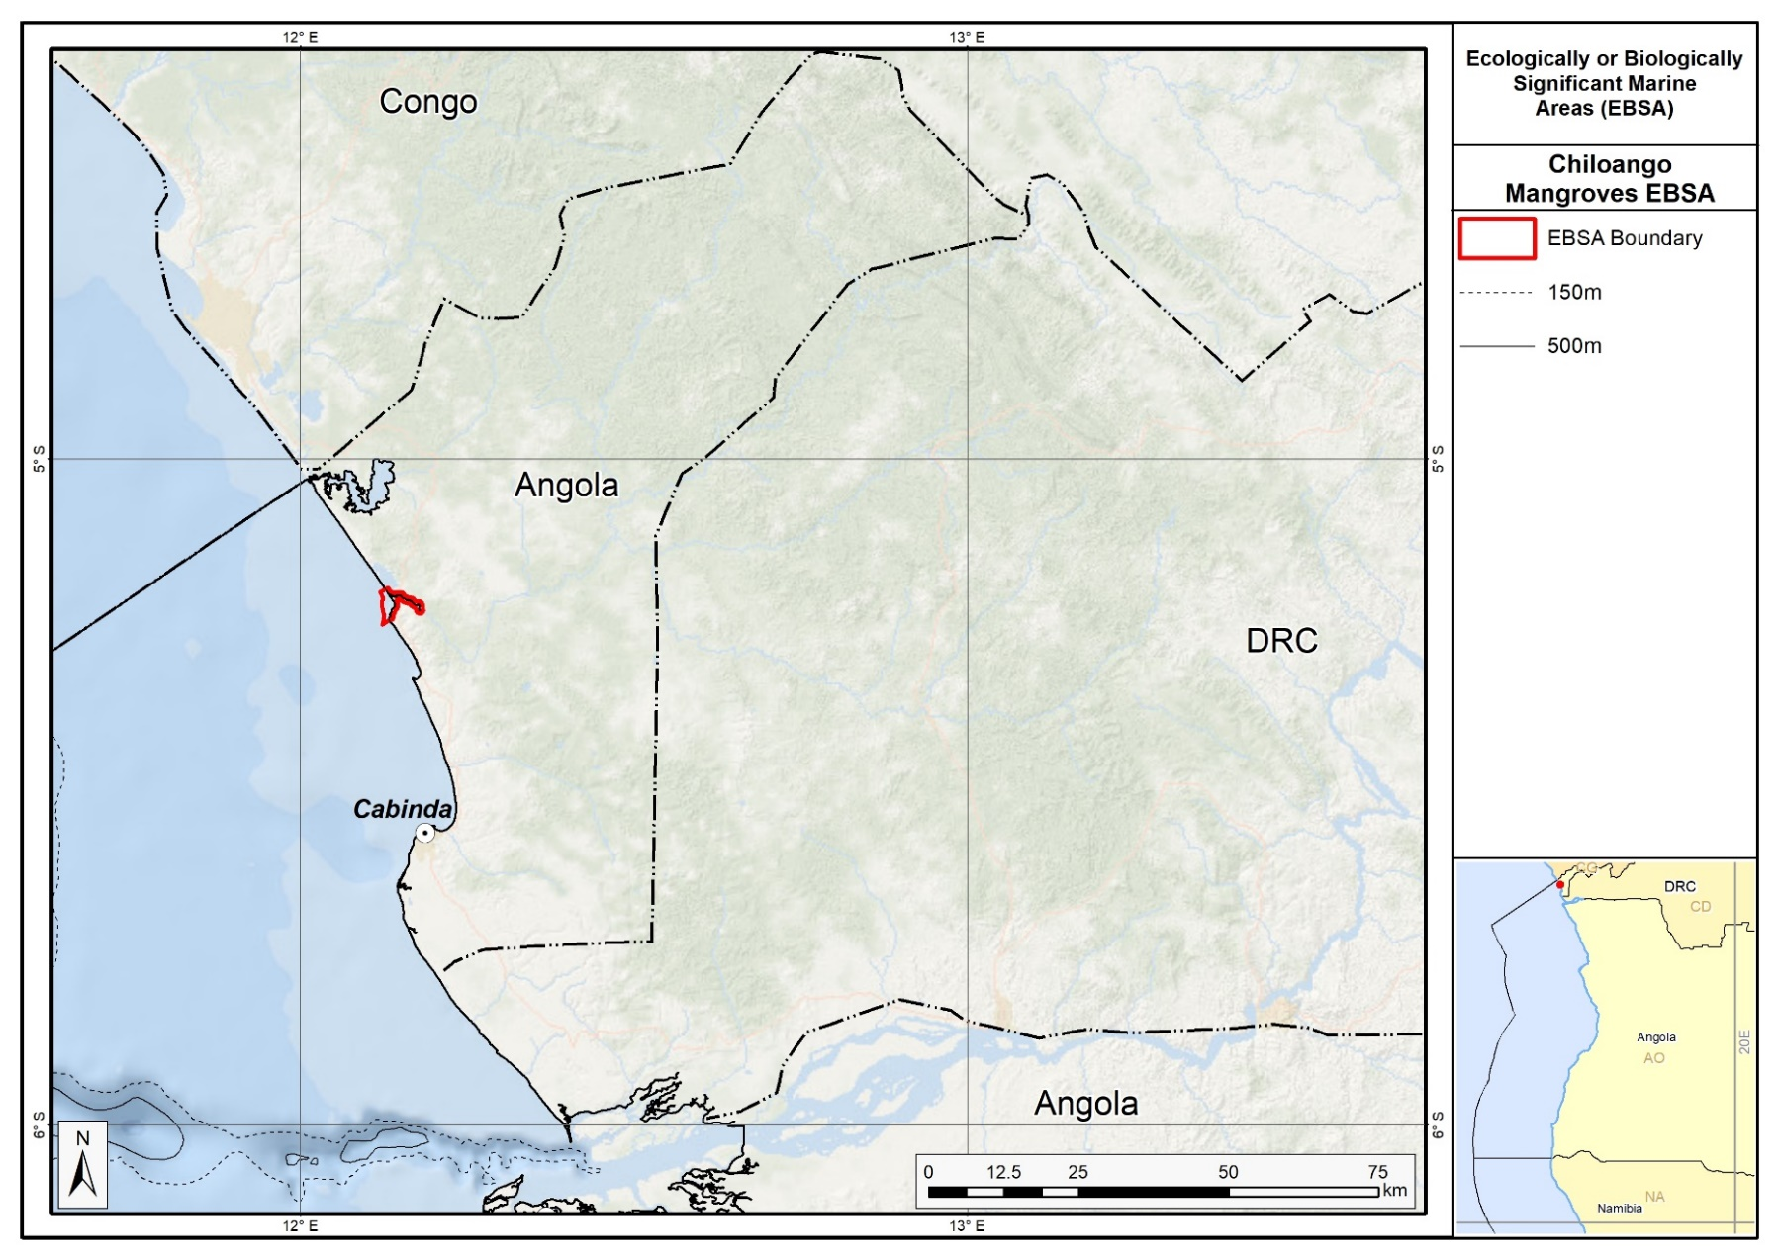
Proposed delineation of the Chiloango Mangroves EBSA.

Feature description of the proposed area
The Chiloango River mouth is dominated by muds from the river. Fresh-water flow out of the Chiloango River also forms a plume of low-salinity water in the adjacent coastal area that, in turn, affects the nearshore coastal processes. These features, as well as the local extent of the turtle nesting beaches, contributed to defining the alongshore extent of the EBSA. Because this is a coastal EBSA, it is described primarily for its benthic features, although the overlying water column in the estuary, surf and inner shelf is very tightly coupled to the key features and species of this site.

The mangrove forests of the region include species such as Rhizophora (R. mangle, R. racemosa and R. harrisonii), which tolerate high levels of salinity. The mangroves cover the whole Chiloango riverbed up to the high tide mark and extend up to the wetland area associated with the river. The Chiloango River is the southern hydrographic basin included in the Lower Guinea ichthyofaunal province, which is one of the 10 ichthyofaunal provinces as defined by Roberts (cited in Darwall et al., 2011). The Lower Guinea ichthyofaunal province extends from the Chiloango River to the Cross River in the north, and shares a boundary with the Congo River basin to the east. This region contains a rich diversity of species, and more than half of the freshwater or marine fish species seen here are endemic to the region. This region also has relatively high numbers of freshwater fish species that are threatened and have limited geographic ranges (Darwall et al., 2011). Further, a species of fresh water crab belonging to the tropical African endemic family, Potamonautidae, is found in the rivers of Cabinda (Darwall et al., 2011). Although biodiversity data are largely limited for Angola, this region is known to have the highest diversity of dragonflies and damselflies (Odonata) within the whole of Africa.

In terms of birds, it is important to mention the rich diversity that includes resident, visiting and seasonal migratory birds that feed and rest here. Among these, it is worth mentioning the presence of cattle egrets, white chest crows, spotted kingfishers, white chested mouse birds and black bishops, among others. In terms of the most relevant reptiles, olive ridley and leatherback turtles can be observed nesting in the region. The beaches here thus provide critical habitat to support important life-history stages of these two threatened species. Marine mammals are also found along the coastline, such as the common whale, humpback whale, common dolphin and spotted dolphin (ACEPA, 2012). The West African Manatee (Trichechus senegalensis) is another threatened marine mammal that is important in the areas, and is classified by the IUCN as Vulnerable largely due to species declines due to hunting and habitat loss (Powell & Kouadio, 2008; Keith Diagne, 2015). Historically, its presence has been recorded in the Chiloango River, but the current distribution is unknown (MINUA, 2006; Morais, 2006), and local extirpations of this species are known across its distribution (Keith Diagne, 2015).

Feature condition and future outlook of the proposed area
Across the system, the ecological condition of the mangrove varies a lot, i.e., from pristine areas to fully deforested areas. Current anthropogenic pressure is visible and worrying, with signs of advanced habitat degradation and destruction in some places (MINAMB et al, 2015). Further, Tati Luemba regrets the level of destruction of the mangrove as a result of stagnant water caused by the limited water mixing between river and sea (Tati Luemba press comm., 2015). It is thus important that the Chiloango Mangroves are protected to prevent the extinction or extirpation of fauna and flora that contribute to the region’s ecological integrity (press comm. Tati Luemba, 2015), especially the iconic and threatened manatee and turtle species. An assessment of ecological condition based on cumulative pressures indicates that 83 % of the area is in Fair condition and the remainder in Good condition, suggesting some degradation, but that the bulk of biodiversity and ecological processes are still intact. This means that establishing the proposed EBSA and implementing appropriate conservation and management measures in this area will contribute to protecting the existing biodiversity.

References
Angolan Association of the Oil Exploration and Production Companies (Associação das Companhias de Exploração e Produção de Angola - ACEPA) (2014) Environmental and Social Baseline to Determine the Coastal Sensitivity of the Areas Between Luanda and Namibe.
Bianchi, G., 1992. Demersal assemblages of the continental shelf and upper slope of Angola. Mar. Ecol. Prog. Ser., 81: 101-120.
Darwall, W.R.T., Smith, K.G., Allen, D.J., Holland, R.A, Harrison, I.J., and Brooks, E.G.E. (eds.). (2011) The Diversity of Life in African Freshwaters: Under Water, Under Threat. An analysis of the status and distribution of freshwater species throughout mainland Africa. Cambridge, United Kingdom and Gland, Switzerland: IUCN. xiii+347pp+4pp cover.
Diniz, A. C. 2006. Características Mesológicas de Angola. Instituto Português de Apoio ao Desenvolvimento. Lisboa, 2006.
Fancony, P., Abel, A. 2012. Effective Management Of Endangered Species In Oil and Gas Operations. International Conference on Health, Safety and Environment in Oil and Gas Exploration and Production, 11-13 September, Perth, Australia, https://doi.org/10.2118/156766-MS.
FAO (1994) Mangrove forest management guidelines (English) In: Food and Agricultural Organisation (FAO) Forestry Paper, no. 117 / FAO, Rome (Italy). Forest Resources Division, 339 p.http://archive.org/stream/mangroveforestma034845mbp/mangroveforestma034845mbp_djvu.txt (accessed 17 April 2013).
Giresse, P. and Kouyoumontzakis, G., 1985. Gabon, Congo, Cabinda and Zaire, pp 625-638. In: Bird, EC and Schwartz, ML (Eds.). The World's Coastline. New York, Van Nostrand Reinhold Co. 1071 pp.
Johnson, D.E., Barrio Froján, C., Turner, P.J., Weaver, P., Gunn, V., Dunn, D.C., Halpin, P., Bax, N.J., Dunstan, P.K., 2018. Reviewing the EBSA process: Improving on success. Marine Policy 88, 75-85.
Keith Diagne, L., 2015. Trichechus senegalensis (errata version published in 2016). The IUCN Red List of Threatened Species 2015: e.T22104A97168578. http://dx.doi.org/10.2305/IUCN.UK.2015-4.RLTS.T22104A81904980.en. Downloaded on 28 August 2018.
Kuedikuenda, S., Xavier, M. (2009). Framework Report on Angola’s Biodiversity. Ministério do Ambiente. Luanda, 2009.
Holness, S., Kirkman, S., Samaai, T., Wolf, T., Sink, K., Majiedt, P., Nsiangango, S., Kainge, P., Kilongo, K., Kathena, J., Harris, L., Lagabrielle, E., Kirchner, C., Chalmers, R., Lombard, M. 2014. Spatial Biodiversity Assessment and Spatial Management, including Marine Protected Areas. Final report for the Benguela Current Commission project BEH 09-01.
Ministério do Urbanismo e Ambiente (MINUA), 2006. Programa de Investimento Ambiental. Relatório do Estado Geral do Ambiente em Angola. Angola.
Ministério do Ambiente (MINAMB), Holísticos, C4 EcoSolutions (2015). “Approaching the urgent adaptation needs and reinforcement of the Angolan abilities in regards to climate change” – Description of selected sites: Chiloango.
Powell, J. & Kouadio, A. (2008) Trichechus senegalensis. In: IUCN 2012. IUCN Red List of Threatened Species. Version 2012.1. http://www.iucnredlist.org. Acedido a 19 de Setembro de 2012.
Shumway, C.A. 1999. Forgotten Waters: Freshwater and Marine Ecosystems in Africa. Strategies for Biodiversity Conservation and Sustainable Development.
http://pdf.usaid.gov/pdf_docs/PNACF449.pdf (accessed 17 April 2013).
Sonangol (2012), Bodiversidade em Cabinda. Luanda, 2012.

Legislation:
Resolução n.º 42/06, de 26 de Julho: Aprova a Estratégia e o Plano de Acção Nacionais para a Biodiversidade. [Citação: EPANB, 2006].
Press Articles:
Luemba, Tati (2015). Secretaria Provincial de Urbanismo e Ambiente de Cabinda.
http://jornaldeangola.sapo.ao/reportagem/mangal_da_foz_do_chiloango_em_risco_de_desaparecer

Other relevant website address or attached documents
Summary of types of habitats and status of threats for the Chiloango Estuary - Cabinda. Data from Holness et al. (2014).
Threat Status | Ecosystem Type | Area km² | Area (%)
Endangered | Cabinda Reflective Sandy Beach | 4,7 | 28%
 | Cabinda Sheltered Rocky Shore | 0,3 | 2%
Endangered Total |  | 5,0 | 29%
Vulnerable | Cabinda Mixed Shore | 4,7 | 27%
Vulnerable Total |  | 4,7 | 27%
Least Threatened | Cabinda Estuarine Shore | 7,4 | 43%
Least Threatened Total |  | 7,4 | 43%
Grand Total |  | 17,1 | 100%

Assessment of the area against CBD EBSA Criteria
CBD EBSA Criteria  (Annex I to decision IX/20) | Description  (Annex I to decision IX/20) | Ranking of criterion relevance
Uniqueness or rarity | Area contains either (i) unique (“the only one of its kind”), rare (occurs only in few locations) or endemic species, populations or communities, and/or (ii) unique, rare or distinct, habitats or ecosystems; and/or (iii) unique or unusual geomorphological or oceanographic features. | Medium
Explanation for ranking

Systems comprising the complex of river, estuary, shore, mangrove and forest are relatively rare in the area, and this particular site comprises the second largest mangrove forest in the country. Further, more than half of the freshwater or marine fish species seen here are endemic to the region. It is also a biodiversity hotspot for dragonflies and damselflies: it has the highest diversity of these insects in all of Africa.

This system has unique ecological characteristics as it associates different aquatic ecosystems. The estuary has riverine (Chiloango River), brackish (estuary), marine (Atlantic Ocean) and wetland areas (the Usanka Lagoon, as the largest wetland area). The interaction of different areas/ components of this system and its abiotic conditions allowed for the establishment of different fauna and flora species. This location has already been described as a coast sensitive location (MINAMB, 2015).

Special importance for life-history stages of species | Areas that is required for a population to survive and thrive. | High
Explanation for ranking

The proposed EBSA is important for as a foraging and resting site for multiple bird species, and as nesting grounds for olive ridley and leatherback turtles. The mangroves also provide key habitat as nursery areas for fish and crustaceans in the estuary.

The migratory birds use the area for resting. Furthermore, the olive ridley and leatherback turtles that are threatened species are also found here. The African Manatee (Trichechus senegalensis) is also found within this area. The Manatee features in the IUCN Red List (in Category V) and is defined as a species that is vulnerable to extinction (Annex I) by the Convention for Threatened Species International Commerce (CITES) and at the same time features in the Annex I of Hunting Law currently in force in Angola providing total protection (MINUA, 2005b).

Importance for threatened, endangered or declining species and/or habitats | Area containing habitat for the survival and recovery of endangered, threatened, declining species or area with significant assemblages of such species. | High
Explanation for ranking

Olive ridley and leatherback turtles are both Vulnerable species that nest on the beaches in this EBSA. Given that these and green turtles nest a little further south at Malongo (monitored as part of the Cabinda Gulf Oil Company—Chevron (CABGOC) environment programme: Malongo Sea Turtle Protection Program; Fancony & Abel, 2012), it is likely that the latter species nests in Chiloango Mangroves as well. The African Manatee (Trichechus senegalensis) is also a Vulnerable species found within this area. Sites that support manatees are particularly important because this mammal has been extirpated from many sites in its distribution due to hunting and habitat fragmentation (Keith Diagne, 2015). For example, one hunter in Angola was identified in a 40-km area around the Congo River mouth, and said in an interview that he had hunted three manatees a week for the last 30 years, another fisherman from around the Bengo River noted that 77 manatees had been killed in the area in one year, and manatee meat has been seen for sale in Luanda (Keith Diagne, 2015). That this site supports both manatees and nesting turtles thus makes this EBSA particularly important for threatened species. In terms of ecosystems, the more than half the EBSA area comprises threatened ecosystem types, including Endangered rocky and sandy shores, and Vulnerable mixed shores.

Vulnerability, fragility, sensitivity, or slow recovery | Areas that contain a relatively high proportion of sensitive habitats, biotopes or species that are functionally fragile (highly susceptible to degradation or depletion by human activity or by natural events) or with slow recovery. | High
Explanation for ranking

The EBSA comprises several features that are fragile, sensitive to disturbance and that will take a long time to recover. Sensitive species with slow recovery include the turtles, manatee, and some of the birds; the mangroves are also sensitive, slow growing and take long to recover from disturbance.

Biological productivity | Area containing species, populations or communities with comparatively higher natural biological productivity. | Medium
Explanation for ranking

Mangroves are among the most productive ecosystems (FAO 1994) and provide highly productive coastal lagoons and estuaries and contains essential organic nutrients. Mangroves are also an important site for reproduction and growth (nursery) of larvae and juvenile stages of important species (Shumway, 1999). This is considered the second biggest mangrove section of the country (MINAMB, 2015).

Biological diversity | Area contains comparatively higher diversity of ecosystems, habitats, communities, or species, or has higher genetic diversity. | High
Explanation for ranking

All habitats in this site present a set of favorable conditions for the existence of different species of plants and animals. The mangroves offer areas for feeding, reproduction, development and resting for an important component of the biodiversity. This biodiversity is noticeable through the presence of a high number of shellfish and a vast diversity of species of marine and fresh water fish. The visiting and seasonal migrating birds can also be seen. The reptiles are diverse and found along all zones, including marine reptiles (olive ridley and leatherback turtle), terrestrial reptiles (pythons) and fresh water reptiles (crocodiles). In relation to mammals, cetaceans and manatees are most relevant, but the small primates, rodents and other small herbivores in the surrounding forests are worth mentioning. This site also has the highest diversity of dragonflies and damselflies (Odonata) within the whole of Africa.

Naturalness | Area with a comparatively higher degree of naturalness as a result of the lack of or low level of human-induced disturbance or degradation. | Medium
Explanation for ranking

Part of the area remains natural, however, a fairly large area has been negativey impacted subsistence agriculture, opening of waterways by local people, wood cutting and coal making (wood from the mangroves), and pollution from discarded waste. A systematic assessment of ecological condition based on cumulative pressures indicates that 83 % of the area is in Fair condition and the remainder in Good condition, suggesting some degradation, but that the bulk of biodiversity and ecological processes are still intact.

Status of submission
Area to be submitted to the Conference of the Parties for acknowledgement of meeting EBSA criteria once review process is finalized.

COP Decision
Not yet submitted.

End of proposed EBSA description

Motivation for Submission
To be developed.

Research Needs
To be developed.

Future Process
To be developed.

Ponta Padrao Mangroves and Turtle Beaches

Proposed EBSA Description

Abstract
The Ponta Padrao Mangroves and Turtle Beaches on the Sereia Peninsula is located in Soyo, at the Congo River mouth in northern Zaire, Angola. The proposed area consists of 17 km of coastline and some of the most important mangroves in Angola associated with the Congo River. There is a network of canals and coves that link to the bay, the most noteworthy being the Pululu, Moita Seca and Soyo Canals, which are largely covered by mangrove forest. It has a particularly rich diversity of plants, birds, mammals, reptiles, fish and invertebrates from both the terrestrial and marine realms, most significantly providing critical habitat for Vulnerable manatees (which are facing local extirpations due to hunting and habitat degradation) and Vulnerable nesting turtles. The ecosystem shows some degree of anthropogenic degradation from construction of new artificial canals, mangrove logging, and coastal development. Several species (including manatees, turtles, birds, mangroves and dunes) are sensitive to disturbance, and have slow growth and/or reproduction rates. The area is thus highly relevant in terms of the EBSA criteria: “Importance for threatened, endangered or declining species and/or habitats” and also “Vulnerability, fragility, sensibility or slow recovery”, and “Biological Diversity”.

Introduction
The Ponta Padrao Mangroves and Turtle Beaches on the Sereia Peninsula, in Soyo, which is along the northern border of Angola’s Zaire Province at the Congo River mouth. It falls in the savannah forest and Angolan woods ecoregion that is composed of palm trees, forest remnants, bush, mangroves and coastal areas. The coastal influences are key to the formation of the Sereia Peninsula, which in turn is fundamental to the maintenance of the estuarine character of Diogo Cão Bay (ERM, 2006a). The Sereia Peninsula has tree- and shrub-form mangroves that serve as a shelter for bird and turtle nests, as well as fulfilling other ecological roles. Apart from the widely distributed and sensitive mangrove habitats, there is a unique area comprising remnants of Atlantic forest that is important in terms of biodiversity. In fact, it represents the last large area of this type in the region (ERM, 2006b).

The zonation of the Sereia mangroves differs from the general zonation of the West African mangrove communities, as described by Chapman (1976), Tomlinson (1986) and Saenger and Bellan (1995). The sandy soil plays a major role in the system laying down fine materials, clay and limos, in the mangroves or near to it. It is confined to the Moita Seca Canal, some sites of the Pululu Canal and is prevalent near Diogo Cão Bay. These locations are clearly identified by the presence of tall mangrove forms. In most other similar sites in West Africa, sandy sediments are colonized by Avicennia germinans, although R. racemosa may act as the pioneer of low-salinity sands (Lebigre, 1983). Bottom sediments along the outer side of Diogo Cão Bay and along the transport canal to the Base of Kwanda have high concentrations of mud (20-95%), while equivalent sediments of the Base of Kwanda up to the furthest points of the Pululu canal are predominantly sand (CSIR, 2003b; Herod, 2003). The Sereia Peninsula mangroves together with the mangroves in the south of the Kwanda Base occupy approximately 39 km². This is relatively small (8 %) in comparison to the broader distribution of mangroves (i.e., in the estuary of the Congo River as a whole), but locally it represents a significant habitat (ENSR, 2005). The mangroves contribute vast amounts of organic carbon to the waterbody of the estuary in the way of leaves, debris and dissolved materials (ERM, 2006a), which elevates the local productivity.

A critical feature of the site is the beaches that line the mangroves. The nearly the full spectrum of beach morphodynamic types is represented, from reflective to dissipative-intermediate types, with the bulk being intermediate. These beaches provide excellent habitat for turtles to nest, particularly for olive ridleys, although green turtles and leatherbacks are also present in the area, with the former recorded nesting there too, recognizing that only a 15 km section is monitored, and local nest densities may be higher than currently reported.

The mangroves and riverine forest associated with the river were fundamental in choosing this site as a proposed EBSA; although not globally significant, these mangroves are of key local significance. Consequently, the reason this EBSA was not included in the original set of EBSAs at the South Eastern Atlantic Workshop in 2013 (UNEP/CBD/RW/EBSA/SEA/1/4) is because this local knowledge was not available at that meeting and is better than the information included in international datasets (e.g., WCMC and the World Mangrove Atlas). Further, the turtle monitoring programme in the area had barely started at the time of the first workshop, and again, the nest data that were just starting to be collected were not available at that meeting; it was not known at the time how important this site is for these threatened species. Because this is a discrete site that is centred around the mangroves and its associated threatened species, it is a Type 1 EBSA (sensu Johnson et al. 2018).

Description of the location

EBSA Region
South-Eastern Atlantic

Location
The Ponta Padrao Mangroves and Turtle Beaches on the Sereia Peninsula is a coastal area located in the town of Soyo, in the extreme north of the Zaire province and bordering the Congo River mouth. The proposed area comprises approximately 50 km² and 17 km of coastline. The whole of the proposed area lies entirely within Angola’s national jurisdiction.

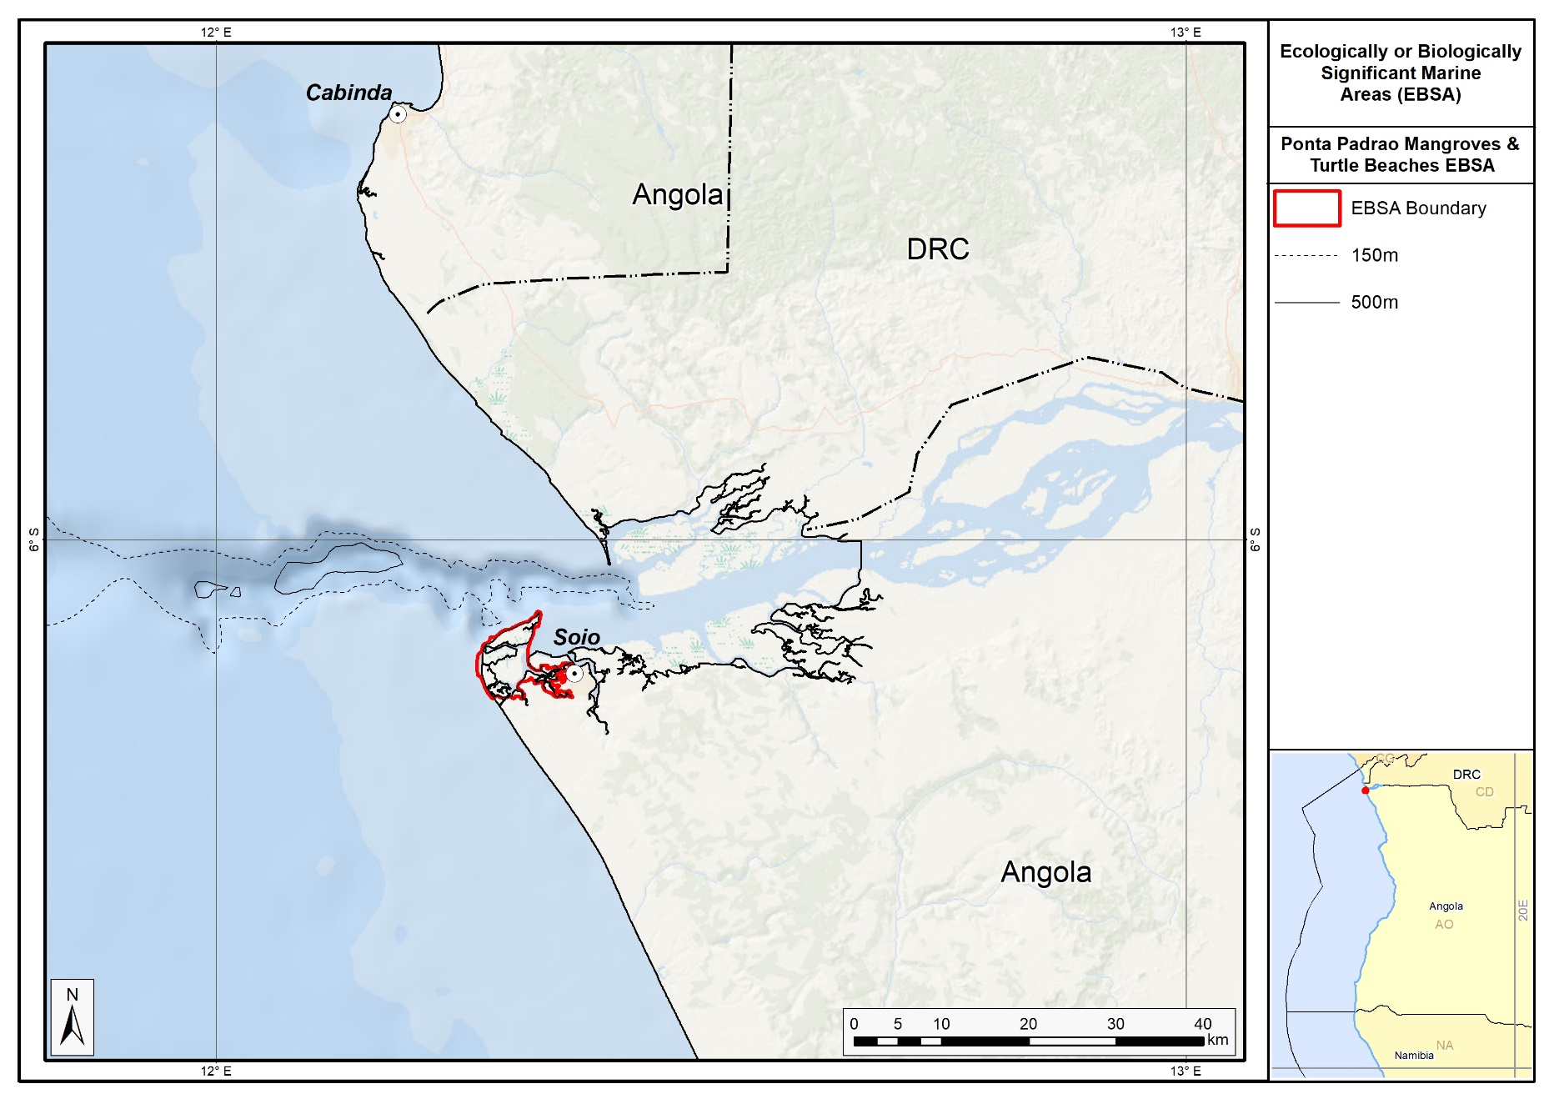
Proposed delineation of the Ponta Padrap Mangroves and Turtle Beaches EBSA.

Feature description of the proposed area
Ponta Padrao Mangroves and Turtle Beaches is a coastal EBSA and is thus described primarily for its benthic features, although the overlying water column in the estuary, surf and nearshore is tightly coupled to the key features and species at this site. The mangroves in the study area are part of the East Atlantic forest, and indigenous knowledge indicates that these mangroves around the Congo River mouth are some of the most important mangroves in Angola. The EBSA comprises tree- and shrub-form mangroves of two main species: Rhizophora racemosa and R. harrisonii, with R. mangle also present but less abundant. Mangroves made up of the African Rhizophora are very tolerant to fresh water (Saenger & Bellan, 1995; Lebigre, 1983, 1999) but may also survive under high salinity levels for at least part of the year. This is consistent with observations of the mangroves in this area; they are almost exclusively fresh water in some places and dominated by R. racemosa and R. harrisonii. In some places, the transitional mangroves have a terrestrial component whose characteristic species are ferns Bolbitis auriculata and the thorny shrub Drepanocarpus lunatus (CSIR, 2005c).

Plant diversity at the site extends to the adjacent forest and dunes as well. The only area of true forest in the EBSA occurs in the Sereia Forest. It covers an area of approximately 4 ha (ERM, 2006). The species of forest trees generally include a variety of fig species, African nutmeg (Pycanthus kombo) and woody species such as Entandrophragma angolensis. It is likely that there is an important component of shrubs and numerous lianas (ERM, 2006a). Although forests are terrestrial systems, they are included in this EBSA because they are interspersed with canals and tributaries that define the extent of the mangroves and other strongly coast-associated features. Similarly, the dunes behind the turtle nesting beaches are a key component of the coastal system because the critical linkages between beaches and dunes are important to maintain to secure resilience of sandy shores in the face of global change, and especially sea-level rise. The dune vegetation of the coastline is dominated by pioneering species. This flora is typical of the Central and West African coast (Lebrun, 1954; Davies and Le Maitre, 2003; CSIR, 2003a), comprising of a variety of herbs (Sesuvium crystallinum, Ipomoea pes-caprae, Canavallia obtusifolia), grasses (Sporobolus virginicus, Eragrostis linearis, etc.) and shrubs (Scaevola plumieri and Chrysobalanus icaco) (ERM, 2006a).

Bird diversity is also rich, including resident, migrating, visiting, and seasonal birds that use the area as a resting and feeding place. The mangroves of Soyo have similar bird communities to the mangroves of the Park des Mangroves in the Democratic Republic of Congo (DRC), which is a designated Ramsar site. Coastal birds found in the area include Phalaropus fulicarius, Larus fuscus, Larus dominicanus, Sterna albifrons and S. maxima (Dean, 2000; Dowsett and Simpson, 1991; Urban et al., 1986). Birds that feed on fish are uncommon within Diogo Cão Bay, although certain species of birds such as the Ceryle maxima, H. chelicuti and H. senegalensis, wader birds and bigger aquatic birds such as Cape cormorants (Phalacrocorax capensis) and small and great white egrets (Egretta alba and E. garzetta) use the margins of the mangrove canals as feeding grounds. The palm-nut vulture (Gypohierax angolensis) and the African fish eagle (Haliaeetus vocifer) are commonly seen over the river-mouth waters and the former over the palm tree savannah as well. A series of threatened and endemic species were identified in Angola, although only some of them exist in the area because there is not enough adequate habitat to support them.

Given the diverse habitats in the area, the EBSA also supports a variety of mammal species. In terms of terrestrial mammals, notable species are the side-striped jackal and wildcat. Marine mammals include cetaceans such as the blue whale, Rorquais, common dolphin and spotted dolphin that are found along the whole of the Angolan coastline. Perhaps most important of all, this site seems to be especially significant for Vulnerable manatees, with these mammals being reported as common in the Congo River (Keith Diagne, 2015). Manatees are in a general state of population decline, with local extirpations reported across its range due to hunting and habitat destruction (Keith Diagne, 2015), making sites where these animals are abundant even more important. Manatees have been hunted in the Congo River, with one hunter noting that he had killed three manatees per week for 30 years (Keith Diagne, 2015). However, current data on the abundance of manatees are limited.

The local reptiles include snakes and marine turtles that nest in the region. Up to five species of turtles (all of which are listed by the IUCN as threatened) use the Atlantic beach in the southeast of Ponta do Padrão as a nesting place (ENSR, 2005), although the site is primarily recognized as a rookery for Vulnerable olive ridley turtles. There are no records of nests in the inner coastline (to the east) of the Peninsula within Diogo Cão Bay, possibly due to high levels of human activity and low salinity (CSIR, 2005). The Kitabanga Project for conservation of marine turtles that was set up in 2003 currently monitors approximately 15 km of the beach of Soyo. The densities of nests recorded between 2011 and 2015 were as follows: 61 nests.km⁻¹ for olive ridley turtles, 0.2 nests.km⁻¹ for green turtles, and no records for leatherback turtles.

The diversity of marine and freshwater fish species is also particularly high. The following commercial species of fish predominate: corvina, sardines, grouper, saw fish, snapper, hammer shark, flounder, stingray, bagre, barracuda, red snapper, grey reef sharks, twaite shad, big eyed haemulidae, beltfish, mullets, and Guinea corvina (ACEPA, 2012). Many of these fish rely on the local zooplankton, which are abundant in the EBSA. There are many invertebrates in the area, including crabs, snails, oysters and shrimps, although the latter are commercially over-exploited. Despite the significant organic flow to Diogo Cão Bay originating from the mangrove and aquatic vegetation, the available data suggest that the benthos is actually impoverished (CSIR, 2005). Within the mangrove margins, macrofauna is limited to mudskippers (Periopthalmus sp) and mangrove crabs (Sesarma sp).

Feature condition and future outlook of the proposed area
The lack of basic infrastructure surrounding the area, such as drinking water, electricity and access roads, makes establishing private settlements in the vicinity very unlikely. However, tourists who come to see the classified historical monument, Ponta do Padrão, do occasionally visit the beach. Overall, however, the site is in good to fair ecological condition based on an assessment of cumulative pressures.

References
Angola LNG ESHIA Addendum Report October 2009.
Angola Resources Consultants (ARC), 2013. Estudo de Impacte Ambiental Social e da Saúde do Projecto de Desenvolvimento do Pólo Oeste no Bloco 15/06, Zaire Angola. Maio 2013.
Chapman, V.J. (1976). Mangrove Vegetation. Vaduz: J Cramer.
Checklist Ministério do Ambiente (MINAMB), Holísticos, C4 EcoSolutions (2015). “Approaching the urgent adaptation needs and reinforcement of the Angolan abilities in regards to climate change” – Description of selected sites: Zaire-Soyo.
CSIR (2003) - Angola LNG Project, Phase 4: Qualitative EIA: Impacts of Site development options on mangroves and related ecosystems (Preliminary Report).
CSIR 2003a. Cameroon National Oil Spill Contingency plan (Draft). February 2003. CSIR Report No. ENVS-C 2003-008.Environmentek, CSIR, Stellenbosch.
CSIR 2003b. Supplemental Data Acquisition Program for Angola LNG Project Site Selection – Phase 2: Preliminary London Convention Compliance Assessment. Report prepared for Texaco Angola Natural Gas Inc. CSIR Report No. ENV-S-C 2003-100C. Environmentek, CSIR, Stellenbosch.
CSIR (2003c) Angola LNG Project – Environmental Due Diligence and Geotechnical Evaluation: Soyo Site. Report prepared for Texaco Angola Natural Gas Inc. CSIR Report No ENV-S-C 2003-063.
CSIR (2005) Angola LNG Project: Environmental, socioeconomic and Health Impact Assessment: Sediment and Water Quality. CSIR Report (in prep).
Dar Al-Handasah (1999) Programma de Desenvolvimento Urbano e Socio Económico. Sumário Executivo.
Davies, S.J. and Le Maitre, D.C., 2003. Peninsula Mussulo Masterplan: Ecological Sensitivity Analysis. CSIR Report No: ENV-S-C 2002-091. CSIR-Environmentek, Stellenbosch, South Africa. Prepared for Africon, South Africa.
Dean, W.R.J. (2000) The birds of Angola. BOU Checklist Series 18 British Ornithological Union, Tring, Herts, Engalnd 433pp.
Dowsett, R.J. and Simpson, R.D.H (1991) The status of seabirds off the coast of Congo. In: Dowsett, RJ and Dowsett-Lemaire, F (eds.) Flora and fauna of the Kouilou Basin (Congo) and their exploitation Tauraco Research Report 4: 241-250.
ENSR International (2005). Scoping Phase Supporting Document for the Angola LNG Project, Proposed Angola LNG Project Environmental, Socioeconomic, and Health Impact Assessment (ESHIA), Março 2005.
ERM (2006a). Angola LNG Environmental, Social and Health Impact Assessment (unpublished).
ERM (2006b). Projecto Angola LNG, Relatório para Divulgação do ESHIA, Sumário Executivo. 2006.
Herod, J., 2003. Trip Report - Visit to Dredging International, Antwerp, Belgium. Copy supplied by John Herod, ChevronTexaco.
Holísticos (2013). Caracterização Ambiental e Social para o Desenho da Sensibilidade Costeira entre Cabinda e Kwanza Sul (Quicombo). Relatório Final, Maio, 2012.
Holness, S., Kirkman, S., Samaai, T., Wolf, T., Sink, K., Majiedt, P., Nsiangango, S., Kainge, P., Kilongo, K., Kathena, J., Harris, L., Lagabrielle, E., Kirchner, C., Chalmers, R., Lombard, M. 2014. Spatial Biodiversity Assessment and Spatial Management, including Marine Protected Areas. Final report for the Benguela Current Commission project BEH 09-01.
Johnson, D.E., Barrio Froján, C., Turner, P.J., Weaver, P., Gunn, V., Dunn, D.C., Halpin, P., Bax, N.J., Dunstan, P.K., 2018. Reviewing the EBSA process: Improving on success. Marine Policy 88, 75-85.
Lebigre, J-M., 1983. Le mangroves des rias du littoral Gabonais. Essai de cartographie typologique. Revue des Bois et Fôret des Tropiques 199: 3-27.
Lebigre, J-M., 1999. Natural dynamics of mangals through their margins: diagnostic elements. Hydrobiologia 413: 103-113.
Lebrun, J., 1954. Sur la végétation du secteur littoral du Congo Belge. Vegetation 5-6: 157-160.
Morais, M., Torres, M., Martins, M. (2005). Análise da Biodiversidade Marinha e Costeira, e Identificação das Pressões de Origem Humana sobre os Ecossistemas Marinhos e Costeiros. Estudo Temático n.º2. Projecto 00011125, Estratégia e Plano de Acção Nacionais para a Biodiversidade (NBSAP). Ministério do Urbanismo e Ambiente, Junho de 2005.
Morais, Michel. 2016. Apresentação pública “Projecto Kitabanga - Estudo e Conservação de Tartarugas Marinhas”.
Saenger, P. and Bellan, M.F., 1995. The mangrove vegetation of the Atlantic coast of Africa. A review. Laboratoire d’Ecolgie Terrestre (UMR 9964), Centre Nationale De La Recherche Scientifique, Universite de Toulouse III, France.
Shumway, C.A. 1999. Forgotten Waters: Freshwater and Marine Ecosystems in Africa. Strategies for Biodiversity Conservation and Sustainable Development.
http://pdf.usaid.gov/pdf_docs/PNACF449.pdf (accessed 17 April 2013).
Tomlinson, P.B., 1986. The Botany of Mangroves. Cambridge University Press, Cambridge.
Urban, E.K., Fry, C.H. and Keith, S. (eds.) (1986) The Birds of Africa Vol. 2. Academic Press, London.

Other relevant website address or attached documents
Summary of types of habitats and status of threats for the Sereia Peninsula. Soyo-Zaire. Data from Holness et al. (2014).
Threat Status | Ecosystem Type | Area km² | Area (%)
Critically Endangered | Congo Intermediate Sandy Beach | 4,9 | 10%
Critically Endangered Total |  | 4,9 | 10%
Endangered | Congo Inshore | 0,3 | 1%
Endangered Total |  | 0,3 | 1%
Vulnerable | Congo Dissipative-Intermediate Sandy Beach | 0,4 | 1%
Vulnerable Total |  | 0,4 | 1%
Least Threatened | Congo Estuarine Shore | 41,5 | 83%
 | Congo Reflective Sandy Beach | 3,0 | 6%
Least Threatened Total |  | 44,5 | 89%
Grand Total |  | 50,1 | 100%

Assessment of the area against CBD EBSA Criteria
CBD EBSA Criteria  (Annex I to decision IX/20) | Description  (Annex I to decision IX/20) | Ranking of criterion relevance
Uniqueness or rarity | Area contains either (i) unique (“the only one of its kind”), rare (occurs only in few locations) or endemic species, populations or communities, and/or (ii) unique, rare or distinct, habitats or ecosystems; and/or (iii) unique or unusual geomorphological or oceanographic features. | Medium
Explanation for ranking

Apart from largely distributed habitats of sensitive mangrove, there is only a single area of remnants of important Atlantic forest in terms of biodiversity, which represents the very last area of this kind of habitat in the region.

Special importance for life-history stages of species | Areas that is required for a population to survive and thrive. | High
Explanation for ranking

Turtle nesting occurs on the Atlantic beaches along the whole peninsula. It is also a nesting and breeding site for many bird species and a feeding and resting place of many other species. The vast mangroves are of extreme importance for fish reproduction in the Congo River mouth. The calm waters of the mangrove forest act as nurseries for juvenile fish and shrimps and the aerial roots, low-level logs and the mud surfaces generally support a varied fauna of oysters, snails, crabs and other invertebrates (Morais et al., 2005).

Importance for threatened, endangered or declining species and/or habitats | Area containing habitat for the survival and recovery of endangered, threatened, declining species or area with significant assemblages of such species. | High
Explanation for ranking

Most importantly, this area supports many threatened species, notably turtles, manatees, and birds. The Kitabanga Project is a marine turtle conservation program that was set up in 2003. It currently monitors approximately 15 km of the Soyo beaches. Densities of turtle nests recorded between 2011 and 2015 are as follows: 61 nests.km⁻¹ for Vulnerable olive ridley turtles, 0.2 nests.km⁻¹ for Endangered green turtles and no records for the Vulnerable leatherback turtle (Morais, 2016). The Congo River is also a site where Vulnerable manatees are commonly found. African manatees are in a general state of population decline, with local extirpations reported across its range due to hunting and habitat destruction (Keith Diagne, 2015), making sites where these animals are abundant even more important. Manatees have been hunted in the Congo River, with one hunter noting that he had killed three manatees per week for 30 years (Keith Diagne, 2015), which is more than 4500 animals. However, current data on the abundance of manatees are limited. There are also several threatened bird species that use the site as a nesting, breeding, foraging and resting site.

In terms of habitats, there is only one area where remnants of the important Atlantic forest remain; thus, the proposed EBSA contains the very last area of this kind of habitat in the region. It also contains Critically Endangered and Vulnerable sandy beach types, and an Endangered inshore ecosystem.

Vulnerability, fragility, sensitivity, or slow recovery | Areas that contain a relatively high proportion of sensitive habitats, biotopes or species that are functionally fragile (highly susceptible to degradation or depletion by human activity or by natural events) or with slow recovery. | High
Explanation for ranking

The proposed EBSA comprises several features that are fragile, sensitive to disturbance and that will take a long time to recover. The mangroves are the most sensitive ecosystem in the proposed EBSA. Sensitive species with slow recovery following impacts to populations include the turtles (around 30 years to sexual maturity), manatees (30-year generation time) and some of the birds. Further, although beaches are largely resilient ecosystems, the adjacent dune systems are very sensitive to disturbance, and the more mature dune forests can take centuries to recover from disturbance.

Biological productivity | Area containing species, populations or communities with comparatively higher natural biological productivity. | Medium
Explanation for ranking

Mangroves are among the most productive ecosystems (FAO 1994) and provide coastal lagoons and estuaries with essential organic nutrients. Mangroves are also an important breeding and nursery area for larvae and important species in juvenile stages, especially for the fish and crustaceans in this area (Shumway, 1999).

Biological diversity | Area contains comparatively higher diversity of ecosystems, habitats, communities, or species, or has higher genetic diversity. | High
Explanation for ranking

The diversity of habitats on the peninsula provide favorable conditions for many species from the marine, coastal, estuarine and terrestrial realms to occur. The site supports particularly diverse assemblages of birds, fish, turtles, invertebrates, small mammals, and snakes. For example, bird species include resident, migrating, visiting, and seasonal birds that comprise similar communities to those at Park des Mangroves in the Democratic Republic of Congo (DRC), which is a designated Ramsar site. The mammals include terrestrial species, such as jackals and wildcats, and marine species, such as a variety of dolphins and whales, and importantly, manatees. Reptiles similarly include terrestrial and marine representatives, including snakes and sea turtles. Both marine and freshwater fish are present, with species ranging from teleost fish to sharks and stingrays. Invertebrates are also diverse, including some commercially important species, such as shrimp.

The plant diversity is particularly notable, with the combination of dune, mangrove and forest species represented in the area, over and above the likely rich communities of microflora that are associated with the high organic loads from the mangroves.

Naturalness | Area with a comparatively higher degree of naturalness as a result of the lack of or low level of human-induced disturbance or degradation. | Medium
Explanation for ranking

The ecosystem shows some degree of anthropogenic degradation caused by existent populations as well as by the setting up of new artificial canals, mangrove wood cutting and the presence of communities. An assessment of ecological condition of the area based on cumulative pressures show that 15 % of the benthic area is in good condition, and the remaining 85 % is in fair condition; 100 % of the pelagic area is in Good condition. This suggests that, although there is widespread modification of the area, biodiversity and the ecological processes are still largely intact.

Status of submission
Area to be submitted to the Conference of the Parties for acknowledgement of meeting EBSA criteria once review process is finalized.

COP Decision
Not yet submitted.

End of proposed EBSA description

Motivation for Submission
To be developed.

Research Needs
To be developed.

Future Process
To be developed.

Longa Coastline

Proposed EBSA Description

Abstract
The proposed Longa Coastline EBSA is in Cuanza-Sul Province in central Angola, and has an approximate area of 470 km². It includes the Longa River mouth, which comprises a mostly undisturbed, high-energy marine system, with a very well protected lagoon behind a sand dune cordon. This coastal configuration creates a particular suite of abiotic conditions that in turn support a rich diversity of fauna and flora. The site is thus especially important for supporting different life-history stages as well as threatened and declining species and habitats, most notably featuring as the site with the highest nest density for Vulnerable olive ridley turtles. Local insights indicate that the lagoon is an important feature that warrants research to understand its biodiversity patterns, processes, and ecological role, which could benefit from traditional knowledge held by members of the local communities. Many of the biodiversity features comprising the EBSA are sensitive to disturbance, slow growing and/or late maturing (including sea turtles, birds and some species of mangroves). The area is thus highly relevant in terms of the EBSA criteria: “Importance for threatened, endangered or declining species and/or habitats” and “Vulnerability, fragility, sensibility or slow recovery”.

Introduction
The coastal portion of the Longa River is characterized by an 8-km long dune-backed sandy shore that shelters a narrow estuarine lagoon in the northern half of the central Angolan coast. The estuary mouth itself breaks through the dunes at various locations along this sandy shore; sometimes in the northern portion of the lagoon, and sometimes in the southern portion. The Longa’s waters are dark (almost black) due to leaching tannins. The plume of brackish and nutrient-rich water exiting the estuary mouth moves to the west and north (Morais et al., 2005). The distinct character of this estuarine system is one of the reasons why this area is proposed as an EBSA. However, there is a clear need for more research to better understand the biodiversity patterns, ecological processes and ecological role of the estuarine lagoon system; local knowledge suggests that it is an important feature, but very little is known about it.

What is known, though, is that the estuary is rarely subjected to sudden alterations from estuary-mouth closure, thus allowing mangroves and marginal banks with vegetation to establish within the system (Holísticos, 2014). The vegetation in the surrounds is predominantly made up of dry forest formations, bushy savannah (with Adansonia, Sterculia, Acacia), grassy savannah (of Setaria welwitschii), grassy steppe with shrubs and trees (Hyphaene gossweileri) and palustrine wetlands (Diniz, 2006). The proposed EBSA extends beyond the estuary system itself, and includes approximately 470 km² (44 km alongshore) of sandy, mixed and rocky shores, and adjacent inshore and estuarine habitats. Most importantly, these beaches support the highest nest densities in Angola for Vulnerable olive ridley turtles. Another species that this site has supported historically is the Vulnerable African manatee. There are no known recent records of this species in Longa River, and so contemporary presence of this species in the Longa Coastline EBSA is not known. Research is required to determine if manatees still exists in the area of if it has been extirpated (and if the latter, why).

The mangroves were fundamental in choosing this site as a proposed EBSA; although not globally significant, these mangroves are of key local significance because they are the southernmost mangroves in Angola. Consequently, the reason this EBSA was not included in the original set of EBSAs at the South Eastern Atlantic Workshop in 2013 (UNEP/CBD/RW/EBSA/SEA/1/4) is because this information was not available at that meeting and local knowledge is better than the information included in international datasets (e.g., WCMC and the World Mangrove Atlas). Further, results from the turtle monitoring programme in the area had not yet been published and thus were not available at the meeting; it was not known at the time how important this site is for these threatened species. Because this is a discrete site that is centred around the mangroves, lagoon and the associated threatened species, it is presented as a Type 1 EBSA (sensu Johnson et al. 2018). It is coastal, and thus does not extend far offshore.

Description of the location

EBSA Region
South-Eastern Atlantic

Location
The proposed area for the Longa Coastline EBSA is located in the province of Cuanza-Sul in central Angola, near the South border of the Quiçama National Park. It includes the Longa River estuary, lagoon and mouth and 44 km of adjacent coastline, covering an approximate area of 470 km². The whole of the proposed area lies entirely within Angola’s national jurisdiction.

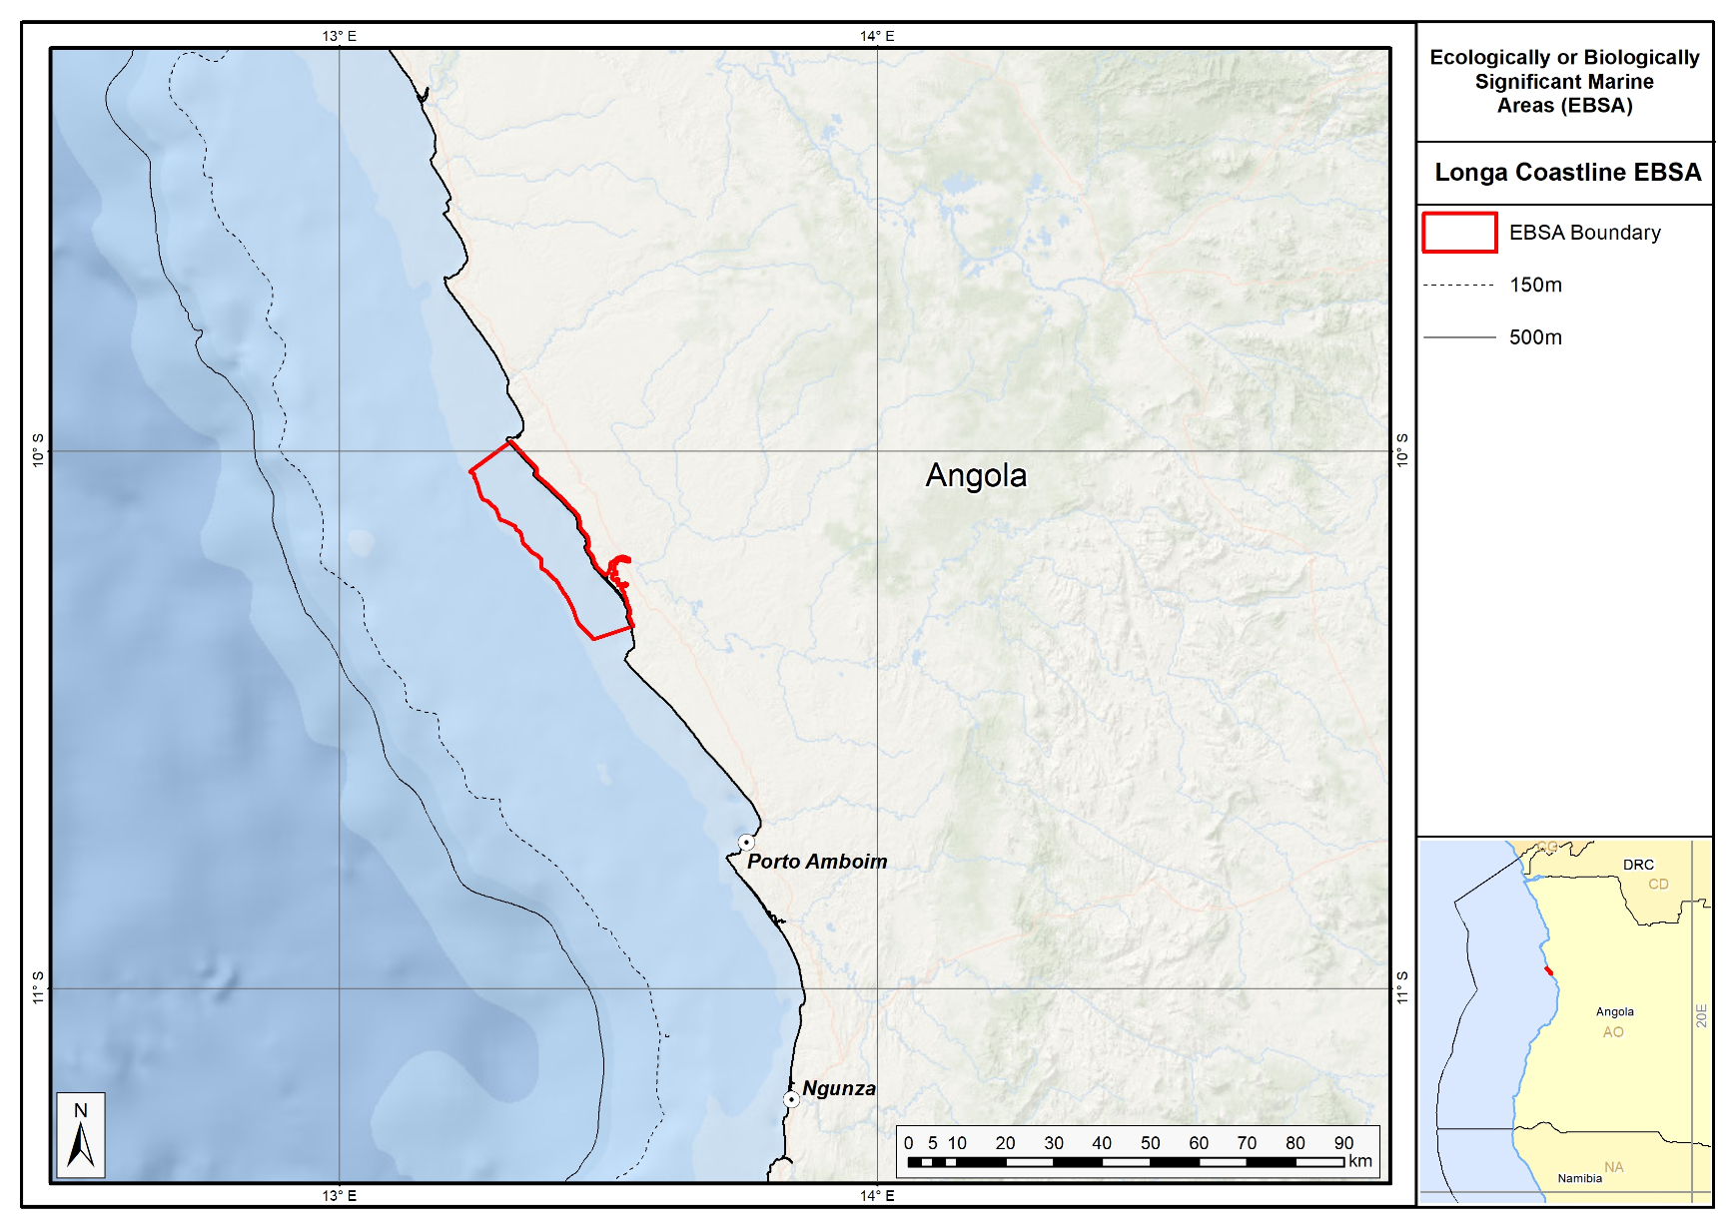
Proposed delineation of the Longa Coastline EBSA.

Feature description of the proposed area
Longa Coastline is a coastal EBSA is in the province of Cuanza-Sul, Angola, and is thus described primarily for its benthic features, although the overlying water column in the estuary and nearshore is very tightly coupled to the ecology of the site. This proposed EBSA spans the confluence of estuarine and marine systems with specific characteristics. Local knowledge indicates that this estuarine lagoon is an important feature because of the uniqueness of the conditions. However, future research on the lagoon component is required to understand the broader significance of this coastal feature. For example, what other species are present; what is the importance/role of the crocodiles, birds and mangrove species; what are the dynamics of the estuary and the effects during mouth breaching or mouth closure and back flooding? Given the local (human) communities in the surrounding area, traditional knowledge could play an important role in future research projects. For example, as noted below, it is said that local fish catches have declined in recent years: research is necessary to establish why, and how this could potentially be mitigated or reversed, and local fishers’ knowledge could be important in reconstructing past information.

The mangroves, comprising trees and shrubs, are the characteristic vegetation of the area, represented by families of Rhizophoraceae and Avicenniaceae. They provide feeding, breeding, nursery and resting areas for an important component of the local biodiversity. The main indicators of this include a high number of crustaceans (lobsters on the marine side; shrimps and crabs on the estuarine side) as well as many species of fish, among which are representatives of families such as Megalopidae, Carangidae, Lutjanidae, Sciaenidae, Polynemidae, Mugilidae and Clariidae (Holísticos, 2014).

Many bird species use the various ecosystems within the proposed EBSA. Birds rest along the sandy shoreline, nest along the vegetation (mangroves and riparian forest) and move among the local habitats. The most dominant groups are sea swallows and seagulls, some waders, diving birds, aquatic birds and birds of prey (MINAMB et al., 2015). The presence of Asian woolly neck (Ciconia episcopus) was confirmed, which is classified as Vulnerable in accordance with the IUCN Threatened Species Red List (Bird Life International, 2017). This bird is mainly threatened due to hunting by humans and loss of habitat.

The area is seen as the most important site for marine turtles nesting along the Angolan coast. The Kitabanga Project has been ongoing since 2003 in this area and currently monitors around 10 km of beach around the Longa River mouth. It has particularly high nest densities for olive ridley turtles (Lepidochelys olivacea). According to Morais (2014), the Longa region is seen as extremely important for olive ridley turtles, a species classified in the IUCN Red List as Vulnerable, with an average density of 175 nests.km⁻¹. The leatherback turtle (Dermochelys coriacea), classified by the IUCN Red List as Vulnerable, is also present at much lower densities of 2 nests.km⁻¹. However, this region is under high pressure from the artisanal fisheries sector where, during the period of 2013/2014, 136 turtles were captured (Morais, 2014). There are also many other reptile species within the proposed EBSA. Crocodiles, for example, are commonly seen along the river banks and along the whole inner side of the sandy shoreline where they rest and nest (MINAMB et al., 2015).

Among the aquatic mammals, manatees use mostly or exclusively the inshore waters up to estuarine areas from the Longa River to the north, and are seen in some estuaries. However, recent records do not show the presence of manatees in the proposed EBSA. Major threats to this animal’s survival are human exploration (illegal hunting), degradation and/or loss of habitat and accidental capture in nets (Morais et al., 2005), and thus the species is classified as Vulnerable. Further research is required to confirm the presence or extirpation of manatees in this EBSA.

Feature condition and future outlook of the proposed area
The people living in the surrounding areas come to this site daily in order to carry out commercial activities. The most popular products sold along the road are already made (i.e. meat, fish, and cold beverages) to feed lorry and bus drivers. The residents state that the capture of fish has gone down significantly over the years in terms of volume and occurrence. The environmental conditions of the estuary mouth and the inner side of the estuary are mainly regulated by the river, especially the levels of flood and drought conditions. These are dependent on the rainy season and annual rainfall rate. Beyond the ongoing turtle monitoring, no research is planned for the area, however, it is highlighted here as a priority.

An assessment of ecological condition of the area based on cumulative pressures show that 15 % of the benthic area is in Good condition, and the remaining 85 % is in Fair condition; 100 % of the pelagic area is in Good condition. This suggests that, although there is widespread modification of the area, biodiversity and the ecological processes are still largely intact.

References
Angolan Association of the Oil Exploration and Production Companies (Associação das Companhias de Exploração e Produção de Angola, ACEPA) (2014). Environmental and Social Characterisation to Determine the Coastal Sensitivity of the Areas Between Luanda and Namibe.
BirdLife International. 2017. Ciconia episcopus. (amended version published in 2016) The IUCN Red List of Threatened Species 2017: e.T22727255A110064997. http://dx.doi.org/10.2305/IUCN.UK.2017-1.RLTS.T22727255A110064997.en. Downloaded on 14 December 2017.
FAO (1994). Mangrove forest management guidelines (English) In: Food and Agricultural Organisation (FAO) Forestry Paper, no. 117 / FAO, Rome (Italy). Forest Resources Division, 339 p. http://archive.org/stream/mangroveforestma034845mbp/mangroveforestma034845
mbp djvu.txt (accessed 17 April 2013)
Holísticos (2014). Caracterização Ambiental e Social para o Desenho da Sensibilidade Costeira entre Luanda e Namibe. Relatório Final, Dezembro de 2014.
Holness, S., Kirkman, S., Samaai, T., Wolf, T., Sink, K., Majiedt, P., Nsiangango, S., Kainge, P., Kilongo, K., Kathena, J., Harris, L., Lagabrielle, E., Kirchner, C., Chalmers, R., Lombard, M. 2014. Spatial Biodiversity Assessment and Spatial Management, including Marine Protected Areas. Final report for the Benguela Current Commission project BEH 09-01.
Johnson, D.E., Barrio Froján, C., Turner, P.J., Weaver, P., Gunn, V., Dunn, D.C., Halpin, P., Bax, N.J., Dunstan, P.K., 2018. Reviewing the EBSA process: Improving on success. Marine Policy 88, 75-85.
Morais, M., Torres, M., Martins, M. (2005). Análise da Biodiversidade Marinha e Costeira, e Identificação das Pressões de Origem Humana sobre os Ecossistemas Marinhos e Costeiros (Estudo Temático n.º2 Projecto 00011125 – Estratégia e Plano de Acção Nacionais para a Biodiversidade (NBSAP). Ministério do Urbanismo e Ambiente. Junho 2005
Morais, M. (2014). Relatório de Actividades, Resultados e Gastos Referentes à Temporada 2013/2014 do Projecto Kitabanga - Conservação de Tartarugas Marinhas. Faculdade de Ciências da Universidade Agostinho Neto. Maio 2014.
Morais, M. (2016). Apresentação pública “Projecto Kitabanga - Estudo e Conservação de Tartarugas Marinhas”.
Morais, M. 2004. Informação para a selecção de zonas húmidas e sua classificação como sítios RAMSAR (RIS) em Angola. IUCN ROSA / MINUA. Luanda.
Ministério do Ambiente (MINAMB), Holísticos, C4 EcoSolutions (2015). “Approaching the urgent adaptation needs and reinforcement of the Angolan abilities in regards to climate change” – Description of selected sites: Longa.
Ministério do Urbanismo e Ambiente (MINUA) (2006). Programa de Investimento Ambiental (2006) Relatório do Estado Geral do Ambiente em Angola. Angola.
Shumway, C.A. (1999). Forgotten Waters: Freshwater and Marine Ecosystems in Africa. Strategies for Biodiversity Conservation and Sustainable Development. Available at: http://pdf.usaid.gov/pdf_docs/PNACF449.pdf (accessed 17 April 2013).

Other relevant website address or attached documents

Summary of types of habitats and status of threats for the Longa Coastline. Data from Holness et al. (2014).
Threat Status | Ecosystem Type | Area km² | Area (%)
Endangered | Kwanza Exposed Rocky Shore | 1,9 | 0%
 | Kwanza Inshore | 383,6 | 82%
 | Kwanza Intermediate Sandy Beach | 3,0 | 1%
 | Kwanza Mixed Shore | 45,0 | 10%
Endangered Total |  | 433,4 | 92%
Vulnerable | Kwanza Estuarine Shore | 7,0 | 1%
Vulnerable Total |  | 7,0 | 1%
Least Threatened | Kwanza Reflective Sandy Beach | 11,4 | 2%
 | Kwanza Sheltered Rocky Shore | 17,7 | 4%
Least Threatened Total |  | 29,1 | 6%
Grand Total |  | 469,5 | 100%

Assessment of the area against CBD EBSA Criteria
CBD EBSA Criteria  (Annex I to decision IX/20) | Description  (Annex I to decision IX/20) | Ranking of criterion relevance
Uniqueness or rarity | Area contains either (i) unique (“the only one of its kind”), rare (occurs only in few locations) or endemic species, populations or communities, and/or (ii) unique, rare or distinct, habitats or ecosystems; and/or (iii) unique or unusual geomorphological or oceanographic features. | Medium
Explanation for ranking

The Longa River mouth is a regionally unique site where there is the combination of a high-energy marine system and a very sheltered estuarine system that jointly created a distinct set of abiotic conditions that support a rich diversity of flora and fauna. It is also one of the most important rookeries in Angola for nesting olive ridley turtles, and the southernmost mangrove community in Angola. Further research is required to fully understand the biodiversity patterns, ecological processes and role of this regionally unique estuarine lagoon system, which may be understated here.

Special importance for life-history stages of species | Areas that is required for a population to survive and thrive. | High
Explanation for ranking

One of the most important attributes of this EBSA is that it is one of the most important turtle rookeries along the Angolan coast. The average nest densities recorded between 2011 and 2015 are as follows: 175 nests.km⁻¹ for the olive ridley turtle (classified as Vulnerable) and 2 nests.km⁻¹ for leatherback turtles (classified as Vulnerable) (Morais, 2016).

The mangroves also offer feeding, breeding, nursery and/or resting sites for many species, including crustaceans, fish and birds. For example, species that use the estuary for breeding and nursery areas include lobsters on the marine side, shrimps and crabs on the estuarine side, and fish from many different families (Holísticos, 2014). The most dominant birds present in the EBSA are sea swallows and seagulls, some waders, diving birds, aquatic birds and birds of prey (MINAMB et al., 2015) that use the site mainly for feeding and resting.

Importance for threatened, endangered or declining species and/or habitats | Area containing habitat for the survival and recovery of endangered, threatened, declining species or area with significant assemblages of such species. | High
Explanation for ranking

This EBSA is highly important for threatened species, particularly for Vulnerable turtles and manatees. Turtle nesting occurs along the whole strip of sand mainly between September and December, with hatching between October and January. Turtle nesting and hatching in this area is monitored by the Kitabanga Project – Conservation of Marine Turtles. Currently, the project monitors around 10 km of beaches of the Longa River mouth. The average nest density recorded between 2011 and 2015 was 175 nests.km⁻¹ for olive ridley turtles and 2 nests.km⁻¹ for leatherback turtles (Morais, 2016), both of which species are listed as Vulnerable. For this reason, Longa Coastline is of extreme importance for olive ridley turtles because it is the area in Angola that contains the highest nest densities. This is one of the main motivations for this EBSA, and for requiring coastal conservation measures.

The African manatee (Trichechus senegalensis) was, in the recent past, found in this area. However, there are no recent records of manatees in the area. The manatee is a Vulnerable species that is showing declines across its range, and extirpations at some sites due to hunting and habitat destruction (Keith Diagne, 2015). Research is required to determine whether this site still supports manatees, or if it has been extirpated (and if so, why). There are also several threatened bird species in the area, e.g., the Asian woolly neck (Ciconia episcopus), which is classified as Vulnerable. Finally, the proposed EBSA includes various threatened habitats, including four Endangered sandy, rocky and mixed shore types, and one inshore type, and one Vulnerable estuarine shore type.

Vulnerability, fragility, sensitivity, or slow recovery | Areas that contain a relatively high proportion of sensitive habitats, biotopes or species that are functionally fragile (highly susceptible to degradation or depletion by human activity or by natural events) or with slow recovery. | High
Explanation for ranking

The proposed EBSA comprises several features that are fragile, sensitive to disturbance and that will take a long time to recover. Sensitive species with slow recovery following impacts to populations include the turtles (around 30 years to sexual maturity), manatees (30-year generation time) and some of the birds. The mangroves are the most sensitive ecosystem in the proposed EBSA because the trees are slow growing. Research is required to determine the vulnerability and sensitivity of the estuarine lagoon system.

Biological productivity | Area containing species, populations or communities with comparatively higher natural biological productivity. | Medium
Explanation for ranking

No data exist for this particular system; however it is known that mangroves are among the most productive ecosystems (FAO 1994), in turn supporting highly productive coastal lagoons and estuaries that contain essential organic nutrients. Mangroves are also important fish spawning sites and nursery areas for larvae and juvenile stages of important species (Shumway, 1999), with lobsters and shrimps of importance in the Longa River.

Biological diversity | Area contains comparatively higher diversity of ecosystems, habitats, communities, or species, or has higher genetic diversity. | High
Explanation for ranking

All habitats in this site present a set of favorable conditions for a rich diversity of species, from plants to iconic vertebrates. The high diversity of plant species at this site comes from the combination of dune, mangrove and forest areas in the proposed EBSA that each support different floral communities. Similarly, habitat diversity contributes to diverse animal species assemblages, with a high number of crustaceans (i.e., lobsters in the marine shore and shrimps and crabs in the estuarine shore) and many species of fish (namely Megalopidae, Carangidae, Lutjanidae, Sciaenidae, Polynemidae, Mugilidae and Clariidae families) (Holísticos, 2014). The most dominant groups of birds include sea swallows and seagulls, some waders, diving birds, aquatic birds and birds of prey (MINAMB et al., 2015). Crocodiles are frequently observed resting and nesting along the riverside and on the inner side of the sandy riverbank (MINAMB et al., 2015), with other repties including several species of turtles, some of which nest on the site’s beaches. Manatees were historically present at this site too, but it is not clear if this is still the case.

Naturalness | Area with a comparatively higher degree of naturalness as a result of the lack of or low level of human-induced disturbance or degradation. | Medium
Explanation for ranking

An assessment of ecological condition of the area based on cumulative pressures show that 15 % of the benthic area is in Good ecological condition, and the remaining 85 % is in Fair ecological condition; 100 % of the pelagic area is in Good ecological condition. This suggests that, although there is widespread modification of the area, biodiversity and the ecological processes are still largely intact.

Some important areas of mangrove and the riparian vegetation around the River Mouth are in pristine condition with little signs of human intervention or global degradation. It is estimated that the size of this area is 30 ha (MINAMB et al., 2015). However, outside of this area some impact result from activities of the community along this road who moves daily to this area to carry out commercial activities. The residents state that the capture of fish has gone down significantly over the years in terms of volume and occurrence. The environmental conditions of the river mouth and the inner side of the estuary are mainly regulated by associated riverside factors, especially the levels of flooding and drought conditions.

Status of submission
Area to be submitted to the Conference of the Parties for acknowledgement of meeting EBSA criteria once review process is finalized.

COP Decision
Not yet submitted.

End of proposed EBSA description

Motivation for Submission
To be developed.

Research Needs
To be developed.

Future Process
To be developed.

Ombaca Canyon and Seamount Complex

Proposed EBSA Description

Abstract
The proposed Ombaca Canyon and Seamount Complex EBSA focuses on offshore canyons, seamounts and key oceanographic features that relate to elevated productivity in the area. It is situated 120 km offshore of Porto Amboim, extends to the boundary of the Angolan EEZ, and covers an area of approximately 37 321 km². Although biodiversity has not yet been comprehensively surveyed, the area is known to support various turtle and cetacean species. The seasonal upwelling also creates periods of intense primary productivity, that in turn promotes productivity of many fish species that are commercially important throughout the BCLME, including supporting very early life history stages of these and other key species. It is also likely that the canyons and seamounts support diverse communities, highly likely to support fragile habitat-forming species, such as corals and sponges. Currently, the entire area is considered to be in Good ecological condition, with virtually pristine biodiversity patterns and processes intact: this site is thus recognized highly for its Naturalness in both benthic and pelagic features.

Introduction
The site comprises a rugged benthic topography of canyons and seamounts, situated within the semi-permanent Angola-Benguela Front. A key characteristic of the oceanography on the Angolan continental shelf is the upwelling phenomenon that starts in May-June, reaches its peak in August-September and probably ends near the end of the year. This upwelling results in intense primary production that in turn influences the production and distribution of fish, thereby playing a critical ecological role for ecosystems in the area. It is known that fish species often adapt their reproductive strategies to ocean currents and productivity cycles, so spawning times and the distribution of the main Angolan species tend to coincide with the observed seasonal oceanographic patterns (Sætersdal et al., 1999). The interactions of the main currents in the region generate areas of divergence along the continental margin (such as the coastal upwelling) as well as along the equator. The intensity of these processes varies with each season.

Description of the location

EBSA Region
South-Eastern Atlantic

Location
The proposed EBSA is approximately 120 km offshore of Porto Amboim, between Luanda and Benguela, and extends to the outer boundary of the Angolan Exclusive Economic Zone. It has an approximate area of 37 321 km². The proposed EBSA lies entirely within Angola’s national jurisdiction.

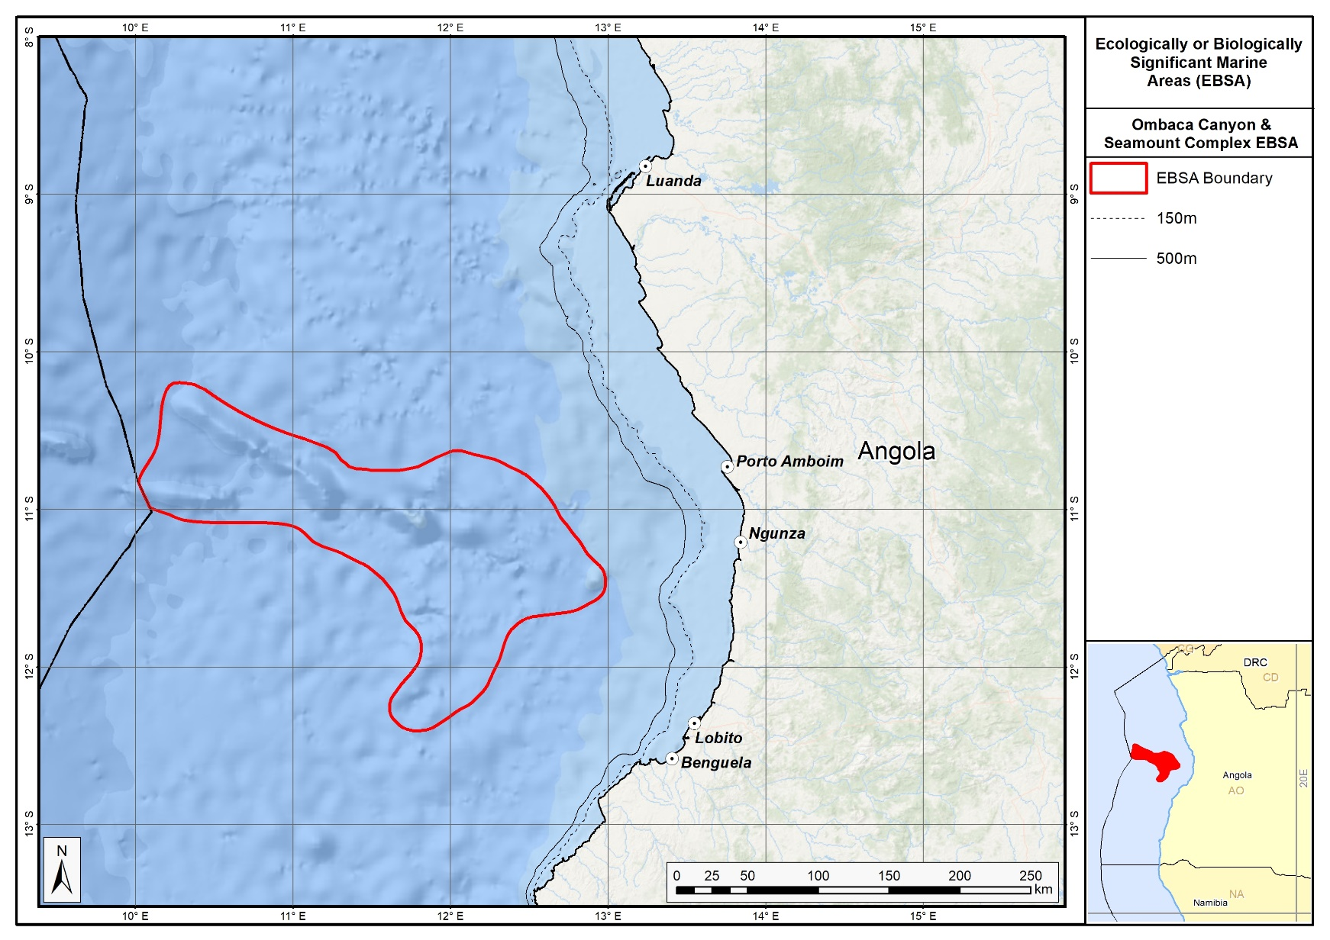
Proposed delineation of the Ombaca Canyon and Seamount Complex EBSA.

Feature description of the proposed area
The outer portion of the continental shelf and slope is mostly regular with a smooth, gentle gradient of approximately 20 m.km⁻¹ within the depth range of -200 to -1000 m, and of approximately 12 m.km⁻¹ between depth ranges of -1000 to -2000 m. At approximately 50 km from the Benguela coastline, the seabed maintains these characteristics but, immediately to the north (towards Sumbe), the seabed rises sharply to depths of shallower than -1000m.

Ocean currents and circulation patterns in the region include a complex set of flows that are linked to a larger system of currents in the tropical east Atlantic. The dominant circulation patterns of the Angolan central and southern continental shelf are driven by the warm Angola Current that moves southwards, and where this current meets the cold Benguela Current at the Angola-Benguela Front (Moroshkin et al., 1970; Meeuwis and Lutjeharms, 1990; Shannon and O'Toole, 1998; and Lass et al., 2000). The Angola Current is fast and stable and penetrates up to depths of 250-300 m, covering both the continental shelf and slope. The typical current speed is 50 cm.s⁻¹ but it can reach or even exceed speeds of 70 cm.s⁻¹ (Moroshkin et al., 1970). The origin of this current, at least on the surface, is the southeastern arm of the South Equatorial Counter-Current.

The Angola-Benguela Front forms where the warm Angola Current, moving south, meets with the cold Benguela Current, moving north. This phenomenon occurs typically in the south of the Bay of Lobito at 14°S – 16°S and is a semi-permanent oceanographic feature. The gradients of temperatures at the surface reach 4°C.°latitude⁻¹, but on average are 1.5°C.°latitude⁻¹. This Front varies by season, reaching maximum levels in the summer when it is wider and is located further south, compared to winter when the front retracts towards the north and has a lower temperature gradient. These variations are related to the seasonality of the Angola Current (Meeuw and Lutjeharms, 1990). Episodic inflows of warm, saline water towards the south may displace the Angola-Benguela Front up to 23°S (Shannon et al, 1986), with effects associated with the general level of biological productivity in the north of the system. Shannon et al (1986) classified these events as ‘Niños de Benguela’ because they are comparable to the ‘El Niño’ of the tropical east Pacific Ocean. However, a northward shift of the Angola-Benguela Front has never been observed on this same scale. High concentrations of phytoplankton biomass occur below the surface where the water column is highly stratified, a phenomenon that also occurs offshore of central Angola (Holligan et al., 1984, Joint et al., 1986, In: ARC, 2013).

Data presented by the INIP (2013) show that phytoplankton is dominated by diatoms and dinoflagellates throughout most of the year in almost all years that were studied (2004, 2008, 2009 and 2010), but that dinoflagellates and cyanobacteria (blue algae) may have dominance over diatoms (2011) and that cyanobacteria may completely dominate the composition of phytoplankton (2012).

There is a lack of detailed knowledge regarding the concentrations and distributions of ichthyoplankton (fish eggs and larvae) in Angolan waters, but eggs and larvae of South African pilchard (sardines; Sardinops sagax), Round Sardinella (Sardinella aurita), European anchovy (Engraulis encrasicolus), cape horse mackerel (Trachurus trachurus capensis) and hakes (Merluccius sp.) occur in the Angola-Benguela Front area as well as the mesopelagic zone. Round Sardinella and Madeiran Sardinella (Sardinella aurita and S. eba (maderensis)) juveniles are vastly distributed over the Angolan Continental Shelf (Wysokinski, 1986, INIP, 2013), thus it is likely that these species, together with Cunene horse mackerel (Trachurus trecae), are important components of the region’s ichthyoplankton (ARC, 2013). The area coincides with the distribution of two species of Sardinella (S. maderensis and S. aurita), Cunene horse mackerel (Trachurus trecae), other demersal fish (mainly Dentex) and deep-water king prawns (ARC, 2013). Other species occurring in deeper areas of the continental shelf and slope include squid, shrimps, crabs and Smallscale Splitfin (Synagrops microlepis) (ARC, 2013).

Five turtle species have been recorded in Angolan waters, namely: leatherbacks (Dermochelys coriacea), olive ridleys (Lepidochelys olivacea), green turtles (Chelonia mydas), loggerheads, (Caretta caretta) and hawksbills (Eretmochelys imbricata) (Carr and Carr 1991; Fretey 2001, Weir et al. 2007). Of these species, only the green turtles, leatherbacks and olive ridleys nest in Angola (Carr and Carr 1991; Fretey 2001). Leatherbacks are known to forage in productive waters and around seamounts, and likely use this area as a foraging ground.

Whales and dolphins are commonly observed in Angolan waters with confirmation of 11 dolphin and 14 whale species in the region. Among these, four species are classified as threatened as per the IUCN criteria (IUCN, 2013) namely, Sei whale, blue whale and common whale being classified as Endangered, while the Sperm Whale is classified as Vulnerable.

Broadly, therefore, the EBSA is a particularly productive area, with productivity likely also enhanced by the rugged undersea topography. However, more research is required to better establish the linkages between the benthic and pelagic systems, that might ultimately require splitting this EBSA into a benthic and dynamic pelagic EBSA. Also, the link between the seamounts within and beyond Angola’s EEZ needs to be investigated, as well as the dynamics of the Angola-Benguela Front in Angola and in the adjacent ABNJ; this new information, subject to international processes, may require an extension of this EBSA into ABNJ. In the interim, however, it is presented here as a Type 2/4 EBSA (sensu Johnson et al. 2018) as a collection of features that are connected by the same ecological processes, and as a dynamic feature viz. the Angola-Benguela Front.

Feature condition and future outlook of the proposed area
An assessment of ecological condition based on cumulative pressures within the EBSA showed that 100 % of the benthic and pelagic area is in Good ecological condition, suggesting that the whole EBSA area is (near) pristine, and has virtually all natural biodiversity patterns and processes still intact.

References
ARC (2013). Estudo de Impacte Ambiental do Projecto de Perfuração no Bloco 24. Relatório Preparado para a BP Exploration Angola (Kwanza-Benguela) Limited. Relatório No. LA753. Dezembro de 2013.
Auel, H., Hagen, W., Ekau, W., and Verheye H.M., 2005. Metabolic adaptations and reduced respiration of the copepod Calanoides carinatus during diapause at depth in the Angola-Benguela Front and northern Benguela upwelling region. Afr. J. Mar. Sci., 27(3): 653-657.
Cadee G.C. 1978. Primary production and chlorophyll in the Zaire river, estuary and plume. Neth. J. Sea Res., 12: 368-381.
Carr T. and C. Carr. 1991. Survey of the sea turtles of Angola. Biological Conservation, 58: 19-29.
Drits A.V. E.G. Arashkevitch and T.N. Semenoval. 1992. Pyrosoma atlanticum (Tunicata, Thaliacea). Grazing impact on phytoplankton standing stock and role in organic carbon flux. J. Plankt. Res., 14(6): 799-809.
Ekau W. and H.M. Verheye. 2005. Influence of oceanographic fronts and low oxygen on the distribution of ichthyoplankton in the Benguela and southern Angolan currents. Afr. J. mar Sci., 27(3): 629-639.
Fretey, J. 2001. Biogeography and Conservation of Marine Turtles of the Atlantic Coast of Africa. Biogeographie et conservation des tortues marines de la côte atlantique de l’Afrique. CMS Technical Series Publication No 6, UNEP/CMS Secretariat, Bonn, Germany.
Holligan P.M., P.J. LeB. Williams, D. Purdie and R.P. Harris. 1984. Photosynthesis, respiration and nitrogen supply of plankton populations in stratified, frontal and tidally mixed shelf waters. Mar. Ecol. Prog. Ser., 17: 201-213.
Holness, S., Kirkman, S., Samaai, T., Wolf, T., Sink, K., Majiedt, P., Nsiangango, S., Kainge, P., Kilongo, K., Kathena, J., Harris, L., Lagabrielle, E., Kirchner, C., Chalmers, R., Lombard, M. 2014. Spatial Biodiversity Assessment and Spatial Management, including Marine Protected Areas. Final report for the Benguela Current Commission project BEH 09-01.
INIP. 2013. Environmental Activity and Fishing Resources, Block 19/24. Report of the Angolan Institute of Fisheries Research for BP Oil Company, Luanda January 2013. 50pp.
Johnson, D.E., Barrio Froján, C., Turner, P.J., Weaver, P., Gunn, V., Dunn, D.C., Halpin, P., Bax, N.J., Dunstan, P.K., 2018. Reviewing the EBSA process: Improving on success. Marine Policy 88, 75-85.
Joint I.R., N.J.P. Owens and A.J. Pomroy. 1986. Seasonal production of photosynthetic picoplankton and nanoplankton in the Celtic Sea. Mar. Ecol. Prog. Ser., 28(2): 251-258.
Lass HU, M Schmidt, V Morholz, and G Nausch 2000. Hydrographic and current measurements in the area of the Angola-Benguela Front. J. Phys. Oceanogr., 30: 2589-2609.
Moroshkin KV, VA Bunov and RP Bulatov 1970. Water circulation in the eastern South Atlantic Ocean. Oceanology, 10: 27-34.
Meeuwis JM and JRE Lutjeharms, 1990. Surface thermal characteristics of the Angola-Benguela front. S. Afr. J. Mar. Sci., 9: 261-279.
Richardson A.J., H.M. Verheye, V Herbert, C Rogers and L.M. Arendse. 2001. Egg production, somatic growth and productivity of copepods in the Benguela Current system and the Angola-Benguela Front. S. Afr. J. Sci., 97: 251-257.
Sætersdal, G., Bianchi, G., Strømme, T., Venema, S.C., 1999. The DR. FRIDTJOF NANSEN Programme 1975–1993. Investigations of fishery resources in developing countries. History of the programme and review of results. FAO Fisheries Technical Paper. No. T391. Rome, FAO. 434p.
Shannon LV, AJ Boyd, GB Brundrit and J Taunton-Clark 1986. On the existence of an El Nino-type phenomenon in the Benguela system. J. Mar. Res., 44(3): 495-520.
Shannon LV and M O'Toole 1998. Integrated overview of the oceanography and environmental variability of the Benguela Current region. Synthesis and Assessment of information on BCLME. Thematic Report 2. UNDP/GEF (RAF/96/G43). 58pp.
Verheye H.M., W. Hagen, H. Auel, W. Ekau, N. Loick, I Rheenen, P. Wencke and S Jones. 2005. Life strategies, energetics and growth characteristics of Calanoides carinatus (Copepoda) in the Angola-Benguela frontal region. Afr. J. mar. Sci., 27(3): 641-651.
Weir CR, Ron T, Morais M, Duarte ADC. 2007. Nesting and at-sea distribution of marine turtles in Angola, West Africa, 2000–2006: occurrence, threats and conservation implications. Oryx 41: 224-231.
Wysokinski, A. 1986. The living marine resource of the southeast Atlantic. FAO Fish. Tech. Pap., (178) Rev: 120 pp.

Other relevant website address or attached documents
Summary of types of habitats and status of threats for Ombaca Canyon and Seamount Complex. Data from Holness et al. (2014).
Threat Status | Ecosystem Type | Area km² | Area (%)
Least Threatened | Cunene Abyss | 8 916,1 | 24%
 | Kwanza Lower Slope | 18 078,1 | 48%
 | Kwanza Seamount | 5 864,9 | 16%
 | Kwanza Upper Slope | 243,9 | 1%
 | Lobito Upper Slope | 7,5 | 0%
 | Sumbe Upper Slope | 4 210,8 | 11%
Least Threatened Total |  | 37 321,2 | 100%
Grand Total |  | 37 321,2 | 100%

Assessment of the area against CBD EBSA Criteria

CBD EBSA Criteria  (Annex I to decision IX/20) | Description  (Annex I to decision IX/20) | Ranking of criterion relevance
Uniqueness or rarity | Area contains either (i) unique (“the only one of its kind”), rare (occurs only in few locations) or endemic species, populations or communities, and/or (ii) unique, rare or distinct, habitats or ecosystems; and/or (iii) unique or unusual geomorphological or oceanographic features. | High
Explanation for ranking

Regional delineation of seamounts and canyons in the Benguela Current Large Marine Ecosystem revealed that these are rare features (Holness et al., 2014) that likely also support rare and/or unique biological communities.

Special importance for life-history stages of species | Areas that is required for a population to survive and thrive. | Medium
Explanation for ranking

Seamounts are known to be associated with relatively high productivity from upwelling, and that they consequently serve as foraging and aggregation areas for many top predators, and other threatened vertebrates, such as turtles – and particularly, leatherbacks. They may also provide important “stepping stones” that allow species to expand their ranges.

Importance for threatened, endangered or declining species and/or habitats | Area containing habitat for the survival and recovery of endangered, threatened, declining species or area with significant assemblages of such species. | Medium
Explanation for ranking
Although none of the ecosystem types represented in the EBSA are threatened, there are several threatened species that frequent the area. These include five turtle species: leatherbacks (Dermochelys coriacea, Vulnerable), olive ridleys (Lepidochelys olivacea, Vulnerable), green turtles (Chelonia mydas, Endangered), and hawksbills (Eretmochelys imbricata, Critically Endangered) (Carr and Carr 1991; Fretey 2001, Weir et al. 2007). Seamounts are generally associated with higher productivity where turtles, particularly leatherbacks, spend time foraging. Four species of cetaceans are classified as threatened, including three Endangered whales (Sei whale, blue whale and common whale) and the Vulnerable Sperm Whale. Other threatened species include the fish Sardinella maderensis that is listed as Vulnerable.
Vulnerability, fragility, sensitivity, or slow recovery | Areas that contain a relatively high proportion of sensitive habitats, biotopes or species that are functionally fragile (highly susceptible to degradation or depletion by human activity or by natural events) or with slow recovery. | Medium
Explanation for ranking

The biological communities associated with the Ombaca Canyon and Seamount Complex have not been comprehensively sampled. However, it is well established that seamounts serve as an important habitat for many fragile, habitat-forming species, including corals and sponges. The turtles and cetaceans associated with this site are also slow growing, and are vulnerable to and slow to recover from declines in their populations. Conservatively, this area is ranked as Medium, but may very well be High.

Biological productivity | Area containing species, populations or communities with comparatively higher natural biological productivity. | High
Explanation for ranking

Biological productivity is elevated in the region as a result of the seasonal upwelling. This results in intense primary production (by diatoms, dinoflagellates and cyanobateria) that in turn influences the production and distribution of fish, thereby playing a critical ecological role for ecosystems in the area. Seamounts are also recognized as sites of relatively higher productivity compared to surrounding areas.

Biological diversity | Area contains comparatively higher diversity of ecosystems, habitats, communities, or species, or has higher genetic diversity. | Medium
Explanation for ranking

The proposed EBSA has not yet been comprehensively sampled for biodiversity, however, there is likely a rich diversity associated with the complex bottom topography, as has been found on other seamounts and in other canyons, including both benthic and pelagic assemblages. Of the diversity that is known, there are many crustacean, fish, turtle, and cetacean species that are resident in or migratory through the area. Studies in a proposed area of this EBSA recorded 195 sampled species (of 8 phyla). However, the juvenile stage was not taken into account when quantifying benthic diversity statistics (except for biomass), resulting in a total of 191 species (excluding the juvenile stage).

Naturalness | Area with a comparatively higher degree of naturalness as a result of the lack of or low level of human-induced disturbance or degradation. | High
Explanation for ranking

An assessment of ecological condition based on cumulative pressures within the EBSA showed that 100 % of the benthic and pelagic area is in Good ecological condition, suggesting that the whole EBSA area is (near) pristine (Holness et al., 2014).

Status of submission
Area to be submitted to the Conference of the Parties for acknowledgement of meeting EBSA criteria once review process is finalized.

COP Decision
Not yet submitted.

End of proposed EBSA description

Motivation for Submission
To be developed.

Research Needs
To be developed.

Future Process
To be developed.

Bentiaba

Proposed EBSA Description

Abstract
The proposed Bentiaba EBSA includes 190 km of coastline, extends about 50 km offshore in the north and 300 km offshore in the south, and spans a total area of 35 631 km². It is located along the Bentiaba coast in the south of Lucira (Namibe province). The morphology of the seabed in this area suggests that the underlying geology comprises sandy, muddy and rocky substrates. In the southern portion, the continental shelf drops steeply, reaching deep depths very near to the coast. This contributes to a key influence of coastal upwelling in driving high productivity in the area. The EBSA includes 24 different habitat types, ranging from intertidal to abyssal types, and including seamounts and canyons. In turn, the diversity of species within this area is particularly high compared to the surrounding areas. The proposed area is currently subjected to very few pressures, and thus most of the site is in a highly natural condition. It is also recognized as a priority area for marine biodiversity in the Benguela Current Large Marine Ecosystem.

Introduction
A key characteristic of the oceanography on the Angolan continental shelf is the upwelling process that starts in May-June, reaches its peak in August-September and probably ends near the end of the year. This upwelling results in intense primary production that in turn influences the production and distribution of fish, thereby playing a critical ecological role for ecosystems in the area. It is known that fish species often adapt their reproductive strategies to ocean currents and productivity cycles, so spawning times and the distribution of the main Angolan species tend to coincide with the observed seasonal oceanographic patterns (Sætersdal et al., 1999).

The offshore ecosystems in the area have not been sufficiently surveyed to allow for a full understanding of their ecological and biological importance. However, it can be said that many seamounts support endemic species and poorly known biodiversity (Sink, 2004). The coastal ecosystems are better researched in Angola, with these ecosystems characterized by diverse communities. Invertebrate animal diversity is represented by Echinodermata, Ctenophora, Sipunculida, Polychaeta, Bryozoa, Brachiopoda, Tunicata and Pycnogonida groups. The Crustaceans and Molluscs, which are of commercial importance, also constitute very important groups in the area (Migoto and Marques, 2003 In: Silva, 2015). Vertebrate communities are similarly diverse, with turtles, marine and coastal birds, seals, dolphins and whales (e.g., the humpback whale (Megaptera novaeangliae) and the Blue whale (Balaenoptera musculus)) all being of great importance. The small pelagic fish found in Angolan waters are made up of sardinellas (Sardinella aurita and Sardinella madeirensis) and mackerel (Cunene Horse Mackerel and Cape Horse Mackerel), with the latter being the major fisheries resource species in the area. Other important pelagic species include the Engraulis encrasicolus and the Sardinops ocellata (Silva, 2015) that originate from the temperate waters of Namibia, limited in the north by the Baía dos Tigres Bank (Bianchi 1986 In: Silva 2015). The yellowfin tuna (Thunnus albacares) and the bigeye tuna (Thunnus obesus) are the most important species of large pelagic fish.

In the EBSA specifically, there are 24 habitat types. Although the area has not been well sampled, it is presumed to be diverse based on the different types of communities associated with those 24 habitats. The shore types include boulder and rocky shores, mixed and sandy shores, with islands shelf, seamount, slope and abyss types represented offshore. Because this site comprises a collection of features and ecosystems that are connected by the same ecological processes, it is proposed as a Type 2 EBSA (sensu Johnson et al. 2018).

Description of the location

EBSA Region
South-Eastern Atlantic

Location
The area includes 190 km of coastline and extends about 50 km offshore in the north and 300 km offshore in the south. The area totals approximately 35 631 km². It is located along the Bentiaba coast, south of Lucira in the province of Namibe. The proposed EBSA lies entirely within Angola’s national jurisdiction.

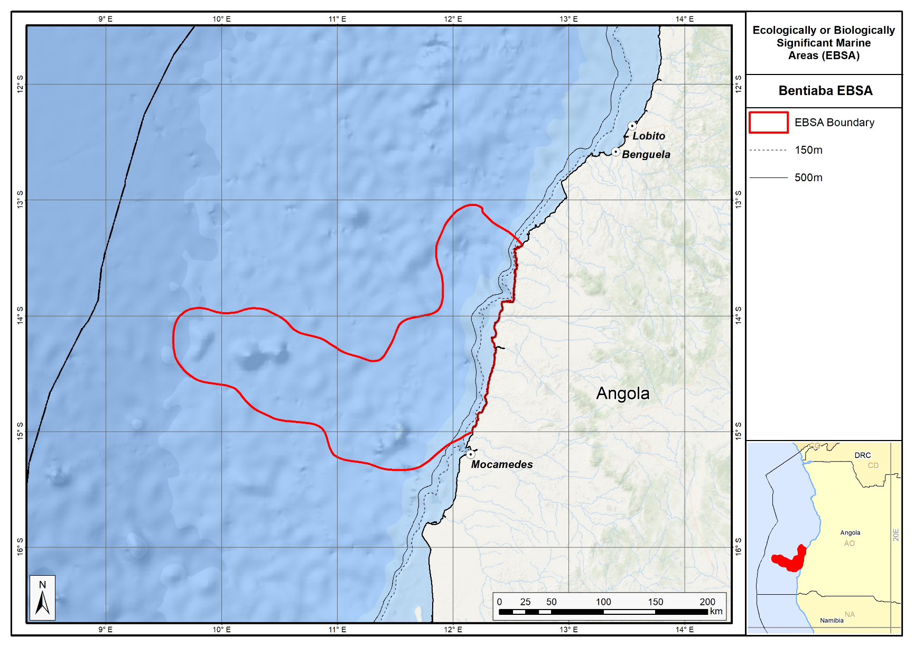
Proposed delineation of the Bentiaba EBSA.

Feature description of the proposed area
The morphology of the seabed in this area suggests that the underlying geology comprises sandy, muddy and rocky substrates. (ARC, 2013). The proposed EBSA spans the section of the Namibe coast where the continental shelf is very narrow because it drops steeply, reaching deep depths very near to the shore. Beyond the 200 m isobath, the continental shelf slopes down to a -3000-m deep abyss with a very smooth and regular gradient. Based on available information for northern Angola, deep-water sediments seem to be dominated by silts and clays with a very high organic carbon content. There are many offshore geomorphic features in this area that are not described in the maritime charts, but that were mapped for the BCLME (Holness et al., 2014), including canyons and seamounts, around which the proposed EBSA is delineated. Even though the EBSA is in an “L shape”, the features in both of these “arms” are similar.

Ocean currents and circulation patterns in the region include a complex set of flows that are linked to a larger system of currents in the tropical east Atlantic. The dominant circulation patterns of the Angolan central and southern continental shelf are driven by the warm Angola Current that moves southwards, and where this current meets the cold Benguela Current at the Angola-Benguela Front (Moroshkin et al., 1970; Meeuwis and Lutjeharms, 1990; Shannon and O'Toole, 1998; and Lass et al., 2000). The Angola Current is fast and stable and penetrates up to depths of 250-300 m, covering both the continental shelf and slope. The typical current speed is 50 cm.s⁻¹ but it can reach or even exceed speeds of 70 cm.s⁻¹ (Moroshkin et al., 1970). The origin of this current, at least on the surface, is the southeastern arm of the South Equatorial Counter-Current.

The Angola-Benguela Front forms where the warm Angola Current, moving south, meets with the cold Benguela Current, moving north. This phenomenon occurs typically in the south of the Bay of Lobito at 14°S – 16°S and is a semi-permanent oceanographic feature. The gradients of temperatures at the surface reach 4°C.°latitude⁻¹, but on average are 1.5°C.°latitude⁻¹. This Front varies by season, reaching maximum levels in the summer when it is wider and is located further south, compared to winter when the front retracts towards the north and has a lower temperature gradient. These variations are related to the seasonality of the Angola Current (Meeuw and Lutjeharms, 1990). Episodic inflows of warm, saline water towards the south may displace the Angola-Benguela Front up to 23°S (Shannon et al, 1986), with effects associated with the general level of biological productivity in the north of the system. Shannon et al (1986) classified these events as ‘Niños de Benguela’ because they are comparable to the ‘El Niño’ of the tropical east Pacific Ocean. However, a northward shift of the Angola-Benguela Front has never been observed on this same scale.

The thermoclines are well developed on the Angolan continental shelf, with depths above 10 - 20m of mixed strata (Van Bennekom & Berger, 1984). Temperature gradients may reach 0.32 °C.m⁻¹ at depths of 25 - 50m, with corresponding firm salinity gradients (Lass et al. 2000). The thermoclines are interrupted by the coastal upwelling along the entire Angolan coast. This coastal upwelling is the most significant oceanographic characteristic of the region and starts in May-June, reaches its peak in August-September and probably ends near the end of the year. Upwelling results from interactions between the main currents of the region and generates areas of divergence both in the continental margin and along the equator. The intensity of these processes depends on season and latitude (ARC, 2013). This is largely due to seasonality in the Benguela Current that flows towards the north, bringing cold water to the Angola-Benguela Front region, and the coastal upwelling driven by the southerly winds that are characteristic of the region (Hardman-Mountford et al 2003).

Upwelling plays a crucial ecological role as it results in a substantial increase in primary production that is of great importance for supporting fish stocks and influencing their distribution. It is known that fish species often adapt their reproductive strategies to ocean currents and productivity cycles, so spawning times and the distribution of the main Angolan species tend to coincide with the observed seasonal oceanographic patterns (Sætersdal et al., 1999). Phytoplankton production rates in the area near the Angola-Benguela Front (>400 gC.m⁻².yr⁻¹) are higher compared to that in northern Angolan (<250 gC.m⁻².yr⁻¹) but much lower than the estimated production rate of >1 000 gC.m⁻².yr⁻¹ further South in the Benguela Current system (ARC, 2013).

The zooplankton consists of crustaceans and other animals that feed on phytoplankton and protists such as Telonemia, and also includes some eggs and larvae of bigger animals. The zooplankton of the region is not well known. However, data from the Angola-Benguela Front show that the species in the Front and immediately north of it (i.e., in the southern Angola Current) are similar to those species in the northern Benguela Current, which are dominated by calanoid copepods (Calanoides and Calanus spp.) (ARC, 2013).

Distributions of ichthyoplankton (fish eggs and larvae) are also poorly known in Angolan waters. However, eggs of the South American pilchard Sardinops sagax and larvae of the Round Sardinella (Sardinella aurita), European Anchovy (Engraulis encrasicolus), Cape horse mackerel (Trachurus Trachurus capensis) and hake (Merluccius sp.) as well as some other mesopelagic species have been recorded within the southern portion of the Angola–Benguela Front.

In general, the benthic fauna of tropical West Africa is relatively poor in comparison with other tropical regions, showing levels of benthic diversity similar to that in the Mediterranean. This low diversity has been attributed to a lack of coral reefs and seagrass meadows along the West African coast; the lack of hard benthic substrates; localised upwelling of colder water in some sites; and the high turbidity from estuarine plumes (ARC, 2013). Nevertheless, invertebrate animal diversity is represented by Echinodermata, Ctenophora, Sipunculida, Polychaeta, Bryozoa, Brachiopoda, Tunicata and Pycnogonida groups. The Crustaceans and Molluscs, which are of commercial importance, also constitute very important groups in the area (Migoto and Marques, 2003 In: Silva, 2015). Furthermore, even though these systems are yet to be sampled, seamounts are known to support diverse assemblages, and are habitat for species that are fragile, sensitive, vulnerable and slow growing, e.g., habitat-forming corals and sponges.

Whales and dolphins are commonly seen along the Angolan coast with 11 species of dolphins and 14 species of whales confirmed in the wider south-west Africa (ARC, 2011). Among these, three Balaeonoptera whale species are classified as Endangered (IUCN, 2011), namely: the Sei whale (B. borealis), Blue whale (B. musculus), and Fin whale (B. physalus). Among the dolphins, only the Atlantic humpback dolphin (Sousa teuszii) is Critically Endangered (but this species was not observed in the study area by Weir, 2010).

The other main species of marine mammals that may be found in the study area include the pinnipeds, such as the Cape Fur Seal (Arctocephalus pusillus). A. pusillus are much more commonly found in high seas in the South of Angola, where there is a big colony in Baía dos Tigres, near the southern boundary with Namibia (Morais et al., 2006).

Importantly, the collection of 24 diverse habitats, and thus presumably communities, in such close proximity resulted in this area being selected in a systematic conservation plan for the region that sought to identify areas of ecological priority (Holness et al., 2014). The combination of upwelling, seamount and canyon features all contribute to the increased productivity of this area. Although the EBSA spans a broad depth range, there are species in this EBSA that similarly have a broad depth range, e.g., the Sipunculid, Onchnesoma steenstrupi found from the subtidal shallow (<10m) to deep sea (1500m; ARC, 2013). Notwithstanding, biodiversity information is very limited for this site, and future research and surveys are highly recommended.

Feature condition and future outlook of the proposed area
An assessment of ecological condition based on cumulative pressures within the EBSA showed that 85 % of the benthic area is in good ecological condition, and 14 % is in fair ecological condition; 60% of the pelagic area is in Good condition and 39 % is in Fair condition. This suggests that most of the EBSA area is highly natural.

References
Angola Resources Consultants (ARC) (2013). Estudo de Impacte Ambiental do Levantamento Sísmico 3D no Offshore da Bacia do Namibe (Blocos 11-13, 27-30 e 42-45). Relatório preparado para WesternGeco. Relatório Nº. LA713G0812. Fevereiro 2013.
Branch, B. (1998). Field guide to snakes and other reptiles of Southern Africa. Third edition. STRUIK. Cape Town., RSA. 399p.
Hardman-Mountford NJ, AJ Richardson, JJ Agenbag, E Hagen, L Nykjaer, FA Shillington, and C Villacastin 2003. Ocean climate of the South East Atlantic observed from satellite data and wind models. Progress in Oceanography 59 (2003): 181–221.
Holness, S., Kirkman, S., Samaai, T., Wolf, T., Sink, K., Majiedt, P., Nsiangango, S., Kainge, P., Kilongo, K., Kathena, J., Harris, L., Lagabrielle, E., Kirchner, C., Chalmers, R., Lombard, M. 2014. Spatial Biodiversity Assessment and Spatial Management, including Marine Protected Areas. Final report for the Benguela Current Commission project BEH 09-01.
Johnson, D.E., Barrio Froján, C., Turner, P.J., Weaver, P., Gunn, V., Dunn, D.C., Halpin, P., Bax, N.J., Dunstan, P.K., 2018. Reviewing the EBSA process: Improving on success. Marine Policy 88, 75-85.
Lass HU, M Schmidt, V Morholz, and G Nausch 2000. Hydrographic and current measurements in the area of the Angola-Benguela Front. J. Phys. Oceanogr., 30: 2589-2609.
Meeuwis JM and JRE Lutjeharms, 1990. Surface thermal characteristics of the Angola-Benguela front. S. Afr. J. Mar. Sci., 9: 261-279.
Migoto, A. E. & Marques, A. C. (2003). Avaliação do estado do conhecimento da diversidade biológica do Brasil. Invertebrados marinhos. Ministério do Meio Ambiente.
Morais, M., Torres, M., Martins, M. (2005). Análise da Biodiversidade Marinha e Costeira, e Identificação das Pressões de Origem Humana sobre os Ecossistemas Marinhos e Costeiros. Estudo Temático n.º2. Projecto 00011125, Estratégia e Plano de Acção Nacionais para a Biodiversidade (NBSAP). Ministério do Urbanismo e Ambiente, Junho de 2005.
Moroshkin KV, VA Bunov and RP Bulatov 1970. Water circulation in the eastern South Atlantic Ocean. Oceanology, 10: 27-34.
Sætersdal, G., Bianchi, G., Strømme, T., Venema, S.C., 1999. The DR. FRIDTJOF NANSEN Programme 1975–1993. Investigations of fishery resources in developing countries. History of the programme and review of results. FAO Fisheries Technical Paper. No. T391. Rome, FAO. 434p.
Shannon LV, AJ Boyd, GB Brundrit and J Taunton-Clark 1986. On the existence of an El Nino-type phenomenon in the Benguela system. J. Mar. Res., 44(3): 495-520.
Shannon LV and M O'Toole 1998. Integrated overview of the oceanography and environmental variability of the Benguela Current region. Synthesis and Assessment of information on BCLME. Thematic Report 2. UNDP/GEF (RAF/96/G43). 58pp.
Silva, J.M. (2015). Zona Costeira de Angola. VII Congresso sobre Planeamento e Gestão das Zonas Costeiras dos Países de Expressão Portuguesa. Participação Ativa nas Zonas Costeiras Aveiro, 14 a 16 de Outubro de 2015.
Sink, K. 2004. Appendix 2: Threats affecting marine biodiversity in South Africa. In: Lombard and Strauss. 2004. National Spatial Biodiversity Assessment. Marine Component (Republic of South Africa). National Botanical Institute, RSA.
Van Bennekom, A.J. and Berger, G.W. 1984. Hydrography and silica budget of the Angola Basin. Neth. J. Sea Res., 17(2-4): 149-200.

Other relevant website address or attached documents
Summary of types of habitats and status of threats for Bentiaba. Namibe. Data from Holness et al. (2014).
Threat Status | Ecosystem Type | Area km² | Area (%)
Endangered | Namibe Exposed Rocky Shore | 2,9 | 0%
Endangered Total |  | 2,9 | 0%
Least Threatened | Benguela Boulder Beach Rocky Shore | 0,0 | 0%
 | Benguela Estuarine Shore | 0,0 | 0%
 | Benguela Exposed Rocky Shore | 0,6 | 0%
 | Benguela Inshore | 18,6 | 0%
 | Benguela Intermediate Sandy Beach | 0,3 | 0%
 | Benguela Island | 180,3 | 1%
 | Benguela Mixed Shore | 0,5 | 0%
 | Benguela Reflective Sandy Beach | 1,3 | 0%
 | Benguela Sheltered Rocky Shore | 31,6 | 0%
 | Cunene Abyss | 6 821,1 | 19%
 | Namibe Boulder Beach Rocky Shore | 0,2 | 0%
 | Namibe Dissipative-Intermediate Sandy Beach | 0,6 | 0%
 | Namibe Estuarine Shore | 5,0 | 0%
 | Namibe Inshore | 145,2 | 0%
 | Namibe Intermediate Sandy Beach | 14,3 | 0%
 | Namibe Lower Slope | 19 409,9 | 54%
 | Namibe Mixed Shore | 23,6 | 0%
 | Namibe Reflective Sandy Beach | 15,4 | 0%
 | Namibe Seamount | 2 119,9 | 6%
 | Namibe Shelf | 1 233,5 | 3%
 | Namibe Shelf Edge | 1 079,3 | 3%
 | Namibe Sheltered Rocky Shore | 32,9 | 0%
 | Namibe Upper Slope | 4 494,1 | 13%
Least Threatened Total |  | 35 628,3 | 100%
Grand Total |  | 35 631,2 | 100%

Assessment of the area against CBD EBSA Criteria
CBD EBSA Criteria  (Annex I to decision IX/20) | Description  (Annex I to decision IX/20) | Ranking of criterion relevance
Uniqueness or rarity | Area contains either (i) unique (“the only one of its kind”), rare (occurs only in few locations) or endemic species, populations or communities, and/or (ii) unique, rare or distinct, habitats or ecosystems; and/or (iii) unique or unusual geomorphological or oceanographic features. | High
Explanation for ranking

Regional delineation of seamounts and canyons in the Benguela Current Large Marine Ecosystem revealed that these are rare features that likely also support rare and/or unique biological communities. The canyons and seamounts in this particular EBSA are especially rare in the region given their close proximity to the coast, whereas most other features like these are located much further offshore (Holness et al., 2014).

Special importance for life-history stages of species | Areas that is required for a population to survive and thrive. | Medium
Explanation for ranking

Seamounts are known to be associated with relatively high productivity from upwelling, and that they consequently serve as foraging and aggregation areas for many top predators, and other threatened vertebrates, such as turtles. They may also provide important “stepping stones” that allow species to expand their ranges.

The benthic ecosystem types support dead organic matter originating from the ocean surface and is a habitat for some species of shrimp, crabs and lobsters. Available data suggests that benthic organisms are abundant with a uniform distribution in regions shallower than -400 m, but are rare and irregularly distributed in deeper waters. A common species is the Sipunculid, Onchnesoma steenstrupi. This species is found largely distributed in water depths ranging from subtidal shallow (<10m) to deep sea (1500m) and occurs in the Northeast Atlantic, Mediterranean Sea, and Gulf of Florida and has also been seen at depths of 1200m along the coast of Nigeria (ARC, 2013).

Importance for threatened, endangered or declining species and/or habitats | Area containing habitat for the survival and recovery of endangered, threatened, declining species or area with significant assemblages of such species. | Low
Explanation for ranking

Of the 24 ecosystem types in the proposed EBSA, only one is threatened: the Endangered Namibe Exposed Rocky Shore. The species diversity is not well known for the area. Although the site is likely to provide habitat that supports threatened species, e.g., turtles, cetaceans, birds and some fish (e.g., Vulnerable Sardinella maderensis), this criterion is conservatively ranked Low until more information is available.

Vulnerability, fragility, sensitivity, or slow recovery | Areas that contain a relatively high proportion of sensitive habitats, biotopes or species that are functionally fragile (highly susceptible to degradation or depletion by human activity or by natural events) or with slow recovery. | Medium
Explanation for ranking

The biological communities in Bentiaba have not been comprehensively sampled. However, it is well established that seamounts serve as an important habitat for fragile species that are sensitive to disturbance and take long to recover, including corals and sponges. Conservatively, therefore, this area is ranked as Medium, but may very well be High.

Biological productivity | Area containing species, populations or communities with comparatively higher natural biological productivity. | High
Explanation for ranking

Seasonal upwelling plays a crucial ecological role in the area as it results in a substantial increase in primary production that is of great importance for supporting fish stocks and influencing their distribution. Phytoplankton production rates in the area near the Angola-Benguela Front (>400 gC.m⁻².yr⁻¹) are higher compared to that in northern Angola (<250 gC.m⁻².yr⁻¹) but much lower than the estimated production rate of >1 000 gC.m⁻².yr⁻¹ further South in the Benguela Current system (ARC, 2013).

Biological diversity | Area contains comparatively higher diversity of ecosystems, habitats, communities, or species, or has higher genetic diversity. | High
Explanation for ranking

The proposed EBSA comprises a particularly diverse collection of 24 habitats that range from intertidal to abyssal types (Holness et al., 2014). In turn, these are expected to support a rich diversity of species within this discrete geographic area, with known representation of numerous invertebrate phyla, as well as vertebrates such as whales, dolphins, seals, birds, turtles, and diverse assemblages of commercially important fish species including both large and small pelagics.

Naturalness | Area with a comparatively higher degree of naturalness as a result of the lack of or low level of human-induced disturbance or degradation. | High
Explanation for ranking

An assessment of ecological condition based on cumulative pressures within the EBSA showed that 85 % of the benthic area is in good ecological condition, and 14 % is in fair ecological condition; 60% of the pelagic area is in Good condition and 39 % is in Fair condition (Holness et al., 2014). This suggests that most of the EBSA area is highly natural.

Status of submission
Area to be submitted to the Conference of the Parties for acknowledgement of meeting EBSA criteria once review process is finalized.

COP Decision
Not yet submitted.

End of proposed EBSA description

Motivation for Submission
To be developed.

Research Needs
To be developed.

Future Process
To be developed.

Namibia

Revised EBSAs

Namib Flyway

Revised EBSA Description

General Information

Summary
The Namib Flyway is a highly productive area in the Benguela system that attracts large numbers of sea- and shorebirds, marine mammals, sea turtles and other fauna. It contains two marine Ramsar sites, six terrestrial Important Bird and Biodiversity Areas (IBAs), two proposed marine IBAs, and key spawning and nursery areas for some fish species. The upwelling cell off Lüderitz has its effect further north with the longshore drift and predominant onshore winds. Thus, primary production of the Benguela current is highest in the central regions of the Namibian coast, driven by delayed blooming. In summary, this area is highly relevant in terms of its importance for life-history stages of species, threatened, endangered or declining species and/or habitats, and biological productivity.

Introduction of the area
The main coastal features contain two sheltered bays (Walvis Bay and Sandwich Harbour), another north-facing but less sheltered bay (Conception Bay), three lagoons (Cape Cross lagoons, Swakop River Mouth Lagoon, and Walvis Bay Lagoon), one cape (Cape Cross) and one man-made shallow water habitat (Mile 4 salt works); the remaining coastline is high energy. The sheltered bays and shallow waters lead to warmer waters and higher productivity. There is a weak upwelling cell off Walvis Bay, which adds to the productivity. The area has been recognized as an important area by the United Nations Environment Programme, African Eurasian Migratory Waterbird Agreement; and the Convention on Migratory Species or “Bonn Convention”. BirdLife International has been funding a seabird breeding project in this area through its Rio Tinto BirdLife Partnership action fund. Two of Namibia’s five Ramsar sites (Walvis Bay and Sandwich Harbour) are included; both Ramsar sites are of international importance for resident bird species as well as resident and transient marine mammals, and constitute key refueling and roosting habitats for many species of migrating waterbirds. Of Namibia’s 19 IBAs, six border or fall in the area (viz., Cape Cross Lagoon, Namib-Naukluft Park, Mile 4 salt works, 30 km beach Walvis-Swakopmund, Walvis Bay and Sandwich Harbour). The area also encompasses key spawning and nursery areas of various fish species, including sardine and anchovy - important forage fish for a range of marine predators.

Since the original description and delineation, the boundary of this EBSA has been refined to improve precision, based on local knowledge of this area and its processes. The Namib Flyway comprises two foraging areas in the north and south of the EBSA, which are connected by a much narrower flyway corridor. Because this site comprises a collection of features and ecosystems that are connected by the same ecological processes, it is proposed as a Type 2 EBSA (sensu Johnson et al. 2018).

Description of the location

EBSA Region
South-Eastern Atlantic

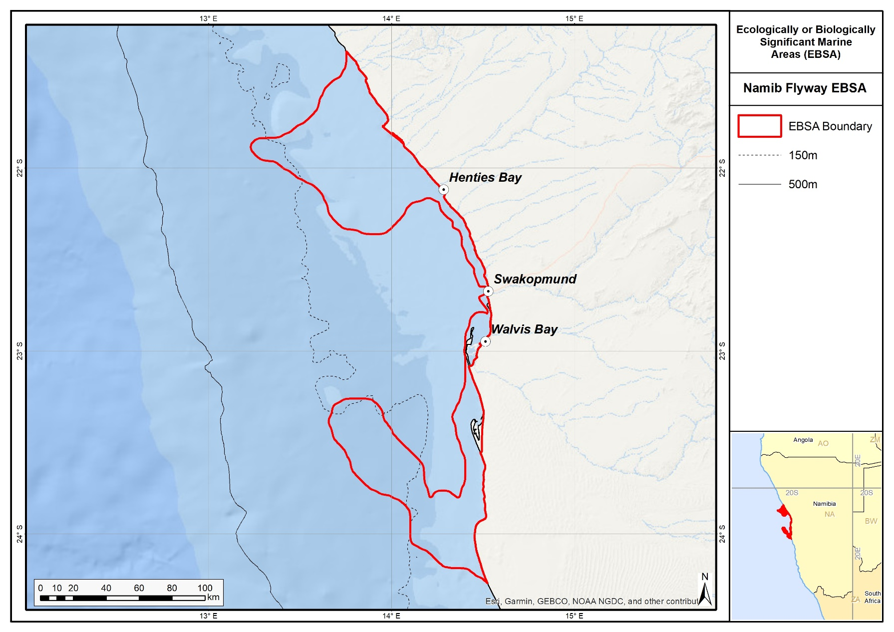
Revised delineation of the Namib Flyway EBSA.

Description of location
The Namib Flyway EBSA extends from 18 km north of Cape Cross to 30 km south of Conception Bay, spanning about 380 km of coastline on the inshore area that borders the Dorob National Park, Cape Cross Seal Reserve and the Namib-Naukluft Park, roughly between latitudes 21 and 24 degrees South. The northern and southern parts extend offshore for up to 83 km, and the central portion is a narrow strip that extends no further than 7 km offshore. The entire area falls within the national jurisdiction of Namibia.

Feature description of the area
The coastline includes mixed rocky and sandy shoreline, which together with the adjacent marine inshore environment supports resident, Palearctic, Oceanic and intra-African migrant bird species. These include seabirds (e.g., terns, gulls, cormorants, gannets, shearwaters, albatrosses, petrels, skuas); shorebirds (e.g., plovers, sandpipers, turnstones, whimbrels, stints, oystercatchers, curlews, knots, godwits, avocets) and waterbirds (e.g., flamingos, ducks, grebes, coots, gallinules, herons). At least 17 threatened bird species occur in the area, either throughout the year or seasonally (Wearne & Underhill 2005, Simmons et al., 2015, IUCN 2016, SABAP_2 2017). Up to about 400,000 birds may be found during summer at Walvis Bay and Sandwich Harbour alone (Simmons 2002, Wearne & Underhill 2005). Cetaceans such as Bottlenose Dolphins, Heaviside’s Dolphins and Southern Right Whales also breed in this area; the small local inshore population of Bottlenose Dolphins appears to be discrete, utilizing a core area between Cape Cross and Sandwich Harbour (Findlay et al., 1992, Elwen & Leeney, 2009). Humpback and Minke whales are common in the area, whereas other species like Fin Whales, beaked whales and other cetaceans also occur there occasionally (e.g. Findlay et al., 1992); however, detailed distribution and population data for most cetacean species in the area are lacking. Seven threatened fish and condricthian species have been recorded in the Namib Flyway area (OBIS 2017), and it is also an important foraging area for leatherback turtles (Shackelton 1993, De Padua Almeida et al., 2003). Four Cape Fur Seal breeding colonies exist at Cape Cross, Pelican Point, Sandwich Harbour and Conception Bay (Kirkman et al., 2013); and the area includes seal foraging hotspots (Skern-Mauritzen et al., 2009). Altogether, there are records for 247 species from this area (OBIS 2017).

The Namib Flyway also includes three Endangered habitat types (Central Namib Outer Shelf, Kuiseb Lagoon Coast and Kuiseb Mixed Shore), with the area being particularly important for Central Namib Outer Shelf and Kuiseb Lagoon Coast. These threat statuses were estimated by assessing the weighted cumulative impacts of various pressures (e.g., extractive resource use, pollution, development, and others) on each habitat type for Namibia (Holness et al., 2014; Table in Other relevant website address or attached documents section).

Feature conditions and future outlook of the proposed area
The terrestrial part of the area to the low water mark is protected in three national parks, namely Dorob National Park, Cape Cross Seal Reserve and Namib-Naukluft Park. The area has three towns and a village: the main harbour town of Namibia: Walvis Bay, in addition to Swakopmund and Henties Bay and the village of Wlotzkasbaken. There is a political drive to expand the towns and village into the Dorob National Park irrespective of the biodiversity importance of the bordering terrestrial and coastal areas. This will require deploclamation. The marine component is partially protected by fishery management regulations such as a “no trawl zone” up to the 200-m depth contour; however, purse-seining activities in the area threaten already depleted local pelagic fish stocks on which a number of marine predators depend (e.g. Sherley et al., 2017). The area is under threat from a large-scale harbour expansion at Walvis Bay, a proposed industrial park, and seabed mining (e.g., for phosphates). Uncontrolled coastal development and off-shore oil exploration are additional threats. Climate change may alter productivity and therefore the area’s capacity to support the large number of animals that are dependent on this area (Roux 2003). Revision of the EBSA boundary has resulted in an improvement in the site’s overall naturalness because many areas of direct impact in the previous delineation are now excluded. Most of the EBSA area is now in a Good (87 %) or Fair condition (9 %) (Holness et al., 2014). Nevertheless, the area is likely to be significantly impacted by activities directly adjacent to the EBSA, and this assessment of condition is likely to be highly optimistic.

References
De Padua Almeida, A., Filgueiras, H., Braby, R., Tiwari, M. 2003. Increasing evidence of leatherback migrations from Brazilian beaches to the west African Coast. Sea Turtle Newsletter, 1: 9-11.
Elwen, S.H., Leeney, R.H. 2009. Report of the Namibian Dolphin Project 2010: Ecology and Conservation of Dolphins in Namibia. Submitted to the Ministry of Fisheries and Marine Resources, Namibia. 26 pp.
Findlay, K.P., Best, P.B., Ross, G.J.B., Cockcroft V.G. 1992. The distribution of small odontocete cetaceans off the coasts of South Africa and Namibia. South African Journal of Marine Science, 12: 237-270.
Holness, S., Kirkman, S., Samaai, T., Wolf, T., Sink, K., Majiedt, P., Nsiangango, S., Kainge, P., Kilongo, K., Kathena, J., Harris, L., Lagabrielle, E., Kirchner, C., Chalmers, R., Lombard, M. 2014. Spatial Biodiversity Assessment and Spatial Management, including Marine Protected Areas. Final report for the Benguela Current Commission project BEH 09-01.
Holtzhausen, J.A., Kirchner, C.H., Voges, S.F. 2001. Observations on the linefish resources of Namibia, 1990-2000, with special reference to West Coast steenbras and silver kob. South African Journal of Marine Science, 23: 135-144.
Hutchings, L., Beckley, L.E., Griffiths, M.H., Roberts, M.J., Sundby, S., van der Lingen, C. 2002. Spawning on the edge: spawning grounds and nursery areas around the southern African coastline. Marine and Freshwater Research, 53: 307-318.
IUCN. 2016. IUCN Red List of Threatened Species. Version 2016-3. www.iucnredlist.org. Downloaded on 10 May 2017.
Johnson, D.E., Barrio Froján, C., Turner, P.J., Weaver, P., Gunn, V., Dunn, D.C., Halpin, P., Bax, N.J., Dunstan, P.K., 2018. Reviewing the EBSA process: Improving on success. Marine Policy 88, 75-85.
Kemper, J., Underhill, L.G., Crawford, R.J.M., Kirkman, S.P. 2007. Revision of the conservation status of seabirds and seals breeding in the Benguela ecosystem. Pp 325 – 342 in Final report for the BCLME (Benguela Current Large Marine Ecosystem) project on top predators as biological indicators of ecosystem change in the BCLME. Kirkman, S.P. (Ed) Animal Demography Unit, University of Cape Town.
Kirkman, S.P., Yemane, D., Oosthuizen, W.H., Meÿer, M.A., Kotze, P.G.H., Skrypzeck, H.l., Vaz Velho, F. Underhill, L.G. 2013. Spatio-temporal shifts of the dynamic Cape fur seal population in southern Africa, based on aerial censuses (1972-2009). Marine Mammal Science, 29: 497-524.
Maartens, L. 2003. Biodiversity Pp 103 – 135 In: Namibia’s Marine Environment. Molloy, F., Reinikainen, T. (Eds) Directorate of Environmental Affairs (DEA) of the Ministry of Environment and Tourism, Namibia.
OBIS. 2017. Summary statistics of biodiversity records in the Namib Flyway EBSA. (Available: Ocean Biogeographic Information System. Intergovernmental Oceanographic Commission of UNESCO. www.iobis.org. Accessed: 2017-07-27).
Roux J-P. 2003. Risks. In: Molloy, F., Reinikainen, T. (Eds) Namibia’s marine environment. Directorate of Environmental Affairs of the Ministry of Environment and Tourism, Windhoek, Namibia, pp. 137-152.
SABAP 2. 2017. Southern African Bird Atlas Project 2. http://sabap2.adu.org.za/index.php. Last accessed 10 May 2017.
Sakko, A. 1998. Biodiversity of marine habitats. In: Biological Diversity in Namibia – A Country Study. Barnard, P. (Ed) Namibian National Biodiversity Task Force. DEA, Windhoek. Pp 189-226.
Shackelton, L. 1993. Environmental Data Workshop for Oil Spill Contingency Planning; Centre for Marine Studies, University of Cape Town, Cape Town.
Sherley, R.B., Ludynia, K., Dyer, B.M., Lamont, T., Makhado, A.B., Roux, J-P., Scales, K.L., Underhill, L.G., Votier, S.C. 2017. Metapopulation tracking juvenile penguins reveals and ecosystem-wide ecological trap. Current Biology, 27: 1-6.
Simmons, R.E. 2002. Sandwich Harbour bird monitoring January 2002. Lanioturdus, 35: 2-4.
Simmons, R.E., Boix-Hinzen, C., Barnes, K.N., Jarvis A.M., Robertson, A. 1998. Important Bird Areas of Namibia. In: Important Bird Areas of southern Africa. Barnes K.N. (Ed) BirdLife South Africa, Johannesburg. Pp 295-332.
Simmons, R.E., Brown, C.J., Kemper, J. 2015. Birds to watch in Namibia: red, rare and endemic species. Ministry of Environment and Tourism and Namibia Nature Foundation, Windhoek, Namibia.
Simmons, R.E., Kolberg, H., Braby, R., Erni, B. 2015. Declines in migrant shorebird populations from a winter-quarter perspective. Conservation Biology, 29: 877-887
Skern-Mauritzen, M., Kirkman, S.P., Olsen, E., Bjørge, A., Drapeau, L., Meÿer, M.A., Roux, J-P., Swanson, S., Oosthuizen, W.H. 2009. Do inter-colony differences in Cape fur seal foraging behavior reflect large-scale changes in the northern Benguela ecosystem? African Journal of Marine Science, 31: 399-408.
Wearne K., Underhill, L.G. 2005. Walvis Bay, Namibia: a key wetland for waders and other coastal birds in southern Africa. Wader Study Group Bulletin, 107: 24-30.

Other relevant website address or attached documents
Summary of habitat types and threat status for Namib Flyway. Data from Holness et al. (2014).
Threat Status | Habitat Type | Area (km²) | Area (%)
Endangered | Central Namib Outer Shelf | 2,041.2 | 19.9
 | Kuiseb Lagoon Coast | 148.8 | 1.4
 | Kuiseb Mixed Shore | 28.4 | 0.3
Endangered Total |  | 2,218.4 | 21.6
Least Threatened | Central Namib Inner Shelf | 6,461.1 | 62.9
 | Kuiseb Dissipative-Intermediate Sandy Beach | 39.1 | 0.4
 | Kuiseb Exposed Rocky Shore | 0.03 | 0
 | Kuiseb Inshore | 1,361.6 | 13.2
 | Kuiseb Intermediate Sandy Beach | 148.8 | 1.4
 | Kuiseb Reflective Sandy Beach | 32.3 | 0.3
 | Kuiseb Sandy Beach Sandy Beach | 16.3 | 0.2
Least Threatened Total |  | 8,059.2 | 78.4
Grand Total |  | 10,277.6 | 100

Assessment of the area against CBD EBSA criteria
C1: Uniqueness or rarity High
Justification
This is the only high-productivity area featuring bays and lagoons on the Namibian coast apart from Lüderitz. It is also one of only two globally Important Bird and Biodiversity Areas in Africa that feature sandy bays and spits. A number of species that are endemic or near-endemic to the Benguela region occur here, including breeding residents such as the Damara Tern, Cape Cormorant and Heaviside’s Dolphin (Sakko 1998; Simmons et al., 1998; Maartens 2003; Kemper et al., 2007; Elwen & Leeney 2009).

C2: Special importance for life-history stages of species High
Justification
The Namib Flyway is an important over-wintering area for several threatened bird species, such as Lesser and Greater Flamingos, Chestnut-banded Plovers and Black-necked Grebes. Numerous sea- and shorebird species, migratory species (Palaearctic and intra-African birds), and resident species use the area for roosting and feeding. This area includes four Cape fur seal colonies, and turtle and cetacean breeding and foraging areas, and includes a small, discrete inshore population of Bottlenose Dolphins (Shackelton 1993; Sakko 1998; Simmons et al., 1998; De Padua Almeida et al., 2003; Maartens 2003; Kemper et al., 2007; Elwen & Leeney 2009; Kirkman et al., 2013; Simmons et al., 2015). It is also a key foraging area for recently fledged African Penguins originating from southern Namibia and the west coast of South Africa (Sherley et al., 2017). Furthermore, the area encompasses known spawning and key nursery areas for several fish species, including sardine and silver kob (Holtzhausen et al., 2001; Hutchings et al., 2002).

C3: Importance for threatened, endangered or declining species and/or habitats High
Justification
Leatherback turtles from the Indian Ocean (regionally Critically Endangered), southwest Atlantic (regionally Critically Endangered), and southeast Atlantic (regionally Data Deficient) come to forage in the offshore waters off Walvis Bay and Sandwich Harbour, where certain jellyfish species occur in great numbers. Other globally threatened species like African Penguins, Cape, Bank and Crowned Cormorants, Damara Terns, Lesser Flamingos and Chestnut-banded Plovers (IUCN 2016) are attracted to this area’s high productivity to forage and/or to breed (Shackelton 1993; Sakko 1998; De Padua Almeida et al., 2003; Kemper et al., 2007; Simmons et al., 2015; IUCN 2016). Seven threatened fish and condricthian species have been recorded in the area, including the Endangered Lithognathus lithognathus, Argyrosomus hololepidotus, and Petrus rupestris, and Vulnerable Mustelus mustelus, Oxynotus centrina, Alopias vulpinus, Cetorhinus maximus (OBIS 2017). Holness et al. (2014) identified three Endangered habitat types (Central Namib Outer Shelf, Kuiseb Lagoon Coast and Kuiseb Mixed Shore), with the area being particularly important for Central Namib Outer Shelf and Kuiseb Lagoon Coast.

C4: Vulnerability, fragility, sensitivity, or slow recovery Medium
Justification
This area is highly sensitive to hydrocarbon and other industrial pollution. Sheltered bays and lagoons are not able to dilute or flush pollutants out of the system easily (Shackelton 1993). Climate change, including a rise in sea surface temperatures, may contribute to an increased vulnerability of the habitats and species in the area (Roux 2003).

C5: Biological productivity High
Justification
The central Namibian coast is situated down-stream of the intensive Lüderitz upwelling cell, and it features sheltered bays; it thus boasts a high level of plankton production, which in turn provides a rich food source to other marine organisms. Migratory species are able to fatten up rapidly here to prepare for long journeys. Leatherback turtles, for example, come from as far as the Indian Ocean, Brazil and Gabon to forage in this area. The Namib Flyway also supports an important nursery area for sardine and other fish species and sustains the highest abundance of cetaceans and seals in relation to the rest of the Namibian coastline (Sakko 1998; Holtzhausen et al., 2001; Hutchings et al., 2002; Maartens 2003; Kemper et al., 2007).

C6: Biological diversity Medium
Justification
The area is characterized by significant habitat heterogeneity, which results in relatively high diversity of species, particularly waterbirds and marine mammals, in comparison to other areas along the Namibian shore (Shackelton 1993; Sakko 1998; Simmons et al., 1998; De Padua Almeida et al., 2003; Maartens 2003; Kemper et al., 2007). There are records for 247 different species from this area (OBIS 2017).

C7: Naturalness Medium
Justification
Coastal town developments and, more recently, the large-scale expansion of the Walvis Bay harbour have impacted the naturalness of the broader area and impacts are very likely to spill over into the EBSA footprint. The area has also experienced high fishing pressure in the past. Some coastal parts have also been modified for large-scale salt production, as well as for guano harvesting (Maartens 2003). The coastal area south of Sandwich Harbour, however, remains largely intact. Revision of the EBSA boundary has resulted in an improvement in the site’s overall naturalness because many areas of direct impact in the previous delineation are now excluded. Most of the EBSA area is now in a Good (87 %) or Fair condition (9 %) (Holness et al., 2014). Nevertheless, because it is likely that spillover effects from adjacent development are significantly underestimated in the assessment of condition, the EBSA was ranked as Medium rather than High in terms of the naturalness criterion.

Status of submission
The Namib Flyway EBSA was recognized as meeting EBSA criteria by the Conference of the Parties. The revised description and boundaries still need to be submitted to COP for approval.

COP Decision
dec-COP-12-DEC-22
End of proposed EBSA revised description

Motivation for Revisions
The EBSA description was updated substantially by searching for and including all relevant information from the latest research within the area. This resulted in the addition of 14 new references to the original description, including the latest biodiversity information from OBIS. A summary table of the represented habitats and their threat status was also included as supplementary information. Two criteria were upgraded by one category rank: Uniqueness and rarity was upgraded from Medium to High after consolidating the latest information, and Naturalness was upgraded from Low to Medium on the basis of the revised boundary, particularly because the heavily impacted areas were deliberately excluded in the new delineation.
The most important change to the EBSA was a significant refinement of the EBSA delineation. This was done to more closely focus the EBSA on the key biodiversity features that underlie its EBSA status to improve precision. The delineation process included an initial stakeholder workshop, a technical mapping process and a subsequent expert review workshop where boundary delineation options were finalised.
The delineation process used a combination of Systematic Conservation Planning (SCP) and Multi-Criteria Analysis methods. The key features used in the analysis were:
- Irreplaceable and near irreplaceable (i.e. very high selection frequency) sites, as well as primary and secondary focus areas identified in the SCP undertaken for the BCLME by Holness et al. (2014).
- Threatened Benthic and Coastal Ecosystems. The analysis focussed on the inclusion of the most threatened ecosystem types found in the area. These types are highlighted in the table in the Other relevant website address or attached documents section. Key threatened ecosystem types were the endangered Central Namib Outer Shelf, Kuiseb Lagoon Coast and Kuiseb Mixed Shore. Delineations and ecosystem threat status from Holness et al. (2014). The Endangered pelagic habitat (Ca14) was also included.
- Areas important for threatened and special species were included. The priority areas and buffer distances around colonies were from Holness et al. (2014). Note that the full extent of the buffer was not necessarily included in the EBSA. Features included in the analysis were:
  - African Penguin colonies and a 20km buffer.
  - Bank Cormorant, Cape Cormorant, White Breasted Cormorant and Crowned Cormorant colonies and a 40km buffer.
  - Gannet colonies with a 40km buffer.
  - High density and diversity bird sites.
  - Seal Colonies and a 20km buffer.
- Boundaries of Important Bird and Biodiversity Areas (IBA).
- Areas of high fish species diversity from the NansClim project (See Holness et al. 2014 for details).
- Areas of high relative naturalness identified in the SCP undertaken for the BCLME by Holness et al. (2014).
- Additional expert identified areas important for cetaceans (especially Atlantic bottlenose, dusky, and the Heaviside dolphins). These are particularly areas off Pelican Point and sub-tidal areas shallower than 50m water depths.
The multi-criteria analysis produced a value surface. The cut-off value (used to determine the spatial extent of the EBSA) was based on expert input and quantitative analysis of effective inclusion of the above features. This entailed taking an iterative parameter calibration-based approach whereby the spatial efficiency of the inclusion of the targeted features was evaluated. The approach aimed to identify a cut-off which most efficiently included prioritised features while minimizing the inclusion of impacted areas. The final boundaries shown in the map (Fig. 2) were validated in an expert workshop.

Research Needs
The increase of industrial activities in the area, particularly expansion of the port and anticipated flurry of hydrocarbon exploration and mining, warrants particular research focus on the myriad of threatened species that rely on the high productivity of this EBSA. Notably, the presence and distribution of cetacean species are largely lacking, and yet these marine mammals are known to be affected by seismic surveys during hydrocarbon exploration. Similarly, the increased risk of marine vessels and animal collisions (as traffic through the expanded port increases) is also an issue for species like leatherback turtles, particularly because the Western Indian Ocean population (that partly use this EBSA as a foraging site) is listed as Critically Endangered. Knowing when and where these animals are in the EBSA will enable better spatial and temporal management of conflicting activities.

Future Process
The Namib Flyway will be a focus EBSA for the status and management options analysis to be undertaken by MARISMA as this area is within the Central Namibian Marine Spatial Planning Core Area.

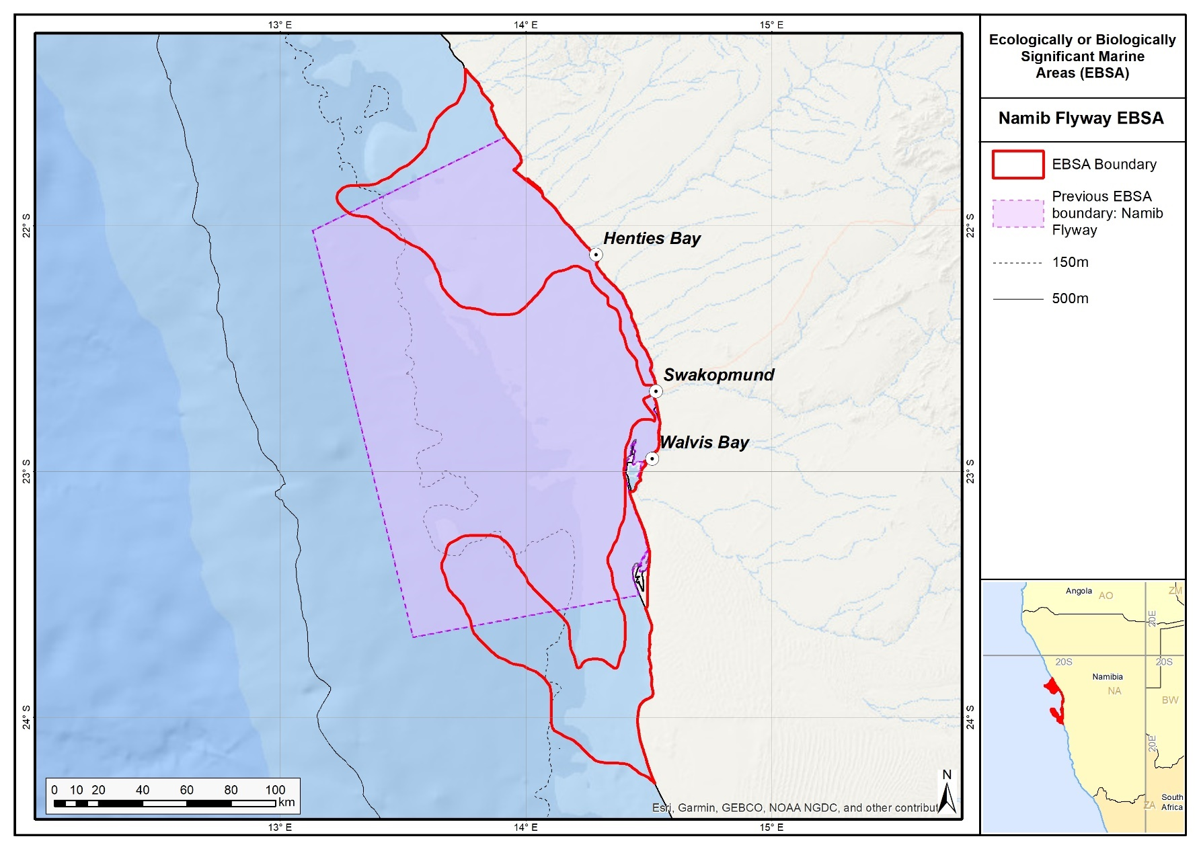
The original and revised boundaries of the Namib Flyway EBSA.

Namibian Islands

Revised EBSA Description

General Information

Summary
The Namibian Islands are located offshore in the central region of the Benguela Current Large Marine Ecosystem (BCLME) within the intensive Lüderitz Upwelling Cell. These islands and their surrounding waters are described primarily in terms of their significance for life history stages of threatened seabird species. The islands are crucial seabird breeding sites within the existing Namibian Islands Marine Protected Area (NIMPA). The surrounding waters are also key foraging grounds for these seabirds for both the adults and as they provide for their chicks, and for Critically Endangered leatherbacks from the Western Indian Ocean that nest in South Africa. The boundaries of the NIMPA are largely based on the foraging ecology of key threatened, breeding seabirds. These features were used here too to expand the boundary of the Namibian Islands EBSA to include the full ecological and biological significance of the islands and adjacent marine environment, not just to represent the islands themselves.

Introduction of the area
The Namibian Islands is a coastal EBSA that is located in the central region of the BCLME within the Lüderitz Upwelling Cell. This upwelling cell plays a significant role in regulating the biomass of fish stocks of central Namibia. Consequently, the islands and adjacent productive waters provide important breeding and foraging habitat for threatened seabirds and marine mammals, and includes important nursery grounds for the commercially important west coast rock lobster, Jasus lalandii (Currie et al., 2008). It is also recognized as a foraging site for regionally Critically Endangered leatherbacks from the Western Indian Ocean that nest in South Africa (Harris et al., 2017). Thus, although the focus of this EBSA is on seabird breeding and foraging, there are several other important species for which this site is important.
The key ecological value of this site was recognised prior to the EBSA process, and in 2009, the Namibian Ministry of Fisheries and Marine Resources (MFMR) gazetted the Namibian Islands Marine Protected Area (NIMPA). The NIMPA covers nearly 1 million ha of coastal waters that encompass all the natural seabird breeding islands in Namibia and the key supporting seabird foraging areas in the surrounding sea. It was later recognised that the original EBSA delineation had focussed on only the breeding islands, and had omitted the critical foraging grounds surrounding the islands that provide fish for the adult birds and as they provision for their chicks. Consequently, the EBSA boundary was revised to include the full extent of this significant ecological feature, following a similar delineation process to how the NIMPA was defined. Because this site comprises a collection of features and ecosystems that are connected by the same ecological processes, it is proposed as a Type 2 EBSA (sensu Johnson et al. 2018).

Description of the location

EBSA Region
South-Eastern Atlantic

Description of location
The original boundary of the Namibian Islands EBSA has been extended to include key seabird foraging areas, much like how the boundary of the NIMPA was defined. It extends alongshore about 400 km from Meob Bay to Chameis Bay and, on average, 30 km offshore from the high-water mark. It is located between the latitudes of 24°S and 28°S, within the national jurisdiction of Namibia.

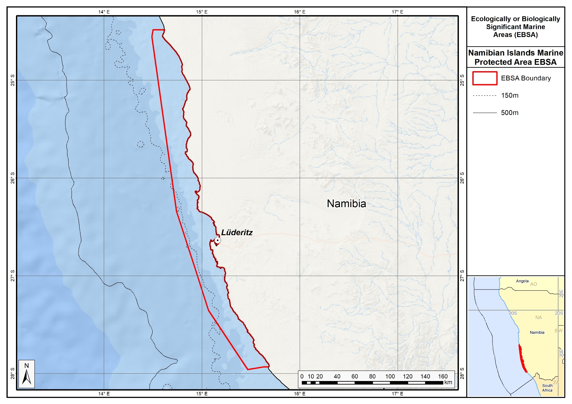
Revised delineation of the Namibian Islands EBSA.

Feature description of the area
The Namibian Islands EBSA is described for both benthic and pelagic features, primarily as a key breeding and foraging area for threatened seabirds, but also as breeding, nursery or foraging areas for several other species that are iconic, threatened or of commercial importance. Eleven seabird species breed on the islands, of which eight are endemic to southern Africa (Kemper et al., 2007). Of these, the African Penguin (Spheniscus demersus), Bank Cormorant (Phalacrocorax neglectus) and the Cape Cormorant (P. capensis) are listed as globally Endangered; the Cape Gannet (Morus capensis) is listed as globally Vulnerable and locally Critically Endangered (Simmons et al., 2015, IUCN 2016). The Namibian populations of African Penguins, Cape Gannets and Bank Cormorants breed exclusively within this EBSA. Productivity at this site is also particularly high because it is situated in the Lüderitz Upwelling Cell in the Benguela Current, which plays a significant role in regulating the biomass of fish stocks of central Namibia. However, the depletion of small pelagic fish stocks in the late 1960s through over-fishing, particularly in southern Namibia, has negatively impacted this area (Roux et al., 2013). This provides special justification for protecting this area to conserve the important threatened species that are so dependent on it.

In recognition of the ecological significance of this area, the design of the NIMPA took seabird tracking data into account to ensure inclusion of critical foraging areas of resident breeding birds (Ludynia et al., 2010a, 2012). Three rock lobster sanctuaries, one linefish sanctuary and key calving areas of southern right whales were also included (Currie et al., 2008). This site is a foraging area for regionally Critically Endangered leatherbacks from the Western Indian Ocean that nest in South Africa (Harris et al., 2017). The NIMPA, which adjoins the Namib-Naukluft and Tsau//Khaeb national parks on the landward side, is sectioned into zones of increasing protection levels, with the highest protection status afforded to the islands. Six of the islands are also designated as Important Bird and Biodiversity Areas (IBAs; Simmons et al., 2015). Altogether, 140 species have been recorded in the EBSA (OBIS 2017).

Feature conditions and future outlook of the proposed area
A lack of quality food poses the greatest threat to seabird populations breeding on Namibia’s islands (Ludynia et al., 2010b, Simmons et al., 2015). The collapse of sardine stocks in the 1960s and anchovy populations in the 1990s (Roux et al., 2013), both significant prey species, threaten the viability of African Penguin, Cape Gannet and Cape Cormorant populations in particular. The recovery of small pelagic fish stocks in southern Namibia is therefore crucial to the continued survival of these species. The coast is vulnerable to marine pollution, especially oil spills, and even a small oil spill at a key breeding site such as Mercury Island could put a significant proportion of the global population of African Penguin, Cape Gannets and/or Bank Cormorants at risk. Namibia’s National Oil Spill Contingency Plan is currently being updated, and a process to draft the Oil Spill Sensitivity Mapping is underway for improved monitoring and prevention. Breeding habitat degradation and associated disturbance (e.g. from guano harvesting) has further rendered breeding seabirds, particularly African Penguins and Cape Gannets, at risk. An increasing emphasis on marine mining, including inshore and coastal mining south of Lüderitz may pose additional threats to seabirds, rock lobsters and marine mammals, such as prey displacement and modification of key marine habitats.

Holness et al. (2014) estimated habitat threat status by assessing the weighted cumulative impacts of various pressures (e.g., extractive resource use, pollution, development and others) on each habitat type for Namibia (Table in Other relevant website address or attached documents section). The results identified small areas of two Critically Endangered habitat types (viz. the Namaqua Intermediate Sandy Beach and Namaqua Reflective Sandy Beach) within the Namibian Islands EBSA. The Critically Endangered status implies that very little (<= 20 %) of the total area of these habitats are in natural/pristine condition, and it is expected that important components of biodiversity pattern have been lost and that ecological processes have been heavily modified. Furthermore, one Endangered habitat type (viz. the Kuiseb Mixed Shore) and three Vulnerable habitat types (viz. the Lüderitz Outer Shelf, Namaqua Exposed Rocky Shore, and Namaqua Inshore) were identified. In particular, the Namibian Islands EBSA is very important for the Lüderitz Outer Shelf, Namaqua Inshore and Kuiseb Mixed Shore habitat types. Overall, Holness et al. (2014) classified 91 % of the Namibian Islands area as being in good condition, which is consistent with the inclusion of the entire area in the NIMPA as part of the EBSA’s boundary revision.

References
Boyer, D.C., Hampton, I. 2001. An overview of the marine living resources of Namibia. South African Journal of Science, 23: 5-35.
Currie, H., Grobler, K., Kemper, J. 2008. Concept note, background document and management proposal for the declaration of Marine Protected Areas on and around the Namibian islands and adjacent coastal areas.
Griffiths, C.L., Van Sittert, L., Best, P.B., Brown, A.C., Clark, B.M., Cook, P.A., Crawford, R.J.M., David, J.H.M., Davies, B., Griffiths, M.H., Hutchings, K., Jerardino, A., Kruger, N., Lamberth, S., Leslie, R.W., Melville-Smith, R., Tarr, R., van der Lingen, C.D. 2005. Impacts of human activities on marine animal life in the Benguela: a historical overview. Oceanography and Marine Biology: Annual Review, 42: 303-392.
Harris, J.M., Branch, G.M., Elliott, B.L., Currie, B., Dye, A.H., McQuaid, D.D., Tomalin, B.J., Velasquez, C. 1998. Spatial and temporal variability in recruitment of intertidal mussels around the coast of southern Africa. South African Journal of Zoology, 33: 1-11.
Harris, L.R., Nel, R., Oosthuizen, H., Meyer, M., Kotze, D., Anders, D., McCue, S., Bachoo, S. 2017. Managing conflicts between economic activities and threatened migratory marine species towards creating a multi-objective blue economy. Conservation Biology, in press.
Holness, S., Kirkman, S., Samaai, T., Wolf, T., Sink, K., Majiedt, P., Nsiangango, S., Kainge, P., Kilongo, K., Kathena, J., Harris, L., Lagabrielle, E., Kirchner, C., Chalmers, R., Lombard, M. 2014. Spatial Biodiversity Assessment and Spatial Management, including Marine Protected Areas. Final report for the Benguela Current Commission project BEH 09-01.
IUCN. 2016. IUCN Red List of Threatened Species. Version 2016-3. www.iucnredlist.org. Downloaded on 1 February 2017.
Johnson, D.E., Barrio Froján, C., Turner, P.J., Weaver, P., Gunn, V., Dunn, D.C., Halpin, P., Bax, N.J., Dunstan, P.K., 2018. Reviewing the EBSA process: Improving on success. Marine Policy 88, 75-85.
Kemper, J. 2006. Heading towards extinction? Demography of the African penguin in Namibia. PhD thesis, University of Cape Town, Cape Town, South Africa, 241 pp.
Kemper, J., Underhill, L.G., Crawford, R.J.M., Kirkman, S.P. 2007. Revision of the conservation status of seabirds and seals breeding in the Benguela ecosystem. In: Kirkman, S.P. (Ed.), Final Report of the BCLME (Benguela Current Large Marine Ecosystem) Project on Top Predators as Biological Indicators of Ecosystem Change in the BCLME. Avian Demography Unit, Cape Town, pp. 325–342.
Kolberg, H. 1992. Untersuchungen bei, und Zählung der Billenpinguine (Spheniscus demersus) auf der Insel Halifax. Mitteilungen: Namibia Wissenschaftliche Gesellschaft 33: 57-71.
Ludynia, K., Jones, R., Kemper, J., Garthe, S., Underhill, L.G. 2010a. Foraging behaviour of bank cormorants in Namibia: implications for conservation. Endangered Species Research, 12: 31-40.
Ludynia, K., Roux, J-P., Jones, R., Kemper, J., Underhill, L.G. 2010b. Surviving off junk: low-energy prey dominates the diet of African penguins Spheniscus demersus at Mercury Island, Namibia, between 1996 and 2009. African Journal of Marine Science, 32: 563-572.
Ludynia, K., Kemper, J., Roux, J. 2012. The Namibian Islands’ Marine Protected Area: Using seabird tracking data to define boundaries and assess adequacy. Biological Conservation, 156: 136-145.
OBIS. 2017. Summary statistics of biodiversity records in the Namibian Islands EBSA. (Available: Ocean Biogeographic Information System. Intergovernmental Oceanographic Commission of UNESCO. www.iobis.org. Accessed: 2017-07-27).
Pallett J. (ed.) 1995. The Sperrgebiet: Namibia’s least known wilderness. DRFN & NAMDEB, Windhoek, Namibia. Roux J-P (2003) – Risks. In: Molloy F. & T. Reinikainen (eds.). Namibia’s marine environment. Directorate of Environmental Affairs of the Ministry of Environment and Tourism, Windhoek, Namibia, pp. 137-152.
Roux, J-P., Best, P.B., Stander, P.E. 2001. Sightings of southern right whales (Eubalaena australis) in Namibian waters 1971-1999. Cetacean Resource Management (Special Issue), 2: 181-185.
Roux, J-P., van der Lingen, C.D., Gibbons, M.J., Moroff, N.E., Shannon, L.J., Smith, A.D.M., Cury, P.M. 2013. Jellyfication of marine ecosystems as a likely consequence of overfishing small pelagic fishes: lessons from the Benguela. Bulletin of Marine Science, 89: 249-284.
Sakko, A. 1998. The influence of the Benguela upwelling system on Namibia’s marine biodiversity. Biodiversity and Conservation, 7: 419-433.
Simmons, R.E., Brown, C.J., Kemper, J. 2015. Birds to watch in Namibia: red, rare and endemic species. Ministry of Environment and Tourism and Namibia Nature Foundation, Windhoek, Namibia.
Van der Lingen, C.D., Shannon, L.J., Cury, P., Kreiner, A., Moloney, C.L., Roux, J-P. Vaz-Velho, F. 2006. Resource and ecosystem variability, including regime shifts, in the Benguela Current System. In: Shannon, V., Hempel, G., Malanotte-Rizzoli, P., Moloney, C.L., Woods, J. (eds) Benguela: Predicting a Large Marine Ecosystem. Elsevier, Amsterdam, pp 147–185.

Other relevant website address or attached documents
Summary of habitat types and threat status for the Namibian Islands EBSA. Data from Holness et al. (2014).
Habitat Threat Status | Habitat Type | Area (km²) | Area (%)
Critically Endangered | Namaqua Intermediate Sandy Beach | 2.1 | 0.0
 | Namaqua Reflective Sandy Beach | 0.3 | 0.0
Critically Endangered Total |  | 2.4 | 0.0
Endangered | Kuiseb Mixed Shore | 10.1 | 0.1
Endangered Total |  | 10.1 | 0.1
Vulnerable | Lüderitz Outer Shelf | 706.7 | 7.4
 | Namaqua Exposed Rocky Shore | 3.6 | 0.0
 | Namaqua Inshore | 62.6 | 0.7
Vulnerable Total |  | 773.0 | 8.1
Least Threatened | Central Namib Inner Shelf | 1,074.8 | 11.3
 | Kuiseb Dissipative-Intermediate Sandy Beach | 3.2 | 0.0
 | Kuiseb Exposed Rocky Shore | 3.1 | 0.0
 | Kuiseb Inshore | 586.0 | 6.2
 | Kuiseb Intermediate Sandy Beach | 40.1 | 0.4
 | Kuiseb Reflective Sandy Beach | 13.1 | 0.1
 | Lüderitz Dissipative Sandy Beach | 4.7 | 0.0
 | Lüderitz Dissipative-Intermediate Sandy Beach | 4.3 | 0.0
 | Lüderitz Exposed Rocky Shore | 42.6 | 0.4
 | Lüderitz Inner Shelf | 4,654.8 | 49.0
 | Lüderitz Inshore | 356.2 | 3.8
 | Lüderitz Intermediate Sandy Beach | 40.8 | 0.4
 | Lüderitz Island | 1,331.5 | 14.0
 | Lüderitz Lagoon Coast | 3.2 | 0.0
 | Lüderitz Mixed Shore | 35.0 | 0.4
 | Lüderitz Reflective Sandy Beach | 13.5 | 0.1
 | Lüderitz Sheltered Rocky Shore | 4.1 | 0.0
 | Lüderitz Very Exposed Rocky Shore | 1.0 | 0.0
 | Namaqua Dissipative-Intermediate Sandy Beach | 7.6 | 0.1
 | Namaqua Inner Shelf | 486.0 | 5.1
 | Namaqua Mixed Shore | 0.2 | 0.0
Least Threatened Total |  | 8,705.7 | 91.7
Grand Total |  | 9,491.1 | 100.0

Assessment of the area against CBD EBSA criteria
C1: Uniqueness or rarity High
Justification
The entire Namibian population of African Penguins (25 % of the global population), Cape Gannets (11 %) and Bank Cormorants (89 %) breed in the EBSA (Kemper et al., 2007, Ludynia et al., 2012). Cape Gannets breed on only six islands globally; three of these are in Namibia, all of which form part of the EBSA. Of the eleven seabird species that breed on the islands, eight are endemic to southern Africa (Kemper et al., 2007).

C2: Special importance for life-history stages of species High
Justification
The islands (and two coastal caves) support the entire Namibian breeding populations of three threatened seabird species. Due to their inaccessibility by terrestrial predators, these sites offer safe breeding and moulting habitat (Kemper 2006, Kemper et al., 2007). Breeding penguins and cormorants forage almost exclusively within the boundaries of the EBSA; breeding gannets have larger foraging ranges, but core feeding activities take place within the EBSA (Ludynia et al., 2010a, 2012). In Namibia, the majority of calving sites for Southern Right Whales (a species that was nearly hunted to extinction in Namibia and has only recently returned to Namibian waters to breed) fall within the EBSA (Roux et al., 2001). Namibian Islands also provides crucial breeding and feeding habitat to a large proportion of the global population of Heaviside’s dolphins at the centre of its distribution (Roux et al., 2001). Furthermore, the extensive kelp beds between Sylvia Hill and Chameis Bay provide important habitat for rock lobsters, including juveniles, immature and egg-bearing females (Currie et al., 2008). Leatherbacks from the Western Indian Ocean also use the EBSA as a foraging ground (Harris et al., 2017).

C3: Importance for threatened, endangered or declining species and/or habitats High
Justification
The Namibian Islands EBSA constitute crucial breeding habitat for several seabird species endemic to the southern African region, including the globally Endangered African Penguin, Cape Cormorant and Bank Cormorant, as well as the locally Critically Endangered Cape Gannet (Simmons et al., 2015). The breeding populations of these species continue to decline globally, and certainly the depletion, and lack of recovery, of small pelagic fish stocks (e.g., sardine, anchovy) in southern Namibia continue to play a key role in the decline of these species locally (IUCN 2016). Also, some regionally Critically Endangered leatherback turtles from the Western Indian Ocean that nest in South Africa use this area as a foraging ground (Harris et al., 2017). Furthermore, the Namibian Islands EBSA includes important threatened habitats (Holness et al., 2014). These include two Critically Endangered habitat types (Namaqua Intermediate Sandy Beach and Namaqua Reflective Sandy Beach), one Endangered type (Kuiseb Mixed Shore), and three Vulnerable types (Lüderitz Outer Shelf, Namaqua Exposed Rocky Shore, Namaqua Inshore; Table in the Other relevant website address or attached documents section.).

C4: Vulnerability, fragility, sensitivity, or slow recovery High
Justification
Breeding seabirds, particularly penguins, are vulnerable to extreme environmental events such as heat waves or severe storms, in part because the nesting habitat has been modified by historic and, to a limited extent, more recent guano harvesting. This may be exacerbated further by the effects of climate change (Griffiths et al., 2005; Kemper et al., 2007). Sea-level rise will threaten the existence and/or spatial extent of the low-lying islands (Roux 2003). In addition, the lack of good-quality small pelagic prey (because of stock depletion followed by a lack of recovery) has led to degraded seabird foraging habitats. These habitats may be further degraded through increasing marine mining activities and coastal industrialization, as well as changes in climate (including warm-water and/or low-oxygen events) in the vicinity of the islands and in key foraging areas.

C5: Biological productivity Medium
Justification
The Namibian Islands EBSA is situated within the intensive Lüderitz Upwelling Cell, which induces high levels of productivity and thus abundant fish and higher trophic level populations. However, the depletion of small pelagic fish stocks in the late 1960s through over-fishing, particularly in southern Namibia, has resulted in a degraded marine ecosystem (Roux et al., 2013), characterized by a decrease in productivity and changes in the overall trophic function in this area.

C6: Biological diversity Low
Justification
As a cold-water and predominantly sandy-bottomed marine environment, the northern Benguela Current ecosystem is considered relatively poor in biological diversity compared to more tropical or substrate-diverse marine ecosystems. However, the coastline and near-shore waters along which the EBSA is situated are characterized by both rocky and sandy substrates, which support a limited (and poorly studied) array of micro- and macroscopic benthos, including seaweeds and invertebrate species (Sakko 1998, Harris et al., 1998). The biodiversity in the inter-tidal zones of the islands tends to be greater than elsewhere in the area, possibly due to high nutrient input from seabird guano. Altogether, 140 species have been recorded in the EBSA (OBIS 2017).

C7: Naturalness High
Justification
The islands themselves have been modified from their pristine states through anthropogenic impacts such as intensive guano scraping activities on the islands (Griffiths et al., 2005). However, the area overall is in good and improving condition, and is fully included in the Marine Protected Area. The surrounding marine environment is well within the Namibian 200 m no-trawl protection zone. Purse-seining is prohibited within the EBSA (as per NIMPA regulations) in order to encourage the recovery of small pelagic fish stocks that are vital to the area’s ecosystem health and functioning. A commercial and recreational lobster fishery is located along the southern coast of Namibia. Coastal development and marine mining in the area have been limited but are expected to expand. Although there have been significant historical impacts (especially on the islands specifically) and there are regional risks from adjacent areas, 91 % of the Namibian Islands EBSA was classified as being in good condition, based on current levels of impacting activities (Holness et al., 2014). This is consistent with the inclusion of the entire area in the NIMPA as part of the EBSA’s boundary revision.

Status of submission
The Namibian Islands EBSA was recognized as meeting EBSA criteria by the Conference of the Parties. The revised description and boundaries still need to be submitted to COP for approval.

COP Decision
dec-COP-12-DEC-22

End of proposed EBSA revised description

Motivation for Revisions
The main change was to include the previously omitted important bird foraging areas surrounding the islands, which also represent foraging, breeding and nursery areas for other significant species. A robust process was used in the delineation of the NIMPA (e.g. consideration of foraging distances of key species and ecological process areas around the islands - see Currie et al. 2008 for specifics). This scientific and technical process was combined with the public, political and administrative processes required for gazetting of protected areas. Therefore, the boundary of the original EBSA has been extended to include key foraging areas, such that it now matches that of the NIMPA boundary.
Eleven new references were added to the Namibian Islands EBSA description, as part of an updated literature search for relevant information. Following the description update, two criteria were upgraded in ranks, largely due to the change in the EBSA boundary, which now spans the full extent of the Namibian Islands MPA. Uniqueness and rarity were upgraded from Low to High (especially linked to the inclusion of large portions of the global range of species, such as bank cormorant, and full inclusion of the Namibian Islands), and Naturalness was upgraded from Medium to High.

Research Needs
No major gaps have been highlighted. Ongoing research and monitoring of key species within the Namibian Islands Marine Protected Area should be undertaken as part of reserve management to ensure effective management of the MPA. In particular, detailed knowledge of the spatial foraging ecology of the key seabird species currently at risk is imperative to understand comprehensively and to monitor.

Future Process
Management of this EBSA is linked to the effective management of the NIMPA. Sufficient research and monitoring needs to take place to ensure:
- The status of key species and ecosystems within the MPA are better understood.
- Conflicting activities are appropriately zoned both within and outside of the MPA.
- The conservation effectiveness of the MPA is monitored on an ongoing basis to support appropriate adaptive management.

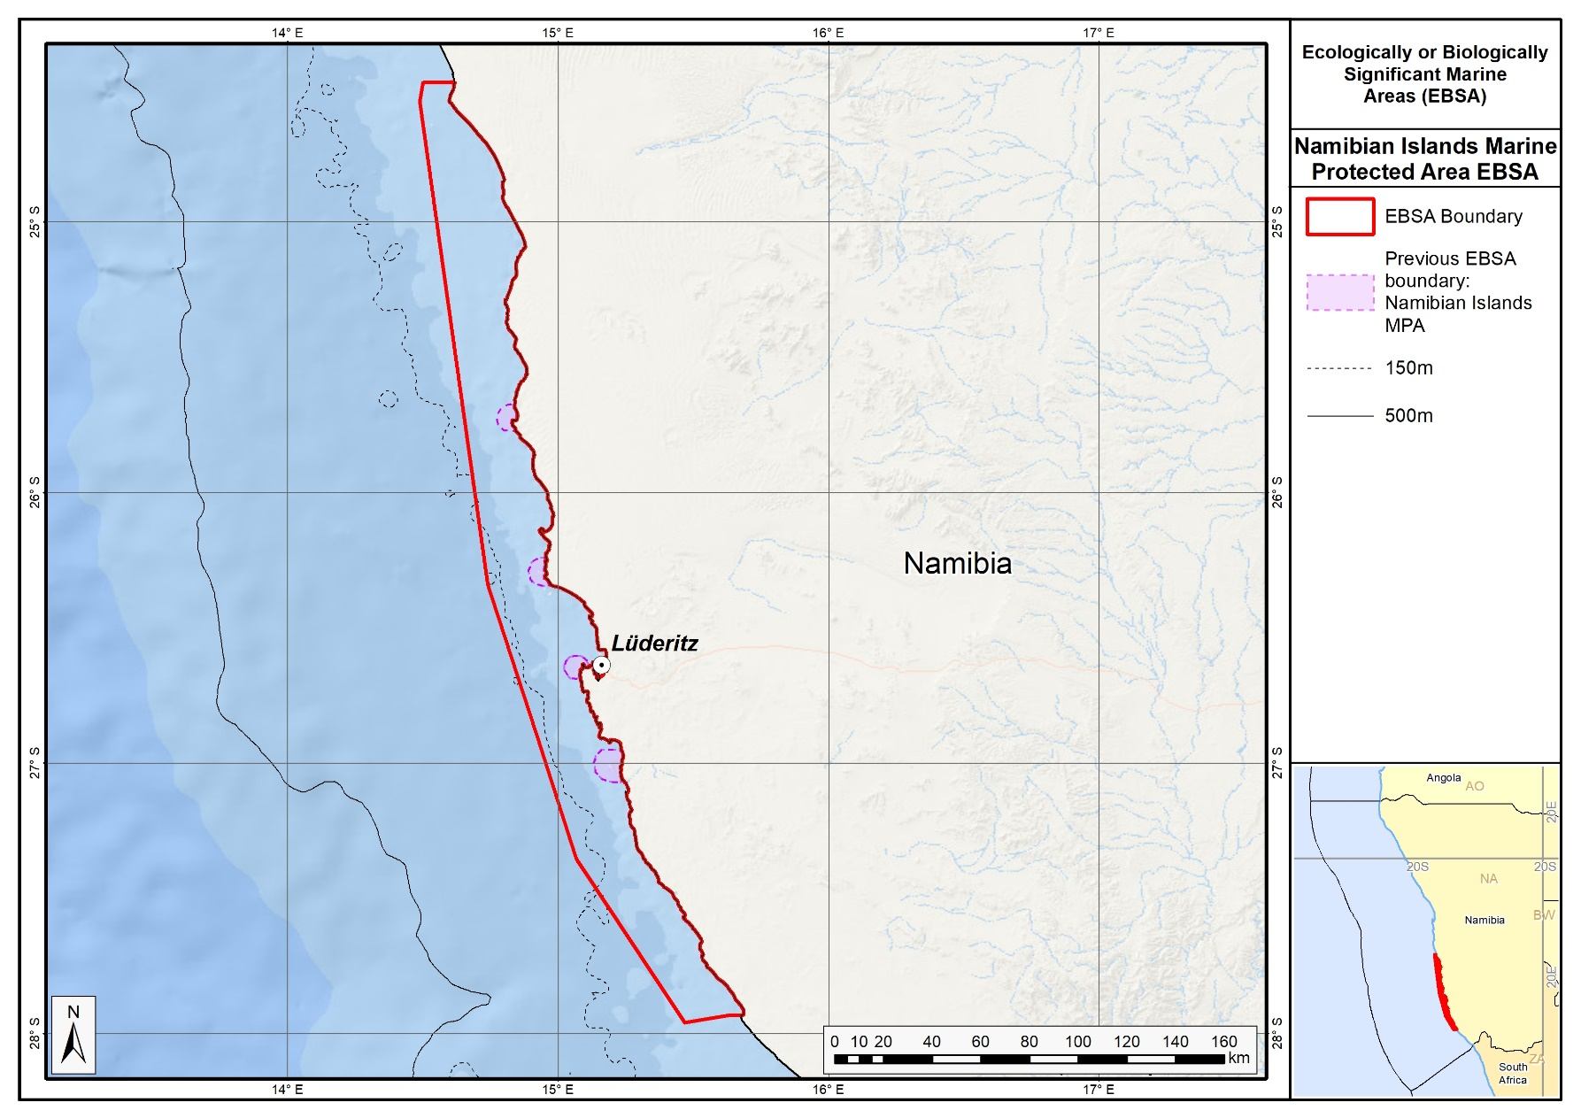
The original and revised boundaries of the Namibian Islands EBSA.

New EBSAs

Cape Fria

Proposed EBSA Description

Abstract
Cape Fria is a coastal EBSA in northern Namibia, 50 km south of the border with Angola. The EBSA encompasses Cape Fria itself, and Angra Fria: a small, prominent bay to the north. Here, the continental shelf is at its narrowest in Namibia, and there is an intense upwelling cell, second only to that found at Lüderitz, which enhances local productivity. Consequently, several top predators use this area as a foraging ground. The EBSA thus extends 100 km along the shore, and 40 km offshore to depths of <250 m in the north (where seals forage) and 5 km offshore in the south (where Damara Terns forage). The upwelling cell also marks the northern boundary of the Benguela Current. Therefore, Cape Fria falls within a biogeographic transition zone, with a relatively high local biodiversity because it comprises species at both the northern and southern limits of their distributions. There is evidence that the area is critical for aggregations of almost the entire global population of Damara Tern, a Benguela System endemic, during specific periods of the year. It is also an important breeding site for Cape fur seals. Given its remote location, the coast is in relatively pristine condition, but may be threatened by industrial development in the future.

Introduction
Cape Fria, also known as Cape Frio, is located along the northern Namibian coast, adjacent to the Skeleton Coast Park. This site was not included in the initial set of EBSAs proposed for Namibia because: it was identified only during a gap analysis of the Namibian EBSA network; local knowledge of the Damara Tern aggregations (see below) was not available at the original South Eastern Atlantic EBSA Workshop in 2013 (UNEP/CBD/RW/EBSA/SEA/1/4); and data and information on the area are both relatively limited because it is so remote. During the gap analysis, it was determined that Cape Fria is a separate EBSA from the Namibe EBSA (previously named: Kunene-Tigres), rather than an extension of it, because it is centred around a separate upwelling cell that is not connected to the upwelling cell that enhances productivity in Namibe.

The Cape Fria EBSA lies at the northern limit of the Benguela Current, possibly influenced by the Angola-Benguela Frontal Zone, and thus within the transition zone between the temperate and sub-tropical bioregions. The larger component extends 40 km offshore, and includes inshore waters on the narrowest portion of the Namibian shelf, spanning a depth range of 0-250 m. It also includes a narrower coastal extension for approximately 60 km alongshore to the south, and approximately 5 km offshore. The unusual shape of this EBSA reflects the foraging ranges of different species that are responding to the upwelling-driven productivity. The broad northern portion is the foraging range of Cape fur seals, because that area supports an important breeding Cape fur seal colony. The narrower southern portion represents the foraging range of Damara Terns that rest on the adjacent shore. Interestingly, this EBSA appears to contain almost the entire global population of Damara Tern on a seasonal basis. Cape Fria EBSA also includes important threatened benthic shelf habitats. This site comprises a collection of features and ecosystems that are connected by the same ecological processes, but some features (e.g., the Damara Tern aggregations) are emphemral; therefore, it is proposed as a Type 2/3 EBSA (sensu Johnson et al. 2018).

Description of the location

EBSA Region
South-Eastern Atlantic

Location
Cape Fria is located about 50 km south of the border between Namibia and Angola. The main body of the Cape Fria EBSA extends 40 km offshore and 100 km along the coast, while an additional section of inshore habitat extends alongshore for approximately 60 km southwards and has a width of approximately 5 km offshore. It lies entirely within Namibia’s national jurisdiction.

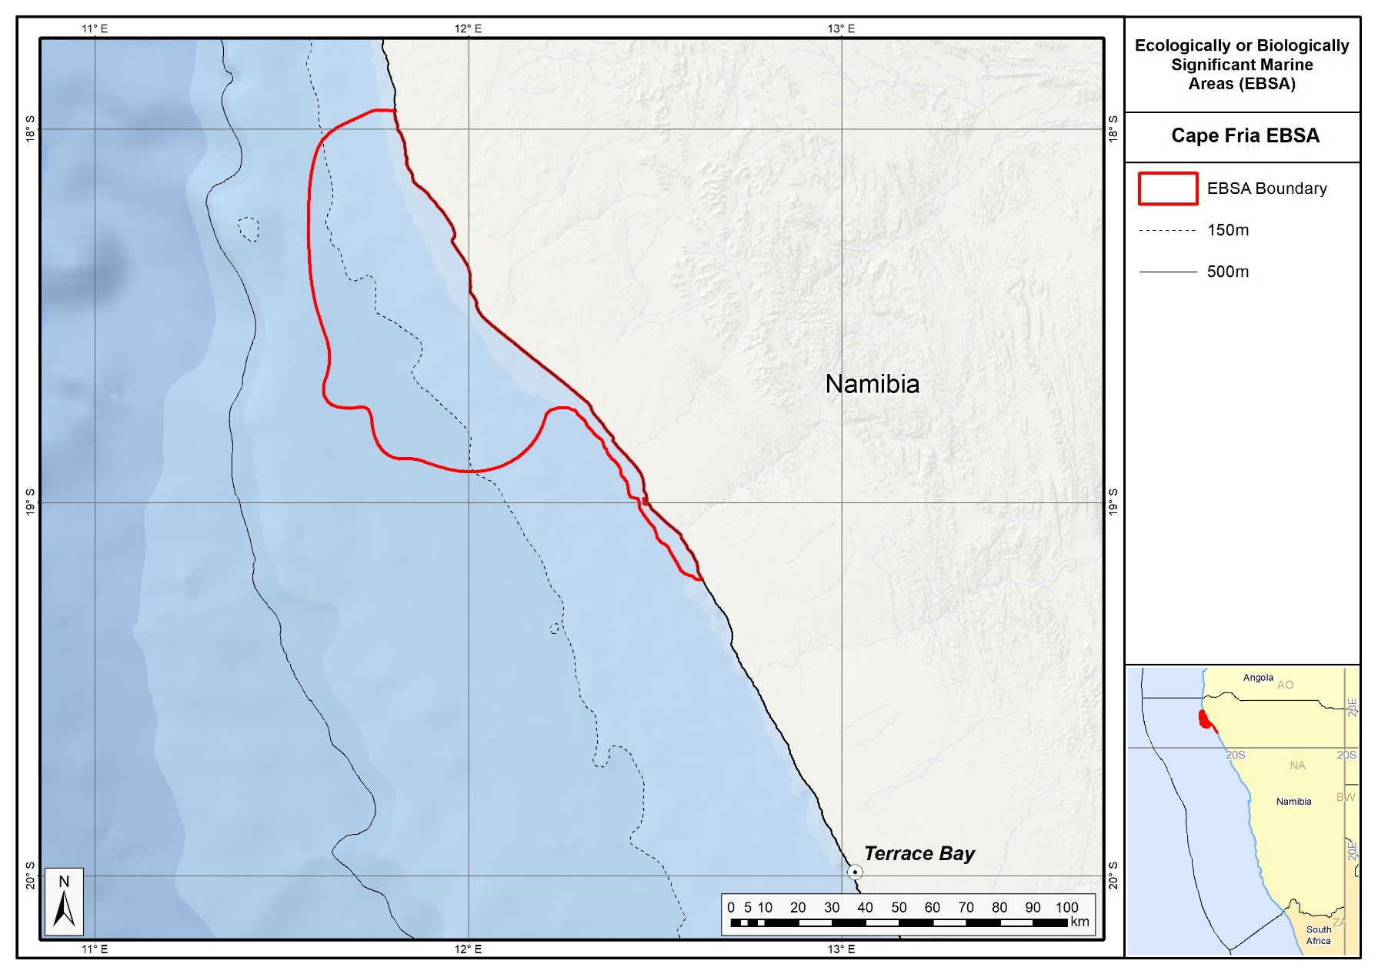
Proposed delineation of the Cape Fria EBSA.

Feature description of the proposed area
The Cape Fria EBSA includes coastal and nearshore elements, and thus described for both benthic and pelagic features. It was identified in a gap analysis (using a systematic conservation planning approach) as an important inshore focus area for conservation of biodiversity features that are not yet sufficiently represented in the existing Namibian EBSA and marine protected area network (Holness et al., 2014). Local habitat heterogeneity is relatively high in this area, with 17 habitat types identified (Holness et al., 2014; Table in the Other relevant website address or attached documents section). Two of these habitats are Endangered: Central Namib Outer Shelf and Kunene Outer Shelf, with the EBSA being particularly important for the latter. In addition, a small portion of the Vulnerable Kunene Shelf Edge habitat type is also found within the Cape Fria EBSA. These threat statuses were determined by assessing the weighted cumulative impacts of various pressures (e.g., extractive resource use, pollution, development, and others) on each habitat type for Namibia (Holness et al., 2014; Table in the Other relevant website address or attached documents section).

Importantly, productivity offshore of Cape Fria is high because it is the site of the second-most intensive upwelling cell in Namibia. Here upwelling is driven both by wind and bottom topography because the site is at the narrowest portion of the continental shelf (Sakko, 1998); further, the wind shadow and poleward currents also contribute to phytoplankton blooms (Jury, 2017). This elevated productivity is at the heart of the EBSA, because it consequently forms a key foraging area for several top predators. The Cape Fria coast supports an important breeding site for Cape fur seals, Arctocephalus pusillus pusillus, with an increasing local population, compared to largely declining populations in southern Namibia (Kirkman et al., 2012). These seals spend time foraging in the northern portion of the EBSA. Cape Fria also supports several species of shore- and seabirds, including over-wintering Palearctic migrant bird species. Most notably, there is evidence that Cape Fria may contain, either seasonally or episodically, almost the entire global population of Damara Tern, Sternula balaenarum, a vulnerable species, endemic to the Benguela System (Braby et al., 1992). The focus area appears to be an annual congregation site prior to the flock migrating northwards. It has been suggested that this is likely to be linked to high food availability, i.e., a high-energy coastline with a presumably reliable food source that is available at night and within about 5 km of the shore. Damara Terns forage more in the southern portion of the EBSA, closer to the shore compared to that of the seals.

Although bird diversity and abundance are fairly low at Cape Fria (Tarr & Tarr, 1987), it may support a relatively high local biodiversity overall because it is situated within the transition zone between the temperate and sub-tropical bioregions (Sakko 1998). Consequently, the communities at Cape Fria comprise species from both bioregions at the northern and southern limits of their respective distributions. This includes various linefish and other commercially important species, such as deep-water hake (Holtzhausen et al., 2001, Kirchner et al., 2011), large-eye dentex (Dentex macrophthalmus), thinlip splitfin (Synagrops microlepis), longfin bonefish (Pterothrissus belloci) and the African mud shrimp (Soleonocera africana; Bianchi et al., 1999).

Feature condition and future outlook of the proposed area
Cape Fria and surrounds is a remote coastal area adjacent to the Skeleton Coast National Park. The focus area is inaccessible to the public, with only limited tourism permitted in the area, and consequently, this area is near-pristine. According to data from Holness et al. (2014) nearly 90 % of the area is classified as being in good condition, with almost all of the remaining area classified as being in fair condition. Inshore and coastal habitats are in particularly good condition and are effectively well protected as a result of their remote location and the terrestrial Skeleton Coast National Park. However, pending plans to build an industrial port and associated infrastructure at Cape Fria or Angra Fria (Paterson, 2007) could potentially impact this. Onshore and offshore prospecting and mining (i.e., diamonds, oil, precious metals) is minimal at present but is expected to occur in the future.

References
Bianchi, G., Carpenter, K.E., Roux, J-P., Molloy, F.J., Boyer, D., Boyer, H.J. 1999. FAO species identification guide for fishery purposes. Field guide to the living marine resources of Namibia. Rome, FAO. 265pp.
Braby, R., Braby, S.J., Simmons, R.E. 1992. 5000 Damara Terns in the northern Namib Desert: a reassessment of world population numbers. Ostrich, 63: 133-135.
Holness, S., Kirkman, S., Samaai, T., Wolf, T., Sink, K., Majiedt, P., Nsiangango, S., Kainge, P., Kilongo, K., Kathena, J., Harris, L., Lagabrielle, E., Kirchner, C., Chalmers, R., Lombard, M. 2014. Spatial Biodiversity Assessment and Spatial Management, including Marine Protected Areas. Final report for the Benguela Current Commission project BEH 09-01.
Holtzhausen, J.A., Kirchner, C.H., Voges, S.F. 2001. Observations on the linefish resources of Namibia, 1990-2000, with special reference to West Coast steenbras and silver kob. South African Journal of Marine Science, 23: 135-144.
Hutchings L., Verheye H.M., Huggett J.A., Demarcq H., Cloete R., Barlow R.G., Louw D., da Silva, A. 2006. Variability of plankton with reference to fish variability in the Benguela Current Large Marine Ecosystem – an overview. In: Benguela – predicting a large marine ecosystem. Shannon V., Hempel G., Malanotte-Rizzoli P., Moloney C., Woods, J. (eds). Elsevier, Amsterdam. Pages: 91-124.
Johnson, D.E., Barrio Froján, C., Turner, P.J., Weaver, P., Gunn, V., Dunn, D.C., Halpin, P., Bax, N.J., Dunstan, P.K., 2018. Reviewing the EBSA process: Improving on success. Marine Policy 88, 75-85.
Jury, M.R. 2017. Coastal upwelling at Cape Frio: Its structure and weakening. Continental Shelf Research, 132: 19-28.
Kirchner C., Japp D.W., Purves M.G., Wilkinson, S. (eds) 2011. Benguela Current Large Marine Ecosystem. Annual state of fish stocks report. Windhoek. 92 pp.
Kirkman, S.P., Yemane, D., Oosthuizen, W.H., Meÿer, M.A., Kotze, P.G.H., Skrypzeck, H., Vaz Velho, F., Underhill, L.G. 2012. Spatio-temporal shifts of the dynamic Cape fur seal population in southern Africa, based on aerial censuses (1972–2009). Marine Mammal Science, 29: 497–524.
Paterson J.R.B. 2007. The Kunene River Mouth: Managing a unique environment. MSc Thesis, Unversity of KwaZulu Natal, Pietermaritzburg, South Africa: 124 pp.
Ryan, P. G., Cooper, J., Stutterheim, C. J. 1984. Waders (Charadrii) and other coastal birds of the Skeleton Coast, South West Africa. Madoqua, 14: 71-78.
Sakko, A.L. 1998. The influence of the Benguela upwelling system on Namibia's marine biodiversity. Biodiversity & Conservation, 7: 419-433.
Tarr, J.G, Tarr., P.W. 1987. Seasonal abundance and the distribution of coastal birds on the northern Skeleton Coast, South West Africa/Namibia. Madoqua, 15: 63-72.

Other relevant website address or attached documents
Summary of habitat types and threat status for Cape Fria. Data from Holness et al. (2014).
Threat Status | Habitat Type | Area (km²) | Area (%)
Endangered | Central Namib Outer Shelf | 243.0 | 5.0
 | Kunene Outer Shelf | 1342.5 | 27.8
Endangered Total |  | 1585.5 | 32.9
Vulnerable | Kunene Shelf Edge | 3.8 | 0.1
Vulnerable Total |  | 3.8 | 0.1
Least Threatened | Central Namib Inner Shelf | 829.4 | 17.2
 | Kunene Exposed Rocky Shore | 0.3 | 0.0
 | Kunene Inner Shelf | 1551.1 | 32.2
 | Kunene Inshore | 275.4 | 5.7
 | Kunene Intermediate Sandy Beach | 61.0 | 1.3
 | Kunene Mixed Shore | 6.3 | 0.1
 | Kunene Reflective Sandy Beach | 1.9 | 0.0
 | Hoanib Dissipative-Intermediate Sandy Beach | 9.8 | 0.2
 | Hoanib Dissipative Sandy Beach | 7.0 | 0.1
 | Hoanib Exposed Rocky Shore | 0.4 | 0.0
 | Hoanib Inshore | 445.4 | 9.2
 | Hoanib Intermediate Sandy Beach | 38.4 | 0.8
 | Hoanib Mixed Shore | 7.9 | 0.2
 | Hoanib Sheltered Rocky Shore | 0.03 | 0.00
Least Threatened Total |  | 3234.5 | 67.1
Grand Total |  | 4823.8 | 100.0

Assessment of the area against CBD EBSA Criteria

CBD EBSA Criteria  (Annex I to decision IX/20) | Description  (Annex I to decision IX/20) |  | Ranking of criterion relevance
Uniqueness or rarity | Area contains either (i) unique (“the only one of its kind”), rare (occurs only in few locations) or endemic species, populations or communities, and/or (ii) unique, rare or distinct, habitats or ecosystems; and/or (iii) unique or unusual geomorphological or oceanographic features. |  | Medium
Explanation for ranking

Cape Fria is both unique and rare for several reasons. It falls within a transition zone between the temperate and sub-tropical bioregions, and includes a relatively rare upwelling cell, second in intensity only to the Lüderitz upwelling cell. Further, a systematic conservation planning assessment (that was undertaken as a gap analysis) identified Cape Fria as an important inshore focus area for place-based conservation of biodiversity features that were not yet sufficiently represented in the existing Namibian EBSA and marine protected area network (Holness et al., 2014). Portions of this focus area were always required to meet biodiversity conservation targets, and hence it can be considered to be “irreplaceable”. Finally, existing evidence indicates that the area may either seasonally or episodically contain almost the entire global population of Damara Tern, Sternula balaenarum, a Benguela System endemic species (Braby et al., 1992). The area appears to be an annual congregation area prior to the flock migrating northwards. It has been suggested that this is likely to be a congregation area linked to high food availability, i.e., a high-energy coastline with a presumably reliable food source that is available at night and within about 5 km of the shore.

Special importance for life-history stages of species | Areas that is required for a population to survive and thrive. |  | High
Explanation for ranking

Cape Fria is an important site for Cape fur seals, which, although it was only relatively recently established as a breeding colony, supports an increasing seal population (Kirkman et al., 2012). This site also exhibits strong terrestrial links because the expanding seal colony supports an expanding population of the Endangered Lappet-faced Vulture, Torgos tracheliotos (Braby, pers. comm.). The Cape Fria EBSA is also an overwintering site for Palearctic waders, although at fairly low densities (Tarr & Tarr, 1987). Further, as noted previously, Cape Fria hosts almost the entire global population of Damara Tern either seasonally or episodically, in what seems to be an annual congregation area prior to the flock migrating northwards (Braby et al., 1992). It is likely that this is linked to high food availability at the site, i.e., a high-energy coastline with a presumably reliable food source that is available at night, and within about 5 km of the shore. Finally, Cape Fria is a transition zone between the cool, temperate southern areas that are influenced by the Benguela current, and a more sub-tropical climate to the north of Namibia (Tarr 1987), and thus may possibly be an important area for adaptation to climate change and range shifts. This is supported by the fact that the area constitutes the northern or southern limit for a number of fish species (Bianchi et al., 1999; Holtzhausen et al., 2001; Kirchner et al., 2011).

Importance for threatened, endangered or declining species and/or habitats | Area containing habitat for the survival and recovery of endangered, threatened, declining species or area with significant assemblages of such species. |  | High
Explanation for ranking

The Cape Fria EBSA contains two Endangered habitat types: Central Namib Outer Shelf and Kunene Outer Shelf, with the area being particularly important for the latter. In addition, a small portion of the Vulnerable Kunene Shelf Edge habitat type is found in this EBSA. As noted previously, the site is also important for the Vulnerable Damara Tern, Sternula balaenarum (Braby et al., 1992), and for Cape fur seals that seem to be generally declining in abundance at rookeries in southern Namibia but increasing here (Kirkman et al., 2014).

Vulnerability, fragility, sensitivity, or slow recovery | Areas that contain a relatively high proportion of sensitive habitats, biotopes or species that are functionally fragile (highly susceptible to degradation or depletion by human activity or by natural events) or with slow recovery. |  | Data Deficient
Explanation for ranking

There is no information to guide ranking the EBSA on this criterion. It could possibly be ranked low because the conditions are unstable and unpredictable, preventing very vulnerable species from persisting (Sakko 1998). However, it could also be argued that the Cape Fria upwelling cell is vulnerable to impacts from climate change.

Biological productivity | Area containing species, populations or communities with comparatively higher natural biological productivity. |  | High
Explanation for ranking

There is an upwelling cell at Cape Fria that enhances local productivity (Sakko, 1998). Upwelling is year-round, but is intensified in winter and early spring (Hutchings et al., 2006; Jury, 2017). It is driven both by wind and bottom topography because the Namibian continental shelf is at its narrowest around Cape Fria (Sakko, 1998); further, the wind shadow and poleward currents also contribute to the phytoplankton blooms (Jury, 2017). This upwelling cell is second in intensity only to the Lüderitz upwelling cell, and the high productivity here that underpins the top predator foraging areas is at the heart of this site’s value as an EBSA.

Biological diversity |  | Area contains comparatively higher diversity of ecosystems, habitats, communities, or species, or has higher genetic diversity. |  | Medium
Explanation for ranking

Shorebird and coastal seabird diversity and density are relatively low in the focus area (Ryan et al., 1984; Tarr & Tarr, 1987). However, the Cape Fria focus area may be an area of high sub-tidal and coastal biodiversity because it is at the transition between temperate and sub-tropical biogeographic regions, with communities comprising species at their southern and northern bioregional limits (Sakko 1998). It is possible that this is enhanced by high productivity from the Cape Fria upwelling cell, and the close proximity to the Walvis Ridge, which has high habitat heterogeneity. The speculated higher biodiversity in the area could be locally important because Namibia generally has low marine species richness (Sakko 1998). Local habitat heterogeneity is also high, with 17 habitats represented within the EBSA.

Naturalness |  | Area with a comparatively higher degree of naturalness as a result of the lack of or low level of human-induced disturbance or degradation. |  | High
Explanation for ranking

Cape Fria is a remote coastal area adjacent to the Skeleton Coast Park. The focus area is inaccessible to the public, with only limited tourism permitted in the area, and because of this, is currently near-pristine.

Status of submission
Area to be submitted to the Conference of the Parties for acknowledgement of meeting EBSA criteria once review process is finalized.

COP Decision
Not yet submitted.

End of proposed EBSA revised description

Motivation for Submission
The Cape Fria area was identified in a gap analysis as one of the two highest priority potential EBSA areas (along with Walvis Ridge Namibia) screened by the national EBSA process (including review of the spatial data from Holness et al. (2014) and inputs from expert workshops). The candidate EBSA was screened against the CBD criteria. Initial assessments indicated that it warranted inclusion. A final delineation and evaluation process was then undertaken, which resulted in the current description of the EBSA.
The delineation process used a combination of Systematic Conservation Planning (SCP) and Multi-Criteria Analysis methods. The key features used in the analysis were:
- Irreplaceable and near irreplaceable (i.e. very high selection frequency) sites, as well as primary and secondary focus areas identified in the SCP undertaken for the BCLME by Holness et al. (2014).
- Threatened Benthic and Coastal Ecosystems. The analysis focussed on the inclusion of the most threatened ecosystem types found in the area. These types are highlighted in the table in the Other relevant website address or attached documents section. Key threatened ecosystem types were the endangered Central Namib Outer Shelf and the Kunene Outer Shelf, and the vulnerable Kunene Shelf Edge. Delineations and ecosystem threat status from Holness et al. (2014).
- Areas important for threatened and special species were included. The priority areas and buffer distances around colonies were from Holness et al. (2014). Note that the full extent of the buffer was not necessarily included in the EBSA. Features included in the analysis were:
  - African Penguin colonies and a 20km buffer.
  - Bank Cormorant, Cape Cormorant, White Breasted Cormorant and Crowned Cormorant colonies and a 40km buffer.
  - Gannet colonies with a 40km buffer.
  - High density and diversity bird sites.
  - Seal Colonies and a 20km buffer.
- Areas of high relative naturalness identified in the SCP undertaken for the BCLME by Holness et al. (2014).
- Additional expert identified areas important for key bird species (especially Damara Tern, see Braby et al. 1992).
The multi-criteria analysis resulted in a value surface. The cut-off value (used to determine the extent of the EBSA) was based on expert input and quantitative analysis of effective inclusion of the above features. This entailed taking an iterative parameter calibration-based approach whereby the spatial efficiency of the inclusion of the targeted features was evaluated. The approach aimed to identify a cut-off which most efficiently included prioritised features while minimizing the inclusion of impacted areas. The final boundaries shown in the map below were validated in an expert workshop.

Research Needs
There is fairly limited research that has been conducted in the area. Consequently, there are many gaps to fill in terms of understanding the biodiversity patterns and ecological processes within this EBSA area (including the phenomenon of the Damara tern aggregations). Further, without having better information on the local species present, there is currently no information from which the vulnerability of the site can be ranked. Knowing the current vulnerability will be key to determining which pressures the site is likely able to withstand.

Future Process
This EBSA is unlikely at this stage to be a focus area for detailed evaluation of status or management requirements. It nevertheless should be considered when general management requirements are being discussed for all Namibian EBSAs.

Walvis Ridge Namibia

Proposed EBSA Description

General Information

Summary
The Walvis Ridge Namibia EBSA lies contiguous to the Walvis Ridge EBSA in the high seas. Together, these two EBSAs span the full extent of the significant hotspot track (seamount chain formed by submarine volcanism) that comprises the aseismic Walvis Ridge and the Guyot Province. This unique feature forms a submarine ridge running north-east to south-west from the Namibian continental margin to Tristan da Cunha and Gough islands at the southern Mid-Atlantic Ridge. The Walvis Ridge Namibia EBSA encompasses the globally rare connection of a hotspot track to continental flood basalt in the Namibian EEZ. Given the high habitat heterogeneity associated with the complex benthic topography, it is likely that the area supports a relatively higher biological diversity, and is likely to be of special importance to vulnerable sessile macrofauna and demersal fish associated with seamounts. Productivity in the Namibian portion of Walvis Ridge is also particularly high because of upwelling resulting from the interaction between the geomorphology of the feature and the nutrient-rich, north-flowing Benguela Current. Although there are fisheries operating over Walvis Ridge in northern Namibia, the EBSA focus area is currently in good condition.

Introduction of the area
The aseismic Walvis Ridge is a seamount chain formed by hotspot submarine volcanism, some of which are guyots, that is connected to a continental flood basalt province in northern Namibia. The ridge presents a barrier between North Atlantic Deep Water to the north and Antarctic Bottom Water to the south. The surface oceanographic regime is the South Atlantic Subtropical Gyre bounded by the productive waters of the Benguela Current System and the Subtropical Convergence Zone. The feature described here is depth-bound around the 4000-m isobath, and contains significant areas within the likely vertical extent of near-surface zooplankton migration (1000 m). Although biologically significant, data from research cruises are patchy and variable, however the greater area is known to support a high diversity of seabirds, some of which are threatened. Further, the steep slopes and seamounts that are characteristic of the ridge likely support enhanced primary production, abundance and species richness. Because this site comprises a complex of features and ecosystems that are connected by the same ecological processes, it is proposed as a Type 2 EBSA (sensu Johnson et al. 2018).

Description of the location

EBSA Region
South-Eastern Atlantic

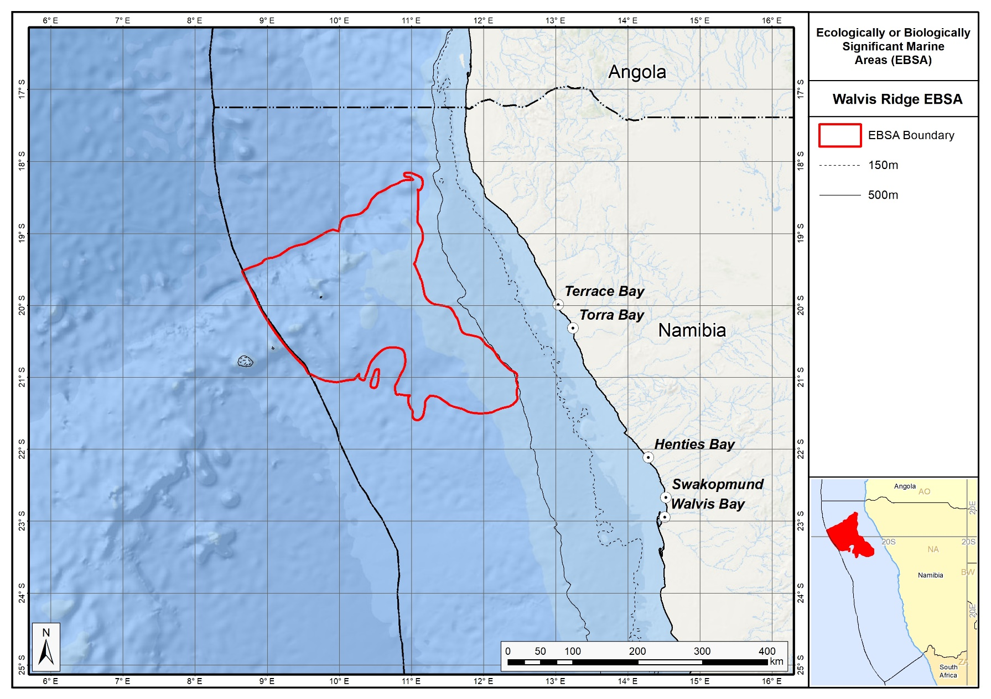
Proposed boundaries of the Walvis Ridge Namibia EBSA.

Description of location
The Walvis Ridge extends obliquely (NE-SW) across the south east Atlantic Ocean from the northern Namibian shelf (18°S) to the Tristan da Cunha island group at the Mid-Atlantic Ridge (38°S). The part of the ridge that lies beyond national jurisdiction is included in the existing Walvis Ridge EBSA that has its north eastern boundary at the Namibian EEZ. The proposed Walvis Ridge Namibia EBSA is contiguous with this high seas EBSA, spanning only that portion of the ridge within Namibia’s national jurisdiction. Given the global rarity of the connection between a hotspot track and the continental flood basalt province, it is imperative that the full extent of this feature is encompassed within an EBSA, including the portion in the Namibian EEZ.

Area Details

Feature description of the area
Walvis Ridge is both a benthic and water column feature: it is a chain of seamounts that individually and collectively constitute an ecologically and biologically significant deep-sea feature, as also recognized by the Census of Marine Life project (CenSeam: http://censeam.niwa.co.nz). Walvis Ridge also includes a number of deep-sea features in addition to the seamounts and guyots, such as steep canyons, embayments formed by massive submarine slides, trough-like structures, a graben, abyssal plains, and a fossilized cold-water coral reef mound community (GEOMAR 2014). Based on these physical features, the ridge can be divided into three sections (GEOMAR 2014). The portion of the ridge within the proposed EBSA forms part of the northern section, which extends SW from the Namibian shelf, with a steep NW scarp, ridge-type seamounts, and guyots with rift arms (GEOMAR 2014).

The high habitat heterogeneity supports moderately diverse biological communities, including benthic macrofauna such as brachiopods, sponges, octocorals, deep-water hexacorals, gastropods, bivalves, polychaetes, bryozoans, cirriped crustaceans, basket stars, ascidians, isopods and amphipods (GEOMAR 2014). Presumably this diversity extends along the full extent of the ridge, and into the Namibian portion. Productivity seems to increase from SW to NE along Walvis Ridge, with sediment organic carbon and the abundance and diversity of phytoplankton communities increasing towards the Namibian shelf, likely reflecting patterns of nutrient transport and upwelling in the north-flowing Benguela Current that are more intense closer to the African continent (GEOMAR 2014).

This EBSA was not included in the original South Eastern Atlantic Workshop that was held in 2013 (UNEP/CBD/RW/EBSA/SEA/1/4) because it was highlighted only in a gap analysis of the national and regional EBSA networks, using systematic conservation planning (Holness et al., 2014). Further, new information has since become available following a recent research cruise (GEOMAR 2014), which has added certainty of the significance of the features. The EBSA boundary links tightly to important benthic features comprising the ridge (produced by combining GEBCO data with that from www.bluehabitats.org: see Harris et al., 2014, and data from Holness et al., 2014). Those features that are continuous with the ridge, as well as isolated hills that are in close proximity are included. The EBSA also includes areas with a high selection frequency in the regional gap analysis (Holness et al., 2014), which suggests that they are irreplaceable areas in the region.

Feature conditions and future outlook of the proposed area
The Walvis Ridge EBSA is primarily recognized as a geological feature but the biota in the area could be vulnerable to fishing (e.g., orange roughy; SEAFO report in FAO Statistical Area 47). The fisheries within the Namibian EEZ are managed by Namibia’s Ministry of Fisheries and Marine Resources. Oil exploration has already taken place within the EBSA, namely Welwitschia-1 well, which was drilled in 2014 at 20°11’9.79”S, 11°19’3.27”E. Although it was found to be dry, future drilling activities in the area are likely. The EBSA is largely in good condition, though some impacted areas exist on the far eastern edge (Holness et al., 2014).

The Walvis Ridge and Walvis Ridge Namibia EBSAs should ideally be merged because they both represent the same feature; however, the former is in the high seas and the latter is under national jurisdiction. Consequently, this merger will depend on international processes around EBSAs that span across country EEZs and ABNJ. It is thus recommended that ABNJ and BBNJ processes are engaged to understand the link between these two EBSAs and how they might be merged in the future.

References
BirdLife International. 2009. Designing networks of marine protected areas: exploring the linkages between Important Bird Areas and ecologically or biologically significant marine areas. Cambridge, UK: BirdLife International. www.cbd.int/doc/meetings/mar/ewbcsima- 01/other/ewbcsima-01-birdlife-02-en.pdf.
BirdLife International. 2010. Marine Important Bird Areas toolkit: standardised techniques for identifying priority sites for the conservation of seabirds at-sea. BirdLife International, Cambridge UK. Version 1.1: May 2010. www.birdlife.org/eu/pdfs/Marine_IBA_Toolkit_2010.pdf.
Census of Marine Life project CenSeam http://censeam.niwa.co.nz, http://seamounts.sdsc.edu.
Clark, M.R., Vinichenko, V.I., Gordon, J.D.M, Beck-Bulat, G.Z., Kukharev, N.N., Kakora, A.F. 2007. Large scale distant water trawl fisheries on seamounts. Pp. 361-412 in Seamounts: Ecology, Fisheries and Conservation. Fish and Aquatic Resources Series 12, T.J. Pitcher, T. Morato, P.J.B. Hart, M.R. Clark, N. Haggan and R.S. Santos, eds, Blackwell Publishing, Oxford.
Durán Muñoz, P., Sayago-Gil, M., Murillo, F.J., Del Río, J.L., López-Abellán, L.J., Sacau, M., Serralde, R. 2012. Actions taken by fishing nations towards identification and protection of vulnerable marine ecosystems in the high seas: The Spanish case (Atlantic Ocean). Marine Policy, 36: 536–543.
FAO FIRMS (Fishery Resources Monitoring System) firms.fao.org.
GEBCO (General Bathymetric Chart of the Oceans) Available at http://www.gebco.net/data_and_poducts/gridded_bathymetry_data/.
GEOMAR, 2014. RV SONNE Fahrtbericht / Cruise Report SO233 WALVIS II: Cape Town, South Africa - Walvis Bay, Namibia: 14.05-21.06.2014. Hoernle, K., Werner, R., Lüter, C (eds). Helmholtz-Zentrum für Ozeanforschung Kiel, Germany: Nr. 22 (N. Ser.), 153 pp.
Harris, L.R., Nel, R., Oosthuizen, H., Meyer, M., Kotze, D., Anders, D., McCue, S., Bachoo, S. 2017. Managing conflicts between economic activities and threatened migratory marine species towards creating a multi-objective blue economy. Conservation Biology, in press.
Harris, P.T., Macmillan-Lawler, M., Rupp, J., Baker, E.K. 2014. Geomorphology of the oceans. Marine Geology, 352: 4-24.
Holness, S., Kirkman, S., Samaai, T., Wolf, T., Sink, K., Majiedt, P., Nsiangango, S., Kainge, P., Kilongo, K., Kathena, J., Harris, L., Lagabrielle, E., Kirchner, C., Chalmers, R., Lombard, M. 2014. Spatial Biodiversity Assessment and Spatial Management, including Marine Protected Areas. Final report for the Benguela Current Commission project BEH 09-01.
Jacobs, C.L., Bett, B.J. 2010. Preparation of a bathymetric map and GIS of the South Atlantic Ocean: a review of available biologically relevant South Atlantic Seamount data for the SEAFO Scientific Committee. National Oceanographic Centre Southampton, Research and consultancy Report No. 71 (unpublished manuscript).
Johnson, D.E., Barrio Froján, C., Turner, P.J., Weaver, P., Gunn, V., Dunn, D.C., Halpin, P., Bax, N.J., Dunstan, P.K., 2018. Reviewing the EBSA process: Improving on success. Marine Policy 88, 75-85.
OBIS. 2017. Summary statistics of biodiversity records in the Walvis Ridge EBSA. (Available: Ocean Biogeographic Information System. Intergovernmental Oceanographic Commission of UNESCO. www.iobis.org. Accessed: 2017-07-27).
Perez, J.A.A, dos Santos Alves, E., Clark, M.R., Bergstad, O.A., Gebruk, A., Azevedo Cardoso, I., Rogacheva, A. 2012. Patterns of life on the southern Mid-Atlantic Ridge: Compiling what is known and addressing future research. Oceanography, 25: 16-31.
Reid, T., Ronconi, R., Cuthbert, R., Ryan, P.G. 2014. The summer foraging ranges of adult spectacled petrels Procellaria conspicillata. Antarctic Science, 26: 23-32.
Rogers, A.D., Gianni, M. 2010. The implementation of UNGA Resolutions 61/105 and 64/72 in the Management of Deep-Sea Fisheries on the High Seas. Report prepared for the Deep Sea Conservation Coalition, International Programme on the State of the Ocean, London UK. 97 pp.
Sanchez, P., Alvarez, J.A. 1988. Scaeurgus unicirrhus (Orbigny, 1840) (Cephalopoda Octopodidae): First record from the South-east Atlantic. South African Journal of Marine Science, 7: 69-74.
Zibrowius, H., Gili, J.M. 1990. Deep-water Scleractinia (Cnidaria Anthozoa) from Namibia, South Africa and Walvis Ridge, southeastern Atlantic. Scientia Marina, 54: 19-46.

Other relevant website address or attached documents
Summary of habitat types and threat status for Walvis Ridge Namibia. Data from Holness et al. (2014).
Threat Status | Habitat Type | Area (km²) | Area (%)
Vulnerable | Central Namib Shelf Edge | 18,113 | 26.1
 | Kunene Shelf Edge | 6,458 | 9.3
Vulnerable Total |  | 24,571 | 35.4
Least Threatened | Kunene Abyss | 5,920 | 8.5
 | Kunene Lower Slope | 8,664 | 12.5
 | Kunene Seamount | 3,818 | 5.5
 | Kunene Upper Slope | 2,298 | 3.3
 | Namib Abyss | 383 | 0.6
 | Namib Lower Slope | 16,573 | 23.9
 | Namib Seamount | 2,290 | 3.3
 | Namib Upper Slope | 4,931 | 7.1
Least Threatened Total |  | 44,877 | 64.6
Grand Total |  | 69,448 | 100.0

Additional Information
Additional criteria: BirdLife Important Bird Areas Criteria (BirdLife 2009, 2010) A1 Regular presence of threatened species; A4ii >1% of the global population of a seabird.

Assessment of the area against CBD EBSA criteria
C1: Uniqueness or rarity High
Justification
As the only extensive seamount chain off of the Mid-Atlantic Ridge in the Southeast Atlantic, the Walvis Ridge is a unique geomorphological feature. It is also one of the few hotspot tracks on earth that connects to continental flood basalt. This rare connection falls within the Walvis Ridge Namibia EBSA.

C2: Special importance for life-history stages of species High
Justification
Seamount chains may facilitate connectivity between individual seamounts over extensive distances. The varied topography and geomorphology support demersal fish resources (based on demersal fisheries records in locations shallower than 2000 m). The varied bathymetry dictates the distribution area and provides significant habitat for bentho-pelagic species (e.g., hotspots for orange roughy), and is also likely to do so for epi-pelagics (Clark et al., 2007, Rogers and Gianni, 2010). These seamounts are significant habitats for cold-water corals and sponges (Zibrowius and Gili, 1990; GEOMAR 2014). Thus, the Walvis Ridge is of special importance for sessile macrofauna and for demersal fish associated with seamounts (FAO FIRMS species distribution maps) (http://firms.fao.org). It includes parts of the foraging areas for globally threatened seabirds, such as the Tristan Albatross (Diomedea dabbenena), Wandering Albatross (Diomedea exulans) and Atlantic Yellow-nosed Albatross (www.seabirdtracking.org). The series of seamounts provides a potential stepping stone feature for organisms from coast to mid ocean (e.g., dispersion of the benthic octopod, Scaeurgus unicirrhus; Sanchez and Alvarez, 1988).

C3: Importance for threatened, endangered or declining species and/or habitats Medium
Justification
Bluefin and big-eye tuna occur in the area (e.g., FishBase), and orange roughy hotspots within the area are known (SEAFO information). Several threatened seabird species also use the Namibian portion of the Walvis Ridge for foraging, e.g., the endangered Atlantic Yellow-nosed Albatross (www.seabirdtracking.org; BirdLife International, 2017).

C4: Vulnerability, fragility, sensitivity, or slow recovery High
Justification
Habitat-forming sessile megafauna are fragile and vulnerable to bottom contact fishing gears and slow to recover from damage. Habitat prediction models and observational data (Durán Muñoz et al., 2012, GEOMAR 2014, Perez et al., 2012) indicate presence of cold-water corals and sponges, and other delicate fauna such as basket and feather stars (see also the OBIS database for species records: http://www.iobis.org/explore/#/area/351). Based on empirical evidence (e.g., observations from Spanish/Namibian cruises on the Valdivia Bank, and along the whole ridge; GEOMAR 2014) the seamounts and deep-sea features along the Walvis Ridge have sensitive habitats, biotopes and species, justifying high criterion ranking.

C5: Biological productivity Medium
Justification
Productivity appears to increase from SW to NE along the Walvis Ridge, as seen in the sediment organic carbon load, and abundance and diversity of plankton that both increase closer to the Namibian shelf (GEOMAR 2014). Several seamounts also extend into the photic zone and may have enhanced primary production. Significant areas are within the likely vertical range of epipelagic zooplankton migration (Jacobs and Bett, 2010).

C6: Biological diversity Medium
Justification
Data on biological diversity associated with the Walvis Ridge are limited, however there are some data on seabirds, fish, and benthic mega-, macro- and meiofauna (see Perez et al., 2012 for a review, and GEOMAR 2014), including 17 922 records of 907 species listed on the OBIS database (OBIS 2017). Observations and the range of habitats created by the seamount chain and immediately adjacent abyssal area suggest comparatively higher diversity of ecosystems, habitats, communities, and species. This has been confirmed to some extent through bathymetric/geological surveys and biological sampling of the benthos, which revealed a variety of benthic macrofauna (GEOMAR 2014). Presumably the comparatively higher biodiversity associated with this geological feature extends into the Namibian portion of the ridge that comprises the Namibian EBSA focus area.

C7: Naturalness High
Justification
Human influence along the Walvis Ridge is largely historic, fisheries were and are mainly confined to seamount summits (SEAFO information, Clark et al., 2007, and relevant papers cited in Perez et al., 2012), and oil exploration drilling has been limited to date. Apart from seamounts that are likely to have been impacted by bottom-fishing, the remainder of the area is considered to have a high degree of naturalness. The EBSA focus area is largely in good condition, though some impacted areas exist on the far eastern edge (Holness et al., 2014).

Status of submission
Area to be submitted to the Conference of the Parties for acknowledgement of meeting EBSA criteria once review process is finalized.

COP Decision
Not yet submitted.

End of proposed EBSA revised description

Motivation for Submission
The Namibian portion of the Walvis Ridge was considered by the Namibian Government to be one of the highest priority potential areas screened in its national EBSA process. The original intent was to extend and revise the existing high seas Walvis Ridge EBSA to include the adjacent sections in the Namibian EEZ. Ecologically and physically the Walvis Ridge is clearly a single feature which does not stop at the Namibian EEZ boundary. The Walvis Ridge system is a unique geomorphological feature with important biodiversity values. Given the global rarity of the connection between the hotspot track and continental flood basalt province, it was seen as imperative that the full extent of this feature was encompassed within the EBSA. Hence, a process was initiated by the Namibian government with the South East Atlantic Fisheries Organisation (SEAFO), which is the intergovernmental fisheries science and management body responsible for the high seas area within which the Walvis Ridge is partially located. However, it became clear that this process was not politically feasible within reasonable timelines. Therefore, the Namibian government is pursuing the recognition of the portion of the Walvis Ridge which falls within the Namibian EEZ as a separate but complementary EBSA to the existing Walvis Ridge EBSA. It remains the intent to secure a single unified EBSA should this becomes possible in the future.
The original high seas EBSA description was revised and updated with the latest research and biodiversity information from OBIS. Consequently, six new references were included. Following revision of the boundary, and an updated literature search, three criteria have been upgraded. Vulnerability, fragility and sensitivity, and Naturalness have both been upgraded from Medium to High, and Biological productivity has been upgraded from Data Deficient to Medium.
The delineation process used a combination of Systematic Conservation Planning (SCP) and Multi-Criteria Analysis methods. The features used in the analysis were:
- Key features from GEBCO data, global benthic geomorphology mapping (www.bluehabitats.org, Harris et al., 2014), and data from BCC spatial mapping project (Holness et al., 2014). The main features included were areas of complex habitat heterogeneity, including steep slopes, canyons, embayments formed by massive submarine slides, trough-like structures, a graben, abyssal plains, and shallow summits of seamounts and guyots.
- Areas with a high selection frequency in the regional spatial prioritization to meet biodiversity targets efficiently, as well as include key geomorphological features of the Ridge (Holness et al., 2014).
- Features that are continuous with the Ridge, as well as isolated hills that are in close proximity were included.

Research Needs
Given the extent of the EBSA, and how far it runs into the high seas, research within the EBSA boundary is largely limited to collaborative cruises that combine physical and biological sampling, usually over a small area. Despite the numerous species records, only a fraction of the EBSA has been sampled, and any new information and data on the system advance our knowledge and understanding of Walvis Ridge. Research should possibly be prioritised in areas where activities are potentially interacting, or will likely interact, negatively with key biodiversity features, e.g., fishing overlaps with known or presumed vulnerable, fragile ecosystems, or threatened species. However, large-scale research in understanding the role of this outstanding feature in the global geophysical processes (including oceanic and climatic processes) will also be key to unlocking future predictions under different climate change scenarios. Alignment between the research and management of the Namibian EEZ and the high seas portions of the Walvis Ridge system will be critical for long term sustainability.

Future Process
It remains the intent to secure a single unified EBSA incorporating the Walvis Ridge Namibia and the existing high seas Walvis Ridge EBSA.
The delineation of the Walvis Ridge Namibia EBSA is more precise than the delineation of the existing high seas Walvis Ridge EBSA; which results in a much closer alignment between the EBSA boundary and the underlying features it represents along the Ridge. If the Walvis Ridge Namibia EBSA and the high seas Walvis Ridge EBSA are to be aligned in the future, it will be necessary to update the boundaries of the integrated EBSA.

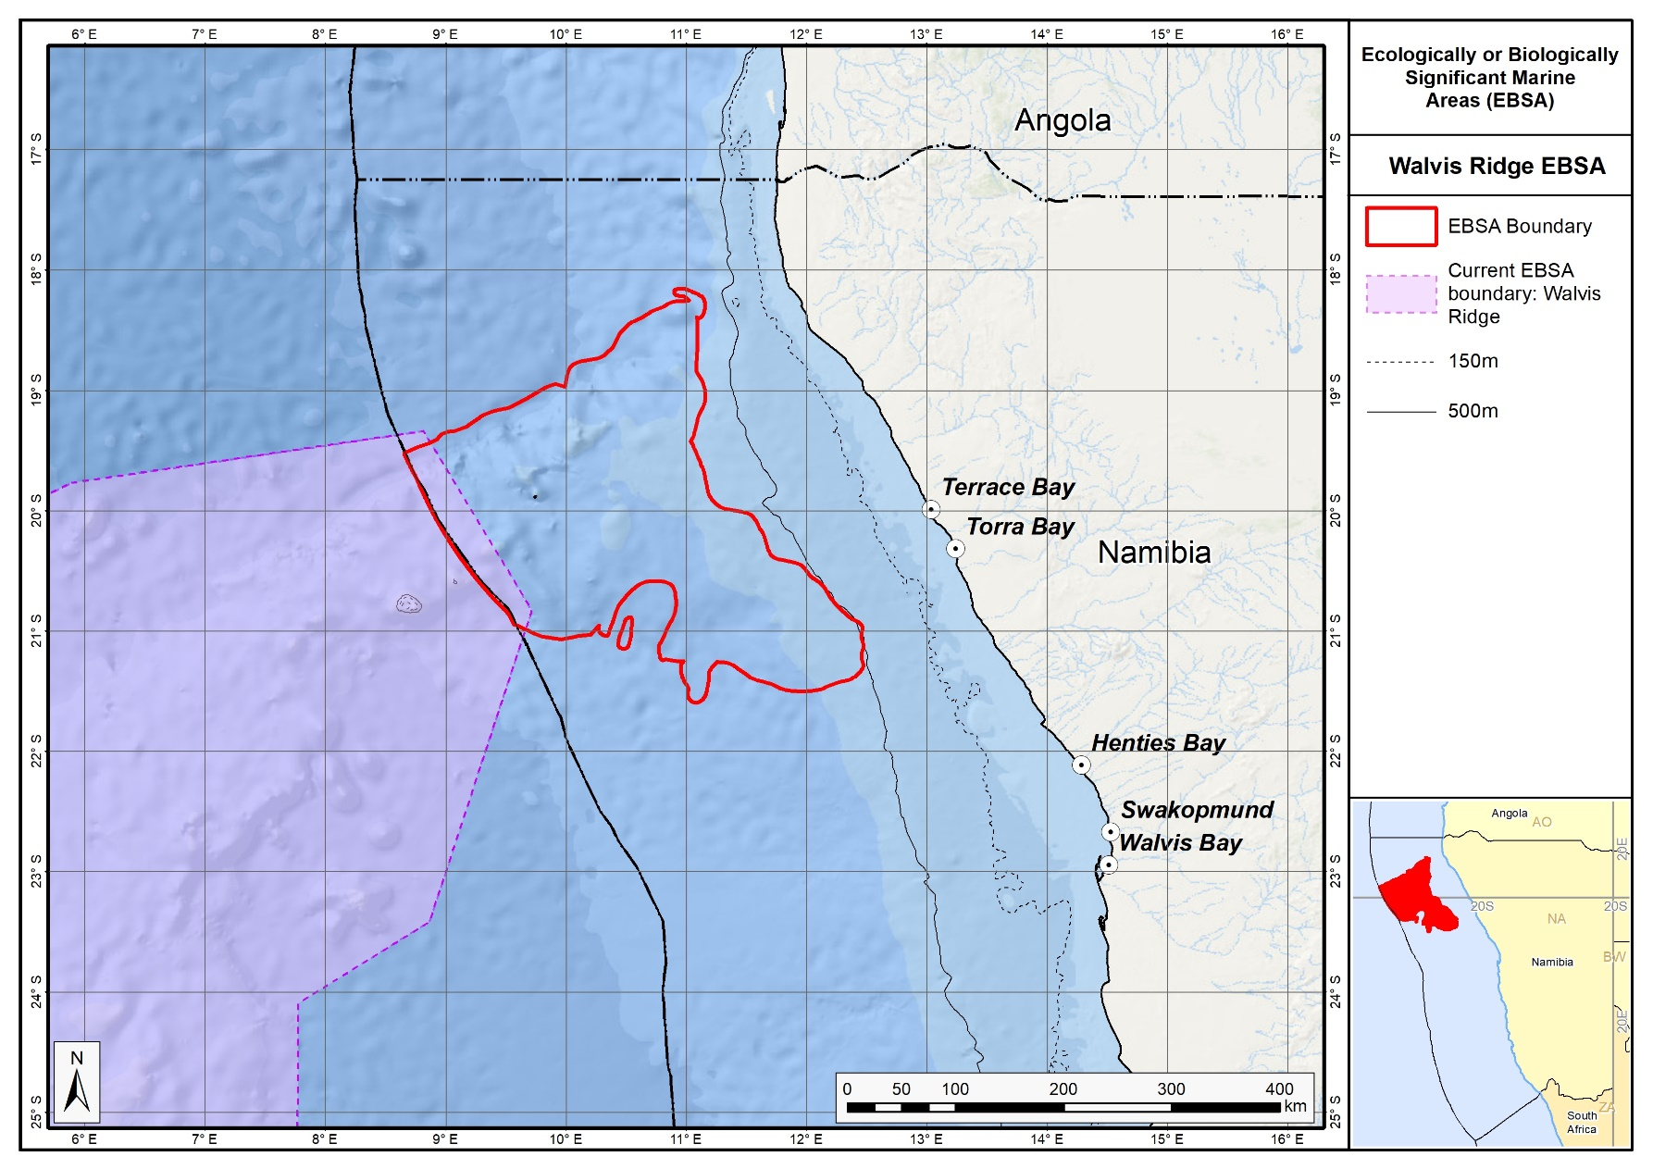

The proposed Walvis Ridge Namibia EBSA in relation to the existing high seas Walvis Ridge EBSA.

South Africa

Revised EBSAs

Namaqua Fossil Forest

Revised EBSA Description

General Information

Summary
The Namaqua Fossil Forest itself is a small (2 km²) seabed outcrop composed of fossilized yellowwood trees in the 136-140 m depth range, approximately 30 km offshore on the west coast of South Africa. The EBSA boundaries are larger at approximately 25 km by 35 km as this is necessary to accommodate likely extended area of the feature which is not precisely known. The fossilized tree trunks have been colonized by fragile, habitat-forming scleractinian corals, confirmed by images from submersible surveys. The outcrops are composed of laterally extensive slabs of rock of dimensions >5 x <1 x <0.5 m. Based on regional side scan sonar interpretations, the outcrop is believed to be unique to the area. The site is un-mined although it may fall within a current diamond mining lease area. Hard grounds have been reported north of the original fossil forest discovery, that are hypothesized to be part of this fossil forest. Further, a newly described habitat-forming sponge is present in the area (Samaai et al., 2017). In summary, the Namaqua Fossil Forest is a unique feature with substantial structural complexity that is highly vulnerable to benthic impacts.

Introduction of the area
The Namaqua Fossil Forest is a small (2 km²) seabed outcrop composed of fossilized yellowwood trees in the 136-140 m depth range on the middle shelf off the Namaqualand coast in South Africa. The EBSA boundaries are larger at approximately 25 km by 35 km as this is necessary to accommodate likely extended area of the feature which is not precisely known. The area is approximately 30 km offshore between Port Nolloth and Kleinsee. Fossilized tree trunks have been colonized by fragile, habitat-forming scleractinian corals. Based on regional side-scan sonar interpretations, the outcrop is believed to be unique to the area. Fragments of fossil tree trunks were, however, recovered from mined areas about 60 km away from this site but those fragments are no longer in-situ and were removed from the seabed. The site is within the productive southern Benguela ecosystem but there is no information on local-scale oceanography for this area.

Description of the location

EBSA Region
South-Eastern Atlantic

Description of location
This area occurs on the middle shelf in the 136-140 m depth range off the Namaqualand coast in South Africa. It is within the EEZ of South Africa.

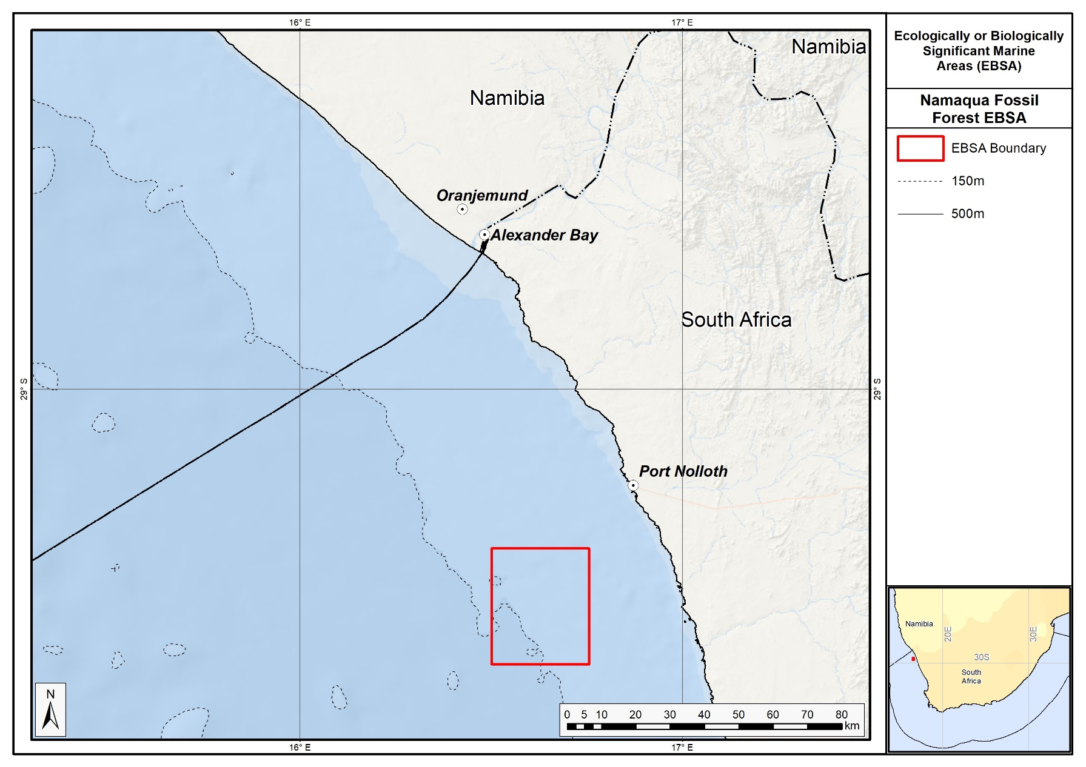

Proposed boundaries of the Namaqua Fossil Forest EBSA.

Area Details

Feature description of the area
This is a benthic feature composed of laterally extensive slabs of rock of lengths greater than 5 m and usually less than 1 m in width. The fossilized wood is reported to extend to 0.5 m in height although the geology of the broader area includes erosion-resistant, high-relief areas (up to 5 m) (Stevenson and Bamford 2003). The lithology has not been sampled directly, but is believed to be claystone. According to in-situ observations during submersible surveys, the fossilized wood has been colonized by scleractinian corals. Apparently, no biological sampling has been conducted previously at the site, with research activities being focused rather on the geology of the area. Two species of fossil wood were documented in the area, both from the Podocarpidae family; Podocarpus jago and P. umzambense, the former being a species described from this site (Bamford & Stevenson, 2002).

Since the original description and delineation of this EBSA, more recent surveys in the area have revealed hard grounds immediately north of the known location of the fossil forest, which are believed to be part of the same feature. Further, a newly described habitat-forming sponge has been recorded in the area (Samaai et al., 2017). Consequently, the boundary of the Namaqua Fossil Forest has been expanded to cover a broader area, which includes the delineation of a currently proposed MPA in South Africa. Although the boundary is still a geometric shape, the revision has improved the precision of the delineation by encompassing a more realistic representation of the full extent of the feature. More dedicated research in this area is required to refine the boundary further to the actual extent of the feature rather than this current approximation. Consequently, this site is presented as a Type 3 EBSA: Spatially stable features whose individual positions are not known (sensu Johnson et al., 2018).

Feature conditions and future outlook of the proposed area
The in-situ surveys of this unique site showed large, intact, fossilized tree trunks that support habitat-building corals and sponges. The site is considered to be unmined. It used to fall within a mining licence area (South African Sea Area MPT 25/2011 (in Concessions 5C and 4C)) where De Beers Consolidated Mines held a marine diamond mining right, which they have subsequently abandoned. Since then, Belton Park Trading 127 (Pty) Ltd have been granted Prospecting Rights for marine diamonds in Concessions 2C, 3C, 4C and 5C, which overlaps with this EBSA (in 4C and 5C). However, the Basic Assessment Report requires a 250 m “no-go” buffer around all known locations of fossilized yellowwood trees (CCA Environmental (Pty) Ltd, 2015). Currently, sampling operations have been undertaken in Concession 2C and 3C, but not near the EBSA (Andrea Pulfrich, pers. comm). There is no known future research planned for the area.

References
Bamford, M.K., Stevenson, I.R. 2002. A submerged Late Cretaceous Podocarpus Forest, West Coast, South Africa. South African Journal of Science, 98: 181-185.
CCA Environmental (Pty) Ltd. 2015. Marine Sediment Sampling Activities in Various Diamond Mining Concession Areas, West Coast, South Africa. Draft Basic Assessment Report. Prepared for: Department of Environmental Affairs, on behalf of: Belton Park Trading 127 (Pty) Ltd. IMD01PBA/DBAR/REV.0, 130 pp.
FAO, 2006. Management of Demersal Fisheries Resources of the Southern Indian Ocean. FAO Fisheries Circular No. 1020 FAO Rome 2006.
FAO, 2009. Annex F of the Report of the Technical Consultation on International Guidelines for the Management of Deepsea Fisheries in the High Seas. Rome, 4–8 February and 25-29 August 2008.
Holness, S., Kirkman, S., Samaai, T., Wolf, T., Sink, K., Majiedt, P., Nsiangango, S., Kainge, P., Kilongo, K., Kathena, J., Harris, L., Lagabrielle, E., Kirchner, C., Chalmers, R., Lombard, M. 2014. Spatial Biodiversity Assessment and Spatial Management, including Marine Protected Areas. Final report for the Benguela Current Commission project BEH 09-01.
Johnson, D.E., Barrio Froján, C., Turner, P.J., Weaver, P., Gunn, V., Dunn, D.C., Halpin, P., Bax, N.J., Dunstan, P.K., 2018. Reviewing the EBSA process: Improving on success. Marine Policy 88, 75-85.
Lagabrielle, E. 2009. Preliminary report: National Pelagic Bioregionalisation of South Africa. Cape Town: South African National Biodiversity Institute.
Rogers, A.D., Clark, M.R, Hall-Spencer, K.M., Gjerde, K.M. 2008. The Science behind the Guidelines: A Scientific Guide to the FAO Draft International Guidelines (December 2007) For the Management of Deep-Sea Fisheries in the High Seas and Examples of How the Guidelines May Be Practically Implemented. IUCN, Switzerland.
Samaai, T., Maduray, S., Janson, L., Gibbons, M.J., Ngwakum, B., Teske, P.R. 2017. A new species of habitat–forming Suberites (Porifera, Demospongiae, Suberitida) in the Benguela upwelling region (South Africa). Zootaxa: 4254, 49-81.
Sink, K., Holness, S., Harris, L., Majiedt, P., Atkinson, L., Robinson, T., Kirkman, S., Hutchings, L., Leslie, R., Lamberth, S., Kerwath, S., von der Heyden, S., Lombard, A., Attwood, C., Branch, G., Fairweather, T., Taljaard, S., Weerts, S., Cowley, P., Awad, A., Halpern, B., Grantham, H., Wolf T. 2012. National Biodiversity Assessment 2012: Technical Report. Volume 4: Marine and Coastal Component. South African National Biodiversity Institute, Pretoria.
Sink, K.J., van der Bank, M.G., Majiedt, P.A., Harris, L.R., Atkinson, L., Karenyi, N., Kirkman, S. (eds) 2019. National Biodiversity Assessment 2018 Technical Report Volume 4: Marine Realm. South African National Biodiversity Institute, Pretoria.
Sink, K.J., Wilkinson, S., Atkinson, L.J., Sims, P.F., Leslie, R.W., Attwood, C.G. 2012b. The potential impacts of South Africa’s demersal hake trawl fishery on benthic habitats: historical perspectives, spatial analyses, current review and potential management actions. Unpublished report. Cape Town: South African National Biodiversity Institute.
Stevenson, R., Bamford, M.K. 2003. Submersible-based observations of in-situ fossil tree trunks in Late Cretaceous seafloor outcrops, Orange Basin, western offshore, South Africa. South African Journal of Geology 106: 315-326.

Other relevant website address or attached documents
Summary of ecosystem types and threat status for Namqua Fossil Forest. Data from Sink et al. (2019).
Threat status | Ecosystem Type | Area (km²) | Area (%)
Least Concern | Namaqua Mid Shelf Rock Outcrops | 20.1 | 2.4
 | Namaqua Muddy Mid Shelf Mosaic | 331.2 | 39.8
 | Namaqua Sandy Mid Shelf | 230.0 | 27.7
 | Southern Benguela Muddy Sands | 250.3 | 30.1
Grand Total |  | 831.6 | 100.0

Assessment of the area against CBD EBSA criteria
C1: Uniqueness or rarity High
Justification
Based on regional side-scan sonar interpretations covering more than 2300 km² between the area offshore of Chamais Bay in Namibia and offshore of the Buffels River in South Africa, there are no other known in situ fossilized yellowwood forests in the region (Stevenson and Bamford 2003). Further, the published images of in situ habitat-building corals prove this site to be one of the few confirmed localities of in situ cold-water corals in the region (Stevenson and Bamford 2003). Other fragments of fossil tree trunks were recovered from test-mine areas north-west of the area that meets the EBSA criteria, but these were buried fragments (Stevenson and Bamford 2003).
C2: Special importance for life-history stages of species No information
Justification
Little is known about the biodiversity and ecology of this small area (Sink et al., 2012a).

C3: Importance for threatened, endangered or declining species and/or habitats No information
Justification
Little is known about the local-scale biodiversity and ecology of this small area (Sink et al., 2012a). However, at a national scale, the most recent map of ecosystem types indicates that there are four ecosystem types present in the area, all of which are Least Concern (Sink et al. 2019).

C4: Vulnerability, fragility, sensitivity, or slow recovery High
Justification
The fossilized wood, accompanying cold-water coral colonies, and habitat-forming sponges are considered vulnerable to any activities that could impact on the seabed (FAO 2006, Rogers et al., 2008, FAO 2009, Sink et al., 2012a,b).

C5: Biological productivity Medium
Justification
This small localized area is unlikely to be more or less productive than the area surrounding it, but it does occur within the productive Southern Benguela ecosystem (Lagabrille 2009, Sink et al., 2012a).

C6: Biological diversity No information
Justification
Little is known about the biodiversity and ecology of this small area (Sink et al., 2012a).

C7: Naturalness No information
Justification
It is unknown whether this area has been impacted by human activities. The area has some overlap with a diamond mining lease area but apparently, it has not yet been mined (Leslie Roos, De Beers, South Africa pers. comm.). There is currently no mining within this offshore diamond mining lease although the future of mining in the area is uncertain (Sink et al., 2011, 2012a). There is no known fishing activity within the site.

Status of submission
The Namaqua Fossil Forest was recognized as meeting EBSA criteria by the Conference of the Parties. The revised description and boundaries still need to be submitted to COP for approval.

COP Decision
dec-COP-12-DEC-22

End of proposed EBSA revised description

Motivation for Submission
A few technical revisions and updates to the description were made, even though little additional information was available. The boundaries were expanded based on new information from recent surveys in the adjacent area so that the new delineation now includes the likely full extent of the fossil outcrop. The new boundaries also include the extent of the proposed Namaqua Fossil Forest MPA, which also contains an adjacent unprotected inner shelf mud habitat type.

Research Needs
- Finer-scale revision of the EBSA would be possible if additional data on the core feature were available. This may require engagement with the lease-holder, and possible co-operative research to determine the actual extent of the fossil forest.
- Systematic biodiversity surveys and improved taxonomic information towards improved classification, and more comprehensive inventories of national biodiversity, especially for endemic and restricted-range species. A national fish atlas is recognised as a national research priority.
- Improved species information within MPAs (and EBSAs) is a recognised national research priority to assess efficacy of existing reserves in meeting biodiversity targets (especially for resource species). This could also inform reserve-network design (e.g., spacing and size of reserves to meet species’ requirements) and stock assessments.
- Species assessments within EBSAs to comprehensively list threatened species and ensure they are being adequately catered for in the MPA and EBSA networks.
- Genetic studies are a recognised research priority towards better understanding marine biodiversity and incorporating this aspect in biodiversity assessment, planning and reserve design.
- The new map of ecosystem types draws on several hundred survey points, but still needs effort to groundtruth the boundaries and monitor changes in ecosystem types as conditions change (especially in river-influenced areas where delivery of muds and other sediment through these conduits drives offshore ecosystem types).
- More ecological studies are required to better understand many of the offshore ecosystem types that are currently mapped, but poorly known. This includes their constituent biodiversity and ecology, ecological processes and ecosystem services.
- There has been substantial improvement of the shelf bathymetry (De Wet 2018); these efforts need to extend further down the slope to the edge of the EEZ such that the bathymetric features are better delineated and known. Even on the shelf, new features are being discovered through recent surveys. This dataset, recognised as a national research priority, could also inform the map of ecosystem types and allow improved precision in the boundaries.
- Long term monitoring programmes need to be established to facilitate early detection of invasive species and to track changes from global change (both climate change and other pressures as economic activities in the ocean intensify and diversify). EBSAs could serve as reference sites given that they are largely in good ecological condition (or at least better condition compared to surrounding areas) and where negotiations are underway to control activities in EBSAs. This could inform location of more sentinel sites in the South African Earth Observation Network array.
- Research on human impact mitigation is also recognised as a national research priority. In this regard, establishing and strengthening protection in EBSAs provides a notable research opportunity. As management regimes change within EBSAs, it is important to track recovery of sites following exclusion of key pressures in well-designed experiments (e.g., before-after, control-impact designs) to quantitatively determine the efficacy of improved management for coastal and marine biodiversity.
- Research to confirm ecological condition within EBSAs is also required.

Future Process
Inclusion of the area into the proposed Namaqua Fossil Forest MPA would secure the EBSA from harmful impacts such as those of mining or trawl fishing.

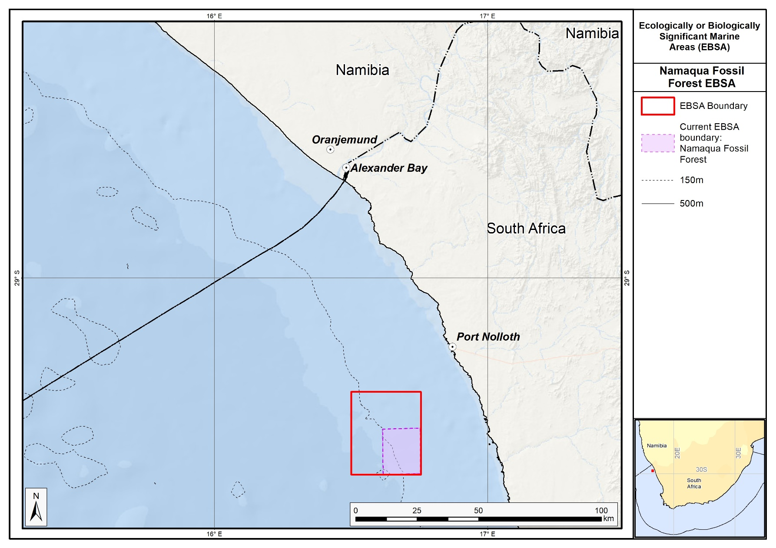
The proposed Namaqua Fossil Forest EBSA in relation to its original extent.

Childs Bank and Shelf Edge (Formerly Childs Bank)

Revised EBSA Description

General Information

Summary
Childs Bank and Shelf Edge is a unique submarine bank feature occurring within South Africa’s EEZ, rising from -400 m to -180 m on the western continental margin on South Africa. This area includes five benthic habitat types, including the bank itself, the outer shelf and the shelf edge, supporting hard and unconsolidated habitat types. Revision of the National Marine Ecosystem Type Map and associated ecosystem threat statuses (following IUCN guidelines) and EBSA boundaries is such that the area includes two Vulnerable and five Least Concern ecosystem types. The benthic area of the bank itself is also considered to be largely in Good ecological condition indicating that the ecological patterns and processes are intact. Childs Bank and associated habitats are known to support structurally complex cold-water corals, hydrocorals, gorgonians and glass sponges; species that are particularly fragile, sensitive and vulernable to disturbance, and recover slowly. The Childs Bank and Shelf Edge area is highly relevant in terms of the following EBSA criteria: “Uniqueness or rarity”, “Vulnerability, fragility, sensitivity or slow recovery” and “Naturalness”. Since its original description, the boundary of this EBSA has been refined to improve precision based on new bathymetry data, ecosystem information (condition and threat status of local benthic and pelagic ecosystem types, and presence of key features including fragile species), and to align with current MPA expansion initiatives.

Introduction of the area
Childs Bank is the only known submarine bank in South Africa. It’s a rugged limestone feature found on the shelf, close to the shelf edge, on the western continental margin of South Africa, approximately 125 km offshore. It rises from a depth of -260 m in the east, -350 m in the west, to form a large, flattened plateau at -200 m (De Wet 2012). The margins of the bank slope gently on the north, east and south sides, but the western edge is a slump-generated outer face of 150 m in height that lies at the edge of the continental shelf, dropping steeply from -350 to -1500 m across a short distance of <60 km (De Wet 2012; Birch and Rogers 1973). The bank area has been estimated to cover 1450 km² (Sink et al., 2012a). The EBSA includes Childs Bank, the shelf and the shelf edge adjacent to the bank, the latter of which is considered likely to host vulnerable hard ground species. The sediment adjacent to the bank is predominantly fine sand with approximately 25% mud, and in some locations small amounts of gravel have been detected (Atkinson 2010). This area was identified as a priority area for protection through two planning studies identifying areas for offshore protection (Sink et al., 2011, Majiedt et al., 2013). Benthic protection in the region of Childs Bank and Shelf Edge would ensure protection of the only submarine bank within South Africa’s EEZ, some protection of the adjacent shelf edge and protection of areas where coral records have been detected.

Description of the location

EBSA Region
South-Eastern Atlantic

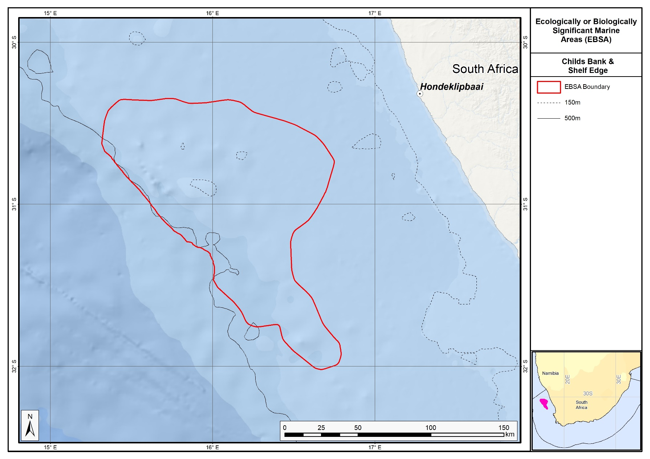

Proposed boundaries of the Childs Bank and Shelf Edge EBSA.

Description of location
The Childs Bank and Shelf Edge area is located approximately 125 km off Hondeklipbaai on the west coast of South Africa, with its northern edge about 90 km from national border with Namibia. It lies entirely within South Africa’s national jurisdiction, largely on the outer shelf but also extending across the shelf edge and slope in some places.

Feature description of the area
Childs Bank is a unique offshore submarine bank habitat type within South Africa’s EEZ, defined as the Southern Benguela Submarine Bank (Sink et al., 2012a). No other known submarine banks occur within South Africa’s EEZ. This EBSA comprises seven ecosystem types, two of which are Vulnerable (Childs Bank Coral Slope, Southern Benguela Sandy Shelf Edge), the rest of which are Least Concern (Childs Bank Plateau and Sandy Slope, Southern Benguela Hard Shelf Edge Mosaic, Southern Benguela Muddy Sands, Southern Benguela Outer Shelf Rocky Sand Mosaic, Southern Benguela Sandy Outer Shelf; Sink et al., 2019). 37% of the Childs Bank and Shelf Edge slopes are trawled (Sink et al., 2012b), highlighting the importance of this site for marine living resources. However, there are several very fragile, vulnerable and sensitive species present in the area. Hydrocorals (e.g. Stylaster sp.), cold-water coral fragments, gorgonians (Acbaria rubra) and glass sponges (Rossella antarctica) were sampled at a virtually untrawled site adjacent to Childs Bank (Atkinson 2010; see also Gilchrist 1922, 1925, Van Bonde 1928, Atkinson et al., 2011). Further, skippers and deck hands from the trawl industry report fragments of corals sometimes caught in isolated locations in this area and that there are several patches of hard ground, requiring additional footrope protection (e.g., bobbins and rockhopper gear, Sink et al., 2012b).
The shelf edge area adjacent to Childs Bank is also a biodiversity hotspot for demersal fish and cephalopods in the southern Benguela (Kirkman et al., 2013). Benthic communities sampled adjacent to the Childs Bank mound revealed high abundance and biomass of benthic infauna and epifauna (Atkinson 2010, Atkinson et al., 2011), indicating that a rich benthic fauna occurs in this region. Two species of burrowing urchins (Spatangus capensis and Brissopsis lyrifera capensis) and a burrowing anemone species (Actinauge granulosus) were detected in high abundances in the Childs Bank and Shelf Edge region, contributing to the bioturbation and oxygenation of sediment, important ecological functions.
The boundary of this EBSA has been refined since its original delineation to improve precision based on new information. The new delineation was based on new bathymetry data, new ecosystem information (site selection frequency in two systematic conservation plans covering the area to meet biodiversity targets, the condition and threat status of the local benthic and pelagic ecosystem types, key features including the bank itself and associated fragile species), and focus areas for MPA expansion in South Africa. The new boundary comprises about two thirds of the original EBSA area and falls mostly within the previous delineation, except for a protrusion along the south east edge. It is presented as a Type 2 EBSA because it contains “spatially stable features whose individual positions are known, but a number of individual cases are being grouped” (sensu Johnson et al., 2018).

Feature conditions and future outlook of the proposed area
Childs Bank and Shelf Edge is currently in Good ecosystem condition, based on cumulative impact scores from multiple anthropogenic pressures (Sink et al., 2012a; Sink et al., 2019). Good-condition sites are those which, based on the low levels of pressure, are expected have both biodiversity pattern and process largely intact and hence can be considered to be in a largely "natural" or "pristine" state. However, the area south and towards the shelf edge of Childs Bank were categorized as Fair and Poor, indicating that there is some impact on biodiversity pattern and/or ecological processes in a small component of the broader area (Sink et al., 2012a; Sink et al., 2019).
The trawl fishing intensity in the northern region of the fishing grounds, including Childs Bank and Shelf Edge, has declined since the mid-1990s (Russell Hall, Sea Harvest pers. comm.), and it is unlikely that this region was as intensively fished as the western grounds, closer to the port of Cape Town. No trawling occurs on the top of the bank, with most fishing taking place around the slope where hard ground, supporting vulnerable habitat-forming species, is most likely to occur. There is scope to protect this feature with limited, if any, adverse impact on the fishery (Sink et al., 2012b).

References
Atkinson, L.J. 2010. Effects of demersal trawling on marine infaunal, epifaunal and fish assemblages: studies in the southern Benguela and Oslofjord. PhD dissertation, University of Cape Town pp. 141.
Atkinson, L.J., Field, J.G., Hutchings, L. 2011. Effects of demersal trawling along the west coast of southern Africa: multivariate analysis of benthic assemblages. Marine Ecology Progress Series: 430:241- 244. doi:10.3354/meps08956.
Birch, G.F., Rogers J. 1973. Nature of the sea floor between Luderitz and Port Elizabeth. South African Shipping News and Fishing Industry Review 18(7): 1-7.
Camhi, M.D., Valenti, S.V., Fordham, S.V., Fowler, S.L., Gibson, C. 2009. The Conservation Status of Pelagic Sharks and Rays: Report of the IUCN Shark Specialist Group Pelagic Shark Red List Workshop. IUCN Species Survival Commission Shark Specialist Group. Newbury, UK. x + 78 p.
De Wet, W. 2012. Bathymetry of the South African Continental Shelf. MSc dissertation. University of Cape Town, South Africa.
FAO, 2006. Management of Demersal Fisheries Resources of the Southern Indian Ocean. FAO Fisheries Circular No. 1020 FAO Rome 2006.
FAO, 2009. Annex F of the Report of the Technical Consultation on International Guidelines for the Management of Deepsea Fisheries in the High Seas. Rome, 4–8 February and 25-29 August 2008.
Gilchrist, J.D.F. 1925. List of fishes, etc., procured. Annexure A in Report of the Fisheries and Marine Biological Survey for the period June, 1923 – June, 1925 4: xxiii-xliii.
Holness, S., Kirkman, S., Samaai, T., Wolf, T., Sink, K., Majiedt, P., Nsiangango, S., Kainge, P., Kilongo, K., Kathena, J., Harris, L., Lagabrielle, E., Kirchner, C., Chalmers, R., Lombard, M. 2014. Spatial Biodiversity Assessment and Spatial Management, including Marine Protected Areas. Final report for the Benguela Current Commission project BEH 09-01.
Johnson, D.E., Barrio Froján, C., Turner, P.J., Weaver, P., Gunn, V., Dunn, D.C., Halpin, P., Bax, N.J., Dunstan, P.K., 2018. Reviewing the EBSA process: Improving on success. Marine Policy 88, 75-85.
Kirkman, S.P., Yemane, D., Kathena, J., Mafwila, S., Nsiangango, S., Samaai, T., Axelsen, B., Singh, L. 2013. Identifying and characterizing of demersal biodiversity hotspots in the BCLME: Relevance in the light of global changes. ICES Journal of Marine Science, 70: 943–954.
Lagabrielle, E. 2009. Preliminary report: National Pelagic Bioregionalisation of South Africa. Cape Town: South African National Biodiversity Institute.
Majiedt, P., Holness, S., Sink, K., Oosthuizen, A., Chadwick, P. 2013. Systematic Marine Biodiversity Plan for the West Coast of South Africa. South African National Biodiversity Institute, Cape Town.
Roberson, L.A., Lagabrielle, E., Lombard, A.T., Sink, K., Livingstone, T., Grantham, H., Harris, J.M. 2017. Pelagic bioregionalisation using open-access data for better planning of marine protected area networks. Ocean & Coastal Management, 148: 214-230.
Rogers, A.D., Clark, M.R, Hall-Spencer, K.M., Gjerde K.M. 2008. The Science behind the Guidelines: A Scientific Guide to the FAO Draft International Guidelines (December 2007) For the Management of Deep-Sea Fisheries in the High Seas and Examples of How the Guidelines May Be Practically Implemented. IUCN, Switzerland.
Sink, K.J., Attwood, C.G., Lombard, A.T., Grantham, H., Leslie, R., Samaai, T., Kerwath, S., Majiedt, P., Fairweather, T., Hutchings, L., van der Lingen, C., Atkinson, L.J., Wilkinson, S., Holness, S., Wolf, T. 2011. Spatial planning to identify focus areas for offshore biodiversity protection in South Africa. Unpublished Report. Cape Town: South African National Biodiversity Institute.
Sink, K., Holness, S., Harris, L., Majiedt, P., Atkinson, L., Robinson, T., Kirkman, S., Hutchings, L., Leslie, R., Lamberth, S., Kerwath, S., von der Heyden, S., Lombard, A., Attwood, C., Branch, G., Fairweather, T., Taljaard, S., Weerts, S., Cowley, P., Awad, A., Halpern, B., Grantham, H., Wolf, T. 2012a. National Biodiversity Assessment 2011: Technical Report. Volume 4: Marine and Coastal Component. South African National Biodiversity Institute, Pretoria.
Sink, K.J., van der Bank, M.G., Majiedt, P.A., Harris, L.R., Atkinson, L., Karenyi, N., Kirkman, S. (eds) 2019. National Biodiversity Assessment 2018 Technical Report Volume 4: Marine Realm. South African National Biodiversity Institute, Pretoria.
Sink, K.J., Wilkinson, S., Atkinson, L.J., Sims, P.F., Leslie, R.W., Attwood, C.G. 2012b. The potential impacts of South Africa’s demersal hake trawl fishery on benthic habitats: historical perspectives, spatial analyses, current review and potential management actions. Unpublished report. Cape Town: South African National Biodiversity Institute.

Other relevant website address or attached documents
Summary of habitat types and threat status for Childs Bank and Shelf Edge EBSA. Data from Sink et al. (2019).
Threat Status | Ecosystem Type | Area (km²) | Area (%)
Vulnerable | Childs Bank Coral Slope | 505.5 | 3.7
 | Southern Benguela Sandy Shelf Edge | 2221.6 | 16.4
Least Concern | Childs Bank Plateau & Sandy Slope | 1620.3 | 11.9
 | Southern Benguela Hard Shelf Edge Mosaic | 1497.7 | 11.0
 | Southern Benguela Muddy Sands | 9.7 | 0.1
 | Southern Benguela Outer Shelf Rocky Sand Mosaic | 5989.2 | 44.1
 | Southern Benguela Sandy Outer Shelf | 1742.8 | 12.8
Grand Total |  | 13586.7 | 100.0

Assessment of the area against CBD EBSA criteria
C1: Uniqueness or rarity High
Justification
The Childs Bank submarine mound is the only such feature known to occur within South Africa’s EEZ and therefore represents a unique feature in this region (Sink et al., 2011, Sink et al., 2012, Majiedt et al., 2013). The selection of this area in a systematic biodiversity plan for the South African west coast is driven by the uniqueness of the site and reduced cost values (few anthropogenic pressures) in the area (Majiedt et al., 2013).
C2: Special importance for life-history stages of species Low
Justification
There is no evidence to suggest that the Childs Bank and Shelf Edge area is of special importance for life history stages of particular species or populations; however, the habitat type is a unique feature within South Africa’s EEZ, and it is possible it may support key ecological processes that are, as yet, unstudied (Sink et al., 2011). Tuna fishers report that this area is a feeding area for tuna (Sink et al., 2011).
C3: Importance for threatened, endangered or declining species and/or habitats Medium
Justification
There are two threatened habitat types in Childs Bank and Shelf Edge: the Vulnerable Childs Bank Coral Slope and Southern Benguela Sandy Shelf Edge ecosystem types (Sink et al., 2019). This area also has some importance for declining species. Some long-lived pelagic species (e.g., blue shark (IUCN Near Threatened) and mako shark (IUCN Vulnerable)) are also caught in fair numbers (~15% of total Atlantic catch) around Childs Bank (DAFF Linefish Section). Populations of these species are believed to be in global decline (Camhi et al., 2009).
C4: Vulnerability, fragility, sensitivity, or slow recovery High
Justification
This area has hard ground habitats on the outer shelf and shelf edge that are considered sensitive to demersal trawling and mining (FAO 2006, FAO 2009, Rogers et al., 2008, Sink et al., 2011, 2012a, 2012b). Samples of cold-water corals, sponges and gorgonians have been reported from this area (Gilchrist 1922, Von Bonde 1928 and Atkinson 2010, 2011) and more recently, skippers and deck hands from commercial trawl vessels have indicated occurrences of such species in their nets when fishing in this area (Sink et al., 2012b).
C5: Biological productivity Low
Justification
Fine-scale variability within this area has not been examined but this area falls within the highly productive shelf area of the Benguela upwelling region (Lagabrielle 2009, Sink et al., 2011, Roberson et al., 2017).
C6: Biological diversity Medium
Justification
This area is considered to host high levels of biodiversity, e.g., infauna and epifauna (Atkinson 2010, Atkinson et al., 2011), demersal fish and cephalopods (Kirkman et al., 2013) and fragile and sensitive habitat-forming species.
C7: Naturalness High
Justification
Childs Bank and Shelf Edge is in “Good” ecological condition, based on cumulative impact scores from multiple anthropogenic pressures (Sink et al., 2012a, Sink et al., 2019). This suggests that, based on the low levels of pressure, the site is expected have both biodiversity pattern and process largely intact and hence can be considered to be in a largely "natural" or "pristine" state.

Status of submission
The Childs Bank EBSA was recognized as meeting EBSA criteria by the Conference of the Parties. The revised name, description and boundaries still need to be submitted to COP for approval.

COP Decision
dec-COP-12-DEC-22
End of proposed EBSA revised description

Motivation for Submission
Some technical revisions and updates to the description were made, even though little additional information was available. Small additions, such as biodiversity information from OBIS were made, but none of these edits were significant enough to drive a change in the EBSA criteria ranks. A supplementary table of the habitats represented in the EBSA and their associated threat status were also included.
The boundary of this EBSA has been refined to more closely focus the EBSA on the key biodiversity features that underlie its EBSA status. The delineation process included an initial stakeholder review, a technical mapping process and then an expert review workshop where boundary delineation options were finalised. The delineation process used a combination of Systematic Conservation Planning and Multi-Criteria Analysis methods. The features used in the analysis were:
- Delineations and threat status of consitituent ecosystem types in the area were included in the analysis and used to refine the boundary of the EBSA.
- Irreplaceable and near irreplaceable (i.e. very high selection frequency) sites, as well as focus areas identified in the SCP undertaken for the BCLME by Holness et al. (2014) and Majiedt et al. (2013) were incorporated. In addition, focus areas for marine protection identified by Sink et al. (2011) were included.
- Key physical features such as the carbonate mound from the National Biodiversity Assessment 2011 (Sink et al., 2011) and BCC spatial mapping project (Holness et al., 2014) were incorporated. These data were refined using the latest GEBCO data and global benthic geomorphology mapping (www.bluehabitats.org, Harris et al., 2014).
- Areas of high relative naturalness identified in the National Biodiversity Assessment 2011 (Sink et al., 2011), the West Coast (Majiedt et al., 2013) and the BCLME spatial assessments (Holness et al., 2014) were included in the analysis. Both pelagic and benthic and coastal condition were incorporated.
- Distributions of known fragile, vulnerable and sensitive habitat-forming species were included (Unpublished SANBI and SAEON data).
The multi-criteria analysis resulted in a value surface. The cut-off value used to determine the extent of the EBSA was based on expert input and quantitative analysis of effective inclusion of the above features. This entailed taking an iterative parameter calibration-based approach whereby the spatial efficiency of the inclusion of the targeted features was evaluated. The approach aimed to identify a cut-off which most efficiently included prioritised features while minimizing the inclusion of impacted areas. The final boundaries shown in the map were validated in a national workshop. The new boundary comprises about two thirds of the original EBSA area and falls mostly within the previous delineation, except for a protrusion along the south east edge.

Research Needs
This item will be populated in a workshop to be held in August/September 2018.

Future Process
Portions of the EBSA have been gazetted for inclusion into the proposed Childs Bank MPA. It is unclear if this EBSA will be subject to detailed attention in the MARISMA EBSA status assessment and management options workplan. This will be decided on in a workshop to be held in August/September 2018.

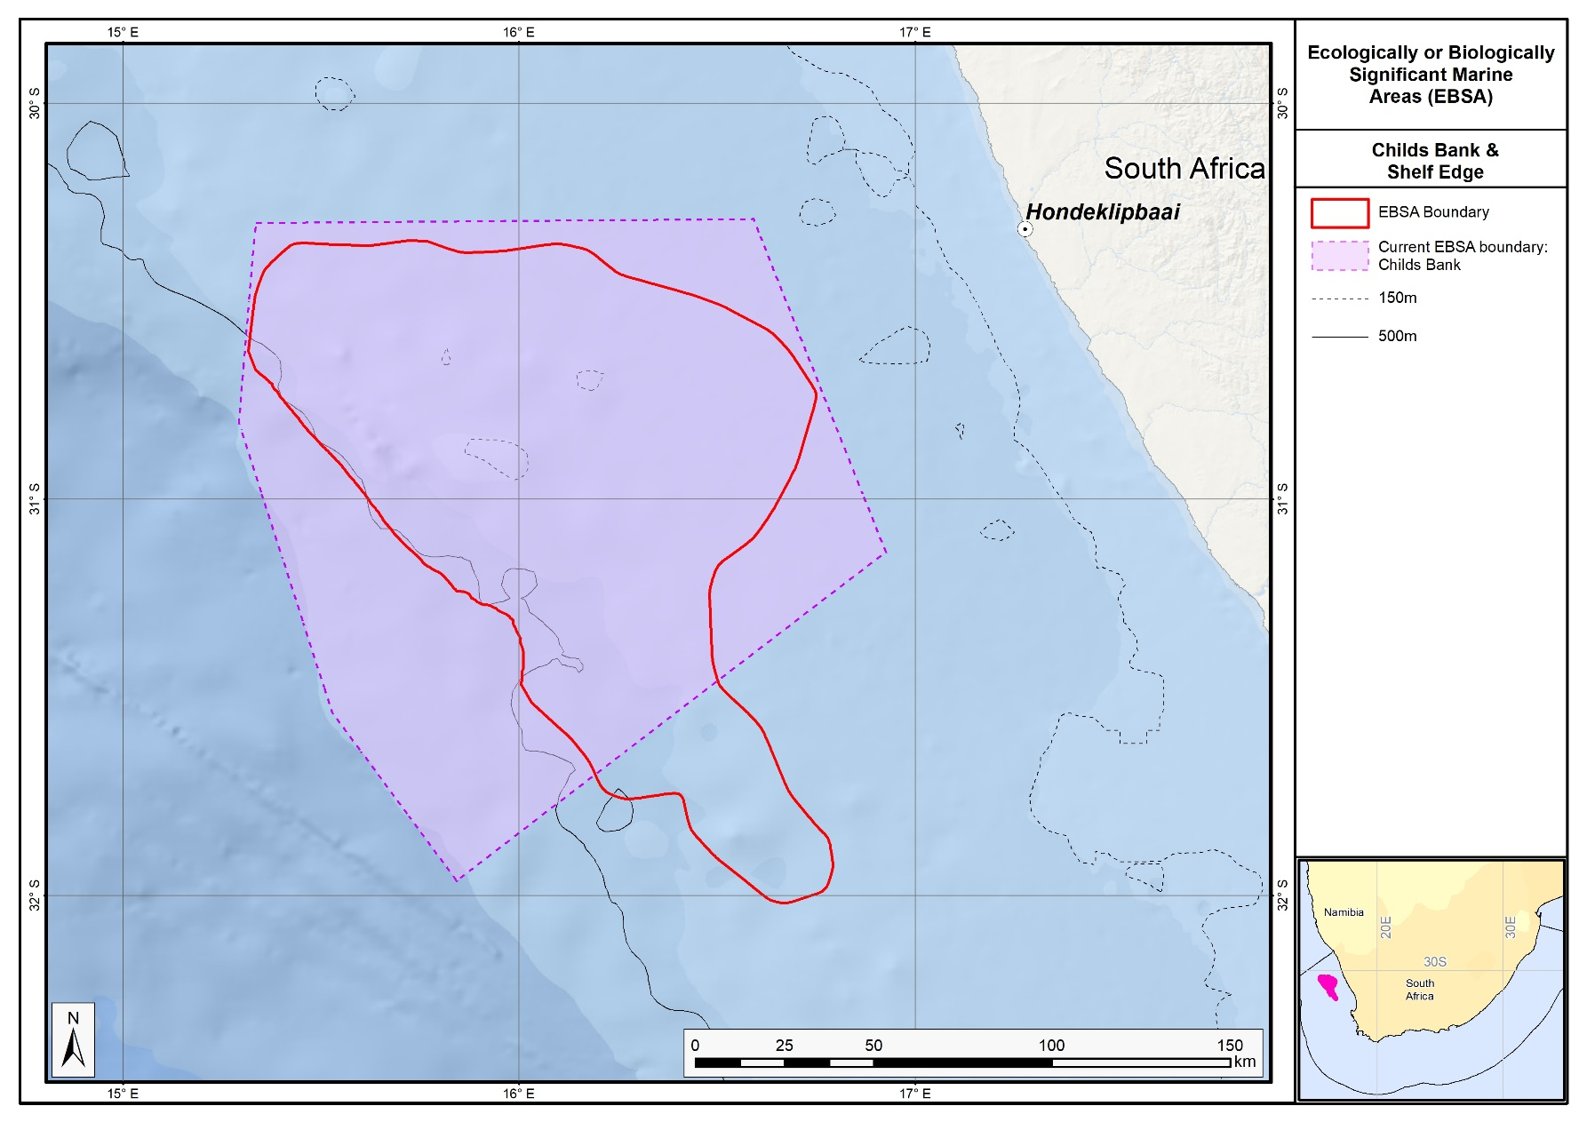
The proposed revised boundaries for the Childs Bank and Shelf Edge EBSA in relation to the original boundaries of the Childs Bank EBSA.

Namaqua Coastal Area

Revised EBSA Description

General Information

Summary
The Namaqua coastal area is on the west coast of South Africa, within the Namaqua bioregion, and is characterized by high productivity and community biomass along its shores. A large proportion of the area is characterized by habitat that is in relatively good (natural/pristine) condition due to much lower levels of anthropogenic pressures relative to other coastal areas in the Northern Province. Consequently, the area is important for several threatened ecoystem types represented there (including two Endangered and four Vulnerable ecosystem types). The area is also important for conservation of estuarine areas and coastal fish species. In summary, the area is highly relevant in terms of the following EBSA criteria: “productivity”, “importance for threatened, endangered or declining species and/or habitats” and “naturalness”. Since its original delineation, the boundary of this EBSA has been extended further offshore by approximately 7-20 km to better align with the underlying biodiversity features following recent research, rather than following an old proposed MPA boundary that was not adopted nor proclaimed.

Introduction of the area
The Namaqua coastal area is located from the estuary of the Spoeg River to the estuary of the Sout River in the Namaqua biogeographic region (bioregion) of South Africa (Sink et al., 2012), and from the dune base to approximately 33-36 km offshore. It consists of Namaqua coastal, inner, middle and outer shelf ecosystem types (Sink et al., 2019). The associated pelagic environment is characterized by upwelling, giving rise to very cold waters with very high productivity/chlorophyll levels (Lagabrielle 2009, Roberson et al., 2017). Altogether, the area includes three estuaries (van Niekerk and Turpie, 2012).

Description of the location

EBSA Region
South-Eastern Atlantic

Description of location
The area is within the national jurisdiction of South Africa, occurring on the west coast, in the Namaqua bioregion. It is bounded to the north and south by the Spoeg and the Sout estuaries, respectively, extending offshore by approximately 33-36 km.

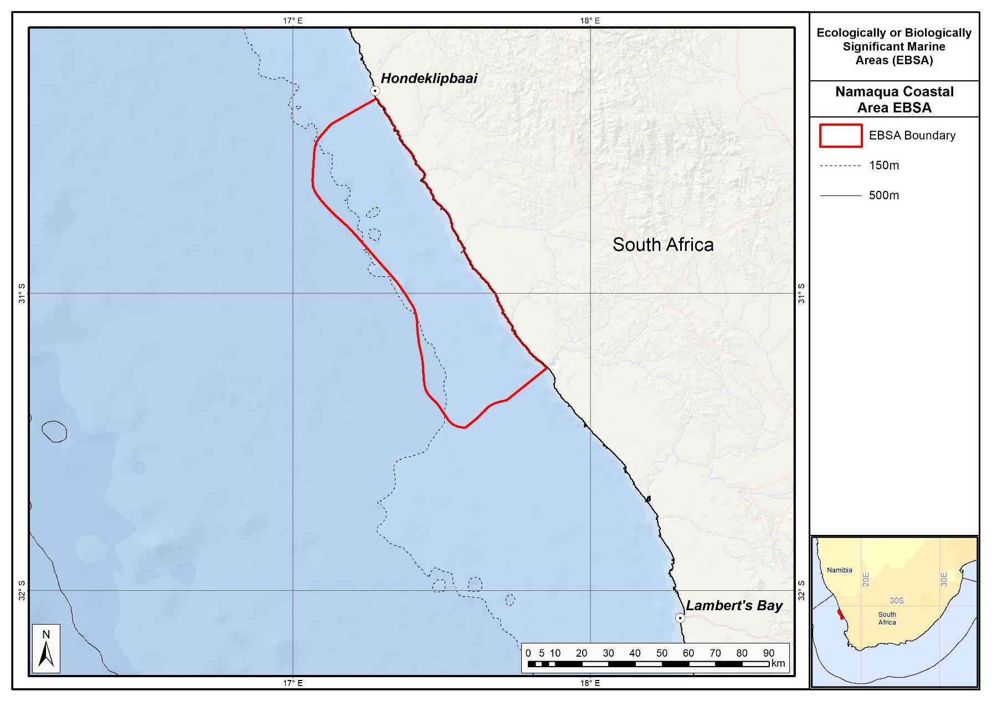
Proposed boundaries of the Namaqua Coastal Area EBSA.

Area Details

Feature description of the area
The area consists of Namaqua coastal, inner, middle and outer shelf ecosystem types (Sink et al., 2019). There are also three estuaries in the area (van Niekerk and Turpie 2011). The associated pelagic environment is characterized by very high productivity, high chlorophyll and very cold water (SST mean = 15.2°C) caused by upwelling (Lagabrielle 2009, Roberson et al., 2017), also serving as an important area for coastal fish (Turpie et al., 2000). Currently the area is unprotected, although the terrestrial habitat adjacent to that part of the area that stretches between two of the river estuaries (the Groen and the Spoeg), is within the Namaqua National Park and is therefore protected. There is also a small MPA in the middle of the EBSA that has been announced, and is in the process of being proclaimed and implemented.
Since original description, the EBSA has been extended offshore by approximately 7-20 km so that the new offshore extent is 36 km at its widest point. The alongshore extent remains the same as before between the Spoeg and Sout estuaries. The extension was based on better alignment with the features comprising the EBSA, and their condition and threat status. This was based on new research (Karenyi 2014) that has allowed better ecosystem mapping in the area, thus affording more precision in the EBSA boundary rather than following an old proposed MPA boundary that was not adopted. The site is presented as a Type 1 EBSA because it contains “Spatially stable features whose positions are known and individually resolved on the maps” (sensu Johnson et al., 2018).

Feature conditions and future outlook of the proposed area
Sink et al. (2012, 2019) estimated the threat status of marine and coastal habitat types identified for South Africa by assessing the (weighted) cumulative impacts of various pressures (e.g., extractive resource use, pollution, development, and others) on each habitat type. Six of the ecosystem types represented in the area are threatened, including two Endangered (Cool Temperate Arid Predominantly Closed Estuary; Southern Benguela Reflective Sandy Shore) and four Vulnerable types (Namaqua Exposed Rocky Shore; Namaqua Kelp Forest; Namaqua Mixed Shore; Namaqua Very Exposed Rocky Shore; Southern Benguela Intermediate Sandy Shore). This implies that there has been substantial degradation in natural/pristine condition of these ecosystem types, and it is expected that important components of biodiversity pattern have been lost and that ecological processes have been moderately to heavily modified.

Part of the coastal extent of the area (between the Brak and Sout rivers) is the only stretch of coast in the Northern Cape province of South Africa that is in good (natural/pristine) condition (Sink et al., 2012). This is because very little mining (the most prominent anthropogenic pressure on this coastline) or other pressures have affected this section. Moreover, other habitat in the area (particularly that between the Spoeg and Groen rivers) was assessed to be mainly in fair condition, with little industry present in the area except for some boat-based mining for which SCUBA is used (Majiedt et al., 2013). Of the three estuaries in the area, two (the Groen and the Spoeg) have been identified as national priorities for estuarine protection (van Niekerk and Turpie 2012). The lack of marine protected areas in South Africa’s Northern Cape province has been highlighted as an issue of concern (Sink et al., 2012, Majiedt et al., 2013), but is being addressed. Considering this and the following characteristics of the area: (i) the threatened habitat types represented there, (ii) the relative lack of human industry and consequently the good condition of much of the habitat in the area, (iii) the connectivity between part of the area and an established terrestrial national park, and (iv) the priority for national estuarine conservation of two of the river mouths in the area, most of the extent of the area has been identified as priority marine/coastal habitat for spatial protection (Sink et al., 2012, Majiedt et al., 2013). Furthermore, a complementarity analysis based on fish distribution data indicated that the coast within the area is a priority area for the conservation of coastal fish species in South Africa (Turpie et al., 2000).

References
Bustamante, R.H., Branch, G.M. 1996. Large scale patterns and trophic structure of southern African rocky shores. The roles of geographic variation and wave exposure. Journal of Biogeography 23: 339-351.
Crawford, R.J.M., Randall, R.M., Whittington, P.A., Waller, L., Dyer, B.M., Allan, D.G., Fox, C., Martin, A.P., Upfold, L., Visagie, J., Bachoo, S., Bowker, M., Downs, C.T., Fox, R., Huisamen, J., Makhado, A.B., Oosthuizen, W.H., Ryan, P.G., Taylor R.H., Turpie, J.K. 2013. South Africa's coastal-breeding white-breasted cormorants: population trends, breeding season and movements, and diet. African Journal of Marine Science, 35: 473-490.
Holness, S., Kirkman, S., Samaai, T., Wolf, T., Sink, K., Majiedt, P., Nsiangango, S., Kainge, P., Kilongo, K., Kathena, J., Harris, L., Lagabrielle, E., Kirchner, C., Chalmers, R., Lombard, M. 2014. Spatial Biodiversity Assessment and Spatial Management, including Marine Protected Areas. Final report for the Benguela Current Commission project BEH 09-01.
Hutchings, L., van der Lingen, C.D., Griffiths, M., Roberts, M.R., Beckley, L.E., Sundby, S. 2002. Spawning on the edge: spawning grounds and nursery areas around the South African coast. Marine and Freshwater Research, 53: 307–318.
Hutchings, L., van der Lingen, C.D., Shannon, L.J., Crawford, R.J.M., Verheye, H.M.S., Bartholomae, C.H., van der Plas, A.K., Louw, D., Kreiner, A., Ostrowski, M., Fidel, Q., Barlow, R.G., Lamont, T., Cotzee, J., Shillington, F., Veitch, J., Currie, J.C., Monteiro, P.M.S. 2009. The Benguela Current: An ecosystem of four components. Progress in Oceanography, 83: 15 – 32.
Johnson, D.E., Barrio Froján, C., Turner, P.J., Weaver, P., Gunn, V., Dunn, D.C., Halpin, P., Bax, N.J., Dunstan, P.K., 2018. Reviewing the EBSA process: Improving on success. Marine Policy 88, 75-85.
Karenyi, N. 2014. Patterns and drivers of benthic macrofauna to support systematic conservation planning for marine unconsolidated sediment ecosystems. PhD thesis. Nelson Mandela Metropolitan University, Port Elizabeth.
Lagabrielle, E. 2009. Preliminary report: National Pelagic Bioregionalisation of South Africa. Cape Town: South African National Biodiversity Institute.
Majiedt, P., Holness, S., Sink, K., Oosthuizen, A., Chadwick, P. 2013. Systematic Marine Biodiversity Plan for the West Coast of South Africa. South African National Biodiversity Institute, Cape Town.
Mann, B.Q. 2000. Status Reports for Key Linefish Species. Durban: Oceanographic Research Institute Special Publication.
Rao, A.S., Hockey, P.A.R., Montevecchi, W.A. 2014. Coastal Dispersal by Pre-Breeding African Black Oystercatchers Haematopus Moquini. Marine Ornithology, 42: 105–112.
Roberson, L.A., Lagabrielle, E., Lombard, A.T., Sink, K., Livingstone, T., Grantham, H., Harris, J.M. 2017. Pelagic bioregionalisation using open-access data for better planning of marine protected area networks. Ocean & Coastal Management, 148: 214-230.
Sink, K., Holness, S., Harris, L., Majiedt, P., Atkinson, L., Robinson, T., Kirkman, S., Hutchings, L., Leslie, R., Lamberth, S., Kerwath, S., von der Heyden, S., Lombard, A., Attwood, C., Branch, G., Fairweather, T., Taljaard, S., Weerts, S., Cowley, P., Awad, A., Halpern, B., Grantham, H., Wolf, T. 2012. National Biodiversity Assessment 2011: Technical Report. Volume 4: Marine and Coastal Component. South African National Biodiversity Institute, Pretoria.
Sink, K.J., van der Bank, M.G., Majiedt, P.A., Harris, L.R., Atkinson, L., Karenyi, N., Kirkman, S. (eds) 2019. National Biodiversity Assessment 2018 Technical Report Volume 4: Marine Realm. South African National Biodiversity Institute, Pretoria.
Turpie, J.K., Beckley, L.E., Katua, S.M. 2000. Biogeography and the selection of priority areas for conservation of South African coastal fishes. Biological Conservation, 92: 59–72.
Van Niekerk, L., Turpie, J.K. (eds). 2012. South African National Biodiversity Assessment 2011: Technical Report. Volume 3: Estuary Component. CSIR Report Number CSIR/NRE/ECOS/ER/2011/0045/B. Council for Scientific and Industrial Research, Stellenbosch.

Other relevant website address or attached documents
Summary of habitat types and threat status for the Namaqua Coastal Area. Data from Sink et al. (2019).
Threat Status | Ecosystem Type | Area (km²) | Area (%)
Endangered | Cool Temperate Arid Predominantly Closed Estuary | 0.5 | 0.0
 | Southern Benguela Reflective Sandy Shore | 1.4 | 0.0
Vulnerable | Namaqua Exposed Rocky Shore | 12.1 | 0.3
 | Namaqua Kelp Forest | 1.7 | 0.0
 | Namaqua Mixed Shore | 19.2 | 0.5
 | Namaqua Very Exposed Rocky Shore | 1.2 | 0.0
Near Threatened | Southern Benguela Intermediate Sandy Shore | 3.1 | 0.1
Least Concern | Namaqua Muddy Mid Shelf Mosaic | 2333.1 | 66.5
 | Namaqua Sandy Inner Shelf | 303.7 | 8.7
 | Namaqua Sandy Mid Shelf | 230.9 | 6.6
 | Southern Benguela Dissipative-Intermediate Sandy Shore | 4.2 | 0.1
 | Southern Benguela Muddy Sands | 345.1 | 9.8
 | Southern Benguela Sandy Outer Shelf | 250.6 | 7.1
Grand Total |  | 3507.1 | 100.0

Assessment of the area against CBD EBSA criteria
C1: Uniqueness or rarity Low
Justification
None of the ecosystem types represented in the area are unique to the area (Sink et al., 2012, 2019, Majiedt et al., 2013).
C2: Special importance for life-history stages of species Medium
Justification
The area is part of the important west coast nursery area for commercially caught pelagic fish species in South Africa (Hutchings et al., 2002). It also includes three estuaries that may also provide nurseries for coastal fish species (van Niekerk and Turpie 2000), many of which are in an over-exploited state (Mann 2000). The site also includes breeding habitat for birds, such as white breasted cormorants (Crawford et al., 2013) and roost sites for African black oystercatchers (Rao et al., 2014).
C3: Importance for threatened, endangered or declining species and/or habitats High
Justification
Two of the ecosystem types represented in the area (Cool Temperate Arid Predominantly Closed Estuary; Southern Benguela Reflective Sandy Shore) are Endangered (Sink et al., 2019). This implies that very little of the total area of these habitat types in South Africa is in natural/pristine condition. The Vulnerable Namaqua Exposed Rocky Shore, Namaqua Kelp Forest, Namaqua Mixed Shore, Namaqua Very Exposed Rocky Shore and Southern Benguela Intermediate Sandy Shore are also found in the area. However, these habitat types were all found to be in good condition in the area, therefore the importance of the area for the conservation of these threatened habitat types has been emphasized (Majiedt et al., 2013). The Namaqua Coastal Area is also important for estuarine conservation, given the presence of three estuaries and the fact that the conservation status of ±80 % of South Africa’s estuarine area is classified as threatened (van Niekerk and Turpie 2012). Furthermore, populations of many coastal fish species in South Africa are under severe conservation threat, mainly due to overexploitation (Mann 2000), and the Namaqua Coastal Area is a key site for protection of coastal fish species in South Africa (Turpie et al., 2000).
C4: Vulnerability, fragility, sensitivity, or slow recovery Medium
Justification
The threatened status of habitat types that occur in the focus area (Sink et al., 2012), implies that degradation and some loss of ecosystem processes has been associated with these habitat types in other areas, and therefore that they are vulnerable to effects of human activities.
C5: Biological productivity High
Justification
The pelagic environment associated with this area is characterized by very cold water, high chlorophyll concentrations and high biological productivity, due to wind-induced upwelling (Hutchings et al., 2009, Lagabrielle 2009, Roberson et al., 2017). Due to the abundance of nutrients associated with the upwelling, the biomass of communities along the shoreline (intertidal) is significantly higher than that in the other two bioregions of South Africa (Bustamante and Branch 1996).
C6: Biological diversity Low
Justification
Although the productivity and biomass of communities along the shore of the Namaqua bioregion (where the EBSA occurs) is higher than elsewhere in the country, the species diversity is lower than elsewhere (Bustamante and Branch 1996).
C7: Naturalness High
Justification
There is a relative lack of human activities (past and present) in the Namaqua Coastal Area. Consequently, even habitat types that are threatened at a national level are in good condition in this area (Sink et al., 2012), and hence have been highlighted as conservation priority areas along the South African west coast (Majiedt et al., 2013).

Status of submission
The Namaqua Coastal Area EBSA was recognized as meeting EBSA criteria by the Conference of the Parties. The revised description and boundaries still need to be submitted to COP for approval.

COP Decision
dec-COP-12-DEC-22
End of proposed EBSA revised description

Motivation for Submission
Some technical revisions and updates to the description were made, even though little additional information was available, and no new research has been carried out in the area since its original adoption in 2014. Small additions, such as biodiversity information from OBIS were made, but none of these edits were significant enough to drive a change in the EBSA criteria ranks. A supplementary table of the habitats represented in the EBSA and their associated threat status was also included.
The boundary of this EBSA has been refined to more closely focus the EBSA on the key biodiversity features that underlie its EBSA status. The delineation process included an initial stakeholder review, a technical mapping process and then an expert review workshop where boundary delineation options were finalised. The delineation process used a combination of Systematic Conservation Planning and Multi-Criteria Analysis methods. The features used in the analysis were:
- Delineations and threat status of consitituent ecosystem types in the area were included in the analysis and used to refine the boundary of the EBSA.
- Irreplaceable and near irreplaceable (i.e. very high selection frequency) sites, as well as focus areas identified in the SCP undertaken for the West Coast by Majiedt et al. (2013) and for the BCLME by Holness et al. (2014) were incorporated.
- Areas of high relative naturalness of benthic and coastal systems identified in the National Biodiversity Assessment 2011 (Sink et al., 2012), the West Coast (Majiedt et al., 2013) and the BCLME spatial assessments (Holness et al., 2014) were included in the analysis.
- Distributions of known fragile, vulnerable and sensitive habitat-forming species were included (Unpublished SANBI and SAEON data).
The multi-criteria analysis resulted in a value surface. The cut-off value used to determine the extent of the EBSA was based on expert input and quantitative analysis of effective inclusion of the above features. This entailed taking an iterative parameter calibration-based approach whereby the spatial efficiency of the inclusion of the targeted features was evaluated. The approach aimed to identify a cut-off which most efficiently included prioritised features while minimizing the inclusion of impacted areas. The final boundaries shown in the map were validated in a national workshop. The new boundary comprises about two thirds of the original EBSA area and falls mostly within the previous delineation, except for a protrusion along the south east edge.

Research Needs
This item will be populated in a workshop to be held in August/September 2018.

Future Process
Portions of the EBSA have been gazetted for inclusion into the proposed Namaqua National Park Coastal MPA. It is unclear if this EBSA will be subject to detailed attention in the MARISMA EBSA status assessment and management options workplan. This will be decided on in a workshop to be held in August/September 2018.

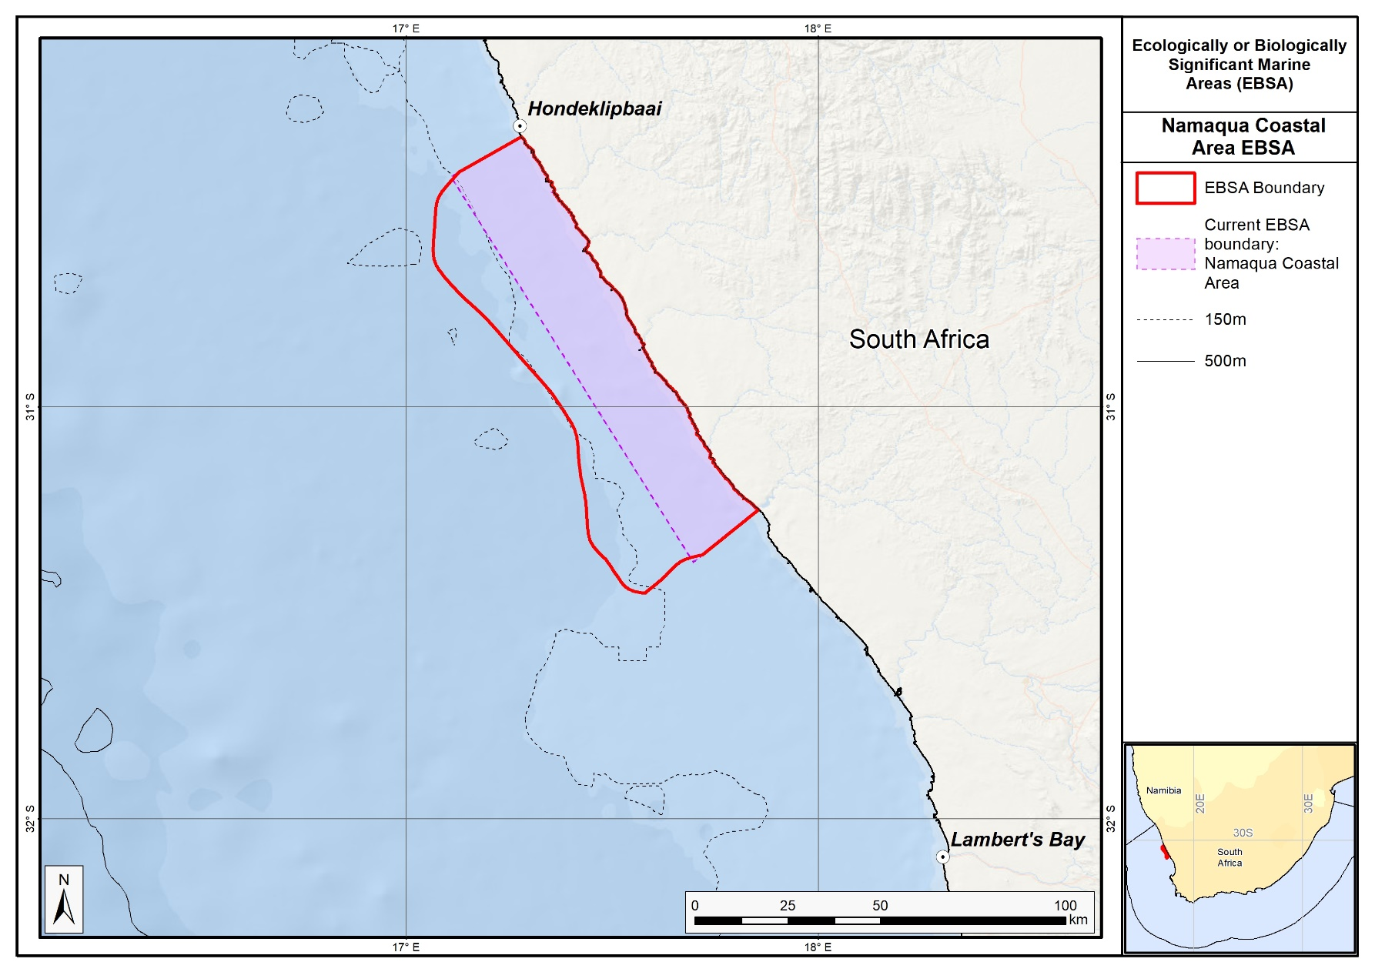
The proposed revised boundaries for the Namaqua Coastal Area EBSA in relation to the original boundaries of the EBSA.

Cape Canyon and Associated Islands, Bays and Lagoon (Formerly Cape Canyon and Surrounds)

Revised EBSA Description

General Information

Summary
Cape Canyon is one of two submarine canyons off the west coast of South Africa (the other being the Cape Point Valley) and this broader area, including St Helena Bay, has been recognized as important in three systematic conservation plans. Both benthic and pelagic features are included, and the area is important for pelagic fish, foraging marine mammals and several threatened seabird species. The area is also important for threatened ecosystem types; there are nine Endangered and 12 Vulnerable ecosystem types, and two that are Near Threatened. There is evidence that the submarine canyon hosts fragile habitat-forming species, and there are other unique and potentially vulnerable benthic communities in the area. The hard ground areas, particularly those outside of the trawl footprint, are also likely to be susceptible to damage and there are increasing petroleum and mining applications in this area. There are several small coastal MPAs within the EBSA.

Introduction of the area
Cape Canyon and Associated Islands, Bays and Lagoon is bounded along the shore from the Sixteen Mile Beach MPA in the south to about 10 km south of Lamberts Bay in the north, extending further offshore in the southern part compared to the northern part. The EBSA includes Langebaan Lagoon, Saldanha Bay, eight islands (Robben, Dassen, Vondeling, Marcus, Malgas, Jutten, Schaapen, Meeuw), the Cape Canyon submarine canyon and adjacent shelf edge, and has been extended to include the whole of St Helena Bay. This area was identified as a priority area through a national plan to identify areas for offshore protection (Sink et al., 2011) and by a systematic biodiversity plan for the west coast (Majiedt et al., 2013). It was also identified as an important area for pelagic ecosystems and species (Grantham et al., 2011).

Description of the location

EBSA Region
South-Eastern Atlantic

Description of location
This focus area is located around the southwest coast of South Africa and is completely within South Africa’s national jurisdiction. Cape Canyon and Associated Islands, Bays and Lagoon is bounded along the shore from the Sixteen Mile Beach MPA in the south to about 10 km south of Lamberts Bay in the north, extending much further offshore (approximately 70 km) in the southern part compared to that in the northern part (<10 km).

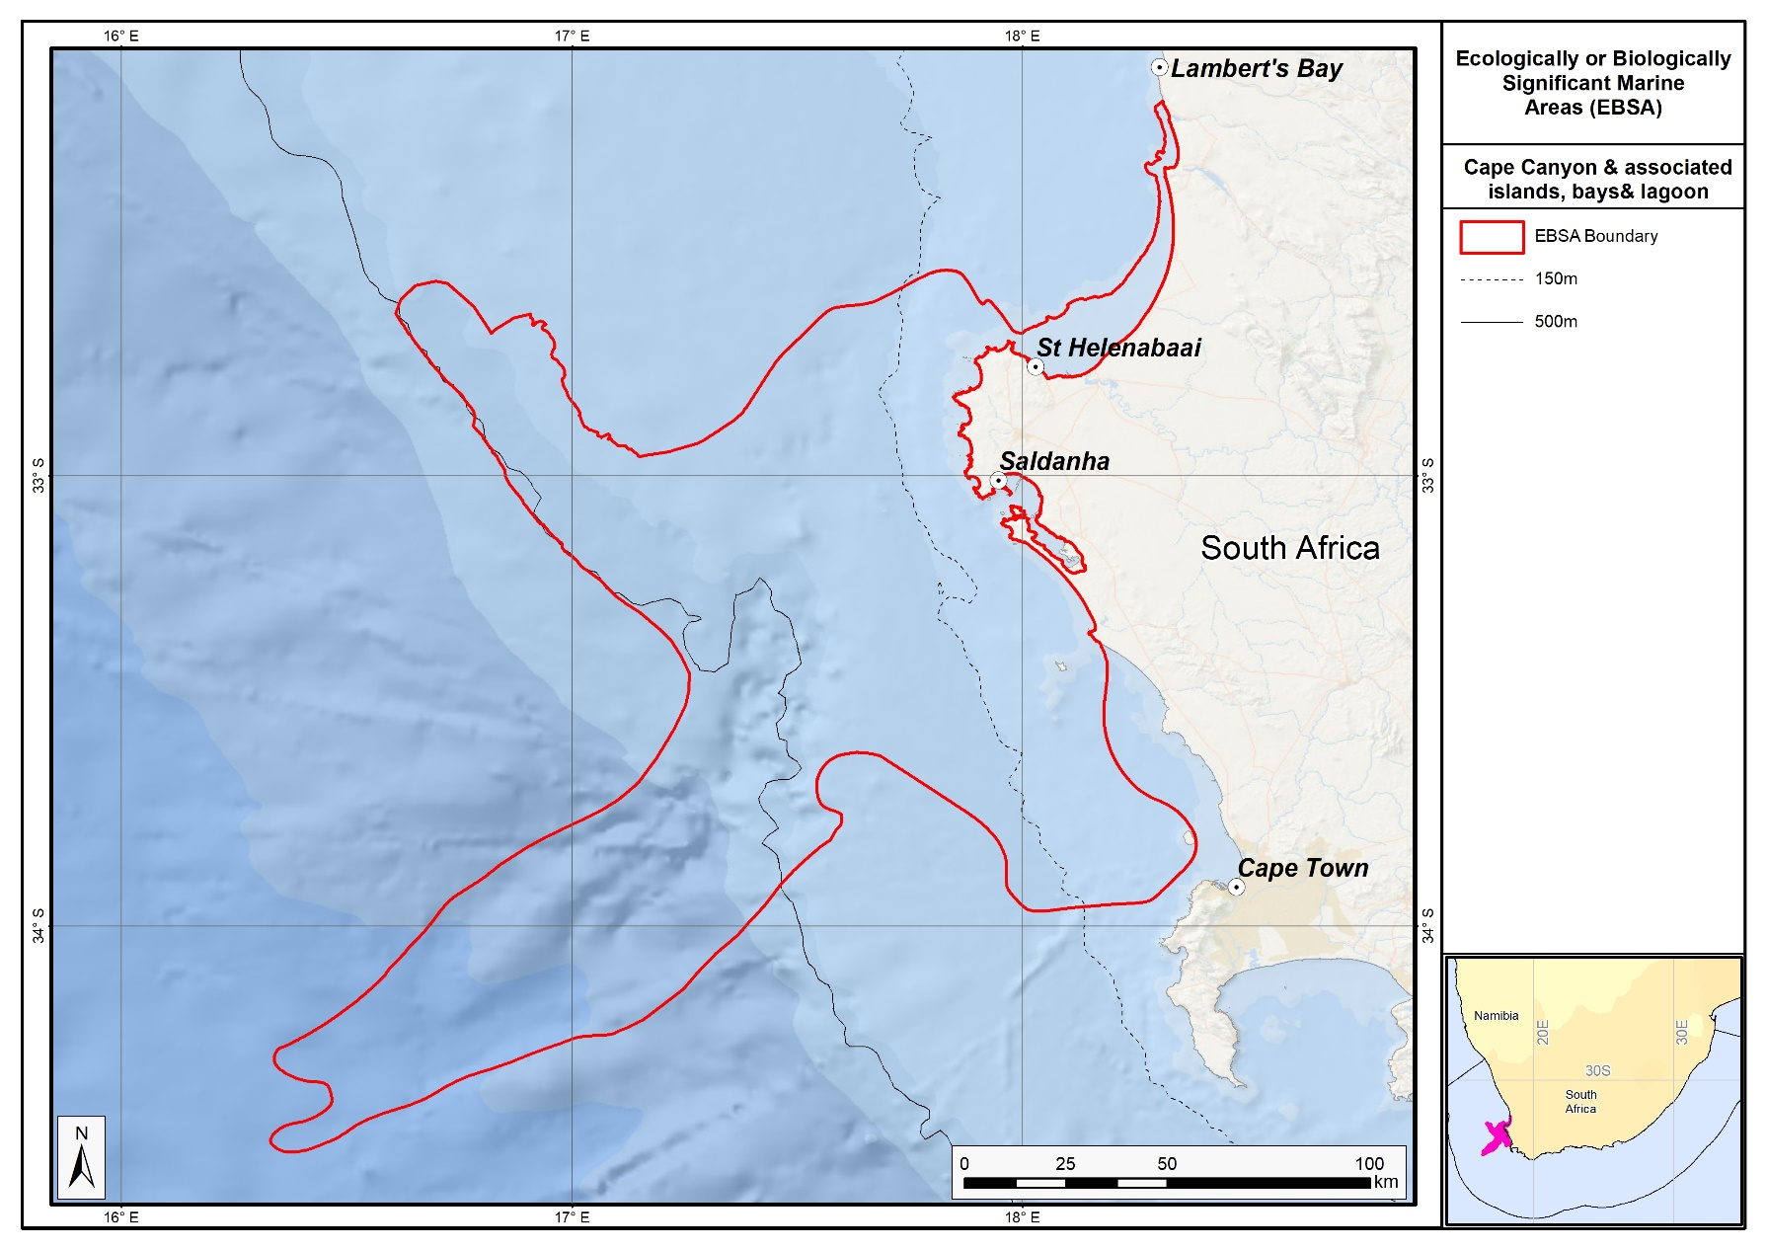
Proposed revised boundaries of the Cape Canyon and Associated Islands, Bays and Lagoon EBSA.

Area Details

Feature description of the area
Cape Canyon and Associated Islands, Bays and Lagoon is a productive area with important benthic and pelagic habitats and physical features that jointly support important life-history stages of species, and threatened, fragile and vulnerable species and habitats. The main geological feature of this EBSA is Cape Canyon itself. It is one of two canyons on the South African west coast (the other being the Cape Point Valley), which has its head about 23 km offshore of Cape Colombine, at -168 m depth, and incises to a depth of about -900 m (De Wet 2012). New bathymetry data clearly show that the main channel (at the canyon head) comprises two separate, parallel channels in the northern and middle sections that combine to form a deeply incised main channel in the south that runs all the way to the outer continental slope, ending at about -3500 m in the Cape Basin (De Wet 2012). The western branch of the main channel is much more deeply incised than is the eastern branch by up to 100 m, and the slope of the western canyon margin is much steeper than that of the eastern side (De Wet 2012). The eight islands are other key geological features in this EBSA, as well as the adjacent lagoon and bay system on the coast. The area includes unconsolidated sand, mud and gravel benthic habitats and a pelagic habitat type that is characterised by elevated productivity and frequent fronts associated with shelf-edge upwelling (Lutjeharms et al., 2000, Lagabrielle 2009, Roberson et al., 2017).
The key geological features, described above, in turn support important biological communities, from fragile to threatened species. These include four distinct benthic macrofaunal communities characterized by molluscs, polychaetes, amphipods and brittle stars (Karenyi 2014), and hard-ground habitats that are poorly known (Sink et al., 2012b). Fragile cold-water corals have been collected within the area. Further, a recent survey sighted seapens, anemones, starfish and cloaked hermit crabs (Sink 2016); all of which species are sensitive to impacts to the seabed. Parts of this dynamic area, particularly within St Helena Bay, experience low-oxygen water that may support unique biological communities (Sink et al., 2011) that are also sensitive to disturbances. The small islands contained in the EBSA provide breeding habitat for several endemic seabird species, most of which are threatened, or seals (Kemper et al., 2007). The area encompasses a key foraging area for marine mammals (Best 2006, Barendse et al., 2011) and two marine Important Bird Areas (Birdlife et al., 2013). The focus area has also been included in annual demersal fish trawl surveys conducted by the Department of Agriculture, Forestry and Fisheries.
Since the original description and delineation of the EBSA, new research has been conducted within the area, allowing a more comprensive understanding of the features and communities at this site. Consequently, the boundary has been revised to improve precision in representing the key benthic and pelagic habitat types and features, as well as key biodiversity features that underpin the EBSA status, such as: fragile and sensitive habitat-forming species, islands, the canyon, and key species (e.g., colonial seabirds). Much of the improvement in the delineation was based on new bathymetry data (De Wet 2012), which has allowed a more precise, data-driven boundary for the EBSA rather than an expert-based boundary. It also also based on new biological sampling that, for example, motivates for extending the EBSA to include the full extent of St Helana Bay to encompass those sensitive communities (Karenyi 2014, Sink 2016). The new boundary also better aligns with current initiatives to expand South Africa’s MPA network. It is presented as a Type 2 EBSA because it contains “spatially stable features whose individual positions are known, but a number of individual cases are being grouped” (sensu Johnson et al., 2018).

Feature conditions and future outlook of the proposed area
Habitat condition within this broad area ranges from good to poor (Sink et al., 2012a). Pressures are increasing, although the area includes several coastal MPAs (Langebaan, Sixteen Mile Beach, Marcus Island, Malgas Island and, Jutten Island) which protect habitats and species to varying extents. It has been recommended that MPAs in the area should be considered for consolidation, extension, or re-zoning to resolve existing resource conflicts, protect threatened species in their core areas, and minimize stakeholder impacts (Sink et al., 2011). The lagoon system is vulnerable to further impacts, and the islands with their associated seabird colonies are all threatened (Kemper et al., 2007). Petroleum exploration is increasing in the area, and there are new applications for seabed mining for phosphates and other minerals.

References
Bailey, G.W. 1991. Organic carbon flux and development of oxygen deficiency on the modern Benguela continental shelf of 22°S: spatial and temporal variability. In R. V. Tysen and T. H. Pearson, editors. Modern and Ancient Continental Shelf Anoxia. Geological Society. Pages 171-183.
Barendse, J., Best, P.B., Thornton, M., Elwen, S.H., Rosenbaum, H.C., Carvalho, I., Pomilla, C., Collins, T.J.Q., Meÿer, M.A., Leeney, R.H. 2011. Transit station or destination? Attendance patterns, regional movement, and population estimate of humpback whales Megaptera novaeangliae off western South Africa based on photographic and genotypic matching. In: Kirkman S, Elwen SH, Pistorius PA, Thornton M, Weir C (eds), Conservation biology of marine mammals in the southern African subregion. African Journal of Marine Science, 33: 353–373.
Best, P.B. 2006. The presence of right whales in summer on the west coast of South Africa: the evidence from historical records. African Journal of Marine Science, 28: 159–166.
BirdLife International, 2013. Marine e-Atlas: Delivering site networks for seabird conservation. Proposed IBA site ‘Atlantic, Southeast 19 – Marine’. Available online: http://54.247.127.44/marineIBAs/default.html. Accessed 11 March 2013
De Wet, W. 2012. Bathymetry of the South African Continental Shelf. MSc dissertation. University of Cape Town, South Africa.
Demarcq, H., Barlow, R., Hutchings, L. 2007. Application of a chlorophyll index derived from satellite data to investigate the variability of phytoplankton in the Benguela ecosystem. African Journal of Marine Science, 29: 271-282.
Gilchrist, J.D.F. 1921. Report of the Fisheries and Marine Biological Survey for the year 1920 1: 1-27.
Grantham, H.S., Game, E.T., Lombard, A.T., Hobday, A.J., Richardson, A.J., Beckley, L.E., Pressey, R.L., Huggert, J.A., Coetzee, J.C., van der Lingen, C.D., Petersen, S.L., Merkle, D., Possingham, H.P. 2011. Accommodating dynamic oceanographic processes and pelagic biodiversity in marine conservation planning. PLoS ONE 6: e16552. DOI:10.1371/journal.pone.0016552.
Holness, S., Kirkman, S., Samaai, T., Wolf, T., Sink, K., Majiedt, P., Nsiangango, S., Kainge, P., Kilongo, K., Kathena, J., Harris, L., Lagabrielle, E., Kirchner, C., Chalmers, R., Lombard, M. 2014. Spatial Biodiversity Assessment and Spatial Management, including Marine Protected Areas. Final report for the Benguela Current Commission project BEH 09-01.
Hutchings, L., Jarre, A., Lamont, T., van den Berg, M., Kirkman, S.P. 2012. St Helena Bay (southern Benguela) then and now: muted climate signals, large human impact. African Journal of Marine Science, 34: 559–583.
Johnson, D.E., Barrio Froján, C., Turner, P.J., Weaver, P., Gunn, V., Dunn, D.C., Halpin, P., Bax, N.J., Dunstan, P.K., 2018. Reviewing the EBSA process: Improving on success. Marine Policy 88, 75-85.
Karenyi, N. 2014. Patterns and drivers of benthic macrofauna to support systematic conservation planning for marine unconsolidated sediment ecosystems. PhD thesis. Nelson Mandela Metropolitan University, Port Elizabeth.
Kemper, J., Underhill, L.G., Crawford, R.J.M., Kirkman, S.P. 2007. Revision of the conservation status of seabirds and seals breeding in the Benguela Ecosystem. In: Kirkman, S.P. (ed.) Final Report of the BCLME (Benguela Current Large Marine Ecosystem) Project on Top Predators as Biological Indicators of Ecosystem Change in the BCLME. Avian Demography Unit, Cape Town, pp 325–342.
Koné, V. Lett, C., Fréon, P. 2013. Modelling the effect of food availability on recruitment success of Cape anchovy ichthyoplankton in the southern Benguela upwelling system, African Journal of Marine Science, 35: 151-161.
Lagabrielle, E. 2009. Preliminary report: National Pelagic Bioregionalisation of South Africa. Cape Town: South African National Biodiversity Institute.
Majiedt, P., Holness, S., Sink, K., Oosthuizen, A., Chadwick, P. 2013. Systematic Marine Biodiversity Plan for the West Coast of South Africa. South African National Biodiversity Institute, Cape Town.
Roberson, L.A., Lagabrielle, E., Lombard, A.T., Sink, K., Livingstone, T., Grantham, H., Harris, J.M. 2017. Pelagic bioregionalisation using open-access data for better planning of marine protected area networks. Ocean & Coastal Management, 148: 214-230.
Sink, K. 2016. Deep Secrets: the outer shelf and slope ecosystems of South Africa. Cruise Report: ALG 230 – ACEP_DSC.
Sink K., Samaai, T. Identifying Offshore Vulnerable Marine Ecosystems in South Africa, Unpublished Sink, K.J., Attwood, C.G., Lombard, A.T., Grantham, H., Leslie, R., Samaai, T., Kerwath, S., Majiedt, P., Fairweather, T., Hutchings, L., van der Lingen, C., Atkinson, L.J., Wilkinson, S., Holness, S., Wolf, T. 2011. Spatial planning to identify focus areas for offshore biodiversity protection in South Africa. Unpublished Report. Cape Town: South African National Biodiversity Institute.
Sink, K., Holness, S., Harris, L., Majiedt, P., Atkinson, L., Robinson, T., Kirkman, S., Hutchings, L., Leslie, R., Lamberth, S., Kerwath, S., von der Heyden, S., Lombard, A., Attwood, C., Branch, G., Fairweather, T., Taljaard, S., Weerts, S., Cowley, P., Awad, A., Halpern, B., Grantham, H., Wolf, T. 2012a. National Biodiversity Assessment 2011: Technical Report. Volume 4: Marine and Coastal Component. South African National Biodiversity Institute, Pretoria.
Sink, K.J., van der Bank, M.G., Majiedt, P.A., Harris, L.R., Atkinson, L., Karenyi, N., Kirkman, S. (eds) 2019. National Biodiversity Assessment 2018 Technical Report Volume 4: Marine Realm. South African National Biodiversity Institute, Pretoria.
Sink, K.J., Wilkinson, S., Atkinson, L.J., Sims, P.F., Leslie, R.W., Attwood, C.G. 2012b. The potential impacts of South Africa’s demersal hake trawl fishery on benthic habitats: historical perspectives, spatial analyses, current review and potential management actions. Unpublished report. Cape Town: South African National Biodiversity Institute.
Wilkinson, S. 2009. Ring Fencing the Trawl Grounds. South African Deep-sea Trawling Industry Association. Report prepared by Capricorn Fisheries Monitoring cc. Cape Town.

Other relevant website address or attached documents
Summary of habitat types and threat status for the Cape Canyon and Associated Islands, Bays and Lagoon. Data from Sink et al. (2019).
Threat Status | Ecosystem Type | Area (km²) | Area (%)
Endangered | Cape Bays | 114.3 | 0.7
 | Cape Island Shore | 2.9 | 0.0
 | Cape Sheltered Rocky Shore | 1.4 | 0.0
 | Cape Upper Canyons | 1893.8 | 11.4
 | Cool Temperate Arid Predominantly Closed Estuary | 0.1 | 0.0
 | Cool Temperate Estuarine Lake | 0.2 | 0.0
 | Cool Temperate Predominantly Open Estuary | 0.3 | 0.0
 | Southern Benguela Muddy Shelf Edge | 814.0 | 4.9
 | Southern Benguela Reflective Sandy Shore | 5.7 | 0.0
Vulnerable | Cape Boulder Shore | 1.3 | 0.0
 | Cape Exposed Rocky Shore | 16.0 | 0.1
 | Cape Kelp Forest | 4.7 | 0.0
 | Cape Lower Canyons | 2483.7 | 15.0
 | Cape Mixed Shore | 12.4 | 0.1
 | Cape Rocky Inner Shelf | 249.3 | 1.5
 | Cape Rocky Mid Shelf Mosaic | 2714.0 | 16.4
 | Cape Sandy Inner Shelf | 253.9 | 1.5
 | Cool Temperate Estuarine Lagoon | 59.8 | 0.4
 | Southern Benguela Rocky Shelf Edge | 1457.2 | 8.8
 | Southern Benguela Sandy Shelf Edge | 6.7 | 0.0
 | St Helena Bay | 545.3 | 3.3
Near Threatened | Cape Very Exposed Rocky Shore | 0.2 | 0.0
 | Southern Benguela Intermediate Sandy Shore | 11.3 | 0.1
Least Concern | Cape Basin Abyss | 628.4 | 3.8
 | Namaqua Sandy Mid Shelf | 9.4 | 0.1
 | Southeast Atlantic Lower Slope | 1994.2 | 12.0
 | Southeast Atlantic Mid Slope | 7.1 | 0.0
 | Southeast Atlantic Upper Slope | 180.3 | 1.1
 | Southern Benguela Dissipative Sandy Shore | 14.1 | 0.1
 | Southern Benguela Dissipative-Intermediate Sandy Shore | 21.2 | 0.1
 | Southern Benguela Outer Shelf Rocky Sand Mosaic | 555.8 | 3.3
 | Southern Benguela Sandy Outer Shelf | 2526.0 | 15.2
Grand Total |  | 16585.2 | 99.9

Assessment of the area against CBD EBSA criteria
C1: Uniqueness or rarity High
Justification
This area was identified by two systematic plans because of rare habitat types including the canyon, rare muds and low-oxygen benthic habitats (Sink et al., 2011, 2012a, 2012b, Majiedt et al., 2013). The Southern Benguela Muddy Shelf Edge comprises only two patches off Saldahna, covering an estimated 567 km², which is included in the EBSA. Cape Canyon is the largest of only two reported submarine canyons on the west coast of South Africa and in the southern Benguela. Further, this site contains the only lagoon in South Africa, and for Saldanha Bay is the largest natural harbour in the country.
C2: Special importance for life-history stages of species High
Justification
The area encompasses a key foraging area for marine mammals including humpback and southern right whales (Best 2006, Barendse et al., 2011) and two marine Important Bird Areas. Closer to shore the Canyon is adjacent to several terrestrial IBAs (Bird Island, Dassen Island, Heuningnes River and estuary system, and the Lower Berg river wetlands). The seas extending from these sites have been proposed as a marine IBA for the following seabird species: African Penguin, Bank Cormorant, Cape Cormorant, Cape Gannet, Caspian Tern, Crowned Cormorant, Damara Tern, Great Crested Tern, Kelp Gull and Hartlaub’s Gull. Further offshore, along the shelf edge where commercial fisheries are concentrated, BirdLife International has identified a large area, which overlaps with the Cape Canyon area, as a potential marine IBA for Atlantic Yellow-nosed and Black-browed albatrosses and Cory’s Shearwater. Several other species (e.g. Shy Albatross and White-chinned Petrel) are likely to qualify as trigger species in this area, but tracking data or analyses are lacking. Grantham et al. (2011) also showed that this area had the highest density of breeding seabirds that feed on pelagic species. High densities of sardine and anchovy eggs contributed to the high selection frequency of this broader area in the offshore systematic biodiversity plan for South Africa (Sink et al., 2011). Spawning and nursery habitat for Cape hakes and is also included in this area (Sink et al., 2011, Kone et al., 2013).
C3: Importance for threatened, endangered or declining species and/or habitats High
Justification
This area is importance for several threatened seabirds including four Endangered seabirds – African Penguin, Bank Cormorant, and Black-browed and Atlantic Yellow-nosed albatrosses. These animals are highly dependent on this area for some or all of their life stages, particularly for foraging. In addition, several species of lower conservation threat status are similarly dependent on this area: the Vulnerable White-chinned Petrel, Cape Cormorant and Cape Gannet.
The area is dominated by a plethora of threatened ecosystem types identified in the National Biodiversity Assessment 2011 (Sink et al., 2012), BCC assessment Holness et al. (2014), and National Biodiversity Assessment 2018 (Sink et al., 2019), with the results from the most recent assessment (NBA 2018) reported here (Sink et al., 2019). Altogether, there are 21 (of 32) ecosystem types represented in the EBSA that are threatened. These include nine Endangered ecosystem types, namely: Cape Bays, Cape Island Shore, Cape Sheltered Rocky Shore, Cape Upper Canyons, Cool Temperate Arid Predominantly Closed Estuary, Cool Temperate Estuarine Lake, Cool Temperate Predominantly Open, Southern Benguela Muddy Shelf Edge and Southern Benguela Reflective Sandy Shore. A further 12 Vulnerable ecosystems are found in the area, namely: Cape Boulder Shore, Cape Exposed Rocky Shore, Cape Kelp Forest, Cape Lower Canyons, Cape Mixed Shore, Cape Rocky Inner Shelf, Cape Rocky Mid Shelf Mosaic, Cape Sandy Inner Shelf, Cool Temperate Estuarine Lagoon, Southern Benguela Rocky Shelf Edge, Southern Benguela Sandy Shelf Edge and St Helena Bay. There are also two ecosystem types that are Near Threatened (Sink et al., 2019).
C4: Vulnerability, fragility, sensitivity, or slow recovery High
Justification
The submarine canyon in this area is considered vulnerable to impact because cold-water corals, gorgonians and other slow-growing, habitat-forming species were observed within this area on submersible footage (Diamondfields International unpublished footage, Sink and Samaai 2009). Gilchrist (1921) also reported cold water corals, black corals and two hundred large sponges in a single otter trawl in this area in 1920, and it was only in the 1990s that trawling was initiated in the hard-ground habitats within this area (Sink et al., 2012b). Deep reefs and hard grounds in the area are also likely to host fragile three-dimensional, habitat-forming species, although this has not been confirmed by in-situ research. These habitats are all considered sensitive to demersal trawling and mining (Sink et al., 2011, 2012a, 2012bb). The low-oxygen habitats and likely biological communities they support are also considered vulnerable.
C5: Biological productivity High
Justification
The most persistent and intense upwelling cell on the entire South African west coast is found within this area at Cape Columbine, resulting in the area downstream having the highest productivity, organic loading (Demarq et al., 2007) and organic carbon deposits on the seafloor (Bailey 1991) on this coast. St Helena Bay has also been identified as the area having the most persistent oxygen-deficient water in the region (Bailey 1991). South of Cape Columbine, a different set of oceanographic features dominate, and frequent pulse upwelling events result in high productivity over shorter periods (Demarq et al., 2007). Cape Canyon and Surrounds includes part of the area with highest copepod biomass on the west coast (Grantham et al., 2011). Large populations of marine top predators forage and/or breed within the area, including several species of seabirds, cetaceans and seals (Best 2006, Barendse et al., 2011, Hutchings et al., 2012).
C6: Biological diversity High
Justification
South Africa’s national map indicates 32 ecosystem types in this area (Sink et al., 2019), and this diversity of ecosystem types is a key driver of this area’s selection in two systematic biodiversity plans (Sink et al., 2011, Majiedt et al., 2013). The submarine canyon, sand and mud habitats, patches of low oxygen water, bays, islands and the adjacent lagoon system contribute to the high habitat diversity in this area (Sink et al., 2011, 2012a, 2019, Majiedt et al., 2013). This is also the only place where two genomic clusters for Zostera capensis are present (in Langebaan).
C7: Naturalness Medium
Justification
There is a moderate level of naturalness within this area. Of the two mapped submarine canyons, there is lower trawling effort and fewer pressures in the Cape Canyon, which is the closer canyon to the city of Cape Town (Sink et al., 2011, Sink et al., 2012a,b). Some of the canyon habitat is outside of the trawling footprint, and there are adjacent hard ground areas that are also untrawled (Wilkinson 2009, Sink et al., 2012b). However, there is a port at Saldanha, and several fisheries sectors operate within this area.

Status of submission
The Cape Canyon and Surrounds EBSA was recognized as meeting EBSA criteria by the Conference of the Parties. The revised name, description and boundaries still need to be submitted to COP for approval.

COP Decision
dec-COP-12-DEC-22
End of proposed EBSA revised description

Motivation for Submission
Some technical revisions and updates to the description were made, even though little additional information was available. A supplementary table of the habitats represented in the EBSA and their associated threat status was also included.
The main change is that the boundary of this EBSA has been significantly refined to more closely focus the EBSA on the key biodiversity features that underlie its EBSA status. The delineation process included an initial stakeholder review which identified the need to include additional features such as the full extent of the Cape Canyon and St Helena Bay, a technical mapping process and then an expert review workshop where boundary delineation options were finalised. The delineation process used a combination of Systematic Conservation Planning and Multi-Criteria Analysis methods. The features used in the analysis were:
- Key physical features (i.e. canyons and islands) from GEBCO data, global benthic geomorphology mapping (www.bluehabitats.org, Harris et al., 2014), and data from the South African National Biodiversity Assessment (Sink et al., 2012) and BCC spatial mapping project (Holness et al., 2014) were compiled. In addition, bays were mapped and included as these have been identified as important features in the new National Biodiversity Assessment 2018 (no reference available yet).
- Delineations and threat status of consitituent ecosystem types in the area were included in the analysis and used to refine the boundary of the EBSA.
- Areas of high relative naturalness of benthic and coastal systems and pelagic systems identified in the National Biodiversity Assessment 2011 (Sink et al., 2012), the West Coast (Majiedt et al., 2013) and the BCLME spatial assessments (Holness et al., 2014) were included in the analysis.
- Areas important for threatened and special species were included. The priority areas and buffer distances around colonies were from Holness et al. (2014). Note that the full extent of the buffer was not necessarily included in the EBSA. Features included in the analysis were:
  - African Penguin colonies and a 20km buffer.
  - Bank Cormorant, Cape Cormorant, White Breasted Cormorant and Crowned Cormorant colonies and a 40km buffer.
  - Gannet colonies with a 40km buffer.
  - Seal Colonies and a 20km buffer.
- Irreplaceable and near irreplaceable (i.e. very high selection frequency) sites, as well as focus areas identified in the SCP undertaken for the West Coast by Majiedt et al. (2013), offshore areas (Sink et al., 2011) and for the BCLME by Holness et al. (2014) were incorporated.
- Distributions of known fragile, vulnerable and sensitive habitat-forming species were included (Unpublished SANBI and SAEON data).
The multi-criteria analysis resulted in a value surface. The cut-off value used to determine the extent of the EBSA was based on expert input and quantitative analysis of effective inclusion of the above features. This entailed taking an iterative parameter calibration-based approach whereby the spatial efficiency of the inclusion of the targeted features was evaluated. The approach aimed to identify a cut-off which most efficiently included prioritised features while minimizing the inclusion of impacted areas. The final boundaries shown in the map were validated in a national workshop. The new boundary comprises about two thirds of the original EBSA area and falls mostly within the previous delineation, except for a protrusion along the south east edge.

Research Needs
There is ongoing research on the distributions of fragile, sensitive and vulnerable habitat-forming species in the area, although it is unlikely to have bearing on the revised boundaries. This item will be further populated in a workshop to be held in August/September 2018.

Future Process
Portions of the EBSA have been gazetted for inclusion into the proposed Robben Island MPA and the Cape Canyon MPA. It is unclear if this EBSA will be subject to detailed attention in the MARISMA EBSA status assessment and management options workplan. This will be decided on in a workshop to be held in August/September 2018.

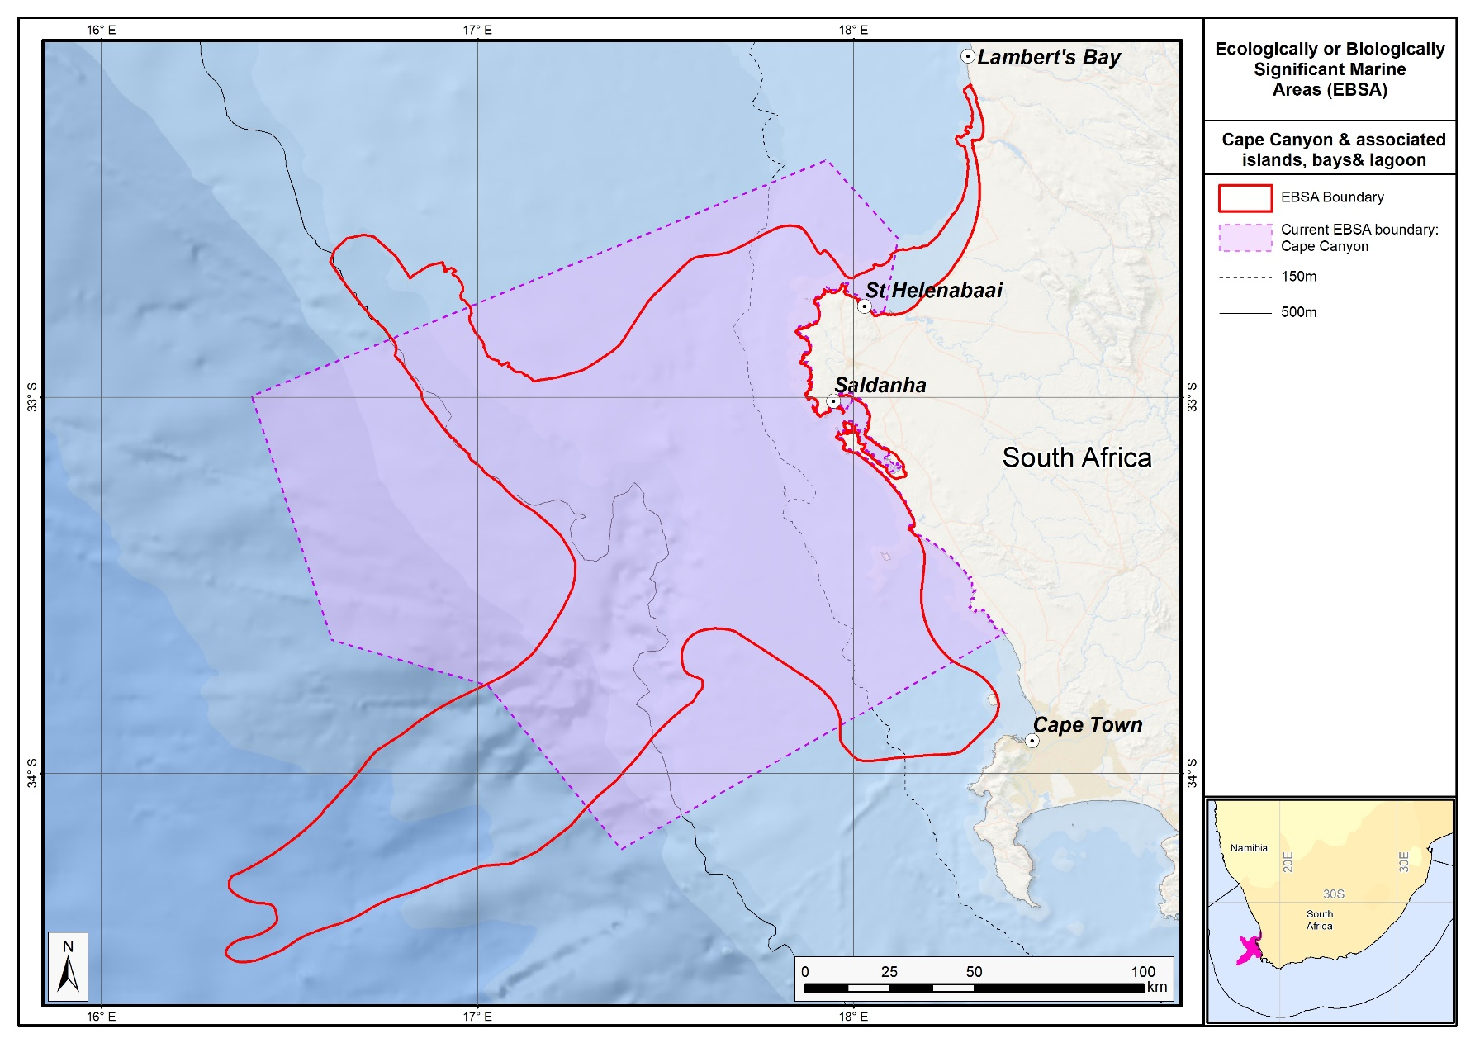
The proposed revised boundaries for the Cape Canyon and associated Islands, Bays and Lagoon EBSA in relation to the original boundaries of the Cape Canyon and Surrounds EBSA.

Browns Bank

Revised EBSA Description

General Information

Summary
Browns Bank includes benthic and pelagic habitats of the outer shelf and shelf edge along the western continental margin of South Africa. The area includes reef-building cold-water corals and untrawled hard grounds. It is an important fish spawning area for demersal and pelagic species. The spawning area is linked to nursery grounds on the inshore area of the west coast and the Agulhas Bank and has better retention than that of areas further north. The Agulhas and Southern Benguela ecoregions meet at the south-eastern boundary of the area and sporadic shelf edge upwelling enhances the productivity along the outer margin. The area is important for threatened habitats and species, including a Critically Endangered benthic habitat type and overlapping substantially with two proposed marine Important Bird Areas, namely for Cory’s Shearwater and Atlantic Yellow-nosed Albatross. The area was also identified as a priority area through two systematic biodiversity plans, meeting targets for habitat representation, hake spawning, and fragile and sensitive habitat-forming species. The boundary of this EBSA has been refined since its first description to improve precision based on focus-area delineation for national MPA expansion, threat status of benthic ecosystem types, and presence of vulnerable, sensitive, fragile and slow-growing species.

Introduction of the area
The area is along the outer shelf and shelf edge of the western continental margin of South Africa, south and slightly east of Cape Agulhas. It includes benthic habitats, including rocky, sandy and reef substrates (Sink et al., 2019), and a pelagic habitat type that is characterised by elevated productivity and frequent fronts due to shelf-edge upwelling (Lutjeharms et al., 2000, Lagabrielle 2009, Roberson et al., 2017). The area ranges from approximately 150 m – 800 m depth and the Agulhas and Southern Benguela ecoregions meet at the its south-eastern edge (Sink et al., 2012), with sporadic shelf-edge upwelling that enhances the productivity along its outer margin (Lagabrielle, 2009, Roberson et al., 2017). The area includes the western Agulhas Bank spawning ground, and is part of a critical area for retention of spawning products (Hutchings et al., 2002). It was identified as a priority area through a national plan to identify areas for offshore protection (Sink et al., 2011) and by a systematic biodiversity plan for the South African west coast (Majiedt et al., 2013).

Description of the location

EBSA Region
South-Eastern Atlantic

Description of location
Browns Bank includes benthic and pelagic habitats of the outer shelf and shelf edge along the western continental margin of South Africa. This area is off the southwest coast of South Africa, almost directly south of Cape Agulhas, and is completely within national jurisdiction.

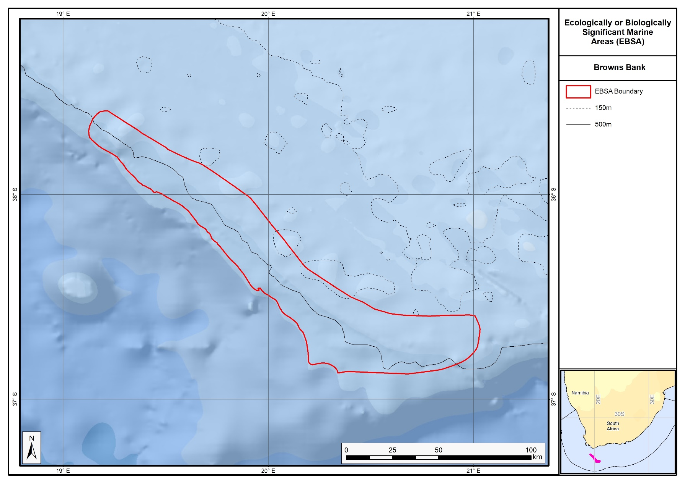
Proposed revised boundaries of the Browns Bank EBSA.

Area Details

Feature description of the area
The Browns Bank area includes unconsolidated sandy habitats, hard ground and reef habitats (Sink et al., 2019). The pelagic habitat is characterised by elevated productivity and frequent fronts due to shelf edge upwelling (Lutjeharms et al., 2000, Lagabrielle 2009, Roberson et al., 2017). The biodiversity at Browns Bank includes benthic macrofaunal communities characterized by high abundances of brittle stars and many species of polychaetes (Karenyi, 2014); cold-water corals, brisingid starfish, and 77 morphospecies of macroinvertebrates have also been collected within the area (Sink 2016). Further, it is a proposed marine Important Bird Area (IBA) for two species of seabirds, Cory’s Shearwater and Atlantic Yellow-nosed Albatross (BirdLife International 2013), indicating that it holds a significant proportion of the global population of these species during some periods of each year for which data are available. Wandering, Shy, Black-browed, and Atlantic yellownose albatrosses sighted in the area, and Pintado petrels are noted as commonly occurring (Sink 2016). Browns Bank is also part of the western Agulhas Bank spawning ground as described by Hutchings et al. (2002). This area has been included in annual demersal fish trawl surveys conducted by the Department of Agriculture, Forestry and Fisheries, and was surveyed during the Deep Secrets cruise in 2016 (Sink 2016).
The boundary of this EBSA has been refined since it was first described. The new boundary falls almost entirely within the old boundary, comprising an area about two thirds of the original delineation. It was refined to improve precision based on selection frequency in the two systematic biodiversity plans covering this area (Sink et al., 2011; Majiedt et al., 2013), new focus area delineations for MPA expansion in South Africa, presence of fragile and sensitive habitat-forming species, and benthic ecosystem types that are threatened. The site is presented as a Type 1 EBSA because it contains “Spatially stable features whose positions are known and individually resolved on the maps” (sensu Johnson et al., 2018).

Feature conditions and future outlook of the proposed area
According to Wilkinson (2009) there are three areas of untrawled hard grounds on the shelf edge within this area, suggesting they are still intact. However, a recent assessment of cumulative pressures to South Africa’s marine environment showed that there is a small portion of the EBSA that is in good ecological condition, some parts in fair condition, but that most of the EBSA has been heavily modified and is in poor ecological condition (Sink et al., 2019).

References
BirdLife International, 2013. Marine e-Atlas: Delivering site networks for seabird conservation. Proposed IBA site ‘Atlantic, Southeast 19 – Marine’. Available online: http://54.247.127.44/marineIBAs/default.html. Accessed 11 March 2013
Hutchings, L., Beckley, L.E., Griffiths, M.H., Roberts, M.J., Sundby, S., van der Lingen, C. 2002. Spawning on the edge: spawning grounds and nursery areas around the southern African coastline. Marine and Freshwater Research, 53: 307-318.
Johnson, D.E., Barrio Froján, C., Turner, P.J., Weaver, P., Gunn, V., Dunn, D.C., Halpin, P., Bax, N.J., Dunstan, P.K., 2018. Reviewing the EBSA process: Improving on success. Marine Policy 88, 75-85.
Karenyi, N. 2014. Patterns and drivers of benthic macrofauna to support systematic conservation planning for marine unconsolidated sediment ecosystems. PhD thesis. Nelson Mandela Metropolitan University, Port Elizabeth.
Lagabrielle, E. 2009. Preliminary report: National Pelagic Bioregionalisation of South Africa. Cape Town: South African National Biodiversity Institute.
Lutjeharms, J.R.E., Cooper, J., Roberts, M. 2000. Upwelling at the inshore edge of the Agulhas Current. Continental Shelf Research, 20: 737 – 761.
Majiedt, P., Holness, S., Sink, K., Oosthuizen, A., Chadwick, P. 2013. Systematic Marine Biodiversity Plan for the West Coast of South Africa. South African National Biodiversity Institute, Cape Town.
Roberson, L.A., Lagabrielle, E., Lombard, A.T., Sink, K., Livingstone, T., Grantham, H., Harris, J.M. 2017. Pelagic bioregionalisation using open-access data for better planning of marine protected area networks. Ocean & Coastal Management, 148: 214-230.
Santos, J., Rouillard, D., Groeneveld, J.C. 2014. Advection-diffusion models of spiny lobster Palinurus gilchristi migrations for use in spatial fisheries management. Marine Ecology Progress Series, 498: 227–241.
Sink, K. 2016. Deep Secrets: the outer shelf and slope ecosystems of South Africa. Cruise Report: ALG 230 – ACEP_DSC.
Sink, K.J., Attwood, C.G., Lombard, A.T., Grantham, H., Leslie, R., Samaai, T., Kerwath, S., Majiedt, P., Fairweather, T., Hutchings, L., van der Lingen, C., Atkinson, L.J., Wilkinson, S., Holness, S., Wolf, T. 2011. Spatial planning to identify focus areas for offshore biodiversity protection in South Africa. Unpublished Report. Cape Town: South African National Biodiversity Institute.
Sink, K., Holness, S., Harris, L., Majiedt, P., Atkinson, L., Robinson, T., Kirkman, S., Hutchings, L., Leslie, R., Lamberth, S., Kerwath, S., von der Heyden, S., Lombard, A., Attwood, C., Branch, G., Fairweather, T., Taljaard, S., Weerts, S., Cowley, P., Awad, A., Halpern, B., Grantham, H., Wolf, T. 2012a. National Biodiversity Assessment 2011: Technical Report. Volume 4: Marine and Coastal Component. South African National Biodiversity Institute, Pretoria.
Sink, K.J., van der Bank, M.G., Majiedt, P.A., Harris, L.R., Atkinson, L., Karenyi, N., Kirkman, S. (eds) 2019. National Biodiversity Assessment 2018 Technical Report Volume 4: Marine Realm. South African National Biodiversity Institute, Pretoria.
Sink, K.J., Wilkinson, S., Atkinson, L.J., Sims, P.F., Leslie, R.W., Attwood, C.G. 2012b. The potential impacts of South Africa’s demersal hake trawl fishery on benthic habitats: historical perspectives, spatial analyses, current review and potential management actions. Unpublished report. Cape Town: South African National Biodiversity Institute.
Wilkinson, S. 2009. Ring Fencing the Trawl Grounds. South African Deep-sea Trawling Industry Association. Report prepared by Capricorn Fisheries Monitoring cc. Cape Town.

Other relevant website address or attached documents
Summary of habitat types and threat status for the Browns bank EBSA. Data from Sink et al. (2019).
Threat Status | Ecosystem Type | Area (km²) | Area (%)
Critically Endangered | Southern Benguela Rocky Shelf Edge Mosaic | 1197.1 | 21.2
Least Concern | Agulhas Outer Shelf Reef Coarse Sediment Mosaic | 385.5 | 6.8
 | Agulhas Rocky Shelf Edge | 414.8 | 7.3
 | Southeast Atlantic Upper Slope | 1938.1 | 34.3
 | Southern Benguela Sandy Outer Shelf | 1541.7 | 27.2
 | Southwest Indian Upper Slope | 180.5 | 3.2
Grand Total |  | 5657.7 | 100.0

Assessment of the area against CBD EBSA criteria
C1: Uniqueness or rarity High
Justification
When first described, Browns Bank was identified by two systematic plans as a priority area because it is the only place where targets for the Southern Benguela Gravel Outer Shelf habitat (which is Critically Endangered) can be met (Majiedt et al., 2013, Sink et al., 2011). It should be noted that this habitat type has a limited extent with an estimated total area of less than 450 km². Since the revision of the National Marine Ecosystem Type Map and the EBSA boundary, this is still true; however, the ecosystem type is now called Southern Benguela Rocky Shelf Edge Mosaic. It is still Critically Endangered, but does extend a little beyond the extent of the EBSA along the shelf edge; the most intact parts of this ecosystem type are included in the EBSA.
C2: Special importance for life-history stages of species High
Justification
This area is part of the western Agulhas Bank spawning ground as described by Hutchings et al. (2002). The gadoid Cape hakes Merluccius capensis and M. paradoxus, the gempylid Thyrsites atun (snoek) and the clupeid Etremeus whiteheadii (round herring) move to the western Agulhas Bank and southern west coast to spawn, generally in late winter and early spring when offshore Ekman losses are at a minimum. The eggs and larvae drift northwards and inshore to the west coast nursery grounds. Browns Bank, an apex area of the Agulhas Bank, is recognized as a critical area for retention of spawning products because eddies in this area help to re-circulate water inshore and link important nursery areas with this spawning habitat on the shelf edge. Strong jet currents on the west coast oblige adult hake to shift southwards to spawn, to ensure that juveniles enter the west coast nursery grounds downstream (Hutchings et al., 2002). The area is also important for juvenile spiny lobsters (Santos et al., 2014). This shelf-edge area also constitutes foraging area for offshore seabirds (BirdLife International 2013). Limited tracking datasets have shown that the shelf edge is heavily used by a diversity of pelagic seabirds. In particular, the Browns Bank site is a proposed marine IBA for two species of seabirds; Cory’s Shearwater and Atlantic Yellow-nosed Albatross (BirdLife International 2013). Additional seabird tracking datasets may result in this site being an IBA for additional species in future.
C3: Importance for threatened, endangered or declining species and/or habitats High
Justification
The Atlantic Yellow-nosed Albatross is globally Endangered, and Browns Bank is a proposed marine IBA site for this species, indicating that it holds a significant proportion of the global population of this species during some periods of each year for which data are available (BirdLife International 2013). This area also contains the last moderately intact patches of Southern Benguela Rocky Shelf Edge Mosaic, a habitat rare type that is considered Critically Endangered (Sink et al., 2012a,b, 2019). Wandering albatross, Shy, Black browed, Atlantic yellownose and Pintado petrels common in area (Sink 2016).
C4: Vulnerability, fragility, sensitivity, or slow recovery Medium
Justification
This area has hard ground habitats on the outer shelf and shelf edge that are considered sensitive to demersal trawling and mining (Sink et al., 2011, 2012a, 2012b). Recently, fisheries observers collected two species of cold-water corals within this area (Capricorn Fisheries Monitoring, unpublished information). The specimens are in the invertebrate collection at iZiko, the South African Museum in Cape Town. Further, recent samples of coral, Thouarella, hermit crabs, and brisingid sea stars have been collection or seen, and 77 invertebrate morph species were identified from the area in a recent survey (Sink 2016).
C5: Biological productivity Medium
Justification
The Agulhas and Southern Benguela ecoregions meet at the southeastern boundary of the area and sporadic shelf edge upwelling enhances the productivity along its outer margin. Based on tracking data, the area holds a significant proportion of the global population of at least two species of seabirds, namely Cory’s Shearwater and the globally Endangered Atlantic Yellow-nosed Albatross (BirdLife International 2013).
C6: Biological diversity Low
Justification
The national habitat map indicates a moderate number of habitat types within the area (Sink et al., 2012 a).
C7: Naturalness Medium
Justification
There are three areas of untrawled hard grounds on the shelf edge within this area (Wilkinson 2009). The Southern Benguela Rocky Shelf Edge Mosaic ecosystem type is in poor condition and there is no remaining area of this habitat type left in good condition, and only fragments in moderate condition (Sink et al., 2012a,b, 2019).

Status of submission
The Browns Bank EBSA was recognized as meeting EBSA criteria by the Conference of the Parties. The revised description and boundaries still need to be submitted to COP for approval.

COP Decision
dec-COP-12-DEC-22
End of proposed EBSA revised description

Motivation for Submission
Some technical revisions and updates to the description were made, even though little additional information was available. A supplementary table of the habitats represented in the EBSA and their associated threat status was also included.
The main change is that the boundary of this EBSA has been slightly adjusted to more closely focus the EBSA on the key biodiversity features that underlie its EBSA status. The delineation process included an initial stakeholder review which identified the need to update boundaries, a technical mapping process and then an expert review workshop where boundary delineation options were finalised. The delineation process used a combination of Systematic Conservation Planning and Multi-Criteria Analysis methods. The features used in the analysis were:
- Irreplaceable and near irreplaceable (i.e. very high selection frequency) sites, as well as focus areas identified in the SCP undertaken for the West Coast by Majiedt et al. (2013), offshore areas (Sink et al., 2011) and by Holness et al. (2014) were incorporated.
- Delineations and threat status of consitituent ecosystem types in the area were included in the analysis and used to refine the boundary of the EBSA.
- Areas of high relative naturalness of benthic and coastal systems and pelagic systems identified in the National Biodiversity Assessment 2011 (Sink et al., 2012a) were included in the analysis.
- Distributions of known fragile, vulnerable and sensitive habitat-forming species were included (Unpublished SANBI and SAEON data).
The multi-criteria analysis resulted in a value surface. The cut-off value used to determine the extent of the EBSA was based on expert input and quantitative analysis of effective inclusion of the above features. This entailed taking an iterative parameter calibration-based approach whereby the spatial efficiency of the inclusion of the targeted features was evaluated. The approach aimed to identify a cut-off which most efficiently included prioritised features while minimizing the inclusion of impacted areas. The final boundaries shown in the map were validated in a national workshop.

Research Needs
This item will be populated in a workshop to be held in August/September 2018.

Future Process
Portions of the EBSA have been gazetted for inclusion into the Brown Bank Corals MPA. It is unclear if this EBSA will be subject to detailed attention in the MARISMA EBSA status assessment and management options workplan. This will be decided on in a workshop to be held in August/September 2018.

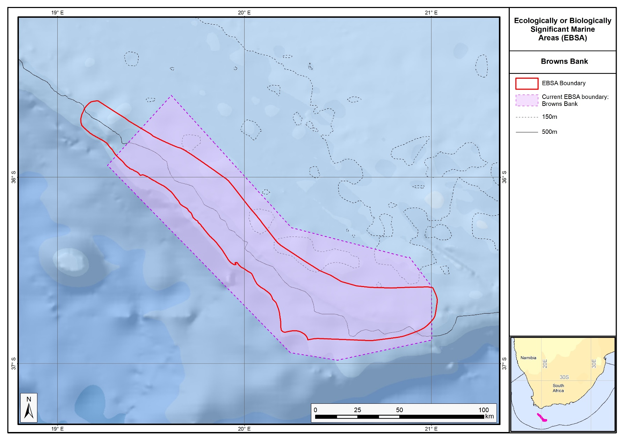
The proposed revised boundaries for the Browns Bank EBSA in relation to its original boundaries.

Agulhas Bank Nursery Area

Revised EBSA Description

General Information

Summary
The Agulhas Bank, a spawning ground and nursery area, is the centre of abundance of numerous warm-temperate species, including several endemic sparids. The bank is an area of wider shelf along the otherwise relatively narrow shelf of South Africa. It is the only warm temperate nursery area for species that spawn on the narrow shelf in the north, and is important for retention, recruitment, and food provision. Dense benthic copepod communities provide a rich food source. The area includes Critically Endangered mud habitats and unique high-profile volcanic offshore reefs that support cold-water coral communities. There is a spawning aggregation area for the threatened endemic reef fish, Petrus rupestris, within this area. Agulhas Bank Nursery Area has been identified as important in two systematic planning initiatives, and contains two existing MPAs at De Hoop and Still Bay. The EBSA boundary has been refined since original delineation to better align with initiatives to expand South Africa’s MPA network, and with the underlying biodiversity features, including fragile and sensitive habitat-forming species.

Introduction of the area
This area within the Agulhas Bank, on the south coast of South Africa, includes benthic and pelagic features that extend from the dune base to shallower than -150 m. Key benthic features include Critically Endangered mud habitats, high-profile volcanic deep reefs, low-profile deep reefs and rare gravels. The Agulhas Bank is important for numerous ecological processes, including spawning, larval retention, recruitment, connectivity and provision of nursery and foraging areas (Hutchings et al., 2002). This area is the centre of abundance of numerous warm temperate species, including several endemic sparids. Some of these species are threatened or overexploited (sparids and sciaenids), and the deep-reef habitats are considered important for the recovery of overexploited deep-reef fish species. However, two coastal MPAs at De Hoop and Still Bay provide some protection for some of the over-exploited species. A spawning area for the threatened endemic reef fish, Petrus rupestris, is located within this area, and aggregations of this species have recently been observed within this EBSA (Sink et al., 2010). The Agulhas Bank area has been identified as a priority using data provided through a national systematic planning initiative (Sink et al., 2011). Hutchings et al. (2002) emphasise the importance of this area as one of three key nursery areas in South Africa and the only one in the warm temperate ecoregion.

Description of the location

EBSA Region
Southern Indian Ocean

Description of location
This EBSA extends from the dune base across to the outer shelf, 175 km south of Cape Infanta in the Western Cape of South Africa, to almost as deep as -150 m. Along the shore it spans the De Hoop MPA in the west, to the headland that marks the start of Mossel Bay in the east. The area includes part of the Alphard and Agulhas Banks, and is entirely within South Africa’s Exclusive Economic Zone (EEZ).

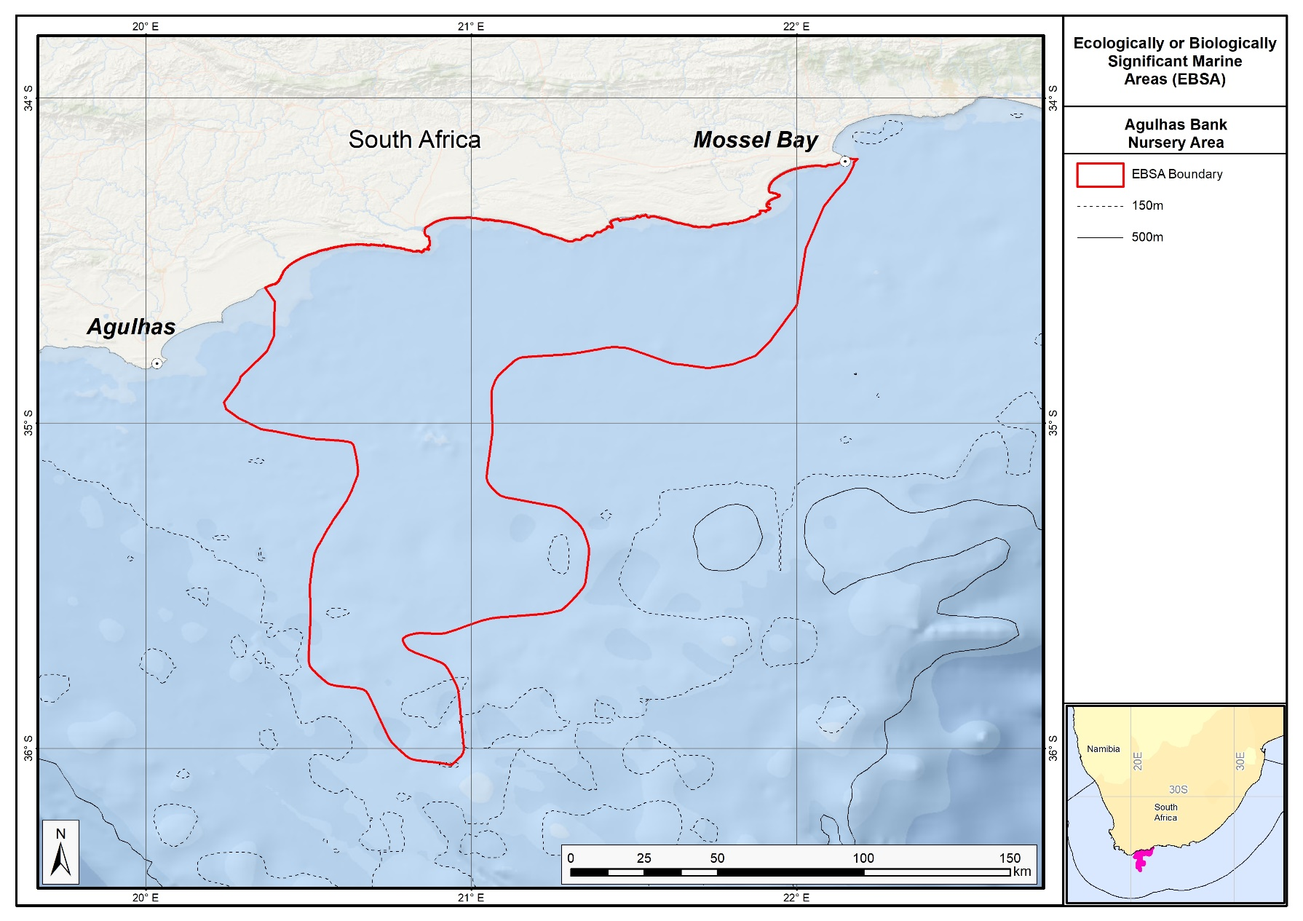
Proposed revised boundaries of the Agulhas Bank Nursery Area EBSA.

Area Details

Feature description of the area
Key benthic features include sandy and mud habitats, high-profile volcanic deep reefs, low-profile deep reefs and rare gravels. The Agulhas Bank is an important nursery area for species that spawn on the narrow shelf further north, including shad (Pomatomus saltatrix) and the sciaenid (Attractoscion aequidens). Squid also spawn in this area, and their paralarvae that hatch from the benthic eggs are dispersed across the bank, where they feed on a dense layer of copepods that occurs close to the seabed in this area (Hutchings et al., 2002). The Agulhas Bank area is moderately productive but has areas of relatively higher productivity within the broader area. There is a cold ridge of water on the central Agulhas Bank, which is a prominent subsurface feature during most summers (Swart and Largier 1987) and is associated with elevated phytoplankton concentrations (Probyn et al., 1994) and dense concentrations of copepods (Verheye et al.1994) and clupeoid fish eggs (Roel et al., 1994). The area is also frequented by migrating regionally Near Threatened loggerhead and regionally Critically Endangered leatherback turtles (Harris et al., 2018). Threatened habitat types in the area include: Critically Endangered Agulhas Muddy Mid Shelf; Endangered Agulhas Bays – West; and Vulnerable Agulhas Exposed Rocky Shore, Agulhas Inner Shelf Reef Sand Mosaic, Agulhas Kelp Forest, Agulhas Sandy Inner Shelf, Agulhas Very Exposed Rocky Shore (Sink et al., 2019). The Agulhas Blues, Agulhas Mid Shelf Reef Sand Mosaic, Agulhas Mixed Shore, Agulhas Muddy Outer Shelf, and Agulhas Sandy Mid Shelf are Near Threatened (Sink et al., 2019). Overexploited and threatened linefish include the endemic red steenbras (Petrus rupestris, Endangered), Dageraad (Chrysoblephus cristiceps, Endangered) and black musselcracker (Cymatoceps nasutus, Vulnerable) (Sink et al., 2012; Sink et al., 2010). The area is also important for juvenile silver kob (Argyrosomus inodorus; Lombard et al., 2010, Attwood et al., 2011). The reef habitats range from low to very high profile, mostly have low rugosity, and support a variety of wall sponges, corals, red algae, kelp, gorgonians, fish and sharks (Gotz et al., 2014; Makwela et al., 2016). Some of these threatened and over-exploited species are protected in the De Hoop and Still Bay MPAs along the coast.
Since the original description, the boundary of this EBSA has been refined to improve precision so that it better represents the features comprising the EBSA, such as benthic habitat types and their condition, and fragile and sensitive habitat-forming species. The new delineation reduces the size of the EBSA to about a third of its original extent, and also aligns better with initiatives to expand the MPA network in South Africa. The site is presented as a Type 1 EBSA because it contains “Spatially stable features whose positions are known and individually resolved on the maps” (sensu Johnson et al., 2018).

Feature conditions and future outlook of the proposed area
South Africa’s National Biodiversity Assessment 2011 (Sink et al., 2012) indicated a range in ecological condition in this area based on an assessment of cumulatives pressures, although the latest assessment (Sink et al., 2019) and boundary revision is such that about half the EBSA is in good ecological condition; the rest is in fair ecological condition. There are deep reefs in the Agulhas Bank Nursery Area that are estimated to be in good ecological condition, even though pressures elsewhere have led to these habitats being considered threatened. Key activities in the area include commercial demersal trawl and longline fisheries, a midwater trawl fishery, trap fisheries for rock lobster, linefishing and expanding petroleum activities.

References
Attwood, C.G., Petersen, S.L., Kerwath, S.E. 2011. By-catch in South Africa's inshore trawl fishery as determined from observer records. ICES Journal of Marine Science, 68: 2163-2174. DOI:10.1093/icesjms/frs162.
Downey-Breedt, N.J., Roberts, M.J., Sauer, W.H.H., Chang, N. 2016. Modelling transport of inshore and deep-spawned chokka squid (Loligo reynaudi) paralarvae off South Africa: the potential contribution of deep spawning to recruitment. Fisheries Oceanography, 25: 28–43.
Götz, A., Kerwath, S.E., Samaai, T., da Silva, C., Wilke, C.G., 2014. An Exploratory Investigation of the Fish Communities Associated with Reefs on the Central Agulhas Bank, South Africa. African Zoology 49, 253-264.Griffiths, MH. 2000. Long-term trends in catch and effort of commercial linefish off South Africa’s Cape Province: snapshots of the 20th century. South African Journal of Marine Science, 22: 81-110.
Harris, L.R., Nel, R., Oosthuizen, H., Meyer, M., Kotze, D., Anders, D., McCue, S., Bachoo, S. 2018. Managing conflicts between economic activities and threatened migratory marine species towards creating a multi-objective blue economy. Conservation Biology, 32: 411-423.
Hutchings, L., Beckley, L.E., Griffiths, M.H., Roberts, M.J., Sundby, S., van der Lingen, C. 2002. Spawning on the edge: spawning grounds and nursery areas around the southern African coastline. Marine and Freshwater Research, 53: 307-318.
Johnson, D.E., Barrio Froján, C., Turner, P.J., Weaver, P., Gunn, V., Dunn, D.C., Halpin, P., Bax, N.J., Dunstan, P.K., 2018. Reviewing the EBSA process: Improving on success. Marine Policy 88, 75-85.
Lagabrielle, E. 2009. Preliminary report: National Pelagic Bioregionalisation of South Africa. Cape Town: South African National Biodiversity Institute.
Lombard, A.T., Attwood, C., Sink, K., Grantham, H. 2010. Use of Marxan to identify potential closed areas to reduce by-catch in the South African trawl fishery. Cape Town: WWF South Africa and the Responsible Fisheries Alliance.
Lutjeharms, J.R.E., Cooper, J., Roberts, M. 2000. Upwelling at the inshore edge of the Agulhas Current. Continental Shelf Research, 20: 737 – 761.
Makwela, M.S., Kerwath, S.E., Götz, A., Sink, K., Samaai, T. & Wilke, C.G. 2016. Notes on a remotely operated vehicle survey to describe reef ichthyofauna and habitats – Agulhas Bank, South Africa. Bothalia, 46: a2108.
Mhlongo, N., Yemane, D., Hendricks, M., Van Der Lingen, C.D. 2015. Have the spawning habitat preferences of anchovy (Engraulis encrasicolus) and sardine (Sardinops sagax) in the southern Benguela changed in recent years? Fisheries Oceanography, 24: 1-14.
Probyn, T.A., Mitchell-Innes, B.A., Brown, P.C., Hutchings, L., Carter, R.A. 1994. A review of primary production and related processes on the Agulhas Bank. South African Journal of Science, 90: 166–73.
Roberson, L.A., Lagabrielle, E., Lombard, A.T., Sink, K., Livingstone, T., Grantham, H., Harris, J.M. 2017. Pelagic bioregionalisation using open-access data for better planning of marine protected area networks. Ocean & Coastal Management, 148: 214-230.
Roel, B.A., Hewitson, J., Kerstan, S., Hampton, I. 1994. The role of the Agulhas Bank in the life cycle of pelagic fish. South African Journal of Science, 90: 185–96.
Sink, K.J., Attwood, C.G., Lombard, A.T., Grantham, H., Leslie, R., Samaai, T., Kerwath, S., Majiedt, P., Fairweather, T., Hutchings, L., van der Lingen, C., Atkinson, L.J., Wilkinson, S., Holness, S., Wolf, T. 2011. Spatial planning to identify focus areas for offshore biodiversity protection in South Africa. Unpublished Report. Cape Town: South African National Biodiversity Institute.
Sink, K., Holness, S., Harris, L., Majiedt, P., Atkinson, L., Robinson, T., Kirkman, S., Hutchings, L., Leslie, R., Lamberth, S., Kerwath, S., von der Heyden, S., Lombard, A., Attwood, C., Branch, G., Fairweather, T., Taljaard, S., Weerts, S., Cowley, P., Awad, A., Halpern, B., Grantham, H., Wolf, T. 2012a. National Biodiversity Assessment 2011: Technical Report. Volume 4: Marine and Coastal Component. South African National Biodiversity Institute, Pretoria.
Sink, K.J., van der Bank, M.G., Majiedt, P.A., Harris, L.R., Atkinson, L., Karenyi, N., Kirkman, S. (eds) 2019. National Biodiversity Assessment 2018 Technical Report Volume 4: Marine Realm. South African National Biodiversity Institute, Pretoria.
Sink, K.J., Wilkinson, S., Atkinson, L.J., Sims, P.F., Leslie, R.W., Attwood, C.G. 2012b. The potential impacts of South Africa’s demersal hake trawl fishery on benthic habitats: historical perspectives, spatial analyses, current review and potential management actions. Unpublished report. Cape Town: South African National Biodiversity Institute.
Swart, V.P., and Largier, J.L. 1987. Thermal structure of Agulhas Bank water. In ‘The Benguela and Comparable Ecosystems’. (Eds A. I. L. Payne, J. A. Gulland and K. H. Brink.) South African Journal of Marine Science, 5: 243–53.
Verheye, H. M., Hutchings, L., Huggett, J. A., Carter, R. A., Peterson, W. T., and Painting, S. J. 1994. Community structure, distribution and trophic ecology of zooplankton on the Agulhas bank with special reference to copepods. South African Journal of Science, 90: 154–66.
Weidberg, N., Porri, F., Von der Meden, C.E.O., Jackson, J.M., Goschen, W., McQuaid, C.D. 2015. Mechanisms of nearshore retention and offshore export of mussel larvae over the Agulhas Bank. Journal of Marine Systems, 144: 70–80.

Other relevant website address or attached documents
Summary of ecosystem types and threat status for the Agulhas Bank Nursery Area EBSA. Data from Sink et al. (2019).
Threat Status | Ecosystem Type | Area km² | Area (%)
Critically Endangered | Agulhas Muddy Mid Shelf | 1731.9 | 12.7
Endangered | Agulhas Bays - West | 323.4 | 2.4
Vulnerable | Agulhas Exposed Rocky Shore | 4.3 | 0.0
 | Agulhas Inner Shelf Reef Sand Mosaic | 389.5 | 2.9
 | Agulhas Kelp Forest | 0.3 | 0.0
 | Agulhas Sandy Inner Shelf | 12.4 | 0.1
 | Agulhas Very Exposed Rocky Shore | 0.3 | 0.0
Near Threatened | Agulhas Blues | 850.3 | 6.2
 | Agulhas Mid Shelf Reef Sand Mosaic | 723.0 | 5.3
 | Agulhas Mixed Shore | 10.5 | 0.1
 | Agulhas Muddy Outer Shelf | 358.0 | 2.6
 | Agulhas Sandy Mid Shelf | 7156.4 | 52.5
Least Concern | Agulhas Dissipative-Intermediate Sandy Shore | 4.5 | 0.0
 | Agulhas Intermediate Sandy Shore | 0.4 | 0.0
 | Agulhas Outer Shelf Gravel Sand Mosaic | 773.1 | 5.7
 | Agulhas Rocky Outer Shelf | 1250.0 | 9.2
 | Alphard Bank | 31.9 | 0.2
Grand Total |  | 13620.0 | 100.0

Assessment of the area against CBD EBSA criteria
C1: Uniqueness or rarity High
Justification
The volcanic offshore Alphard Bank is a unique feature that supports kelp, soft corals, stylasterine corals, and sponges (Sink et al., 2010; Makwela et al., 2016). Rare habitats within this area include some of the muddy and gravel ecosystem types (Sink et al., 2012a, 2019).
C2: Special importance for life-history stages of species High
Justification
The Agulhas Banks Nursery Area is of particular importance for the life-history stages of multiple fish species, including inter alia endemic, threatened, and commercially important species. Fish that use the area for spawning, are: Red steenbras (Petrus rupestris, Endangered) and other linefish species (Hutchings et al., 2002) including anchovy (Mhlongo et al., 2015). There have also been recent observations of spawning aggregations of the endemic reef fish Petrus rupestris within this area (Sink et al., 2010). It also serves as a nursery area for silver kob (Argyrosomus inodorus; Attwood et al., 2011), geelbek, shad, white stumpnose (Hutchings et al., 2002). This area also supports a relatively high proportion of juvenile hake (Merluccius capensis; Sink et al., 2011). Squid paralarvae (Downey-Breedt et al., 2016) and mussel larvae are also present, with mussel veligers found in high abundances up to 87 km from the shore (Weidberg et al., 2015).
C3: Importance for threatened, endangered or declining species and/or habitats High
Justification
Threatened habitat types in the area include: Critically Endangered Agulhas Muddy Mid Shelf; Endangered Agulhas Bays – West; and Vulnerable Agulhas Exposed Rocky Shore, Agulhas Inner Shelf Reef Sand Mosaic, Agulhas Kelp Forest, Agulhas Sandy Inner Shelf, Agulhas Very Exposed Rocky Shore (Sink et al., 2019). The Agulhas Blues, Agulhas Mid Shelf Reef Sand Mosaic, Agulhas Mixed Shore, Agulhas Muddy Outer Shelf, and Agulhas Sandy Mid Shelf are Near Threatened (Sink et al., 2019). This area has also been identified through systematic planning as containing habitat important for overexploited and threatened linefish. This includes the endemic overexploited sparids such as red steenbras (Petrus rupestris), Dageraad (Chrysoblephus cristiceps, Endangered) and black musselcracker (Cymatoceps nasutus, Vulnerable) (Sink et al., 2012). The area is also recognized as important for the recovery of the overexploited silver kob (Argyrosomus inodorus; Attwood et al., 2011), and the reefs serve as aggregating structures for some overexploited fish species, such as the carpenter (Argyrozona argyrozona; Gotz et al., 2014). The overexploitation of linefish species is reported by Griffiths (2000). Further, regionally Near Threatened loggerheads and regionally Critically Endangered leatherbacks frequent this area on their migrations, also using the Agulhas Banks as a foraging ground (Harris et al., 2018).
C4: Vulnerability, fragility, sensitivity, or slow recovery Medium
Justification
High-profile deep reefs and hard grounds with stylasterine corals, black corals, gorgonians and wall sponges have been observed in this area through in-situ ROV surveys (Sink et al., 2010; Makwela et al., 2016). All of these are fragile species that are sensitive to disturbance, taking very long to recover from any impacts to the seabed.
C5: Biological productivity Medium
Justification
The Agulhas Bank area is moderately productive (Hutchings et al., 2002 and references therein) but has areas of relatively higher productivity within the broader area. There is a ridge of cold water, which is a prominent subsurface feature during most summers on the central Agulhas Bank (Swart and Largier 1987) and is associated with elevated phytoplankton concentrations (Probyn et al., 1994) and dense concentrations of copepods (Verheye et al.1994) and clupeoid fish eggs (Roel et al., 1994).

C6: Biological diversity Medium
Justification
There is high sparid and invertebrate biodiversity (core of the distribution of several endemic species) in the Agulhas Bank Nursey Area. The reef habitats range from low to very high profile, mostly have low rugosity, and support a variety of wall sponges, corals, red algae, kelp, gorgonians, fish and sharks (Gotz et al., 2014; Makwela et al., 2016). The site includes fish such as shad (Pomatomus saltatrix), geelbek (Attractoscion aequidens), red steenbras (Petrus rupestris), Dageraad (Chrysoblephus cristiceps), black musselcracker (Cymatoceps nasutus), and silver kob (Argyrosomus inodorus; Lombard et al., 2010; Sink et al., 2010; Attwood et al., 2011; Sink et al., 2012). Other well-known species include squid (Hutchings et al., 2002) and loggerhead and leatherback turtles (Harris et al., 2018). Further, this area was selected as a priority in systematic planning because of the relatively higher habitat diversity and thus opportunities to meet multiple biodiversity targets efficiently.

C7: Naturalness Medium
Justification
There is only one pelagic habitat type (Ab2) within this area, which is in good ecological condition (Sink et al., 2012). Benthic condition ranges from poor to good (Sink et al., 2012), but some deep reefs are apparently untrawled and in good ecological condition. The volcanic feature known as the Alphard Banks is in good ecological condition (Sink et al., 2010). The two MPAs in the EBSA also provide protection from many pressures and are in better ecological condition compared to that of the surrounding area.

Status of submission
The Agulhas Bank EBSA was recognized as meeting EBSA criteria by the Conference of the Parties. The revised description, criteria assessment and boundaries still need to be submitted to COP for approval.

COP Decision
dec-COP-12-DEC-22

End of proposed EBSA revised description

Motivation for Submission
Significant changes have been made to the Agulhas Bank Nursery Area EBSA description. Additional data have resulted in further substantiated evaluations of two of the EBSA criteria, namely Criterion 2: importance for life-history stages, and Criterion 3: importance for threatened species. Additional references have been added and updates to the description were made. A supplementary table of the habitats represented in the EBSA and their associated threat status was also included.
There has also been a significant delineation change of this EBSA to more closely focus the EBSA on the key biodiversity features that underlie its EBSA status. The delineation process included an initial stakeholder review which identified the need to update boundaries, a technical mapping process and then an expert review workshop where boundary delineation options were discussed. The boundaries were revised a final time to accommodate the latest NBA 2018 assessment results and the review workshop discussion. The delineation process used a combination of Systematic Conservation Planning and Multi-Criteria Analysis methods. The features used in the analysis were:
- Irreplaceable and near irreplaceable (i.e. very high selection frequency) sites, as well as focus areas identified in the Systematic Conservation Plans undertaken for the West Coast by Majiedt et al. (2013), offshore areas (Sink et al., 2011) and by Holness et al. (2014) were incorporated.
- Delineations and threat status of consitituent ecosystem types in the area were included in the analysis and used to refine the boundary of the EBSA.
- Areas of high relative naturalness of benthic and coastal systems and pelagic systems identified in the National Biodiversity Assessment 2011 (Sink et al., 2012a) were included in the analysis.
- Distributions of known fragile, vulnerable and sensitive habitat-forming species were included (Unpublished SANBI and SAEON data).
The multi-criteria analysis resulted in a value surface. The cut-off value used to determine the extent of the EBSA was based on expert input and quantitative analysis of effective inclusion of the above features. This entailed taking an iterative parameter calibration-based approach whereby the spatial efficiency of the inclusion of the targeted features was evaluated. The approach aimed to identify a cut-off which most efficiently included prioritised features while minimizing the inclusion of impacted areas. The final boundaries shown in the map were validated in a national workshop.

Research Needs
This item will be populated in a workshop to be held in August/September 2018.

Future Process
Portions of the EBSA have been gazetted for inclusion into the Agulhas Muds MPA and the Agulhas Bank Complex MPA. It is unclear if this EBSA will be subject to detailed attention in the MARISMA EBSA status assessment and management options workplan. This will be decided on in a workshop to be held in August/September 2018.

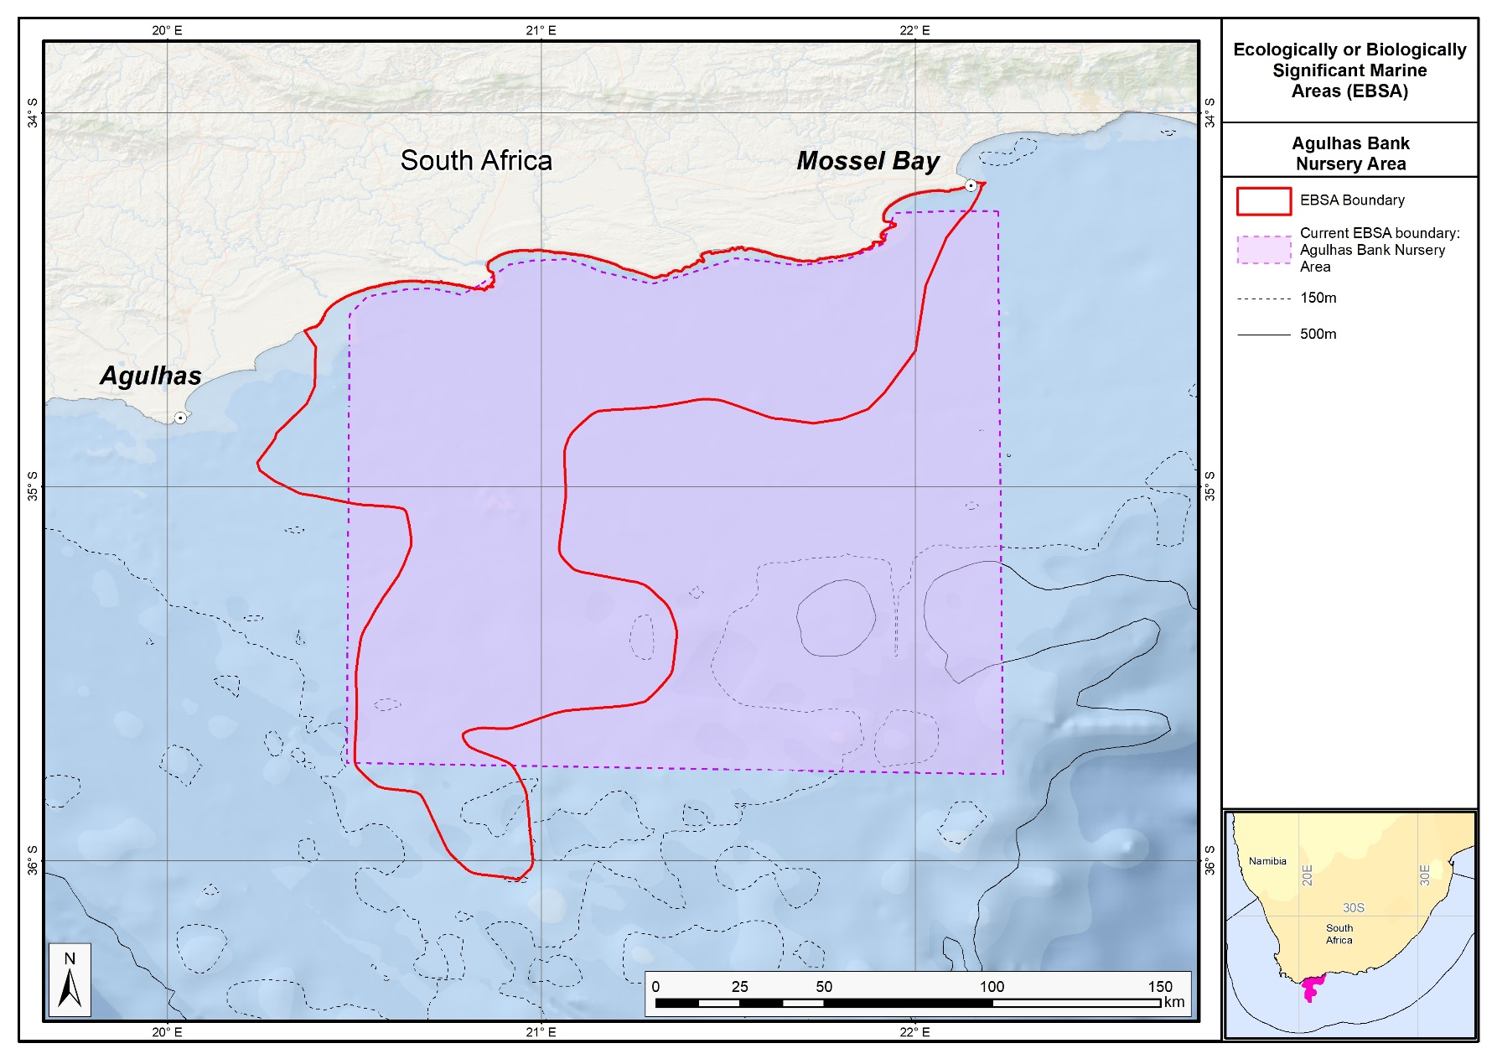
The proposed revised boundaries for the Agulhas Bank Nursery Area EBSA in relation to its original boundaries.

Mallory Escarpment and Trough (Formerly Agulhas Slope and Seamounts)

Revised EBSA Description

General Information

Summary
The outer margin along the southern tip of the Agulhas Bank represents a dynamic offshore area with high productivity and high pelagic and benthic habitat heterogeneity. The Agulhas and Southern Benguela ecoregions meet at this point, and sporadic shelf-edge upwelling enhances the productivity along the outer margin. The area is recognized as a spawning area for sardine, anchovy, horse mackerel and hake, and this apex area of the Agulhas Bank is recognized as a critical area for retention of spawning products. Eddies in this area help recirculate water inshore and link important nursery areas with spawning habitat on the shelf edge. Importantly, the EBSA includes the Mallory escarpment and trough segment of the Agulhas-Falkland Fracture Zone. This is a unique feature in the region, and certainly slopes as steep as this one (20°) are globally very rare. The area was identified as a priority through a national spatial plan because of high habitat diversity. Since the original description (of Agulhas Slope and Seamounts), the boundary has been refined and split into two to better represent the underlying EBSA features. No ecological research has been conducted in this EBSA but is strongly recommended.

Introduction of the area
Mallory Escarpment and Trough includes the outer margin along the southern tip of the Agulhas Bank in South Africa, chiefly encompassing the key features of the Agulhas-Falkland Fracture Zone, including a slope as steep as 20° in some places (De Wet 2012). The Agulhas and Southern Benguela ecoregions (Sink et al., 2012) meet at this point, resulting in a dynamic offshore area with high pelagic and benthic habitat heterogeneity. Further, sporadic shelf-edge upwelling enhances the productivity along the outer margin (Lagabrielle, 2009, Roberson et al., 2017). The area is recognized as a spawning area for sardine, anchovy, horse mackerel and hake, and this apex of the Agulhas Bank is recognized as a critical area for retention of spawning products (Hutchings et al., 2002). Eddies in this area help recirculate water inshore and link important nursery areas with spawning habitat on the shelf edge. Leatherback turtles also frequent this area along their migrations (Harris et al., 2018). This area was identified as a priority through a national plan to identify focus areas for offshore protection (Sink et al., 2011) because it has relatively high habitat diversity and can meet multiple benthic and pelagic habitat conservation targets in a small area. It also contains regionally unique, globally very rare features.

Description of the location

EBSA Region
Southern Indian Ocean

Description of location
The EBSA focus area is at the apex of the Agulhas Bank at the southern tip of the continental shelf edge off southern Africa. It is directly south of Cape Infanta and Cape Agulhas in the Agulhas-Falkland Fracture Zone, and is entirely within South Africa’s EEZ. It contains the Mallory escarpment and trough, and lies immediately west of the Shackleton Seamount Complex EBSA.

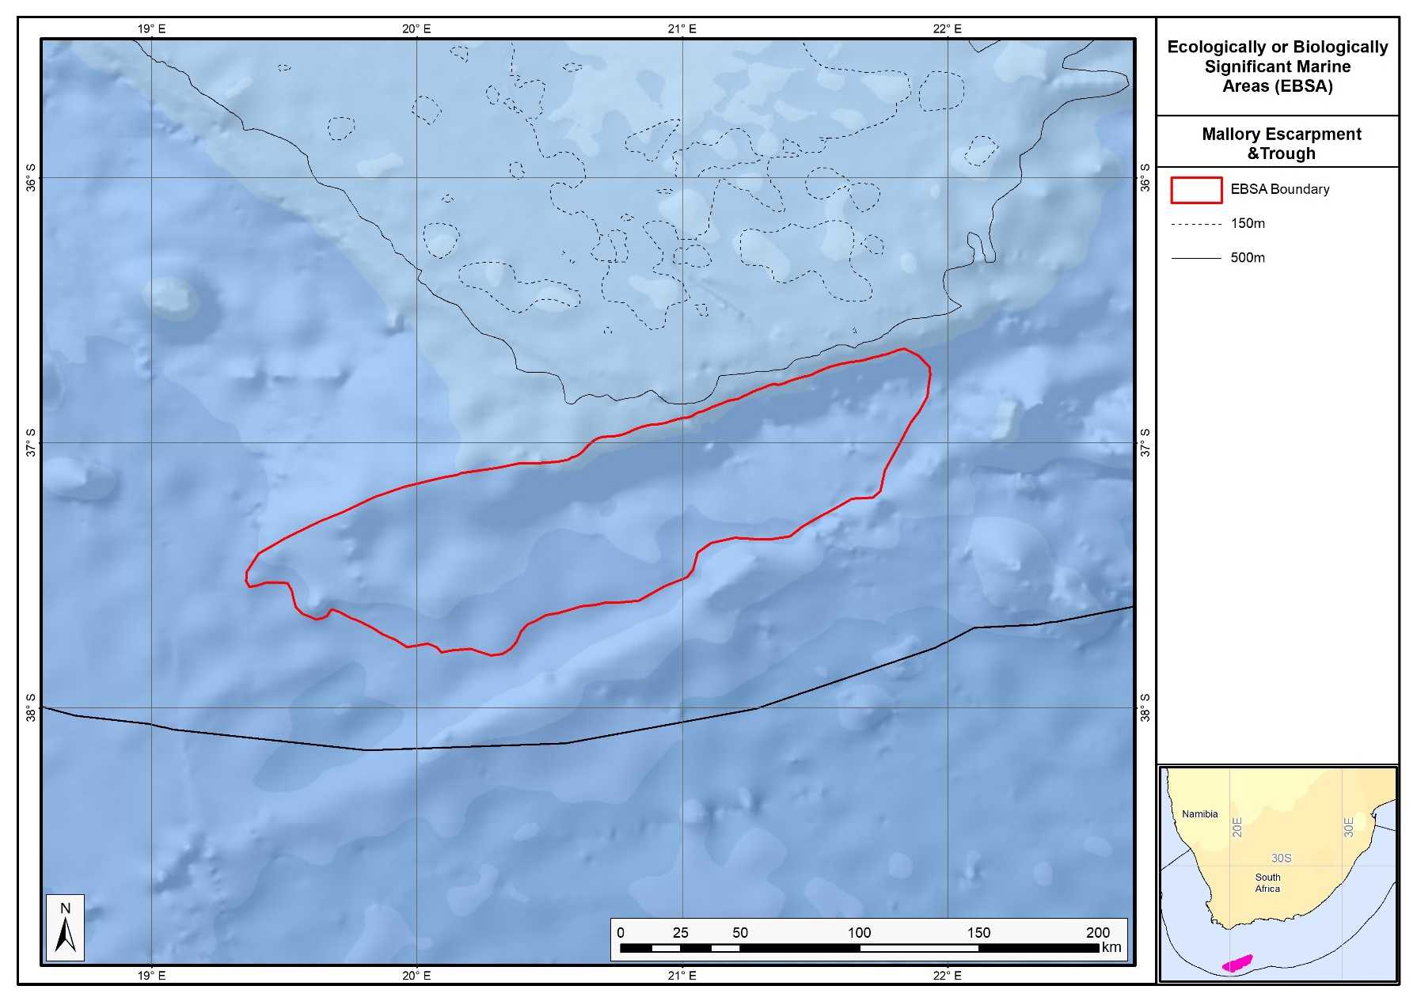
Proposed revised boundaries of the Mallory Escarpment and Trough EBSA.

Area Details

Feature description of the area
The area includes benthic and pelagic features, including: the shelf edge, a very steep slope and a trough as part of the Agulhas-Falkland Fracture Zone; shelf-edge driven upwelling; and fragile and sensitive habitat-forming species. Habitat diversity is thus particularly high for a location this far offshore. This dynamic area consequently supports numerous ecological processes, such as spawning and foraging, and comprises a rich diversity of both resident (e.g., benthic gorgonians) and transient (e.g., migrating leatherbacks) species.
The delineation of this EBSA was refined since its first description, and is now split into two EBSAs: one for the seamounts, and one for the escarpment and trough features. The revision was based on high selection frequency of sites in the two systematic biodiversity plans covering the area, tighter alignment to the benthic topography (from a new national dataset: De Wet 2012), new focus areas for MPA expansion in South Africa, presence of fragile and sensitive habitat-forming species, and new delineation of the constitutent ecosystem types. Effectively, these new data helped to improve the precision of the EBSA boundary so that it better reflects the underlying features. It is presented as a Type 2 EBSA because it contains “spatially stable features whose individual positions are known, but a number of individual cases are being grouped” (sensu Johnson et al., 2018).

Feature conditions and future outlook of the proposed area
The shelf edge, slope and trough have not been sampled, although in-situ research is recommended in this area. Nevertheless, there are various fisheries operating in the area, but some of the hard grounds represented in the EBSA are outside of the trawl footprint. Broadly speaking, there is relatively little pressure in this area at present, the ecosystem types are in good ecological condition.

References
De Wet, W. 2012. Bathymetry of the South African Continental Shelf. MSc dissertation. University of Cape Town, South Africa.
Harris, L.R., Nel, R., Oosthuizen, H., Meyer, M., Kotze, D., Anders, D., McCue, S., Bachoo, S. 2018. Managing conflicts between economic activities and threatened migratory marine species towards creating a multi-objective blue economy. Conservation Biology, 32, 411-423.
Hutchings, L., Beckley, L.E., Griffiths, M.H., Roberts, M.J., Sundby, S., van der Lingen, C. 2002. Spawning on the edge: spawning grounds and nursery areas around the southern African coastline. Marine and Freshwater Research, 53: 307-318.
Johnson, D.E., Barrio Froján, C., Turner, P.J., Weaver, P., Gunn, V., Dunn, D.C., Halpin, P., Bax, N.J., Dunstan, P.K., 2018. Reviewing the EBSA process: Improving on success. Marine Policy 88, 75-85.
Lagabrielle, E. 2009. Preliminary report: National Pelagic Bioregionalisation of South Africa. Cape Town: South African National Biodiversity Institute.
Lutjeharms, J.R.E., Cooper, J., Roberts, M. 2000. Upwelling at the inshore edge of the Agulhas Current. Continental Shelf Research, 20: 737 – 761.
Roberson, L.A., Lagabrielle, E., Lombard, A.T., Sink, K., Livingstone, T., Grantham, H., Harris, J.M. 2017. Pelagic bioregionalisation using open-access data for better planning of marine protected area networks. Ocean & Coastal Management, 148: 214-230.
Sink, K. 2016. Deep Secrets: the outer shelf and slope ecosystems of South Africa. Cruise Report: ALG 230 – ACEP_DSC.
Sink, K.J., Attwood, C.G., Lombard, A.T., Grantham, H., Leslie, R., Samaai, T., Kerwath, S., Majiedt, P., Fairweather, T., Hutchings, L., van der Lingen, C., Atkinson, L.J., Wilkinson, S., Holness, S., Wolf, T. 2011. Spatial planning to identify focus areas for offshore biodiversity protection in South Africa. Unpublished Report. Cape Town: South African National Biodiversity Institute.
Sink, K., Holness, S., Harris, L., Majiedt, P., Atkinson, L., Robinson, T., Kirkman, S., Hutchings, L., Leslie, R., Lamberth, S., Kerwath, S., von der Heyden, S., Lombard, A., Attwood, C., Branch, G., Fairweather, T., Taljaard, S., Weerts, S., Cowley, P., Awad, A., Halpern, B., Grantham, H., Wolf, T. 2012. National Biodiversity Assessment 2011: Technical Report. Volume 4: Marine and Coastal Component. South African National Biodiversity Institute, Pretoria.
Sink, K.J., van der Bank, M.G., Majiedt, P.A., Harris, L.R., Atkinson, L., Karenyi, N., Kirkman, S. (eds) 2019. National Biodiversity Assessment 2018 Technical Report Volume 4: Marine Realm. South African National Biodiversity Institute, Pretoria.

Other relevant website address or attached documents
Summary of habitat types and threat status for the Mallory Escarpment and Trough EBSA. Data from Sink et al. (2019).
Threat Status | Ecosystem Type | Area (km²) | Area (%)
Least Concern | Agulhas Basin Abyss | 7799.9 | 59.7
 | Cape Basin Abyss | 357.1 | 2.7
 | Southeast Atlantic Lower Slope | 527.7 | 4.0
 | Southeast Atlantic Mid Slope | 3.0 | 0.0
 | Southwest Indian Lower Slope | 3487.2 | 26.7
 | Southwest Indian Mid Slope | 898.0 | 6.9
Grand Total |  | 13072.9 | 100.0

Assessment of the area against CBD EBSA criteria
C1: Uniqueness or rarity High
Justification
The steep slope (20°) of Mallory Trough is the steepest portion of the entire South African continental shelf. It is also the only trough system in the Benguela region, and slopes as steep as 20° are globally very rare.

C2: Special importance for life-history stages of species High
Justification
The Agulhas Slope and Seamounts is recognized as a spawning area for small pelagic fish (sardine, anchovy, horse mackerel) and hake (Hutchings et al., 2002, Sink et al., 2011). This apex area of the Agulhas Bank is also recognized as a critical area for retention of spawning products. Eddies in this area help re-circulate water inshore and link important nursery areas with spawning habitat on the shelf edge. The shelf edge constitutes foraging area for offshore seabirds (Birdlife data, see references below).
C3: Importance for threatened, endangered or declining species and/or habitats Medium
Justification
One of the pelagic habitat types in the area is characterised by elevated productivity and frequent fronts due to shelf edge upwelling (Lutjeharms et al., 2000, Lagabrielle 2009, Roberson et al., 2017). Consequently, regionally Critically Endangered leatherback turtles frequent this area (Petersen et al., 2009a; Harris et al., 2018), and the shelf edge is a feeding area for threatened seabirds such as Albatross (Petersen et al., 2009b).
C4: Vulnerability, fragility, sensitivity, or slow recovery High
Justification
This area includes hard shelf edge and a very steep slope. These are likely to support fragile long-lived biota. Video images of the shelf edge show cold-water corals, gorgonians and large sponges (Sink et al., 2011). Vulnerable biota that use this area include long-lived seabirds, turtles and sharks, and the area has been identified by analyses aimed at identifying priority areas for reducing by-catch in the large pelagic fishery (Sink et al., 2011.)
C5: Biological productivity High
Justification
There is higher productivity here, which is related to the eastern limit of the Benguela upwelling on the outer shelf (Pelagic habitat type Ab3) and very frequent SST and chlorophyll fronts (Lutjeharms et al., 2000, Lagabrielle 2009, Sink et al., 2011, 2012, Roberson et al., 2017). Cool productive water is advected onto the shelf in this sheer zone through Agulhas Current–driven upwelling cells (Lutjeharms et al., 2000).
C6: Biological diversity High
Justification
This area has high pelagic and benthic habitat heterogeneity for an offshore site, comprising six ecosystem types at the confluence of the Indian and Atlantic Ocean basins. The very steep slope is also expected to host a rich diversity of species because it spans a very large depth range over a proportionately small area.
C7: Naturalness High
Justification
Rough grounds and strong currents already offer some protection from pressures to this area (Sink et al., 2011, 2012). Relatively lower levels of disturbance occur in this area (Sink et al., 2012), and most of the local hard areas fall outside of the hake trawl footprint (Sink et al., 2011).

Status of submission
The Agulhas Slope and Seamounts EBSA was recognized as meeting EBSA criteria by the Conference of the Parties. The revised Mallory Escarpment and Trough EBSA name, description, and boundaries still need to be submitted to COP for approval.

COP Decision
dec-COP-12-DEC-22
End of proposed EBSA revised description

Motivation for Submission
Significant changes have been made to the delineation of the original Agulhas Slope and Seamounts EBSA and to the description, such that it is necessary to split the original EBSA into two, and revise the name of this EBSA to Mallory Escarpment and Trough to accurately reflect the features. Additional references have been added and updates to the description were made. A supplementary table of the ecosystem types represented in the EBSA and their associated threat status was also included.
An important change has been the significant delineation change of this EBSA to more closely focus the EBSA on the key biodiversity features in this area that support its EBSA status. The delineation process included an initial stakeholder review which identified the need to update boundaries, a technical mapping process and then an expert review workshop where boundary delineation options were reviewed, revised and finalised. The delineation process used a combination of Systematic Conservation Planning and Multi-Criteria Analysis methods. The features used in the analysis were:
- Key physical features (i.e. the seamounts, escarpment and trough) identified from the latest GEBCO data, global benthic geomorphology mapping (www.bluehabitats.org, Harris et al., 2014), the National Biodiversity Assessment 2011 (Sink et al., 2012) and BCC spatial mapping project (Holness et al., 2014) were incorporated.
- Irreplaceable and near irreplaceable (i.e. very high selection frequency) sites, as well as focus areas identified in the Systematic Conservation Plans undertaken for the West Coast by Majiedt et al. (2013), offshore areas (Sink et al., 2011) and by Holness et al. (2014) were incorporated.
- Delineations and threat status of consitituent ecosystem types in the area were included in the analysis and used to refine the boundary of the EBSA.
- Areas of high relative naturalness of benthic and coastal systems and pelagic systems identified in the National Biodiversity Assessment 2011 (Sink et al., 2012a) were included in the analysis.
- Distributions of known fragile, vulnerable and sensitive habitat-forming species were included (Unpublished SANBI and SAEON data).
The multi-criteria analysis resulted a value surface. The cut-off value used to determine the extent of the EBSA was based on expert input and quantitative analysis of effective inclusion of the above features. This entailed taking an iterative parameter calibration-based approach whereby the spatial efficiency of the inclusion of the targeted features was evaluated. The approach aimed to identify a cut-off which most efficiently included prioritised features while minimizing the inclusion of impacted areas. The final boundaries shown in the map were validated in a national workshop.

Research Needs
This item will be populated in a workshop to be held in August/September 2018.

Future Process
Portions of the EBSA have been gazetted for inclusion into the Southwest Indian Seamount MPA. It is unclear if this EBSA will be subject to detailed attention in the MARISMA EBSA status assessment and management options workplan. This will be decided on in a workshop to be held in August/September 2018.

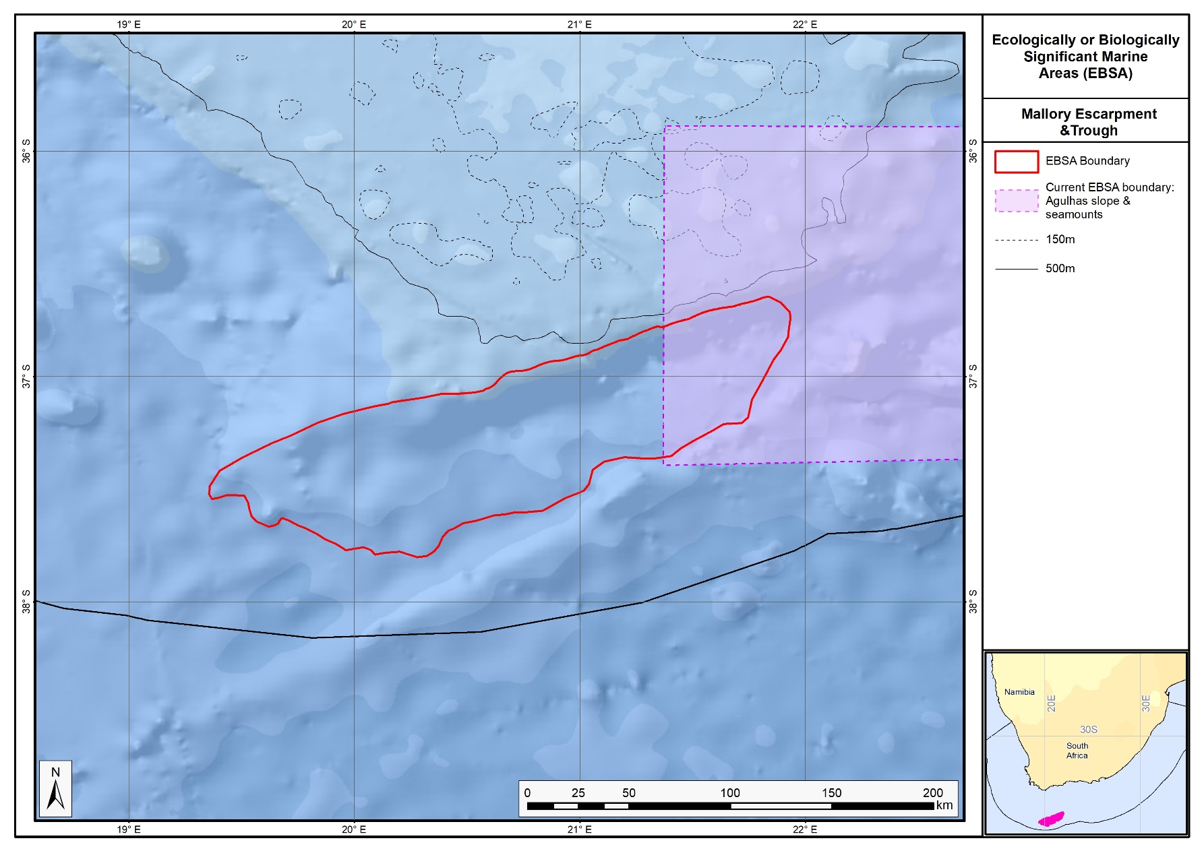
The proposed revised boundaries for the Mallory Escarpment and Trough EBSA in relation to the original Agulhas Slope and Seamounts.

Shackleton Seamount Complex (Formerly Agulhas Slope and Seamounts)

Revised EBSA Description

General Information

Summary
The outer margin along the southern tip of the Agulhas Bank represents a dynamic offshore area with high productivity and high pelagic and benthic habitat heterogeneity. The Agulhas and Southern Benguela ecoregions meet at this point, and sporadic shelf-edge upwelling enhances the productivity along the outer margin. The area is recognized as a spawning area for sardine, anchovy, horse mackerel and hake, and this apex area of the Agulhas Bank is recognized as a critical area for retention of spawning products. Here, eddies help recirculate water inshore and link important nursery areas with spawning habitat on the shelf edge. Notably, this EBSA also contains the Mallory, Shackleton and Natal Seamounts. This area was identified as a priority through a national spatial plan because of high habitat diversity. Since the original description, the boundary of this EBSA has been refined to better represent the underlying EBSA features, and split into two: Shackleton Seamount Complex, and Mallory Escarpment and Trough. Although a recent cruise surveyed two sites at the northern edge of the EBSA, deteriorating weather conditions limited operations; further research and in situ surveys of the unexplored hard shelf edge and seamounts are recommended in this area.

Introduction of the area
Shackleton Seamount Complex includes the outer margin along the southern tip of the Agulhas Bank in South Africa. It is a dynamic offshore area with high pelagic and benthic habitat heterogeneity. The area includes outer shelf, shelf edge, slope and seamount habitats. The Agulhas and Southern Benguela ecoregions meet at this point (Sink et al., 2012), and sporadic shelf edge upwelling enhances the productivity along the outer margin (Lagabrielle, 2009, Roberson et al., 2017). The site is recognized as a spawning area for sardine, anchovy, horse mackerel and hake, and this apex of the Agulhas Bank is recognized as a critical area for retention of spawning products (Hutchings et al., 2002). Here, eddies help recirculate water inshore and link important nursery areas with spawning habitat on the shelf edge. Leatherback turtles also frequent these seamounts along their migrations (Harris et al., 2018). This area was identified as a priority through a national plan to identify focus areas for offshore protection (Sink et al., 2011) because it has relatively high habitat diversity and can meet multiple benthic and pelagic habitat conservation targets in a small area.

Description of the location

EBSA Region
Southern Indian Ocean

Description of location
The EBSA focus area is at the apex of the Agulhas Bank at the southern tip of the continental shelf edge off southern Africa. It is directly south of Mossel Bay in the Agulhas-Falkland Fracture Zone, and is entirely within South Africa’s EEZ. It contains the Mallory, Shackleton and Natal Seamounts, and lies immediately east of the Mallory Escarpment and Trough EBSA.

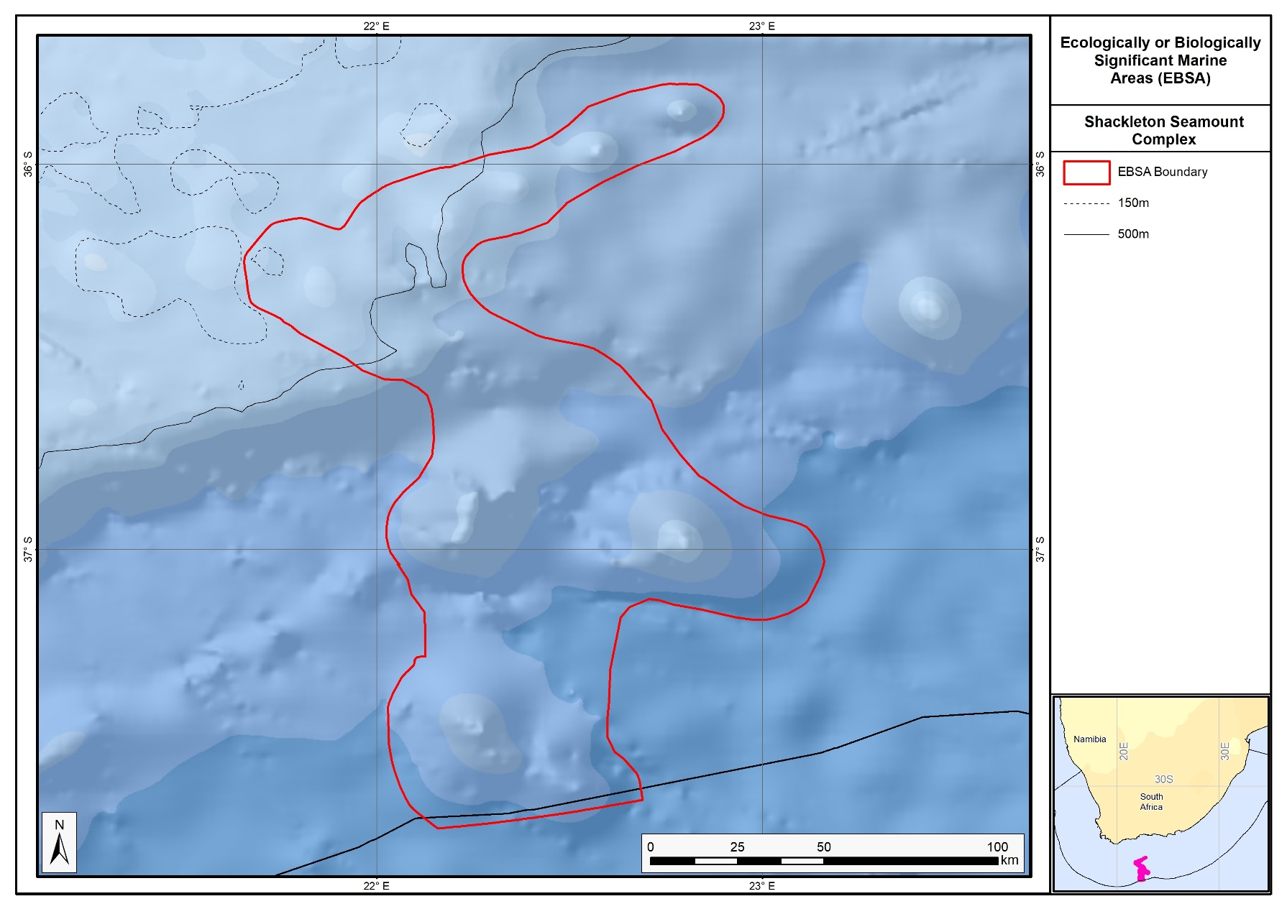
Proposed revised boundaries of the Shackleton Seamount Complex EBSA.

Area Details

Feature description of the area
The area includes benthic and pelagic features, including shelf edge, slope and seamounts, shelf-edge driven upwelling, and fragile and sensitive habitat-forming species. Habitat diversity is thus particularly high, with eight ecosystem types occurring in this dynamic area. It consequently supports numerous ecological processes, such as spawning and foraging, and comprises a rich diversity of both resident (e.g., benthic gorgonians) and transient (e.g., migrating leatherbacks) species. Two sites at the northern edge of the EBSA were recently surveyed; however, deteriorating weather conditions limited research operations (Sink 2016). Nevertheless, the sites were reported to be less muddy than expected, and samples of yellow scleractinian coral, stylasterine corals and bryozoans were collected (Sink 2016).
The delineation of this EBSA was refined since its first description, and is now split into two EBSAs: one for the seamounts, and one for the escarpment and trough features. The revision was based on high selection frequency of sites in the two systematic biodiversity plans covering the area, tighter alignment to the benthic topography (from a new national dataset: De Wet 2012), new focus areas for MPA expansion in South Africa, presence of fragile and sensitive habitat-forming species, and presence of threatened benthic ecosystem types. Effectively, these new data helped to improve the precision of the EBSA boundary so that it better reflects the underlying features. It is presented as a Type 2 EBSA because it contains “spatially stable features whose individual positions are known, but a number of individual cases are being grouped” (sensu Johnson et al., 2018).

Feature conditions and future outlook of the proposed area
The shelf edge and seamounts have not been sampled, although in-situ research is recommended in this area. Nevertheless, there are various fisheries operating in the area, but some of the hard grounds represented in the EBSA are outside of the trawl footprint. Broadly speaking, there is relatively little pressure in this area at present, and the ecosystem types are in good condition.

References
De Wet, W. 2012. Bathymetry of the South African Continental Shelf. MSc dissertation. University of Cape Town, South Africa.
Harris, L.R., Nel, R., Oosthuizen, H., Meyer, M., Kotze, D., Anders, D., McCue, S., Bachoo, S. 2018. Managing conflicts between economic activities and threatened migratory marine species towards creating a multi-objective blue economy. Conservation Biology, 32, 411-423.
Hutchings, L., Beckley, L.E., Griffiths, M.H., Roberts, M.J., Sundby, S., van der Lingen, C. 2002. Spawning on the edge: spawning grounds and nursery areas around the southern African coastline. Marine and Freshwater Research, 53: 307-318.
Johnson, D.E., Barrio Froján, C., Turner, P.J., Weaver, P., Gunn, V., Dunn, D.C., Halpin, P., Bax, N.J., Dunstan, P.K., 2018. Reviewing the EBSA process: Improving on success. Marine Policy 88, 75-85.
Lagabrielle, E. 2009. Preliminary report: National Pelagic Bioregionalisation of South Africa. Cape Town: South African National Biodiversity Institute.
Lutjeharms, J.R.E., Cooper, J., Roberts, M. 2000. Upwelling at the inshore edge of the Agulhas Current. Continental Shelf Research, 20: 737 – 761.
Roberson, L.A., Lagabrielle, E., Lombard, A.T., Sink, K., Livingstone, T., Grantham, H., Harris, J.M. 2017. Pelagic bioregionalisation using open-access data for better planning of marine protected area networks. Ocean & Coastal Management, 148: 214-230.
Sink, K. 2016. Deep Secrets: the outer shelf and slope ecosystems of South Africa. Cruise Report: ALG 230 – ACEP_DSC.
Sink, K.J., Attwood, C.G., Lombard, A.T., Grantham, H., Leslie, R., Samaai, T., Kerwath, S., Majiedt, P., Fairweather, T., Hutchings, L., van der Lingen, C., Atkinson, L.J., Wilkinson, S., Holness, S., Wolf, T. 2011. Spatial planning to identify focus areas for offshore biodiversity protection in South Africa. Unpublished Report. Cape Town: South African National Biodiversity Institute.
Sink, K., Holness, S., Harris, L., Majiedt, P., Atkinson, L., Robinson, T., Kirkman, S., Hutchings, L., Leslie, R., Lamberth, S., Kerwath, S., von der Heyden, S., Lombard, A., Attwood, C., Branch, G., Fairweather, T., Taljaard, S., Weerts, S., Cowley, P., Awad, A., Halpern, B., Grantham, H., Wolf, T. 2012. National Biodiversity Assessment 2011: Technical Report. Volume 4: Marine and Coastal Component. South African National Biodiversity Institute, Pretoria.
Sink, K.J., van der Bank, M.G., Majiedt, P.A., Harris, L.R., Atkinson, L., Karenyi, N., Kirkman, S. (eds) 2019. National Biodiversity Assessment 2018 Technical Report Volume 4: Marine Realm. South African National Biodiversity Institute, Pretoria.

Other relevant website address or attached documents
Summary of habitat types and threat status for the Shackleton Seamount Complex EBSA. Data from Sink et al. (2019).
Threat Status | Ecosystem Type | Area (km²) | Area (%)
Least Concern | Agulhas Basin Abyss | 3403.0 | 28.4
 | Agulhas Outer Shelf Reef Coarse Sediment Mosaic | 805.8 | 6.7
 | Agulhas Rocky Shelf Edge | 1003.6 | 8.4
 | Southwest Indian Lower Slope | 1765.0 | 14.7
 | Southwest Indian Mid Slope | 1260.7 | 10.5
 | Southwest Indian Seamount | 2072.4 | 17.3
 | Southwest Indian Slope Seamount | 888.7 | 7.4
 | Southwest Indian Upper Slope | 733.0 | 6.1
Grand Total |  | 11932.2 | 99.6

Assessment of the area against CBD EBSA criteria
C1: Uniqueness or rarity Medium
Justification
This area includes 3 of 4 known seamounts within the Davie Seamount cluster (Sink et al., 2011, 2012). These seamounts are relatively isolated and are thus likely to host distinct communities.

C2: Special importance for life-history stages of species High
Justification
Shackleton Seamount Complex is recognized as a spawning area for small pelagic fish (sardine, anchovy, horse mackerel) and hake (Hutchings et al., 2002, Sink et al., 2011). This apex area of the Agulhas Bank is also recognized as a critical area for retention of spawning products. Eddies in this area help re-circulate water inshore and link important nursery areas with spawning habitat on the shelf edge. The shelf edge constitutes foraging area for offshore seabirds (Birdlife data, see references below), and the seamounts are a foraging area for leatherback turtles (Harris et al., 2018). It is also an important Mako shark nursery area.
C3: Importance for threatened, endangered or declining species and/or habitats Medium
Justification
One of the pelagic habitat types in the area is characterised by elevated productivity and frequent fronts due to shelf edge upwelling (Lutjeharms et al., 2000, Lagabrielle 2009, Roberson et al., 2017). Consequently, regionally Critically Endangered leatherback turtles frequent this area (Petersen et al., 2009a; Harris et al., 2018), and the shelf edge is a feeding area for threatened seabirds such as Albatross (Petersen et al., 2009b).
C4: Vulnerability, fragility, sensitivity, or slow recovery High
Justification
This area includes hard shelf edge and seamounts (some of the hard grounds are untrawled). These are likely to support fragile long-lived biota. Video images of the shelf edge show cold-water corals, gorgonians and large sponges (Sink et al., 2011). Vulnerable biota that use this area include long-lived seabirds, turtles and sharks, and the area has been identified by analyses aimed at identifying priority areas for reducing by-catch in the large pelagic fishery (Sink et al., 2011.)
C5: Biological productivity High
Justification
There is higher productivity here, which is related to the eastern limit of the Benguela upwelling on the outer shelf (Pelagic habitat type Ab3) and very frequent SST and chlorophyll fronts (Lutjeharms et al., 2000, Lagabrielle 2009, Sink et al., 2011, 2012, Roberson et al., 2017). Cool productive water is advected onto the shelf in this sheer zone through Agulhas Current-driven upwelling cells (Lutjeharms et al., 2000).
C6: Biological diversity High
Justification
This area has high pelagic and benthic habitat heterogeneity. Four pelagic habitat types (Ab3, Bc1, Cb3 and Cb4) and occur in this dynamic area (Sink et al., 2011, 2012), with eight ecosystem types present that include shelf, slope, seamount and abyssal types (Sink et al., 2019).
C7: Naturalness High
Justification
Rough grounds and strong currents already offer some protection from pressures to this area (Sink et al., 2011, 2012). Relatively lower levels of disturbance occur in this area (Sink et al., 2012), and most of the local hard areas fall outside of the hake trawl footprint (Sink et al., 2011).

Status of submission
The Agulhas Slope and Seamounts EBSA was recognized as meeting EBSA criteria by the Conference of the Parties. The revised Shackleton Seamount Complex EBSA name, description, and boundaries still need to be submitted to COP for approval.

COP Decision
dec-COP-12-DEC-22

End of proposed EBSA revised description

Motivation for Submission
Significant changes have been made to the delineation of the original Agulhas Slope and Seamounts EBSA and to the description, such that it is necessary to split the original EBSA into two, and revise the name of this EBSA to Shackleton Seamount Complex to accurately reflect the features. Additional references have been added and updates to the description were made. A supplementary table of the habitats represented in the EBSA and their associated threat status was also included.
An important change has been the significant delineation change of this EBSA to more closely focus the EBSA on the key biodiversity features in this area that support its EBSA status. The delineation process included an initial stakeholder review which identified the need to update boundaries, a technical mapping process and then an expert review workshop where boundary delineation options were reviewed, revised again and then finalised. The delineation process used a combination of Systematic Conservation Planning and Multi-Criteria Analysis methods. The features used in the analysis were:
- Key physical features (i.e. the seamounts, escarpment and trough) identified from the latest GEBCO data, global benthic geomorphology mapping (www.bluehabitats.org, Harris et al., 2014), the National Biodiversity Assessment 2011 (Sink et al., 2012) and BCC spatial mapping project (Holness et al., 2014) were incorporated.
- Irreplaceable and near irreplaceable (i.e. very high selection frequency) sites, as well as focus areas identified in the Systematic Conservation Plans undertaken for the West Coast by Majiedt et al. (2013), offshore areas (Sink et al., 2011) and by Holness et al. (2014) were incorporated.
- Delineations and threat status of consitituent ecosystem types in the area were included in the analysis and used to refine the boundary of the EBSA.
- Areas of high relative naturalness of benthic and coastal systems and pelagic systems identified in the National Biodiversity Assessment 2011 (Sink et al., 2012a) were included in the analysis.
- Distributions of known fragile, vulnerable and sensitive habitat-forming species were included (Unpublished SANBI and SAEON data).
The multi-criteria analysis resulted a value surface. The cut-off value used to determine the extent of the EBSA was based on expert input and quantitative analysis of effective inclusion of the above features. This entailed taking an iterative parameter calibration-based approach whereby the spatial efficiency of the inclusion of the targeted features was evaluated. The approach aimed to identify a cut-off which most efficiently included prioritised features while minimizing the inclusion of impacted areas. The final boundaries shown in the map were validated in a national workshop.

Research Needs
This item will be populated in a workshop to be held in August/September 2018.

Future Process
Portions of the EBSA have been gazetted for inclusion into the Southwest Indian Seamount MPA. It is unclear if this EBSA will be subject to detailed attention in the MARISMA EBSA status assessment and management options workplan. This will be decided on in a workshop to be held in August/September 2018.

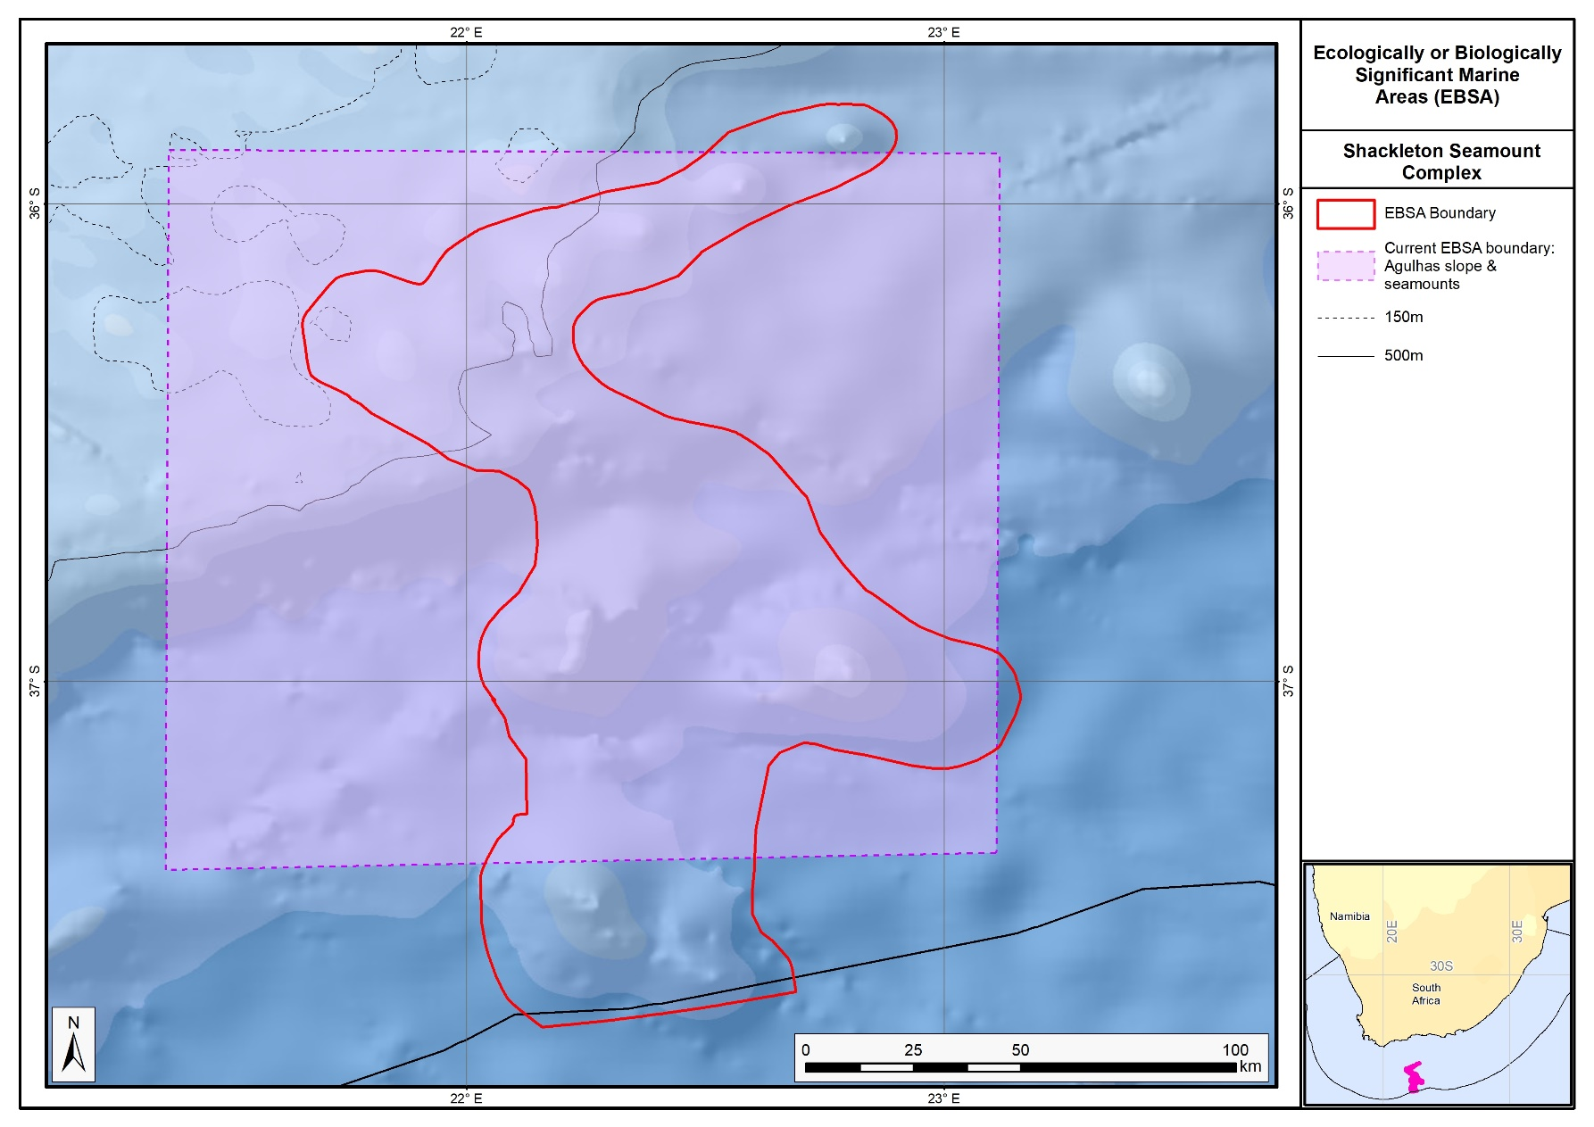
The proposed revised boundaries for the Shackleton Seamount Complex EBSA in relation to the original Agulhas Slope and Seamounts.

Secret Reef, Kingklip Ridge and Kingklip Koppies (Formerly Offshore of Port Elizabeth)

Proposed EBSA Description

Abstract
The recent discovery of important benthic features that were partially represented in the Offshore of Port Elizabeth EBSA prompted that EBSA to be split into two, with Secret Reef, Kingklip Ridge and Kingklip Koppies EBSA better representing the new features. Secret Reef is a newly discovered biogenic coral reef structure that is outside of the trawl footprint on the shelf edge of the South African south coast. Notably, it contains dense communities of fragile and sensitive coral and bryozoan species. Such features are relatively rare in the area. Secret Reef links to the Kingklip Ridge and Kingklip Koppies, offshore of St Francis Bay. These are a newly discovered unique rocky ridge and undersea hills (koppies in Afrikaans) that support fragile corals and are covered by dense clouds of plankton and hake. Three of the five ecosystem types represented in the EBSA are threatened, including the Endangered Kingklip Ridge and Vulnerable Kingklip Koppies and Agulhas Coarse Sediment Shelf Edge ecosystem types. Further research is encouraged for this site.

Introduction
An interesting feature was recently discovered inside the Offshore of Port Elizabeth EBSA: a unique rocky ridge protruding out of the upper slope that supports corals and is covered by dense clouds of plankton and hake (Sink 2016). Adjacent to the ridge is a series of rocky koppies (Afrikaans for ‘hills’). A little further west, also on the shelf edge and upper slope of the South African south coast, is Secret Reef. This is a newly discovered biogenic coral reef structure that supports fragile and sensitive corals and byrozoans. Given that these special benthic features appear to be connected along the shelf edge and upper slope, it prompted a split in the Offshore of Port Elizabeth EBSA into Algoa to Amathole, which comprises the bulk of the original EBSA, and this EBSA: Secret Reef, Kingklip Ridge and Kingklip Koppies. This allowed for a better delineation of an EBSA that more accurately reflected the underlying features, which in this case are largely benthic features.

Given its position on the shelf edge and upper slope, despite being a relatively small EBSA (approximately 23 km x 233 km), it spans a broad depth range of -150 to -1000 m. It comprises five ecosystem types, three of which are threatened, including an Endangered type. This area is also an important place in which to meet biodiversity targets because it had high selection frequency in a national systematic conservation plan (Sink et al., 2011; SANBI unpublished results in analysis for Madjiedt et al., 2013).

The reason this area was not fully included in the original Offshore of Port Elizabeth EBSA is because the constituent features were not yet discovered, and thus the information was not available at the Southern Indian Ocean Regional Workshop to Facilitate the Description of Ecologically or Biologically Significant Marine Areas (UNEP/CBD/RW/EBSA/SIO/1/4) in 2013. It is presented as a Type 2 EBSA because it contains “spatially stable features whose individual positions are known, but a number of individual cases are being grouped” (sensu Johnson et al., 2018).

EBSA Region
Southern Indian Ocean

Location
Secret Reef lies on the Grue Bank, about 100 km offshore of Knysna, approximately half way along the South African south coast in the Agulhas Current. The EBSA spans from here to offshore of the middle of St Francis Bay, along the shelf edge and a little down the slope. The EBSA falls entirely within South Africa’s EEZ.

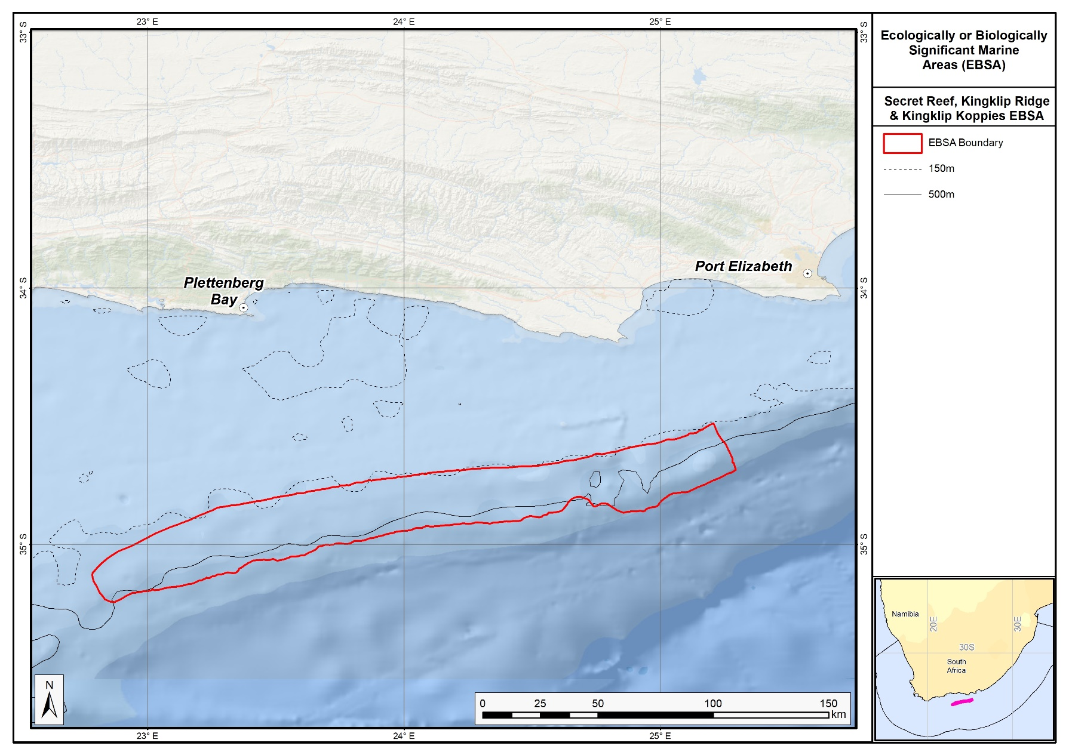
Proposed boundaries of the Secret Reef, Kingklip Ridge and Kingklip Koppies EBSA.

Feature description of the proposed area
Kingklip ridge rises like a wall on the upper slope, offshore of Cape St Francis. It has dimensions of 530 m wide and about 40 km long, running parallel to the shelf edge on the slope that goes from -200 m to -600 m and deeper (Sink 2016). At the crest and edges of the northern end of the ridge, at approximately -350 m, are reef-forming scleratinean corals (Sink 2016). Above the ridge are dense clouds of plankton and hake, and demersal trawlers reportedly use this feature against which they herd fish (Sink 2016). The Kingklip koppies, west of the ridge, are rocky hills that also support fragile benthic species. Even further west, Secret Reef is a newly discovered biogenic coral reef structure on the shelf edge and upper bathyal area (Sink 2016). It includes threatened benthic habitats and fragile, sensitive, vulnerable species, such as: scleractinian corals, stylasterine corals, bryozoans, molluscs, and crabs that have been sampled in this area (Sink 2016). Given the connections among these similar benthic features, they were delineated as a single EBSA. Thus, the EBSA is most important for benthic features, although the overlying water column is also relevant.

The ecosystem types represented in the EBSA include the Endangered Kingklip Ridge, Vulnerable Agulhas Coarse Sediment Shelf Edge and Kingklip Koppies, and Least Concern Agulhas Rocky Shelf Edge, and Southwest Indian Upper Slope (Sink et al., 2019). Because these features are so recently discovered, there is very little information available about them, other than the data that were collected on the cruise when they were found (Sink 2016). These data include single-beam echo sounder depth transects, in situ samples, and ROV footage (Sink 2016).

Feature condition and future outlook of the proposed area
Ecological condition is estimated in South Africa by assessing cumulative pressures to the marine environment (Sink et al., 2012, 2019). Ecological condition is poor in the northern and eastern portions of the EBSA (over Kingklip Ridge and the easternmost Kingklip Koppies), and moderate to mostly good in the south west corner (over Secret Reef; Sink et al., 2019). The primary pressures in the area are from fishing for large pelagic fish, and demersal and pelagic sharks, with some influence from shipping and other fishing industries to a lesser degree. Secret Reef itself is outside of the trawl footprint so the site is high in live coral cover (Sink 2016). However, all of the reef-building coral observed on the Kingklip Ridge was broken, with evidence of both recent and older damage. This is presumed to be the result of trawling damage to the reef (Sink 2016). Research was recently conducted in the area as part of a larger programme to survey South Africa’s marine environment (Sink 2016). No future research is currently planned, although it has been strongly recommended (Sink 2016).

References
Johnson, D.E., Barrio Froján, C., Turner, P.J., Weaver, P., Gunn, V., Dunn, D.C., Halpin, P., Bax, N.J., Dunstan, P.K., 2018. Reviewing the EBSA process: Improving on success. Marine Policy 88, 75-85.
Majiedt, P., Holness, S., Sink, K., Oosthuizen, A., Chadwick, P. 2013. Systematic Marine Biodiversity Plan for the West Coast of South Africa. South African National Biodiversity Institute, Cape Town.
Sink, K. 2016. Deep Secrets: the outer shelf and slope ecosystems of South Africa. Cruise Report: ALG 230 – ACEP_DSC.
Sink, K.J., Attwood, C.G., Lombard, A.T., Grantham, H., Leslie, R., Samaai, T., Kerwath, S., Majiedt, P., Fairweather, T., Hutchings, L., van der Lingen, C., Atkinson, L.J., Wilkinson, S., Holness, S., Wolf, T. 2011. Spatial planning to identify focus areas for offshore biodiversity protection in South Africa. Unpublished Report. Cape Town: South African National Biodiversity Institute.
Sink, K., Holness, S., Harris, L., Majiedt, P., Atkinson, L., Robinson, T., Kirkman, S., Hutchings, L., Leslie, R., Lamberth, S., Kerwath, S., von der Heyden, S., Lombard, A., Attwood, C., Branch, G., Fairweather, T., Taljaard, S., Weerts, S., Cowley, P., Awad, A., Halpern, B., Grantham, H., Wolf, T. 2012. National Biodiversity Assessment 2011: Technical Report. Volume 4: Marine and Coastal Component. South African National Biodiversity Institute, Pretoria.
Sink, K.J., van der Bank, M.G., Majiedt, P.A., Harris, L.R., Atkinson, L., Karenyi, N., Kirkman, S. (eds) 2019. National Biodiversity Assessment 2018 Technical Report Volume 4: Marine Realm. South African National Biodiversity Institute, Pretoria.

Other relevant website address or attached documents
Summary of habitat types and threat status for the Secret Reef, Kingklip Ridge and Kingklip Koppies EBSA. Data from Sink et al. (2019).
Threat Status | Ecosystem Type | Area (km²) | Area (%)
Endangered | Kingklip Ridge | 103.6 | 1.9
Vulnerable | Agulhas Coarse Sediment Shelf Edge | 2440.1 | 44.8
 | Kingklip Koppies | 642.9 | 11.8
Least Concern | Agulhas Rocky Shelf Edge | 1673.4 | 30.7
 | Southwest Indian Upper Slope | 582.5 | 10.7
Grand Total |  | 5442.5 | 100.0

Assessment of the area against CBD EBSA Criteria
C1: Uniqueness or rarity High
Justification
The coral mound comprising Secret Reef is a relatively rare feature in the broader area. It also contains the only known portions of the Kingklip Ridge and Kingklip Koppies ecosystem types, both of which are unique in South Africa.

C2: Special importance for life-history stages of species Medium
Justification
Further research is required to determine if this site supports important life-history stages of species. However, given the uniqueness of the ecosystem types and the dense clouds of plankton and hake above the Kingklip Ridge and Kingklip Koppies, it is presumed that this area is important for species’ life-histories.

C3: Importance for threatened, endangered or declining species and/or habitats High
Justification
The site includes three threatened ecosystem types, two of which are found exclusively in the EBSA: Endangered Kingklip Ridge and Vulnerable Kingklip Koppies. It is not yet known whether this site is important for threatened or declining species, and this would require more research in the area. However, it is presumed that the two unique ecosystem types (Kingklip Ridge and Kingklip Koppies) both support threatened species given that the ecosystem types are threatened.

C4: Vulnerability, fragility, sensitivity, or slow recovery High
Justification
Secret Reef is a biogenic coral mound that has fragile scleractinian corals, stylasterine corals, and bryozoans (Sink 2016). Similarly, Kingklip Ridge was observed to contain reef-building scleratinian corals, and Kingklip Koppies contained Thouarella (a primnoid coral), bamboo coral, many mobile invertebrates (Sink 2016). All of these are fragile, sensitive species that are vulnerable to damage, and that take long to recover from impacts.

C5: Biological productivity Medium
Justification
There are dense clouds of plankton and hake over Kingklip Ridge (Sink 2016), suggesting high localised productivity at the site. However, time-averaged MODIS Aqua data on chlorophyll concentration (NASA Giovanni Portal: https://giovanni.gsfc.nasa.gov) shows that productivity inside Secret Reef is not higher compared to that of the surrounding area.

C6: Biological diversity Medium
Justification
Because Secret Reef is outside of the trawl footprint, reef diversity inside the EBSA is relatively higher than that in the surrounding area (Sink 2016). Further, the relatively small EBSA comprises five ecosystem types that span a depth range of 850 m.

C7: Naturalness Medium
Justification
Secret Reef itself is outside of the trawl footprint, so this feature itself is close to pristine and high in live coral cover (Sink 2016). Based on a national assessment of cumulative pressures on the marine environment, the broader EBSA has portions in good and poor ecological condition, with a much smaller area that is moderately modified, (Sink et al., 2019). Thus, overall, the condition is fair.

Status of submission
The Offshore of Port Elizabeth EBSA was recognized as meeting EBSA criteria by the Conference of the Parties. The revised Secret Reef, Kingklip Ridge and Kingklip Koppies EBSA name, description, and boundaries still need to be submitted to COP for approval.

COP Decision
dec-COP-12-DEC-22

End of proposed EBSA revised description

Motivation for Submission
Recent survey data indicated that Secret Reef, Kingklip Ridge and Kingklip Koppies are small but rare and very vulnerable features justifying conservation attention, which were only partly represented in the original Offshore of Port Elizabeth EBSA. Significant changes have been made to the delineation of the Offshore of Port Elizabeth EBSA, such that it was necessary to split the EBSA into two, and revise the name of this one to Secret Reef, Kingklip Ridge and Kingklip Koppies EBSA to accurately reflect the features comprising the EBSA. This then also required a substantial revision to the description and criteria ranks. A supplementary table of the habitats represented in the EBSA and their associated threat status was also included. Given the new extent and inclusion of additional features, criteria level changes were made to almost all criteria. Criterion 1 was upgraded from Medium to High; Criterion 2 was downgraded from High to Medium; Criterion 4 was upgraded from Medium to High; Criteria 5 and 5 were downgraded from High to Mediums; and Criteria 3 and 7 remained the same.

The delineation process included an initial stakeholder review, a technical mapping process and then an expert review workshop where boundary delineation options were finalised. The delineation process used a combination of Systematic Conservation Planning and Multi-Criteria Analysis methods. The features used in the analysis were:
- Key physical features (i.e. the coral mound, ridge, koppies and surrounds) from recent survey work (Sink, 2016).
- Delineations and threat status of consitituent ecosystem types in the area were included in the analysis and used to refine the boundary of the EBSA.
- Irreplaceable and near irreplaceable (i.e. very high selection frequency) sites which relate closely to the EBSA criteria of “Uniqueness and rarity” from the Systematic Conservation Planning process undertaken for Majiedt et al. (2013) and the broader analysis for the BCLME by Holness et al. (2014).
- Areas of high relative naturalness identified in the National Biodiversity Assessment 2011 (Sink et al., 2012), the West Coast (Majiedt et al., 2013) and the BCLME spatial assessments (Holness et al., 2014) were included in the analysis. Both pelagic and benthic and coastal condition were incorporated.
- Distributions of known fragile, vulnerable and sensitive habitat-forming species were included (Unpublished SANBI and SAEON data).
The multi-criteria analysis resulted a value surface. The cut-off value used to determine the extent of the EBSA was based on expert input and quantitative analysis of effective inclusion of the above features. This entailed taking an iterative parameter calibration-based approach whereby the spatial efficiency of the inclusion of the targeted features was evaluated. The approach aimed to identify a cut-off which most efficiently included prioritised features while minimizing the inclusion of impacted areas. The final boundaries shown in the map were validated in a national workshop.

Research Needs
Future research is needed to determine the extent of connectivity among the three key benthic features. Further biological sampling and surveys are also recommended. Any additional research needs will be populated in a workshop to be held in August/September 2018.

Future Process
It is unclear if this EBSA will be subject to detailed attention in the MARISMA EBSA status assessment and management options workplan. This will be decided on in a workshop to be held in August/September 2018.

Algoa to Amathole (Formerly Offshore of Port Elizabeth)

Revised EBSA Description

General Information

Summary
This EBSA encompasses the likely biggest single collection of significant and special marine features in all of South Africa that also jointly support key ecological processes, including important land-sea connections. Complex ocean circulation occurs here, where the Agulhas Current leaves the coast, following the shelf break. This results in the formation of cold-water eddies, intrusions of Agulhas water onto the shelf and large offshore meanders of the Agulhas Current. Consequently, this EBSA includes spawning areas, nursery areas and key transport pathways for demersal and pelagic fish. In turn this supports a myriad of top predators, including shark and seabird breeding and foraging areas. Notably, the islands in Algoa Bay support the easternmost colony of Endangered African penguins and the largest colony of Cape Gannets in southern Africa. Given the regional oceanography, regionally Critically Endangered leatherback and regionally Near Threatened loggerhead turtles migrate through the EBSA between their nesting and foraging grounds, with hatchlings of both species also passing through during their dispersal from the nesting beaches. Green turtles have also been sighted in the area. Further, the EBSA includes 40 ecosystem types, 19 of which are threatened and a further seven that are Near Threatened. Sensitive features and species include submarine canyons, steep shelf edge, deep reefs, outer shelf and shelf edge gravels, and reef-building cold-water corals ranging in depth between 100 and 1000 m. It also contains several key biodiversity features, including: stromatolites; sites where coelocanths are present; a Critically Endangered localised endemic estuarine pipefish; several priority estuaries; rare habitat types of limited spatial extent; and a few existing coastal marine protected areas.

Introduction of the area
This EBSA spans the Eastern Cape shoreline in South Africa between Sardinia Bay MPA and Amathole MPA/Kei River mouth. It extends from the dune base to approximately the continental shelf break/slope, thus spanning a depth range of approximately 0-2000 m. It is important for both benthic and pelagic features, comprising an offshore area of high habitat complexity, and containing a myriad of unique and interesting biodiversity features. Benthic features include a large shelf-intersecting canyon (Sink et al., 2011), and rare seabed habitat types (Sink et al., 2012). The pelagic environment is characterised by complex ocean circulation patterns because the EBSA includes the point where the Agulhas Current leaves the coast, following the shelf break. This results in the formation of cold-water eddies, intrusions of Agulhas water onto the shelf, large offshore meanders of the Agulhas Current, and upwelling. This oceanography supports key ecological processes. Given the close proximity of the Eastern Cape universities, there is substantial ecological research and data available for this coastal area, and an extensive array of in-water devices for long-term ecological research within Algoa Bay.

Description of the location

EBSA Region
Southern Indian Ocean

Description of location
This EBSA spans the Eastern Cape shoreline between Sardinia Bay MPA and Amathole MPA / Kei River mouth in South Africa. It extends from the dune base to approximately the continental shelf break, as far west as south of Cape St Francis, and also encompasses the functional zone of several priority estuaries. It lies entirely within South Africa’s national jurisdiction.

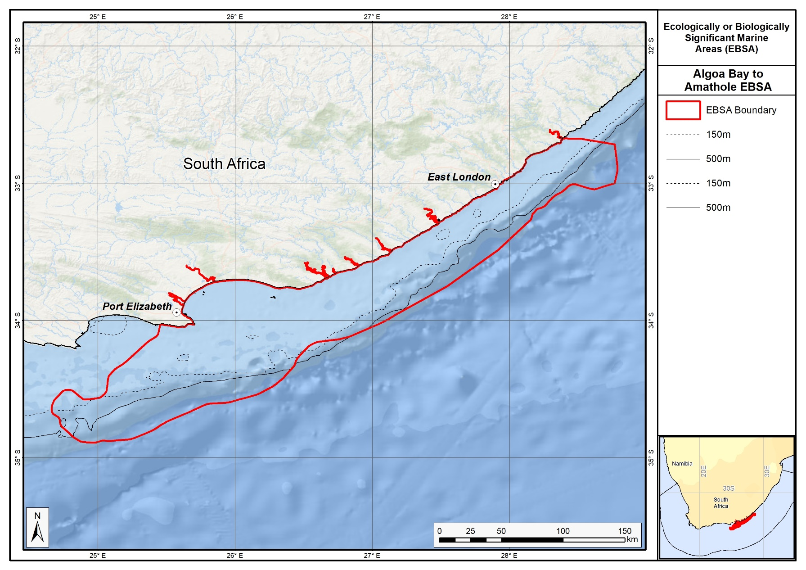
Proposed revised boundaries of the Algoa to Amathole EBSA.

Area Details

Feature description of the area
Algoa to Amathole EBSA is one of the most ecologically and biologically significant areas in South Africa. This area contains a myriad of rare, unique and diverse physical and biological features that are found on the seabed and in the overlying water column, that in turn support many key processes, including critical land-sea connections. The EBSA centres approximately around Algoa Bay, which also aligns with where the Agulhas Current leaves the coast, following the shelf break. This results in complex ocean circulation, including the formation of cold-water eddies, intrusions of Agulhas water onto the shelf, and large offshore meanders of the Agulhas Current; and productivity is enhanced by coastal upwelling (Goschen et al., 2015) and relatively rare surf diatom accumulations in the surf zone (Campbell & Bate 1988, Campbell 1996). Consequently, the area serves as spawning and/or nursery grounds for certain commercially-important demersal and pelagic fish species (Pattrick et al., 2016; Rishworth et al., 2015), squid (Downey-Breedt et al., 2016; Lipiński et al., 2016) sharks (Smale et al., 2015) and whales (Melly et al., in press); as transiting/foraging areas for seabirds, sharks, cetaceans (e.g., Koper et al., 2016; Melly et al., in press), and turtles; and forms part of the migration routes of loggerhead and leatherback turtles (Harris et al., 2018), with hatchlings of both species passing through the area during their dispersal. Green turtles, killer whales and coelocanths have also been sighted in the area. Notably, Algoa Bay hosts the largest groups of bottlenose dolphins (Bouveroux et al., 2018), largest colony of Endangered African penguins (Pichegru et al., 2010), and largest colony of Cape gannets (Crawford et al., 2007) in the world.
The new delineation of this EBSA to include priority estuaries, now includes breeding sites of the Critically Endangered, and locally endemic pipefish: Syngnathus watermeyeri (Vorwerk et al., 2007). These estuaries, together with the extension to include the coastal areas, also better represents some critical ecological processes that support the important offshore features. For example, these include key linkages among spawning, post-hatch and nursery areas commercially important fish species that span the surf zone to nearshore and the shelf (Pattrick et al., 2016). Many of the fish in the area also use the estuaries for part of their life-histories.
Habitat diversity is also high within the EBSA. There are 40 ecosystem types represented (Sink et al., 2019), with benthic features including stromatolites, canyons, steep shelf edge, deep reefs, outer shelf and shelf edge gravels, and reef-building cold-water corals ranging in depth between -100 and -1000 m. There is also growing research (with interesting results) into marine biochemistry, microbiology, and potential pharmaceuticals and natural products from the biota in Algoa Bay and surrounds (e.g., Matobole et al., 2017; Ntozonke et al., 2017; Waterworth et al., 2017), as well as research into the recently discovered stromatolites on the shore (Perissinotto et al., 2014).
There has been substantial research in the area since the EBSA was first proposed, that has contributed significantly to identifying the features that are present, their extent and importance. The boundary of this EBSA was refined to align with initiatives to expand South Africa’s MPA network, and better represent the underlying features comprising the EBSA to improve precision in the delineation, including: the canyons, rocky ridge, fragile and sensitive habitat-forming species, other key species, and key (threatened) habitats. The new boundary also includes more of the existing coastal MPAs in the region. It is presented as a Type 2 EBSA because it contains “spatially stable features whose individual positions are known, but a number of individual cases are being grouped” (sensu Johnson et al., 2018).

Feature conditions and future outlook of the proposed area
The South African National Biodiversity Assessment 2011 (Sink et al., 2012) indicated declining conditions overall in this area (based on pressure data and an ecosystem-pressure matrix) with conditions ranging from fair to poor across this broad area. Key pressures include commercial demersal trawl and longline fisheries, a midwater trawl fishery, linefishing, trap fisheries for rock lobster, shark fisheries and mining activities. Red tides have also become more common in recent years, some of which have been toxic (Pitcher et al., 2014). However, a large portion of Algoa Bay has been announced as a marine protected area, which will serve as a marine extension to the existing terrestrial Greater Addo Elephant National Park. Declaration and implementation of this MPA is imminent. There are also several small coastal MPAs included in the new boundary. Research is ongoing in this area.

References
BirdLife International, 2009. Designing networks of marine protected areas: exploring the linkages between Important Bird Areas and ecologically or biologically significant marine areas. Cambridge, UK: BirdLife International. www.cbd.int/doc/meetings/mar/ewbcsima-01/other/ewbcsima-01-birdlife-02-en.pdf
BirdLife International. 2010. Marine Important Bird Areas toolkit: standardised techniques for identifying priority sites for the conservation of seabirds at-sea. BirdLife International, Cambridge UK. Version 1.1: May 2010. www.birdlife.org/eu/pdfs/Marine_IBA_Toolkit_2010.pdf
Bouveroux, T.N., Caputo, M., Froneman, P.W., Plön, S. 2018. Largest reported groups for the Indo‐Pacific bottlenose dolphin (Tursiops aduncus) found in Algoa Bay, South Africa: Trends and potential drivers. Marine Mammal Science, in press. https://doi.org/10.1111/mms.12471
Campbell, E.E. (1996). The global distribution of surf diatom accumulations. Revista Chilena Historia Natural, 69: 495-501.
Campbell, E.E., Bate, G.C. 1988. The estimation of annual primary production in a high energy surf-zone. Botanica Marina, 31: 337-343.
Crawford, R. J. M., Dundee, B. L., Dyer, B. M., Klages, N. T., Meÿer, M. A., Upfold, L. 2007. Trends in numbers of Cape gannets (Morus capensis), 1956/57–2005/06, with a consideration of the influence of food and other factors – ICES Journal of Marine Science, 64: 169–177.
Downey-Breedt, N.J., Roberts, M.J., Sauer, W.H.H., Chang, N. 2016. Modelling transport of inshore and deep-spawned chokka squid (Loligo reynaudi) paralarvae off South Africa: the potential contribution of deep spawning to recruitment. Fisheries Oceanography, 25: 28–43.
Goschen, W.S., Bornman, T.G., Deyzel, S.H.P., Schumann, E.H. 2015. Coastal upwelling on the far eastern Agulhas Bank associated with large meanders in the Agulhas Current. Continental Shelf Research, 101: 34–46.
Harris, L.R., Nel, R., Oosthuizen, H., Meyer, M., Kotze, D., Anders, D., McCue, S., Bachoo, S. 2018. Managing conflicts between economic activities and threatened migratory marine species towards creating a multi-objective blue economy. Conservation Biology, 32: 411-423.
Hutchings, L., Beckley, L.E., Griffiths, M.H., Roberts, M.J., Sundby, S., van der Lingen, C. 2002. Spawning on the edge: spawning grounds and nursery areas around the southern African coastline. Marine and Freshwater Research, 53: 307-318.
Johnson, D.E., Barrio Froján, C., Turner, P.J., Weaver, P., Gunn, V., Dunn, D.C., Halpin, P., Bax, N.J., Dunstan, P.K., 2018. Reviewing the EBSA process: Improving on success. Marine Policy 88, 75-85.
Koper, R.P., Karczmarski, L., Du Preez, D., Plön, S. 2016. Sixteen years later: Occurrence, group size, and habitat use of humpback dolphins (Sousa plumbea) in Algoa Bay, South Africa. Marine Mammal Science, 32: 490–507.
Lagabrielle, E. 2009. Preliminary report: National Pelagic Bioregionalisation of South Africa. Cape Town: South African National Biodiversity Institute.
Lipiński, M.R., van der Vyver, J.S.F., Shaw, P., Sauer, W.H.H. 2016. Life cycle of chokka-squid Loligo reynaudii in South African waters, African Journal of Marine Science, 38:4, 589-593.
Lutjeharms, J.R.E., Cooper, J., Roberts, M. 2000. Upwelling at the inshore edge of the Agulhas Current. Continental Shelf Research, 20: 737 – 761.
Matobole, R., van Zyl, L., Parker‐Nance, S., Davies‐Coleman, M., Trindade, M. 2017. Antibacterial Activities of Bacteria Isolated from the Marine Sponges Isodictya compressa and Higginsia bidentifera Collected from Algoa Bay, South Africa. Marine Drugs, 15: 47.
Melly, B.L., McGregor, G., Hofmeyr, G.J.G., and Plön, S. in press. Spatio-temporal distribution and habitat preferences of cetaceans in Algoa Bay, South Africa. Journal of the Marine Biological Association of the United Kingdom, 1-15. https://doi.org/10.1017/S0025315417000340
Mhlongo, N., Yemane, D., Hendricks, M. 2015. Have the spawning habitat preferences of anchovy (Engraulis encrasicolus) and sardine (Sardinops sagax) in the southern Benguela changed in recent years? Fisheries Oceanography 24: 1–14.
Ntozonke, N., Okaiyeto, K., Okoli, A., Olaniran, A., Nwodo, U., Okoh, A. 2017. A Marine Bacterium, Bacillus sp. Isolated from the Sediment Samples of Algoa Bay in South Africa Produces a Polysaccharide-Bioflocculant. International Journal of Environmental Research and Public Health, 14: 1149.
Pattrick, P., Strydom, N.A., Harris, L., Goschen, W.S. 2016. Predicting spawning locations and modelling the spatial extent of post hatch areas for fishes in a shallow coastal habitat in South Africa. Marine Ecology Progress Series, 560: 223-235.
Perissinotto, R., Bornman, T.G., Steyn, P.-P., Miranda, N.A.F., Dorrington, R.A., Matcher, G.F., Strydom, N., Peer, N., 2014. Tufa stromatolite ecosystems on the South African south coast. South African Journal of Science 110, 01-08.
Pichegru, L., Grémillet, D., Crawford, R.J.M., Ryan, P.G. 2010. Marine no-take zone rapidly benefits endangered penguin. Biology Letters. DOI: 10.1098/rsbl.2009.0913
Pitcher, G.C., Cembella, A.D., Krock, B., Macey, B.M., Mansfield, L., Probyn, T.A. 2014. Identification of the marine diatom Pseudo-nitzschia multiseries (Bacillariophyceae) as a source of the toxin domoic acid in Algoa Bay, South Africa. African Journal of Marine Science, 36: 523-528.
Rishworth, G.M., Strydom, N.A., Potts, W. 2014. Fish utilization of surf-zones. Are they changing? A case study of the Sheltered, warm-temperate King’s Beach. African Zoology, 49: 5-21.
Roberson, L.A., Lagabrielle, E., Lombard, A.T., Sink, K., Livingstone, T., Grantham, H., Harris, J.M. 2017. Pelagic bioregionalisation using open-access data for better planning of marine protected area networks. Ocean & Coastal Management, 148: 214-230.
Santos, J., Rouillard, D., Groeneveld, J.C. 2014. Advection-diffusion models of spiny lobster Palinurus gilchristi migrations for use in spatial fisheries management. Marine Ecology Progress Series, 498: 227–241.
Sink, K.J., Attwood, C.G., Lombard, A.T., Grantham, H., Leslie, R., Samaai, T., Kerwath, S., Majiedt, P., Fairweather, T., Hutchings, L., van der Lingen, C., Atkinson, L.J., Wilkinson, S., Holness, S., Wolf, T. 2011. Spatial planning to identify focus areas for offshore biodiversity protection in South Africa. Unpublished Report. Cape Town: South African National Biodiversity Institute.
Sink, K., Holness, S., Harris, L., Majiedt, P., Atkinson, L., Robinson, T., Kirkman, S., Hutchings, L., Leslie, R., Lamberth, S., Kerwath, S., von der Heyden, S., Lombard, A., Attwood, C., Branch, G., Fairweather, T., Taljaard, S., Weerts, S., Cowley, P., Awad, A., Halpern, B., Grantham, H., Wolf, T. 2012. National Biodiversity Assessment 2011: Technical Report. Volume 4: Marine and Coastal Component. South African National Biodiversity Institute, Pretoria.
Sink, K.J., van der Bank, M.G., Majiedt, P.A., Harris, L.R., Atkinson, L., Karenyi, N., Kirkman, S. (eds) 2019. National Biodiversity Assessment 2018 Technical Report Volume 4: Marine Realm. South African National Biodiversity Institute, Pretoria.
Smale, M.J., Dicken, M.L., Booth, A.J. 2015. Seasonality, behaviour and philopatry of spotted ragged‑tooth sharks Carcharias taurus in Eastern Cape nursery areas, South Africa. African Journal of Marine Science, 37: 219-231.
Vorwerk, P.D., Froneman, P.W., Paterson, A.W. 2007. Recovery of the critically endangered river pipefish, Syngnathus watermeyeri, in the Kariega Estuary, Eastern Cape province. South African Journal of Science, 103: 199-201.
Waterworth, S., Jiwaji, M., Kalinski, J.-C., Parker-Nance, S., Dorrington, R. 2017. A Place to Call Home: An Analysis of the Bacterial Communities in Two Tethya rubra Samaai and Gibbons 2005 Populations in Algoa Bay, South Africa. Marine Drugs, 15: 95.
Weidberg, N., Porri, F., Von der Meden, C.E.O., Jackson, J.M., Goschen, W., McQuaid, C.D. 2015. Mechanisms of nearshore retention and offshore export of mussel larvae over the Agulhas Bank. Journal of Marine Systems, 144: 70–80.

Other relevant website address or attached documents
Summary of ecosystem types and threat status for the Algoa to Amathole EBSA. Data from Sink et al. (2019).
Threat Status | Ecosystem Type | Area (km²) | Area (%)
Endangered | Kei Fluvial Fan | 40.8 | 0.2
 | Kei Reef Complex | 93.0 | 0.5
Vulnerable | Agulhas Bays - East | 1003.0 | 5.1
 | Agulhas Coarse Sediment Shelf Edge | 1221.5 | 6.2
 | Agulhas Exposed Rocky Shore | 6.2 | 0.0
 | Agulhas Exposed-Stromatolite Rocky Shore | 3.6 | 0.0
 | Agulhas Inner Shelf Reef Sand Mosaic | 373.2 | 1.9
 | Agulhas Island Shore | 3.0 | 0.0
 | Agulhas Mid Shelf Reef Complex | 35.1 | 0.2
 | Agulhas Sandy Inner Shelf | 411.4 | 2.1
 | Agulhas Sandy Outer Shelf | 4525.8 | 23.0
 | Agulhas Stromatolite Mixed Shore | 4.0 | 0.0
 | Agulhas Upper Canyons | 102.0 | 0.5
 | Agulhas Very Exposed Rocky Shore | 0.4 | 0.0
 | Amathole Hard Shelf Edge | 468.7 | 2.4
 | Warm Temperate Large Fluvially Dominated Estuary | 5.7 | 0.0
 | Warm Temperate Large Temporarily Closed Estuary | 8.8 | 0.0
 | Warm Temperate Predominantly Open Estuary | 73.0 | 0.4
Near Threatened | Agulhas Boulder Shore | 0.6 | 0.0
 | Agulhas Dissipative Sandy Shore | 1.5 | 0.0
 | Agulhas Mid Shelf Reef Sand Mosaic | 396.0 | 2.0
 | Agulhas Mixed Shore | 60.4 | 0.3
 | Agulhas Sandy Mid Shelf | 3616.2 | 18.4
 | Agulhas Very Exposed-Stromatolite Rocky Shore | 0.2 | 0.0
 | Amathole Lace Corals | 131.6 | 0.7
Least Concern | Agulhas Dissipative-Intermediate Sandy Shore | 50.5 | 0.3
 | Agulhas Intermediate Sandy Shore | 0.8 | 0.0
 | Agulhas Lower Canyons | 1152.5 | 5.9
 | Natal Deep Shelf Edge | 370.6 | 1.9
 | Natal Pondoland Lower Canyons | 612.6 | 3.1
 | Pondoland Mid Shelf Coarse Sediment Reef Mosaic(B) | 1316.4 | 6.7
 | Pondoland Shelf Edge Gravel Reef Mosaic | 261.7 | 1.3
 | Southwest Indian Mid Slope | 2128.6 | 10.8
 | Southwest Indian Upper Slope | 1172.6 | 6.0
 | Warm Temperate Small Temporarily Closed Estuary | 3.6 | 0.0
N/A | Warm Temperate Micro-estuary | 0.5 | 0.0
Grand Total |  | 19656.0 | 100.0

Assessment of the area against CBD EBSA criteria
C1: Uniqueness or rarity High
Justification
Rare habitat types in this region include outer shelf mixed sediments, canyons and stromatolites (Sink et al., 2019), and relatively rare – nationally and globally – surf diatom accumulations (Campbell 1996, Campbell & Bate 1988). This site includes a large canyon that intersects with the shelf (Sink et al., 2011). It also contains a Critically Endangered localised endemic estuarine pipefish, and sites where coelocanths are present.
C2: Special importance for life-history stages of species High
Justification
This area includes foraging areas for African penguins and Cape gannets (Sink et al., 2011). BirdLife International data also indicate importance for damara terns, kelp gulls and roseate terns. Species that have shown spawning activity in this area include (among others) kingklip, squid, sparids, sardine, anchovy, kob and hake (Hutchings et al., 2002, Sink et al., 2011; Mhlongo et al., 2015, Downey-Breedt et al., 2016; Lipiński et al., 2016; Pattrick et al., 2016). This is considered an area of crucial importance for the eggs and larvae spawned upstream to enter the Agulhas Bank nursery area (Hutchings et al., 2002). Offshore of Port Elizabeth is also particularly important for mussel larvae (Weidberg et al., 2015) and spiny lobsters (Santos et al., 2014).
C3: Importance for threatened, endangered or declining species and/or habitats High
Justification
This area includes areas important for the survival of several IUCN Red-listed species, including the African penguin Spheniscus demersus (Endangered on the IUCN Red List) and the Cape Gannet Morus capensis (Vulnerable on the IUCN Red List). This area is also used by green, loggerhead, and leatherback turtles (respectively listed as Endangered, Near Threatened and Critically Endangered on the IUCN global redlist for the South West Indian Ocean region; Petersen et al., 2009, Harris et al., 2018).
There are 19 threatened ecosystem types, and a further seven Near Threatened ecosystem types. The threatened types include the Endangered Kei Fluvial Fan and Kei Reef Complex ecosystem types, and the Vulnerable Agulhas Bays - East, Agulhas Coarse Sediment Shelf Edge, Agulhas Exposed Rocky Shore, Agulhas Exposed-Stromatolite Rocky Shore, Agulhas Inner Shelf Reef Sand Mosaic, Agulhas Island Shore, Agulhas Mid Shelf Reef Complex, Agulhas Sandy Inner Shelf, Agulhas Sandy Outer Shelf, Agulhas Stromatolite Mixed Shore, Agulhas Upper Canyons, Agulhas Very Exposed Rocky Shore, Amathole Hard Shelf Edge, Warm Temperate Large Fluvially Dominated Estuary, Warm Temperate Large Temporarily Closed Estuary and Warm Temperate Predominantly Open Estuary ecosystem types.
C4: Vulnerability, fragility, sensitivity, or slow recovery Medium
Justification
This area includes submarine canyons, steep shelf edge, deep reefs and outer shelf and shelf edge gravels. These habitats may support fragile habitat-forming species. Cold-water corals (Goniocorella dumosa, Solenosmilia variabilis) have been recorded in the area (Sink et al., 2011) and are in the Iziko South African museum invertebrate collection.
C5: Biological productivity High
Justification
Productivity offshore of Port Elizabeth is medium to high, and very variable. Chlorophyll-a concentrations are also highly variable, associated with frequent SST and chlorophyll fronts on the steep outer shelf (Lagabrielle 2009, Sink et al., 2011, Roberson et al., 2017). Coastal upwelling may be driven, or at least enhanced, by the formation of Natal pulses (Goschen et al., 2015).
C6: Biological diversity High
Justification
Four pelagic habitat types and 16 benthic habitat types lead to high habitat heterogeneity in this area: Agulhas island, Agulhas mixed sediment inner and outer shelf, Agulhas sandy inner shelf, Agulhas hard inner and outer shelf, Agulhas sandy outer shelf, Agulhas canyon, Agulhas gravel outer shelf, Agulhas gravel shelf edge, Agulhas muddy inner and outer shelf, Southwest Indian upper bathyal and lower bathyal (Sink et al., 2012). The associated communities supported by these habitats is thus also diverse.
C7: Naturalness Medium
Justification
Although some areas are assessed as in poor condition (based on pressure data, see South Africa’s National Biodiversity Assessment 2011, Sink et al., 2012), there are many examples of habitat types in good condition and include examples of features that may support fragile and vulnerable habitat forming species (Sink et al., 2012).

Status of submission
The Offshore of Port Elizabeth EBSA was recognized as meeting EBSA criteria by the Conference of the Parties. The revised Algoa to Amathole EBSA name, description, and boundaries still need to be submitted to COP for approval.

COP Decision
dec-COP-12-DEC-22

End of proposed EBSA revised description

Motivation for Submission
Significant changes have been made to the delineation of the original Offshore of Port Elizabeth EBSA and to the description, such that it was necessary to split the EBSA into two, and revise the name of this one to Algoa to Amathole EBSA to accurately reflect the geographical location of the EBSA. Additional references have been added and significant updates to the description were made. A supplementary table of the habitats represented in the EBSA and their associated threat status was also included. Given the new extent and inclusion of additional features, criteria level changes were made to Criterion 1: Uniqueness or rarity and Criterion 7: Naturalness, respectively upgraded from medium to high, and low to medium.

An important change has been the significant revision of the EBSA boundaries to reflect the key biodiversity features in this area. The delineation process included an initial stakeholder review which identified the need to update boundaries, a technical mapping process and then an expert review workshop where boundary delineation options were finalised. The delineation process used a combination of Systematic Conservation Planning and Multi-Criteria Analysis methods. The features used in the analysis were:
- Key physical features (especially canyons) identified from the latest GEBCO data, global benthic geomorphology mapping (www.bluehabitats.org, Harris et al., 2014), the National Biodiversity Assessment 2011 (Sink et al., 2012) and BCC spatial mapping project (Holness et al., 2014) were incorporated. In addition, island linked habitat types were included.
- Irreplaceable and near irreplaceable (i.e. very high selection frequency) sites, as well as focus areas identified in the Systematic Conservation Plans undertaken for the West Coast by Majiedt et al. (2013), offshore areas (Sink et al., 2011) and by Holness et al. (2014) were incorporated.
- Delineations and threat status of consitituent ecosystem types in the area were included in the analysis and used to refine the boundary of the EBSA.
- Areas important for threatened and special species were included. The priority areas and buffer distances around colonies were from Holness et al. (2014). Note that the full extent of the buffer was not necessarily included in the EBSA. Features included in the analysis were:
  - African Penguin colonies and a 20km buffer.
  - Cape Cormorant and White Breasted Cormorant colonies and a 40km buffer.
  - Gannet colonies with a 40km buffer.
  - Seal Colonies and a 20km buffer.
- Areas of high relative naturalness of benthic and coastal systems and pelagic systems identified in the National Biodiversity Assessment 2011 (Sink et al., 2012a) were included in the analysis.
- Distributions of known fragile, vulnerable and sensitive habitat-forming species were included (Unpublished SANBI and SAEON data).
The multi-criteria analysis resulted in a value surface. The cut-off value used to determine the extent of the EBSA was based on expert input and quantitative analysis of effective inclusion of the above features. This entailed taking an iterative parameter calibration-based approach whereby the spatial efficiency of the inclusion of the targeted features was evaluated. The approach aimed to identify a cut-off which most efficiently included prioritised features while minimizing the inclusion of impacted areas. The final boundaries shown in the map were validated in a national workshop.

Research Needs
There is substantial research and ongoing monitoring within this focus area already. Any additional future research needs will be populated in a workshop to be held in August/September 2018.

Future Process
Portions of the EBSA have been gazetted for inclusion into the Amathole Offshore MPA, the Addo Elephant Park MPA and the Port Elizabeth Corals MPA. It is unclear if this EBSA will be subject to detailed attention in the MARISMA EBSA status assessment and management options workplan. This will be decided on in a workshop to be held in August/September 2018.

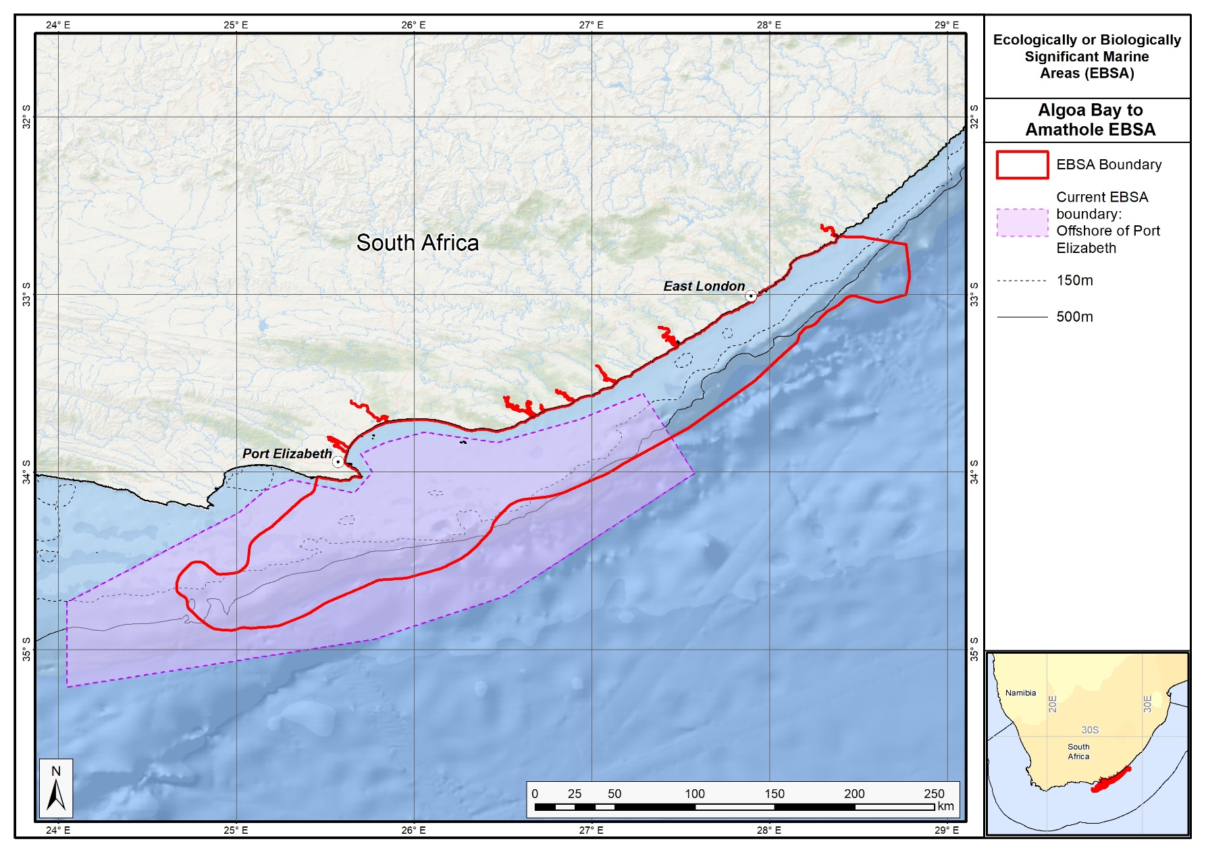
The proposed revised boundaries for the Algoa to Amathole EBSA in relation to the original Offshore of Port Elizabeth EBSA.

Protea Banks and Sardine Route

Revised EBSA Description

General Information

Summary
Protea Banks and Sardine Route is a coastal EBSA that includes a key component of the migration path for several fish (known as the sardine run) and an offshore area of high habitat complexity. Benthic features include a unique deep-reef system known as Protea Banks, steep shelf edge and slope, and several submarine canyons. The sardine run is a temporary feature associated with foraging top predators, including seabirds, mammals, sharks and gamefish. Protea Banks is also an aggregating area, with spawning of sciaenids and sparids reported. Some of these species are in decline and are considered threatened. This area has moderate productivity, and the sardine run represents an important ecological process that facilitates the transfer of nutrients from the more productive Agulhas Bank into the more oligotrophic environment further north. This EBSA includes five existing coastal MPAs, two of which are being expanded to improve protection of key marine biodiversity assets.

Introduction of the area
The Protea Banks and Sardine Route includes a key component of the migration path for several fish (known as the sardine run) and an offshore area of high habitat complexity. Benthic features include a unique deep reef system known as Protea Banks, steep shelf edge and slope, and several canyons. Protea Banks comprises a relatively shallow “seamount” that drops to extensive rocky flats that extend towards the shelf edge (the full extent of which is currently uncertain). Diversity is high in this area, with 37 ecosystem types represented in the EBSA, 19 of which are threatened and a further six are Near Threatened. It constitutes a site of fish spawning aggregations and is home to an abundance of soft corals, algae and molluscs, many of which are endemic. The area includes benthic and pelagic features, with further details on habitats, processes and species detailed in Mann (2000), Freon et al. (2010), Sink et al. (2011), Harris et al. (2011) and Ezemvelo KZN Wildlife (2012). The sardine run is an annual, temporary feature usually associated with foraging top predators, including seabirds, mammals (O’Donoghue et al., 2010a, 2010b), sharks and gamefish (Dudley and Cliff 2010, Fennessy et al., 2010).

Description of the location

EBSA Region
Southern Indian Ocean

Description of location
Protea Banks and Sardine Route is a coastal EBSA, entirely with the South African EEZ. Alongshore, it extends from the Aliwal Shoal MPA in the north, to the Dwesa-Cwebe MPA in the south. Although it extends only 25-35 km offshore from the dune base across most of the EBSA, it covers a vast depth range because the continental shelf is so narrow in this area. Most of Protea Banks and Sardine Route extends from 0 m to -1800 m or deeper.

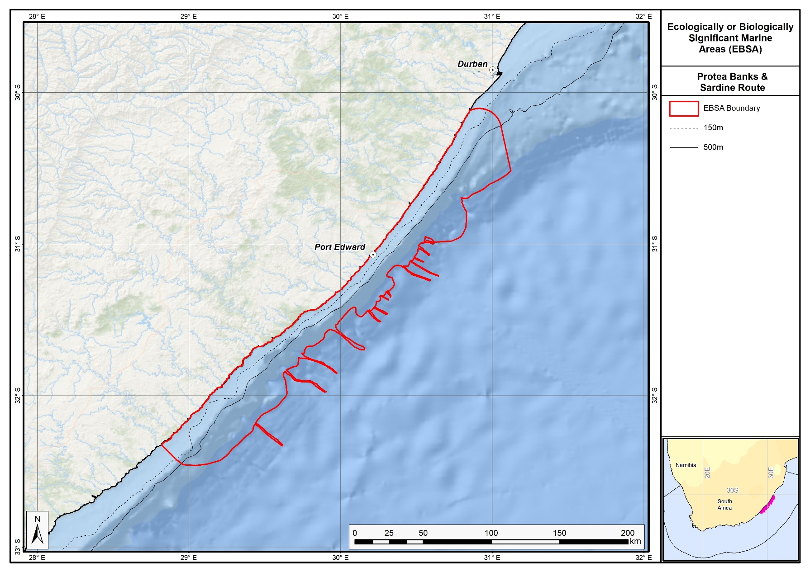
Proposed revised boundaries of the Protea Banks and Sardine Route EBSA.

Area Details

Feature description of the area
This area includes benthic and pelagic features, with details on habitats, processes and species in Mann (2000), Freon et al., (2010), Sink et al., (2011), Harris et al., (2011) and Ezemvelo KZN Wildlife (2012). The EBSA includes 31 ecosystem types, seven of which are Endangered, 12 are Vulnerable and a further six are Near Threatened (Sink et al., 2019). This span a rich diversity of types, including a variety of shore types (including estuarine shores), reefs, unconsolidated-sediment benthic types, slope types and canyons (Sink et al., 2019). The area includes part of a key migration pathway (known as the sardine run) that is an important ecological process believed to play a role in the transfer of productivity from the productive Agulhas Bank into the less productive area in southern KwaZulu-Natal. Some research has been conducted on the sardine migration (see Freon et al., 2010, Van der Lingen et al., 2010) but the heterogeneous benthic habitats in deep water are poorly studied. Key habitats include a unique deep-reef feature, submarine canyons (with seven reef-building cold-water coral records, representing three different species, in the national invertebrate museum collection), hard shelf edge and unconsolidated shelf and shelf edge sediments. In situ research is needed in the deeper areas of this EBSA.
There has been new research in the area since the EBSA was first proposed, that has contributed significantly to identifying the features that are present, their extent and importance. The boundary of this EBSA was also refined to align with initiatives to expand South Africa’s MPA network, and better represent the underlying features comprising the EBSA to improve precision in the delineation. It is presented as a Type 2/4 EBSA (sensu Johnson et al., 2018) for containing “spatially stable features whose individual positions are known, but a number of individual cases are being grouped” and “features that are inherently not spatially fixed. The position of this feature moves seasonally and among years.”. The benthic features (e.g., reefs and canyons) are spatially fixed and grouped, and the sardine run is a seasonal phenomenon that occurs in the same area, but the exact position is variable across years.

Feature conditions and future outlook of the proposed area
South Africa’s National Biodiversity Assessment 2011 (Sink et al., 2012) indicated declining conditions in the original delineation (based on pressure data and an ecosystem-pressure matrix), with conditions ranging from fair to poor. In an updated assessment, and in the new delineation, cumulative pressure was moderate across the EBSA overall; however, cumulative pressure in the northern portion and along the coast is high (Sink et al., 2019). There are five existing MPAs in this EBSA, some of which have moderate to high cumulative pressure within them. Protection of biodiversity assets in this EBSA will be strengthened with notable expansion of two of the existing reserves underway. Fish species in the area include threatened or depleted species. There is planned research in the Protea Banks area through the African Coelacanth Ecosystem Program Phase III.

References
BirdLife International, 2009. Designing networks of marine protected areas: exploring the linkages between Important Bird Areas and ecologically or biologically significant marine areas. Cambridge, UK: BirdLife International. www.cbd.int/doc/meetings/mar/ewbcsima-01/other/ewbcsima-01-birdlife-02-en.pdf
BirdLife International, 2010. Marine Important Bird Areas toolkit: standardised techniques for identifying priority sites for the conservation of seabirds at-sea. BirdLife International, Cambridge UK. Version 1.1: May 2010. www.birdlife.org/eu/pdfs/Marine_IBA_Toolkit_2010.pdf
De Clerck, O., Bolton, J.J., Anderson, R.J., Coppejans, E. 2005. Guide to the seaweeds of KwaZulu-Natal. Scripta Botanica Belgica Vol.33. Meise: National Botanic Garden of Belgium.
Ezemvelo KZN Wildlife, 2012. Focus areas for additional marine biodiversity protection in KwaZulu-Natal, South Africa. Unpublished Report - Jan 2012. Scientific Services, Ezemvelo KZN Wildlife: Durban. Pp 62.
Fréon, P., Coetzee, J.C., van der Lingen, C.D., Connell, A.D., O’Donoghue, S.H., Roberts, M.J., Demarcq, H., Attwood, C.G., Lamberth, S.J., Hutchings, L. 2010. Review and tests of hypotheses about causes of the KwaZulu-Natal sardine run. African Journal of Marine Science, 32: 449–479.
Johnson, D.E., Barrio Froján, C., Turner, P.J., Weaver, P., Gunn, V., Dunn, D.C., Halpin, P., Bax, N.J., Dunstan, P.K., 2018. Reviewing the EBSA process: Improving on success. Marine Policy 88, 75-85.
O’Donoghue, S.H., Drapeau, L., Peddemors, V.M. 2010a. Broad-scale distribution patterns of sardine and their predators in relation to remotely sensed environmental conditions during the KwaZulu- Natal sardine run. African Journal of Marine Science, 32: 279–291.
O’Donoghue, S.H., Whittington, P.A., Peddemors, V.M,. Dyer, B.M. 2010b. Abundance and distribution of avian and marine mammal predators of sardine observed during the 2005 KwaZulu-Natal sardine run survey. African Journal of Marine Science, 32: 361–374.
O’Donoghue, S.H., Drapeau, L., Dudley, S.F.J., Peddemors, V.M. 2010c. The KwaZulu-Natal sardine run: shoal distribution in relation to nearshore environmental conditions, 1997–2007. African Journal of Marine Science, 32: 293–307.
Fennessey, S.T., Pradervand, P., De Bryn P. 2010. Influence of the sardine run on selected nearshore predatory teleosts in KwaZulu-Natal. African Journal of Marine Science, 32: 375- 382.
Harris, J.M., Livingstone, T., Lombard, A.T., Lagabrielle, E., Haupt, P., Sink, K., Mann, B., Schleyer, M. 2011. Marine Systematic Conservation Assessment and Plan for KwaZulu-Natal - Spatial priorities for conservation of marine and coastal biodiversity in KwaZulu-Natal. Ezemvelo KZN Wildlife.
Harris, L.R., Nel, R., Oosthuizen, H., Meyer, M., Kotze, D., Anders, D., McCue, S., Bachoo, S. 2018. Managing conflicts between economic activities and threatened migratory marine species towards creating a multi-objective blue economy. Conservation Biology, 32, 411-423.
Haupt, P. 2010. Conservation assessment and plan for fish species along the KwaZulu-Natal coast. MSc Thesis, Nelson Mandela Metropolitan University, South Africa.
Hutchings, L., Beckley, L.E., Griffiths, M.H., Roberts, M.J., Sundby, S., van der Lingen, C. 2002. Spawning on the edge: spawning grounds and nursery areas around the southern African coastline. Marine and Freshwater Research, 53: 307-318.
Lagabrielle, E. 2009. Preliminary report: National Pelagic Bioregionalisation of South Africa. Cape Town: South African National Biodiversity Institute.
Lutjeharms, J.R.E., Gründlingh, M., Carter, R.A. 1989. Topographically induced upwelling in the Natal Bight. South African Journal of Science, 85: 310 -316.)
Lutjeharms, J.R.E., Cooper, J., Roberts, M. 2000. Upwelling at the inshore edge of the Agulhas Current. Continental Shelf Research, 20: 737 – 761.
Roberson, L.A., Lagabrielle, E., Lombard, A.T., Sink, K., Livingstone, T., Grantham, H., Harris, J.M. 2017. Pelagic bioregionalisation using open-access data for better planning of marine protected area networks. Ocean & Coastal Management, 148: 214-230.
Sink, K.J., Attwood, C.G., Lombard, A.T., Grantham, H., Leslie, R., Samaai, T., Kerwath, S., Majiedt, P., Fairweather, T., Hutchings, L., van der Lingen, C., Atkinson, L.J., Wilkinson, S., Holness, S., Wolf, T. 2011. Spatial planning to identify focus areas for offshore biodiversity protection in South Africa. Unpublished Report. Cape Town: South African National Biodiversity Institute.
Sink, K., Holness, S., Harris, L., Majiedt, P., Atkinson, L., Robinson, T., Kirkman, S., Hutchings, L., Leslie, R., Lamberth, S., Kerwath, S., von der Heyden, S., Lombard, A., Attwood, C., Branch, G., Fairweather, T., Taljaard, S., Weerts, S., Cowley, P., Awad, A., Halpern, B., Grantham, H., Wolf, T. 2012. National Biodiversity Assessment 2011: Technical Report. Volume 4: Marine and Coastal Component. South African National Biodiversity Institute, Pretoria.
Sink, K.J., van der Bank, M.G., Majiedt, P.A., Harris, L.R., Atkinson, L., Karenyi, N., Kirkman, S. (eds) 2019. National Biodiversity Assessment 2018 Technical Report Volume 4: Marine Realm. South African National Biodiversity Institute, Pretoria.
www.seabirdtracking.org – tracking contributors who provided data presented at this workshop are: Maria Ana Dias, Paulo Catry, Teresa Catry, Robert Crawford, Richard Cuthbert, Karine Delord, Jacob Gonzalez-Solis, Jano Hennicke, Matthieu Le Corre, Deon Nel, Malcolm Nicoll, Jose Pedro Granadeiro, Samantha Petersen, Richard Phillips, Patrick Pinet, Jaime Ramos, Jean-Baptiste Thiebot, Ross Wanless, Henri Weimerskirch, Vikash Tatayah.

Other relevant website address or attached documents
Summary of ecosystem types and threat status for the Protea Banks and Sardine Route EBSA. Data from Sink et al. (2019).
Threat Status | Ecosystem Type | Area (km²) | Area (%)
Endangered | Natal Inner Shelf Reef Sand Mosaic | 215.5 | 2.3
 | Natal Mid Shelf Reef Gravel Mosaic | 841.1 | 9.0
 | Protea Mid Shelf Reef Complex | 15.5 | 0.2
 | Subtropical Large Fluvially Dominated Estuary | 1.7 | 0.0
 | Subtropical Large Temporarily Closed Estuary | 7.5 | 0.1
 | Subtropical Predominantly Open Estuary | 4.2 | 0.0
 | Trafalgar Reef Complex | 58.7 | 0.6
Vulnerable | Agulhas Exposed Rocky Shore | 0.1 | 0.0
 | Aliwal Shoal Reef Complex | 5.2 | 0.1
 | Natal Boulder Shore | 0.3 | 0.0
 | Natal Mixed Shore | 40.5 | 0.4
 | Natal-Delagoa Reflective Sandy Shore | 0.8 | 0.0
 | Pondoland Inner Shelf Reef Sand Mosaic (C) | 249.3 | 2.7
 | Port St Johns Inner Shelf Reef Mosaic (A) | 48.5 | 0.5
 | Port St Johns Muddy Mid Shelf | 124.8 | 1.3
 | Port St Johns Muddy Shelf Edge | 129.4 | 1.4
 | Subtropical Small Temporarily Closed Estuary | 7.5 | 0.1
 | Warm Temperate Large Temporarily Closed Estuary | 0.5 | 0.0
 | Warm Temperate Predominantly Open Estuary | 0.2 | 0.0
Near Threatened | Agulhas Mixed Shore | 1.0 | 0.0
 | Natal Exposed Rocky Shore | 28.2 | 0.3
 | Natal Pondoland Shelf Edge Coarse Sand Reef Mosaic | 593.9 | 6.4
 | Natal Very Exposed Rocky Shore | 1.0 | 0.0
 | Natal-Delagoa Dissipative Sandy Shore | 0.7 | 0.0
 | Natal-Delagoa Intermediate Sandy Shore | 10.1 | 0.1
Least Concern | Agulhas Dissipative-Intermediate Sandy Shore | 0.1 | 0.0
 | Natal Deep Shelf Edge | 695.7 | 7.4
 | Natal Pondoland Lower Canyons | 868.7 | 9.3
 | Natal Pondoland Upper Canyons | 83.1 | 0.9
 | Natal-Delagoa Dissipative-Intermediate Sandy Shore | 9.2 | 0.1
 | Pondoland Mid Shelf Coarse Sediment Reef Mosaic(B) | 676.2 | 7.2
 | Pondoland Shelf Edge Gravel Reef Mosaic | 859.1 | 9.2
 | Southwest Indian Lower Slope | 384.5 | 4.1
 | Southwest Indian Mid Slope | 2234.1 | 23.9
 | Southwest Indian Upper Slope | 1146.3 | 12.3
N/A | Subtropical Micro-estuary | 1.6 | 0.0
Grand Total |  | 9344.7 | 100.0

Assessment of the area against CBD EBSA criteria
C1: Uniqueness or rarity High
Justification
This area includes two unique features: a large component of the migratory route of a migratory population of sardines and a unique deep-reef feature that hosts species known only from this location. It is noted that this could be perceived as unique because deep reefs are poorly studied in this region, but no similar bathymetric features have been noted in this depth range in the province (Sink et al., 2011). The migratory route component is a key part of the migration path for several species and is part of a globally unique phenomenon referred to as the “sardine run” (Freon et al., 2010). The term “sardine run” is part of the cultural heritage of the South African nation and refers to a natural phenomenon that involves the coastal, alongshore movement during early austral winter of a small and variable fraction of the South African population of sardine (Sardinops sagax) from the eastern Agulhas Bank to the KwaZulu-Natal (KZN) coast. The sardine run is associated with foraging top predators such as seabirds, mammals (O’Donoghue et al., 2010a, 2010b), sharks and gamefish (Dudley and Cliff 2010, Fennessy et al., 2010) that facilitate its visual detection. This site also contains some endemic seaweed species (De Clerck et al., 2005).
C2: Special importance for life-history stages of species High
Justification
This area includes the Protea Banks, a known spawning aggregation site for several species (Mann 2000) and an area that is part of an important migration path for several species, most notably the “sardine run”. A genetically distinct portion of the South African population of sardine Sardinops sagax migrates through this area as part of a well-known phenomenon that is less well understood from a process perspective (Van der Lingen et al., 2010). The sardines are followed by large numbers of sharks, cetaceans and seabirds. Key species in this migration event include Geelbek (Atractoscion aequidens) and Garrick (Lichia amia), and the area is also important for the endemic and threatened sparid Seventy-four (Polysteganus undulosus) (Mann et al., 2000, Fennessey et al., 2010). This area is considered a nursing ground for the sparid Chrysoblephus puniceus (Ezemvelo KZN Wildlife 2012). BirdLife data indicate that this area is important for foraging white chinned petrels, and the sardine run is a key ecological event providing forage fish for Cape gannets (Freon et al., 2010, O’Donoghue et al., 2010).
C3: Importance for threatened, endangered or declining species and/or habitats High
Justification
This area has some importance for overexploited sparids and sciaenids (Mann 2000) and Vulnerable (IUCN global redlist) seabirds. Overexploited sparid and scienids include Chrysoblephus puniceus (Mann 2000). Cape gannets and white chinned petrels utilise this area (Freon et al., 2010, Birdlife tracking data). The Protea Banks and Sardine Route is also a key component of the regionally Critically Endangered leatherback turtles’ migration route (Harris et al., 2018), with hatchlings of both leatherbacks and (regionally Near Threatened) loggerheads also dispersing through the area. Green turtles and hawksbills are also present on reefs in the area as well. The 19 threatened ecosystem types within this EBSA include the Endangered: Natal Inner Shelf Reef Sand Mosaic, Natal Mid Shelf Reef Gravel Mosaic, Protea Mid Shelf Reef Complex, Subtropical Large Fluvially Dominated Estuary, Subtropical Large Temporarily Closed Estuary, Subtropical Predominantly Open Estuary, Trafalgar Reef Complex; and the Vulnerable: Agulhas Exposed Rocky Shore, Aliwal Shoal Reef Complex, Natal Boulder Shore, Natal Mixed Shore, Natal-Delagoa Reflective Sandy Shore, Pondoland Inner Shelf Reef Sand Mosaic (C), Port St Johns Inner Shelf Reef Mosaic (A), Port St Johns Muddy Mid Shelf, Port St Johns Muddy Shelf Edge, Subtropical Small Temporarily Closed Estuary, Warm Temperate Large Temporarily Closed Estuary, and Warm Temperate Predominantly Open Estuary. A further six ecosystem types are Near Threatened (Sink et al., 2019).
C4: Vulnerability, fragility, sensitivity, or slow recovery Medium
Justification
This area includes submarine canyons, an area of steep shelf edge and a unique deep-reef system. These habitats may support fragile habitat-forming species. Seven records of two species of reef-building coldwater corals (Goniocorella dumosa, Solenosmilia variabilis) have been recorded in the area (Sink et al., 2011) and are in the Iziko South African museum invertebrate collection. In-situ surveys have not been undertaken in this area, and further research is needed to provide more information on habitat sensitivity.
C5: Biological productivity Medium
Justification
This steep area has a relatively high frequency of chlorophyll-a and SST fronts (Lagabrielle 2009, Sink et al., 2012, Roberson et al., 2017). Further, the sardine run phenomenon provides a huge, albeit temporary, increase in productivity.
C6: Biological diversity High
Justification
Sink et al. (2011) show the high benthic habitat diversity in this area, with 36 ecosystem types represented in a small area. The dynamic pelagic environment and the sardine run also contribute to the high diversity in the pelagic ecosystems (Freon et al., 2010, Van der Lingen et al., 2010).
C7: Naturalness Low
Justification
Cumulative pressure overall is moderate, with some coastal areas under much higher cumulative pressure (Sink et al., 2019). There is no pelagic long-lining inshore of 20 nm in this area (Sink et al., 2011).

Status of submission
The Protea banks and Sardine Route EBSA was recognized as meeting EBSA criteria by the Conference of the Parties. The revised description and boundaries still need to be submitted to COP for approval.

COP Decision
dec-COP-12-DEC-22
End of proposed EBSA revised description

Motivation for Submission
Some technical revisions and updates to the description were made, even though little additional information was available. A supplementary table of the habitats represented in the EBSA and their associated threat status was also included. Criterion 3: importance for threatened species was particularly much better substantiated, but this did not result in a change in the rank evaluation.
The main change is that the boundary of this EBSA has been slightly adjusted to more closely focus the EBSA on the key biodiversity features that underlie its EBSA status. The delineation process included an initial stakeholder review which identified the need to update boundaries, a technical mapping process and then an expert review workshop where boundary delineation options were discussed. The boundaries were revised a final time to accommodate the latest NBA 2018 assessment results and the review workshop discussion. The delineation process used a combination of Systematic Conservation Planning and Multi-Criteria Analysis methods. The features used in the analysis were:
- Irreplaceable and near irreplaceable (i.e. very high selection frequency) sites, as well as focus areas identified in the national SCP analysis undertaken for the West Coast by Majiedt et al. (2013), offshore areas (Sink et al., 2011) and by Holness et al. (2014) were incorporated.
- Key physical features (especially canyons) identified from the latest GEBCO data, global benthic geomorphology mapping (www.bluehabitats.org, Harris et al., 2014) and the National Biodiversity Assessment 2011 (Sink et al., 2012) were incorporated.
- Delineations and threat status of consitituent ecosystem types in the area were included in the analysis and used to refine the boundary of the EBSA.
- Areas of high relative naturalness of benthic and coastal systems and pelagic systems identified in the National Biodiversity Assessment 2011 (Sink et al., 2012a) were included in the analysis.
- Distributions of known fragile, vulnerable and sensitive habitat-forming species were included (Unpublished SANBI and SAEON data).
The multi-criteria analysis resulted a value surface. The cut-off value used to determine the extent of the EBSA was based on expert input and quantitative analysis of effective inclusion of the above features. This entailed taking an iterative parameter calibration-based approach whereby the spatial efficiency of the inclusion of the targeted features was evaluated. The approach aimed to identify a cut-off which most efficiently included prioritised features while minimizing the inclusion of impacted areas. The final boundaries shown in the map were validated in a national workshop.

Research Needs
There is planned research in the Protea Banks area through the African Coelacanth Ecosystem Program Phase III. Any additional research needs will be populated in a workshop to be held in August/September 2018.

Future Process
Portions of the EBSA have been gazetted for inclusion into the Aliwal Shoal MPA and the Protea banks MPA. It is unclear if this EBSA will be subject to detailed attention in the MARISMA EBSA status assessment and management options workplan. This will be decided on in a workshop to be held in August/September 2018.

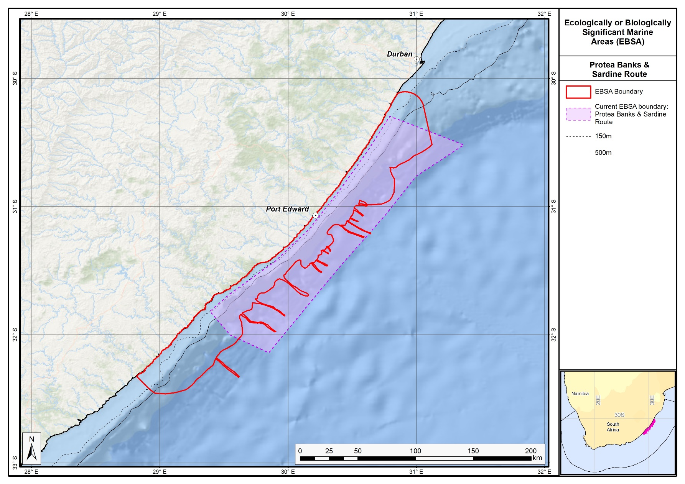
The proposed revised boundaries for the Protea Banks and Sardine Route EBSA in relation to its original boundaries.

KwaZulu-Natal Bight and uThukela River (Formerly Natal Bight)

Revised EBSA Description

General Information

Summary
The KwaZulu-Natal Bight and uThukela River is important for numerous ecological processes, including terrestrial-marine connectivity, larval retention, recruitment and provision of nursery and foraging areas. The area includes rare habitat types and supports some species known to exist in few localities. Cool productive water is advected onto the shelf through Agulhas- and wind-driven upwelling cells, and continental runoff from the large uThukela River is important for the delivery of detritus to the bight (which drives food webs), and maintenance of mud and other unconsolidated sediment habitats. The turbid, nutrient-rich conditions are important for life-history phases (breeding, nursery and feeding) for crustaceans, demersal fish, migratory fish, turtles and sharks, some of which are threatened. Particularly vulnerable and fragile ecosystems and species include submarine canyons, cold-water corals and slow-growing sparids. This EBSA is particularly important for threatened ecosystem types. Of the 27 ecosystem types represented, 20 (74%) are threatened including nine Endangered and 11 Vulnerable types, with a further two types that are Near Threatened.

Introduction of the area
The KwaZulu-Natal Bight and uThukela River is important for numerous ecological processes, including terrestrial-marine connectivity, larval retention, recruitment and provision of nursery and foraging areas. The area incorporates rare habitat types and supports some species known to exist in few localities. Cool productive water is advected onto the shelf through Agulhas- and wind-driven upwelling cells, and continental runoff from the large uThukela River is important for the delivery of detritus to the bight (which drives food webs), and maintenance of mud and other unconsolidated-sediment habitats. The turbid, nutrient-rich conditions are important for life-history phases (breeding, nursery and feeding) for crustaceans, demersal fish, migratory fish, turtles and sharks. Some of these species are threatened (turtles, scalloped hammerhead) or overexploited (sparids and sciaenids), and the deep reef and palaeo-shoreline habitats are considered important for the recovery of overexploited deep-reef fish species. Other particularly vulnerable and fragile ecosystems and species include submarine canyons, cold-water corals and slow-growing sparids. Nine Endangered habitat types occur in this area and a further 11 are Vulnerable (Sink et al., 2019). The Thukela Banks have been identified as a priority area by two different systematic biodiversity plans, a national plan to identify focus areas for offshore protection (Sink et al., 2011) and a fine-scale provincial plan for the province of KwaZulu-Natal (Harris et al., 2011).
Since the original description and delineation, the boundary of the EBSA has been revised to improve precision and better represent the underlying features. Importantly, the lower reaches of the uThukela River are now included because it is the key driver of the system. It is the conduit for sediment delivery to the near- and offshore ecosystems of the KwaZulu-Natal Bight, and provides the critical link between land and sea that underpins this EBSA. In fact, it was considered such an important addition that it prompted a name change for this EBSA, from Natal Bight to KwaZulu-Natal Bight and uThukela River. Further, recent research in the area has, inter alia, improved knowledge of the seabed composition, and thus the extent of the mud habitats and the Bight itself is now better understood and mapped, allowing a more accurate delineation of the EBSA. It is presented as a Type 2 EBSA because it contains “spatially stable features whose individual positions are known, but a number of individual cases are being grouped” (sensu Johnson et al., 2018).

Description of the location

EBSA Region
Southern Indian Ocean

Description of location
East coast of South Africa, extending from Maphelane to Durban, from the shore to -2000 m, including the Thukela Banks, the KwaZulu-Natal Bight nursery area, the shelf edge and upper bathyal zone. The area is entirely within South Africa’s EEZ.

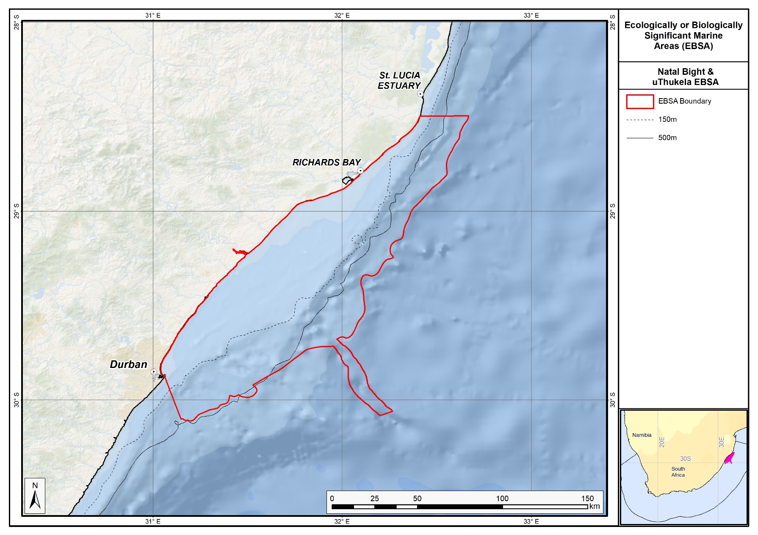
Proposed revised boundaries of the KwaZulu-Natal Bight and uThukela River EBSA.

Area Details

Feature description of the area
The area is characterized by extensive alluvial deposits forming banks, primarily off the uThukela River but also off the Mgeni River to a lesser degree (see Sink et al., 2011). The seafloor is thus sedimentary in nature but varies in the degree to which it is consolidated. The banks are productive in terms of benthic and deposit feeeders, an attribute typical of such features.

Feature conditions and future outlook of the proposed area
The National Biodiversity Assessment 2011 (Sink et al., 2012) indicated declining condition overall in the original EBSA (based on pressure data and an ecosystem-pressure matrix) with conditions ranging from fair to poor across the overall area. An updated assessment (Sink et al., 2019) on the new delineation shows ecological condition ranges from good to poor across the EBSA, with condition generally worse closer to the shore. Key pressures include the crustacean trawl fishery, a line fishery targeting sparids and sciaenids, and there are emerging mining and petroleum applications. A submarine cable has recently been laid in the area. Research on a number of the aforementioned aspects has been undertaken (but not published) by the Oceanographic Research Institute in Durban. There is planned research in the area through the African Coelacanth Ecosystem Program Phase III.

References
Ezemvelo KZN Wildlife, 2012. Focus areas for additional marine biodiversity protection in Natal, South Africa. Unpublished Report - Jan 2012. Scientific Services, Ezemvelo KZN Wildlife: Durban. Pp 62.
Fennessy, S. 2016. Subtropical demersal fish communities on soft sediments in the KwaZulu-Natal Bight, South Africa, African Journal of Marine Science, 38: sup1, S169-S180.
Harris, J.M., Livingstone, T., Lombard, A.T., Lagabrielle, E., Haupt, P., Sink, K., Mann, B., Schleyer, M. 2011 Marine Systematic Conservation Assessment and Plan for KwaZulu-Natal - Spatial priorities for conservation of marine and coastal biodiversity in KwaZulu-Natal. Ezemvelo KZN Wildlife.
Harris, L.R., Nel, R., Oosthuizen, H., Meyer, M., Kotze, D., Anders, D., McCue, S., Bachoo, S. 2018. Managing conflicts between economic activities and threatened migratory marine species towards creating a multi-objective blue economy. Conservation Biology, 32, 411-423.
Haupt, P. 2010. Conservation assessment and plan for fish species along the KwaZulu-Natal coast. MSc Thesis, Nelson Mandela Metropolitan University, South Africa.
Hutchings, L., Beckley, L.E., Griffiths, M.H., Roberts, M.J., Sundby, S., van der Lingen, C. 2002. Spawning on the edge: spawning grounds and nursery areas around the southern African coastline. Marine and Freshwater Research, 53: 307-318.
Johnson, D.E., Barrio Froján, C., Turner, P.J., Weaver, P., Gunn, V., Dunn, D.C., Halpin, P., Bax, N.J., Dunstan, P.K., 2018. Reviewing the EBSA process: Improving on success. Marine Policy 88, 75-85.
Lagabrielle, E. 2009. Preliminary report: National Pelagic Bioregionalisation of South Africa. Cape Town: South African National Biodiversity Institute.
Lutjeharms, J.R.E., Gründlingh, M., Carter, R.A. 1989. Topographically induced upwelling in the Natal Bight. South African Journal of Science, 85: 310 -316.
Lutjeharms, J.R.E., Cooper, J., Roberts, M. 2000.Upwelling at the inshore edge of the Agulhas Current. Continental Shelf Research, 20: 737 – 761.
Roberson, L.A., Lagabrielle, E., Lombard, A.T., Sink, K., Livingstone, T., Grantham, H., Harris, J.M. 2017. Pelagic bioregionalisation using open-access data for better planning of marine protected area networks. Ocean & Coastal Management, 148: 214-230.
Roberts, M.J., Nieuwenhuys, C. 2016. Observations and mechanisms of upwelling in the northern KwaZulu-Natal Bight, South Africa, African Journal of Marine Science, 38: S43-S63.
Scharler, U.M., van Ballegooyen, R.C. Ayers, M.J. 2016. A system-level modelling perspective of the KwaZulu-Natal Bight ecosystem, eastern South Africa, African Journal of Marine Science, 38: S205-S216.
Sink, K.J., Attwood, C.G., Lombard, A.T., Grantham, H., Leslie, R., Samaai, T., Kerwath, S., Majiedt, P., Fairweather, T., Hutchings, L., van der Lingen, C., Atkinson, L.J., Wilkinson, S., Holness, S., Wolf, T. 2011. Spatial planning to identify focus areas for offshore biodiversity protection in South Africa. Unpublished Report. Cape Town: South African National Biodiversity Institute.
Sink, K., Holness, S., Harris, L., Majiedt, P., Atkinson, L., Robinson, T., Kirkman, S., Hutchings, L., Leslie, R., Lamberth, S., Kerwath, S., von der Heyden, S., Lombard, A., Attwood, C., Branch, G., Fairweather, T., Taljaard, S., Weerts, S., Cowley, P., Awad, A., Halpern, B., Grantham, H., Wolf, T. 2012. National Biodiversity Assessment 2011: Technical Report. Volume 4: Marine and Coastal Component. South African National Biodiversity Institute, Pretoria.
Sink, K.J., van der Bank, M.G., Majiedt, P.A., Harris, L.R., Atkinson, L., Karenyi, N., Kirkman, S. (eds) 2019. National Biodiversity Assessment 2018 Technical Report Volume 4: Marine Realm. South African National Biodiversity Institute, Pretoria.
Taylor, F.E., Arnould, M.N., Bester, M.N, Crawford, R.J.M., Bruyn, P.J.N, Delords, K., Makhado, A.B., Ryan, P.G., Tosh, C.A., Weimerskirchs, H. 2011. The seasonal distribution and habitat use of marine top predators in the Southern Indian Ocean, and implications for conservation. WWF report, South Africa.

Other relevant website address or attached documents
Summary of habitat types and threat status for the KwaZulu-Natal Bight and uThukela River EBSA. Data from Sink et al. (2019).
Threat Status | Ecosystem Type | Area (km²) | Area (%)
Endangered | Durnford Inner Shelf Reef Complex | 460.5 | 4.4
 | Natal Bight Deep Shelf Edge | 1654.6 | 15.6
 | Natal Bight Mid Shelf Reef Complex | 23.0 | 0.2
 | Natal Bight Mid Shelf Reef Sand Mosaic | 534.7 | 5.1
 | Natal Bight Sandy Inner Shelf | 145.9 | 1.4
 | Subtropical Estuarine Lake | 1.7 | 0.0
 | Subtropical Large Fluvially Dominated Estuary | 6.3 | 0.1
 | Subtropical Large Temporarily Closed Estuary | 0.5 | 0.0
 | Subtropical Predominantly Open Estuary | 2.5 | 0.0
Vulnerable | Durnford Mid Shelf Reef Complex | 431.8 | 4.1
 | Natal Bight Muddy Inner Shelf | 328.7 | 3.1
 | Natal Bight Muddy Shelf Edge | 400.6 | 3.8
 | Natal Bight Outer Shelf Coarse Sediment Reef Mosaic | 647.8 | 6.1
 | Natal Mixed Shore | 9.0 | 0.1
 | Natal-Delagoa Reflective Sandy Shore | 2.7 | 0.0
 | St Lucia Sandy Mid Shelf | 496.0 | 4.7
 | Subtropical Small Temporarily Closed Estuary | 0.5 | 0.0
 | uThukela Mid Shelf Coarse Sediment Reef Mosaic | 789.4 | 7.5
 | uThukela Mid Shelf Mud Coarse Sediment Mosaic | 1348.7 | 12.7
 | uThukela Outer Shelf Muddy Reef Mosaic | 531.8 | 5.0
Near Threatened | Natal Exposed Rocky Shore | 0.1 | 0.0
 | Natal-Delagoa Intermediate Sandy Shore | 20.2 | 0.2
 | uThukela Canyon | 417.8 | 3.9
Least Concern | Natal-Delagoa Dissipative-Intermediate Sandy Shore | 11.3 | 0.1
 | Southwest Indian Mid Slope | 0.8 | 0.0
 | Southwest Indian Upper Slope | 2281.2 | 21.6
 | St Lucia Sandy Inner Shelf | 31.6 | 0.3
Grand Total |  | 10579.6 | 100.0

Assessment of the area against CBD EBSA criteria
C1: Uniqueness or rarity Medium
Justification
Endemic and rare species include: Spotted legskate (Anacanthobatis marmoratus), Porcupine stingray (Urogymnus asperrimus); the Bearded Goby (Taenioides jacksoni) is also endemic (Haupt 2010, Livingston et al., 2012). There are rare gravel and mud habitat types in the area, as well as a submarine canyon of limited extent (Sink et al., 2012). There is also a unique demersal fish community near the Thukela Banks (Fennesey 2016), and it is the only portion of the South African east coast that has a relatively wide shelf area.
C2: Special importance for life-history stages of species High
Justification
The KwaZulu-Natal Bight and uThukela River supports important life-history stages for a myriad of species. These functions include serving as a migration corridor for fish (e.g., Geelbek – Atractoscion aequidens, White stumpnose – Rhabdosargus holubi, Shad - Pomatomus saltatrix, Dusky kob - Argynosomus japonicas (Vulnerable), and Garrick – Lichia amia). It is also part of the migration route and spawning area for sardine – Sardinops sagax; many shark and fish species also spawn in the KwaZulu-Natal Bight (e.g., Bull shark – Carcharhinus leucas, Sand tiger shark – Carcharias taurus, Black musselcracker – Cymatoceps nasutus, and King mackerel – Scomber japonicas). The KwaZulu-Natal Bight and uThukela River is also an important nursery area for sharks and fish (e.g., Scalloped hammerhead – Sphyrna lewini (EN), Slinger – Chrysoblephus puniceus, Black musselcracker – Cymatoceps nasutus), and an important feeding and migration area for Critically Endangered leatherback turtles (Dermochelys coriacea; Haupt 2010, Harris et al., 2011, Vogt 2011, Sink et al., 2011, Ezemvelo KZN Wildlife 2012; Harris et al., 2018). There are also critical linkages between the Thukela Bank prawn-trawling ground and the estuarine nursery areas, emphasising the area’s role in ecosystem connectivity and supporting recruitment of many commercially important species (Scharler et al., 2016).
C3: Importance for threatened, endangered or declining species and/or habitats High
Justification
The KwaZulu-Natal Bight and uThukela River contains at least 11 threatened species, including: the Critically Endangered Seventy-four (Polysteganus undulosus), leatherbacks (Dermochelys coriacea) and hawksbills (Eretmochelys imbricata); Endangered Scalloped hammerhead (Sphyrna lewini), great hammerhead (Sphyrna mokarran), dageraad (Chrysoblephus christiceps), red stumpnose (Chrysoblephus gibbiceps), and green turtles (Chelonia mydas); and Vulnerable Flapnose houndshark (Scylliogaleus quecketti), porcupine stingray (Urogymnus asperrimus), dusky kob (Argynosomus japonicas), and bearded goby (Taenioides jacksoni). There are also endemic sparids of conservation concern: Polysteganus coeruleopunctatus, as well as Near Threatened loggerheads (Caretta caretta). There are 20 threatened ecosystem types, including nine Endangered types, and 11 Vulnerable types (Sink et al., 2019).
C4: Vulnerability, fragility, sensitivity, or slow recovery Medium
Justification
The KwaZulu-Natal Bight and uThukela River contains features and species that are slow growing, fragile, and sensitive to disturbance, e.g., submarine canyons, shelf edge, deep reefs and cold-water corals (Sink et al., 2011, 2012).
C5: Biological productivity High
Justification
The KwaZulu-Natal Bight and uThukela River contains Indian Ocean water, with high but variable chlorophyll-a levels associated with very frequent SST and chlorophyll-a fronts (Lagabrielle 2009, Roberson et al., 2017). This pelagic habitat (Cb3) is characterised by cool productive water that has been advected onto the shelf in this sheer-zone through Agulhas Current-driven upwelling cells (Lutjeharms et al., 2000, Lutjeharms et al., 2000). Upwelling in the KwaZulu-Natal Bight is largely wind-driven (Roberts & Nieuwenhuys, 2016). Further, it has recently been discovered that substantial inputs of (mainly terrigenous) detritus from the uThukela River drive food webs in the KwaZulu-Natal Bight and uThukela River, particularly of the benthic communities which dominate the local food webs (Scharler et al., 2016).
C6: Biological diversity High
Justification
There is high habitat heterogeneity in the KwaZulu-Natal Bight and uThukela River EBSA, with 27 ecosystem types represented (Sink et al., 2019) and new evidence of diverse demersal fish communities in the area (Fennessey 2016).
C7: Naturalness Medium
Justification
Most of the area is in fair to poor ecological condition, however, there are still substantial portions of the EBSA that are still in good ecological condition (Sink et al., 2019).

Status of submission
The KwaZulu-Natal Bight EBSA was recognized as meeting EBSA criteria by the Conference of the Parties. The revised name, description and boundaries still need to be submitted to COP for approval.

COP Decision
dec-COP-12-DEC-22
End of proposed EBSA revised description

Motivation for Submission
Some technical revisions and updates to the description were made based on recent research. A supplementary table of the habitats represented in the EBSA and their associated threat status was also included. A criteria level change was made on Criterion 5: Biological productivity and Criterion 6: Biological diversity, with ranks respectively upgraded from Medium to High, and Low to Medium. This was based on new research for productivity (Scharler et al., 2016) and demersal fish diversity (Fennessey 2016). Further, empirical evidence from the National Biodiversity Assessment (Sink et al., 2012) showed that a rank of Low for Criterion 7: Naturalness was not justified for this EBSA, and thus the rank was upgraded to Medium.
The main change is that the boundary of this EBSA has been slightly adjusted to more closely focus the EBSA on the key biodiversity features that underly its EBSA status. In particular, this includes adding the lower reaches of the uThukela River, which provides the critical link between land and sea in delivering sediment to the near- and offshore ecosystems comprising the KwaZulu-Natal Bight. The delineation process included an initial stakeholder review which identified the need to update boundaries, a technical mapping process and then an expert review workshop where boundary delineation options were finalised. The delineation process used a combination of Systematic Conservation Planning and Multi-Criteria Analysis methods. The features used in the analysis were:
- The key KwaZulu-Natal Bight ecosystems (i.e. those shelf and inshore types dominated by sediment inputs) were focussed on.
- Irreplaceable and near irreplaceable (i.e. very high selection frequency) sites, as well as focus areas identified in the national SCP analysis undertaken as part of Majiedt et al. (2013) and focus areas for offshore protection (Sink et al., 2011) were included.
- Key physical features (especially canyons) identified from the latest GEBCO data, global benthic geomorphology mapping (www.bluehabitats.org, Harris et al., 2014) and the National Biodiversity Assessment 2011 (Sink et al., 2012) were incorporated.
- Delineations and threat status of consitituent ecosystem types in the area were included in the analysis and used to refine the boundary of the EBSA.
- Areas of high relative naturalness of benthic and coastal systems and pelagic systems identified in the National Biodiversity Assessment 2011 (Sink et al., 2012a) and 2018 (Sink et al., 2019) were included in the analysis.
- Distributions of known fragile, vulnerable and sensitive habitat-forming species were included (Unpublished SANBI and SAEON data).
The multi-criteria analysis resulted in a value surface. The cut-off value used to determine the extent of the EBSA was based on expert input and quantitative analysis of effective inclusion of the above features. This entailed taking an iterative parameter calibration-based approach whereby the spatial efficiency of the inclusion of the targeted features was evaluated. The approach aimed to identify a cut-off which most efficiently included prioritised features while minimizing the inclusion of impacted areas. The final boundaries shown in the map were validated in a national workshop.

Research Needs
There is planned research in this focus are through the African Coelacanth Ecosystem Program Phase III. Any additional research needs will be populated in a workshop to be held in August/September 2018.

Future Process
Portions of the EBSA have been gazetted for inclusion into the uThukela MPA. It is unclear if this EBSA will be subject to detailed attention in the MARISMA EBSA status assessment and management options workplan. This will be decided on in a workshop to be held in August/September 2018.

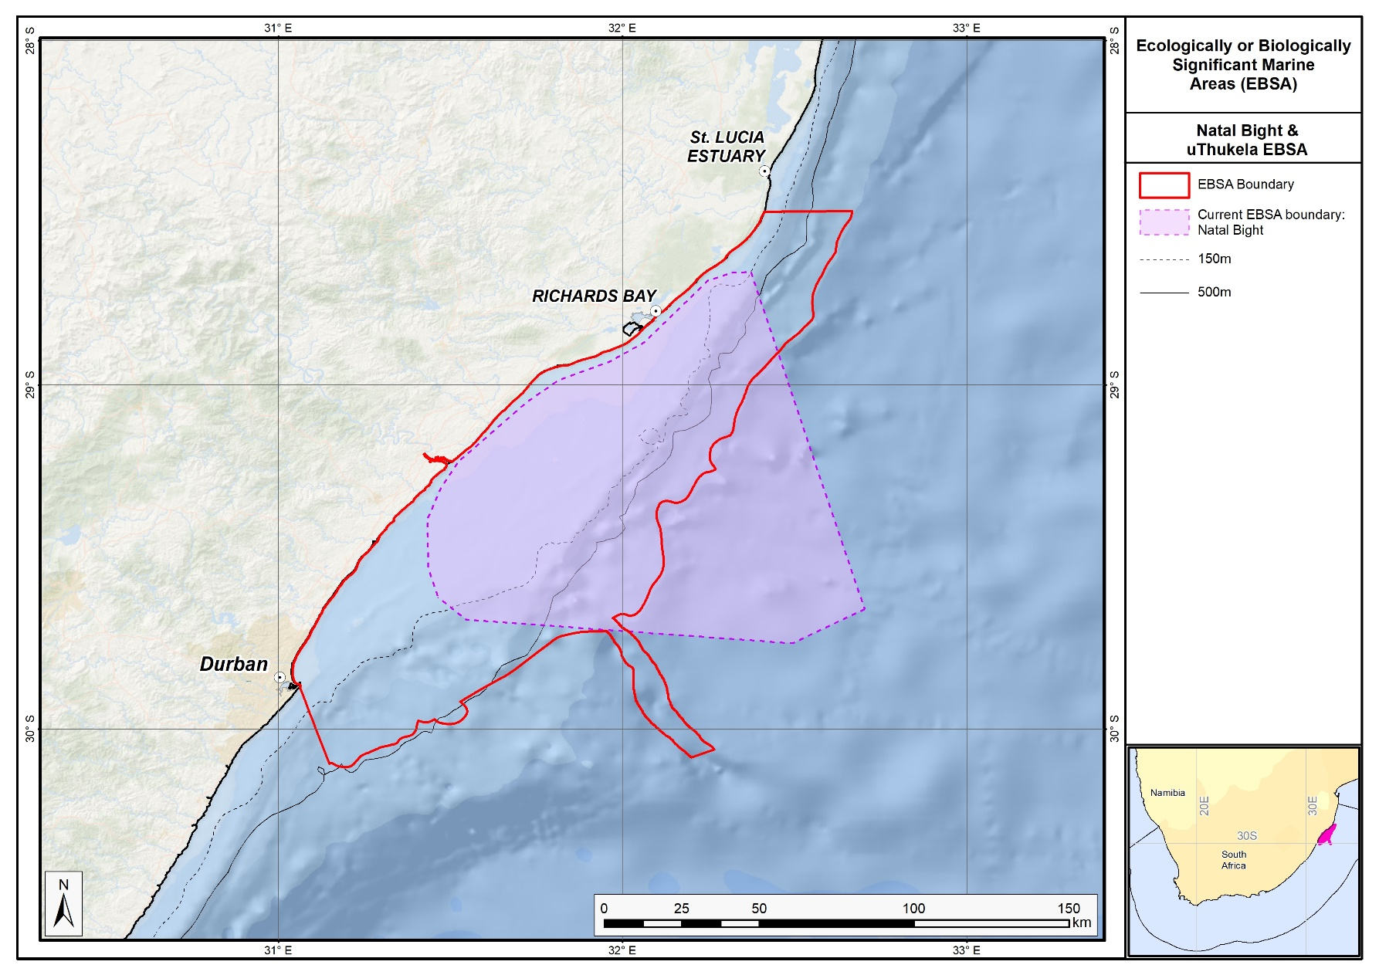
The proposed revised boundaries for the KwaZulu-Natal Bight and uThukela River EBSA in relation to the original boundaries of the Natal Bight EBSA.

New EBSAs

Protea Seamount Cluster

Proposed EBSA Description

Abstract
The Protea Seamount Cluster is in the south Atlantic abyss off the SSW flank of the Agulhas continental shelf, within the South African EEZ. It is a unique feature in that it is the only seamount cluster in the south Atlantic abyss in South Africa’s EEZ. The seamounts support more productivity and diversity compared to adjacent sites, and offer a site for migratory species to aggregate around. Notably, the Protea Seamount Cluster contains vulnerable and sensitive ecosystems and species, some of which are threatened, e.g. the site is visited by regionally Critically Endangered leatherback turtles. It is in good condition given the currently low anthropogenic pressure in the area, promoting the importance of its protection. This EBSA is particularly relevant for its: Uniqueness and rarity; Importance for threatened or declining species and habitats; Vulnerability and sensitivity; and Naturalness.

Introduction
The Protea Seamount Cluster focus area lies on the SSW flank of the Agulhas continental shelf: an oceanic plateau that extends several hundreds of kilometres south of South Africa. The focus area is south west of the Browns Bank EBSA, entirely within and up to the edge of the South African EEZ. The site includes the base of the lower slope, but falls mainly within the south Atlantic abyss. Late Eocene volcanism created the seamount cluster in this focus area, including Protea and Argentina Seamounts (among others). The Agulhas Current, which flows south-westward along the eastern coast of South Africa, has its retroflection in this area. Given this position, and its location relative to the Agulhas basin and Agulhas continental shelf, the seamount cluster is an important aggregation site for several migratory species, such as sharks, tuna, and turtles. These animals are also likely attracted to the site for the higher local productivity that is usually associated with seamounts. The Protea Seamount Cluster also contains vulnerable, fragile and sensitive ecosystems and species, and thus the focus area both includes and is important for both benthic and pelagic features. It is considered highly relevant in terms of the following EBSA criteria: “Uniqueness and rarity”, “Importance for threatened or declining ecosystems and species”, and “Naturalness”.

This site was recognised as important at the original South Eastern Atlantic Workshop for EBSA Identification in 2013, but that there was not enough information available to score it against the EBSA criteria at the time (see UNEP/CBD/RW/EBSA/SEA/1/4 Annex 6, Area 5). However, some new data and information have now made description and delineation of the EBSA possible, although criterion rankings still rely heavily on inferred information in many cases. Therefore, the criteria were benchmarked against those ranks given to other EBSAs described for seamounts specifically (see the section: Other relevant website address or attached documents). The seamounts are the underpinning feature of this EBSA, but it also comprises additional features and ecosystems that are connected by seamount-related ecological processes. Consequently, it is proposed as a Type 2 EBSA (sensu Johnson et al. 2018).

Description of the location

EBSA Region
South-Eastern Atlantic

Location
The Protea Seamount Cluster focus area occurs within the national jurisdiction of South Africa. It is found in the south Atlantic abyss off the SSW flank of the Agulhas continental shelf: an oceanic plateau that extends several hundreds of kilometres south of South Africa. It lies south west of the Browns Bank EBSA, and extends to the boundary of South Africa’s EEZ.

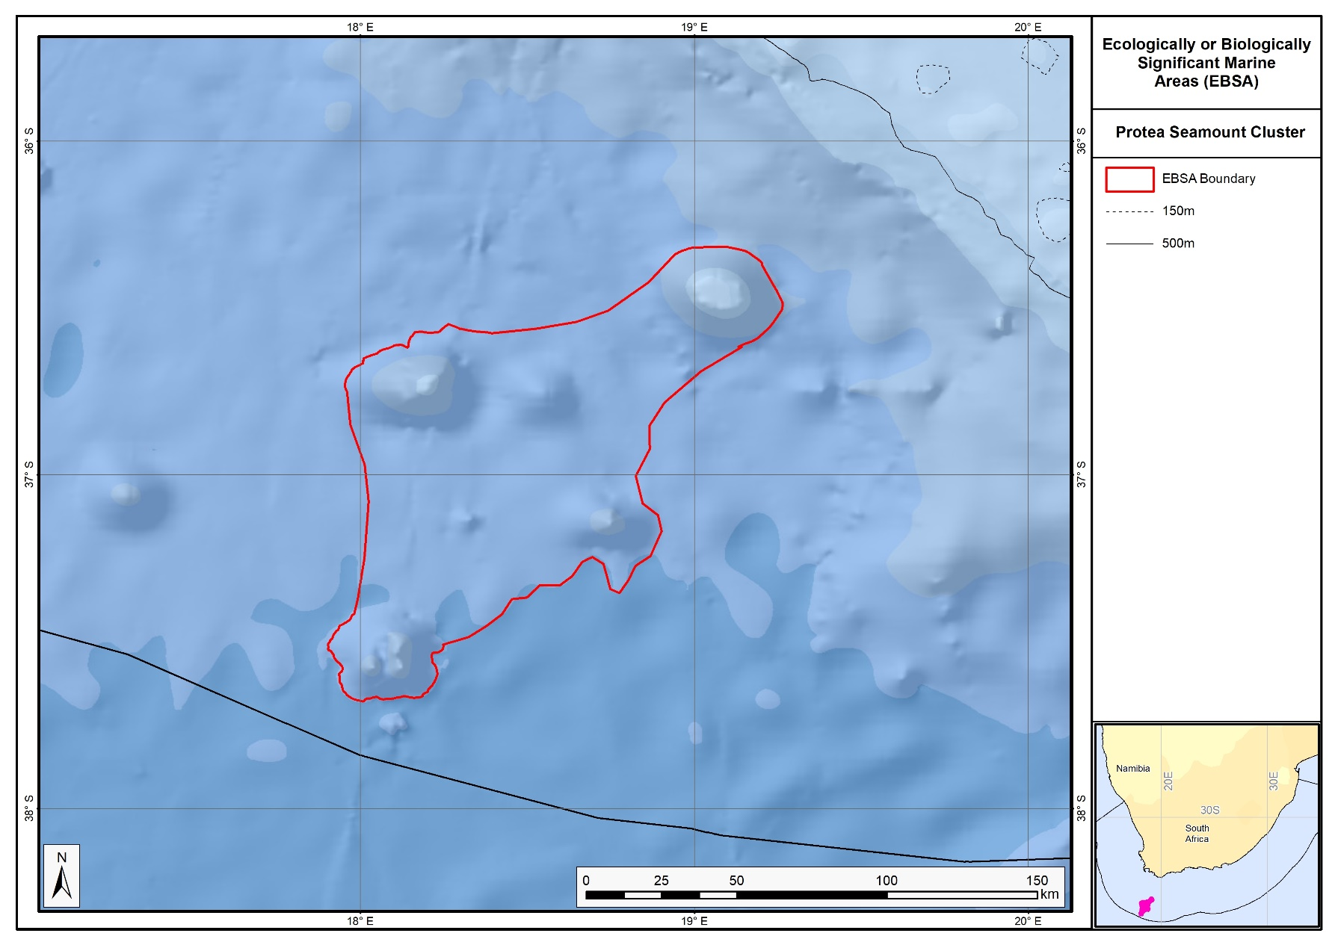
Proposed boundaries of the Protea Seamount Cluster EBSA.

Feature description of the proposed area
The Protea Seamount Cluster focus area is important for both its benthic and pelagic features, notably for supporting threatened habitats and species, and vulnerable, fragile and sensitive ecosystems and species. It comprises a seamount cluster that includes the Protea Seamount, and a few others, that rise from the southeast Atlantic abyss. The Agulhas Current, which flows south-westward along the eastern coast of South Africa, has its retroflection in this area. Given this position, and its location relative to the Agulhas basin and Agulhas continental shelf, local productivity is high at the site. Consequently, it serves as an important aggregation site for migratory species, such as sharks, seabirds (Halpin et al., 2009), and tuna. Further, adult female leatherback turtles have been satellite tracked to these seamounts and surrounds following nesting (Luschi et al., 2003, 2006, Robinson 2014, Harris et al., 2018), with the site likely used by juvenile turtles as well. There has been one previous scientific expedition to Protea Seamount (in 2001), which was focused on deep-sea pelagic birds.

The Protea Seamount Cluster had a high selection frequency in two systematic conservation plans to represent biodiversity efficiently (Majiedt et al., 2013; Sink et al., 2011). The EBSA was delineated based on this selection frequency, key features (seamounts, fragile and sensitive habitat-forming species, and portions of threatened habitat in good condition), and to align with a national initiative to expand MPAs in South Africa. Protecting this site is important because of its vulnerability to both pelagic fishing and benthic trawling. Although no research is currently planned for this area, it is recommended for this EBSA, particularly towards informing appropriate spatial management of this site.

Note that there are other seamounts in the surrounding area that are not included in the delineation of the EBSA because they are much smaller, unnamed, or there are no records of fragile, habitat-forming species for these sites and they are considered data deficient. There is a matrix of abyssal and and bathyal habitat in between the seamouts that is included in the delineation because it represents the broader area where the top predators aggregate in the water column in response to the elevated productivity of the site, likely also encompassing the full extent of seamount-related ecological processes. In addition, it is an efficient way to include a natural, near-pristine portion of these habitat types in the EBSA network that is likely to be taken up in spatial management processes for the seamounts themselves, especially because these areas were identified as a priority in the two systematic conservation plans mentioned above.

Feature condition and future outlook of the proposed area
Sink et al. (2012, 2019) estimated the threat status of marine ecosystem types in South Africa by assessing the cumulative impacts of various pressures (e.g. extractive resource use, pollution and others) on each ecosystem type. The latest assessment (Sink et al., 2019) shows the whole area to be in natural ecological condition. However, the area is highly vulnerable to exploitation due to its unprotected status. The area is in a good condition, largely because it has been subjected to relatively little extractive resource use (e.g. fishing, mining) pressure, and is relatively remote and often subjected to high seas with winds of around 50 knots.

References
Halpin, P.N., A.J. Read, E. Fujioka, B.D. Best, B. Donnelly, L.J. Hazen, C. Kot, K. Urian, E. LaBrecque, A. Dimatteo, J. Cleary, C. Good, L.B. Crowder, and K.D. Hyrenbach. 2009. OBIS-SEAMAP: The world data center for marine mammal, sea bird, and sea turtle distributions. Oceanography, 22: 104-115
Harris, L.R., Nel, R., Oosthuizen, H., Meyer, M., Kotze, D., Anders, D., McCue, S., Bachoo, S. 2018. Managing conflicts between economic activities and threatened migratory marine species towards creating a multi-objective blue economy. Conservation Biology, 32: 411-423.
Johnson, D.E., Barrio Froján, C., Turner, P.J., Weaver, P., Gunn, V., Dunn, D.C., Halpin, P., Bax, N.J., Dunstan, P.K., 2018. Reviewing the EBSA process: Improving on success. Marine Policy 88, 75-85.
Luschi, P., Sale, A., Mencacci, R., Hughes, G.R., Lutjeharms, J.R.E., Papi, F. 2003. Current transport of leatherback sea turtles (Dermochelys coriacea) in the ocean. Proceedings of the Royal Society of London. Series B: Biological Sciences, 270: S129-S132.
Luschi, P., Lutjeharms, J.R.E., Lambardi, P., Mencacci, R., Hughes, G.R., and Hays, G.C. 2006. A review of migratory behaviour of sea turtles off southeastern Africa. South African Journal of Science, 102: 51-58.
Majiedt, P., Holness, S., Sink, K., Oosthuizen, A., Chadwick, P. 2013. Systematic Marine Biodiversity Plan for the West Coast of South Africa. South African National Biodiversity Institute, Cape Town.
Robinson, N. 2014. Migratory ecology of sea turtles. PhD Thesis. Perdue University, United States of America.
Sink, K.J., Attwood, C.G., Lombard, A.T., Grantham, H., Leslie, R., Samaai, T., Kerwath, S., Majiedt, P., Fairweather, T., Hutchings, L., van der Lingen, C., Atkinson, L.J., Wilkinson, S., Holness, S., Wolf, T. 2011. Spatial planning to identify focus areas for offshore biodiversity protection in South Africa. Unpublished Report. Cape Town: South African National Biodiversity Institute.
Sink, K., Holness, S., Harris, L., Majiedt, P., Atkinson, L., Robinson, T., Kirkman, S., Hutchings, L., Leslie, R., Lamberth, S., Kerwath, S., von der Heyden, S., Lombard, A., Attwood, C., Branch, G., Fairweather, T., Taljaard, S., Weerts, S., Cowley, P., Awad, A., Halpern, B., Grantham, H., Wolf, T. 2012. National Biodiversity Assessment 2011: Technical Report. Volume 4: Marine and Coastal Component. South African National Biodiversity Institute, Pretoria.
Sink, K.J., van der Bank, M.G., Majiedt, P.A., Harris, L.R., Atkinson, L., Karenyi, N., Kirkman, S. (eds) 2019. National Biodiversity Assessment 2018 Technical Report Volume 4: Marine Realm. South African National Biodiversity Institute, Pretoria.

Other relevant website address or attached documents
Summary of habitat types and threat status for Protea Seamount Cluster. Data from Sink et al. (2019).
Threat Status | Ecosystem Type | Area (km2) | Area (%)
Least Concern | Cape Basin Abyss | 1241.9 | 13.8
 | Cape Basin Complex Abyss | 5318.4 | 59.0
 | Southeast Atlantic Lower Slope | 0.2 | 0.0
 | Southeast Atlantic Seamount | 1576.3 | 17.5
 | Southeast Atlantic Slope Seamount | 882.7 | 9.8
Grand Total |  | 9019.5 | 100.0

To benchmark the criteria ranking for this proposed EBSA, we plotted the frequency of all criteria ranks for seamount-related EBSAs in the global network (Figure X below)
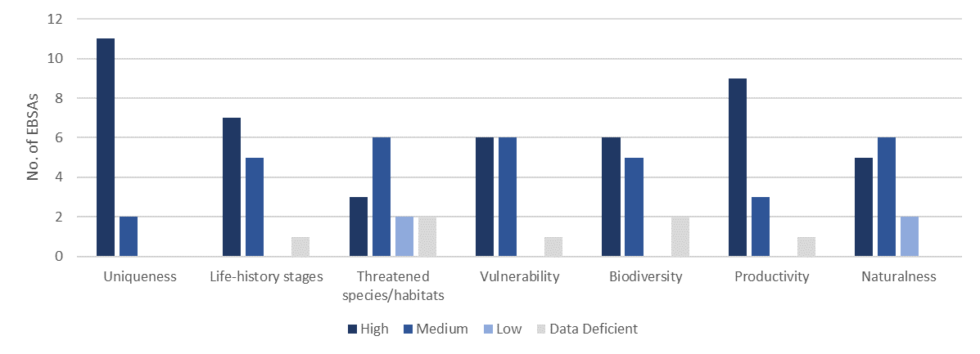
Figure X. Frequency of the criteria ranks for EBSAs in the global network that are described specifically for seamounts (n=13): Juan Fernández Ridge Seamounts; Emperor Seamount Chain and Northern Hawaiian Ridge; North-east Pacific Ocean Seamounts; New England and Corner Rise Seamounts; Tabou Canyon and Seamount; Cayar Seamount; Atlantis Seamount; Coral Seamount and Fracture Zone Feature; Agulhas Slope and Seamounts; Central Louisville Seamount Chain; Monowai Seamount; Seamounts of West Norfolk Ridge; and Sagami Trough and Island and Seamount Chain of Izu-Ogasawara.

Assessment of the area against CBD EBSA Criteria
CBD EBSA Criteria  (Annex I to decision IX/20) | Description  (Annex I to decision IX/20) |  |  | Ranking of criterion relevance
Uniqueness or rarity | Area contains either (i) unique (“the only one of its kind”), rare (occurs only in few locations) or endemic species, populations or communities, and/or (ii) unique, rare or distinct, habitats or ecosystems; and/or (iii) unique or unusual geomorphological or oceanographic features. |  |  | Medium
Explanation for ranking
This is the only seamount cluster in the Atlantic Ocean portion of the South African EEZ, although there are other seamount clusters in the surrounding area beyond national jurisdiction.

Special importance for life-history stages of species | Areas that is required for a population to survive and thrive. |  |  | Medium
Explanation for ranking
Data are relatively limited for assessing this criterion. However, given the locally high productivity in the focus area, it is expected that the Protea Seamount Cluster is a key foraging site for migratory species in particular. Further, all other EBSAs globally that include seamounts rank the site at medium or high importance for this criterion, indicative of the ecological role that the feature plays in offshore systems that can be inferred here too. OBIS-SEAMAP (Halpin et al., 2009) shows 1-10 records of megavertebrate (marine mammal, seabird, sea turtle and ray and shark) observations for most of the area around these seamounts in the southeast Atlantic, and a 10-100 records within the EBSA region.

Importance for threatened, endangered or declining species and/or habitats | Area containing habitat for the survival and recovery of endangered, threatened, declining species or area with significant assemblages of such species. |  |  | Medium
Explanation for ranking
This a site where regionally Critically Endangered leatherback turtles have been recorded based on satellite tracking data (Harris et al., 2018), and a site where other threatened species (e.g., tuna, sharks and seabirds) are expected or known to occur. Global rankings for seamount-specific EBSAs are either High or Medium for this criterion; data are limited for this site specifically, thus it is scored as Medium.

Vulnerability, fragility, sensitivity, or slow recovery | Areas that contain a relatively high proportion of sensitive habitats, biotopes or species that are functionally fragile (highly susceptible to degradation or depletion by human activity or by natural events) or with slow recovery. |  |  | High
Explanation for ranking
Almost all other seamount-specific EBSAs rank this criterion as Medium or High. This is because seamounts are habitats for many indicator species of vulnerable marine ecosystems (Watling & Auster 2017). Therefore, within Protea Seamount Cluster, it is likely that there are fragile, sensitive species, such as corals and sponges, that are vulnerable to impacts on the seabed and that would take a long time to recover if impacted. This is supported by known presence localities of fragile, vulnerable and sensitive habitat-forming species (Unpublished SANBI and SAEON data) within the EBSA area. Further, the top predators that frequent this site (e.g., Harris et al., 2018) are also slow to recover from population impacts, particularly leatherback turtles given how long they take to reach sexual maturity, and the low survivorship from hatchling to adult (approximately 1 in 1000 survive).

Biological productivity | Area containing species, populations or communities with comparatively higher natural biological productivity. |  |  | Medium
Explanation for ranking
Seamounts are considered to be relatively productive systems, with most other EBSAs for seamounts ranking this criterion as High. No data are available for the Protea Seamount Cluster; however, Chlorophyll-a concentrations (MODIS-Aqua data on the NASA Giovanni Portal: https://giovanni.gsfc.nasa.gov/giovanni) show marginally higher values within this area compared to the surrounding abyss.

Biological diversity |  | Area contains comparatively higher diversity of ecosystems, habitats, communities, or species, or has higher genetic diversity. | Medium
Explanation for ranking
No are data available, however, given the habitat heterogeneity as a result of the seamount cluster, local biodiversity is expected to be higher than adjacent sites, which is confirmed by the global rankings of seamount-specific EBSAs that score this criterion either High or Medium. Further, given the productivity and physical location that makes aggregation of migratory species likely, biodiversity is expected to be higher than the surrounding area. This is supported by the relatively greater abundances (likely representing a greater diversity of species) of megavertebrates in the EBSA region compared to that of the surrounding area (Halpin et al., 2009), and records of up to 100 species of animals in the OBIS database (http://www.iobis.org) within this EBSA. There are three main ecosystem types that make up this EBSA, with a very small portion of a fourth ecosystem type (Sink et al.,2019).

Naturalness |  | Area with a comparatively higher degree of naturalness as a result of the lack of or low level of human-induced disturbance or degradation. | High
Explanation for ranking
The focus area is all assessed to be in natural ecological condition (Sink et al., 2012, 2019), largely because the area has been subjected to relatively low levels of anthropogenic pressures because it is relatively remote and often subjected to high seas with winds of around 50 knots. This contrasts with many seamounts further north in the Benguela system that are not in good ecological condition because they have high fishing pressure.

Status of submission
Area to be submitted to the Conference of the Parties for acknowledgement of meeting EBSA criteria once review process is finalized.

COP Decision
Not yet submitted.

End of proposed EBSA revised description

Motivation for Submission
A previous tentative description for a Protea Seamount EBSA was previously compiled, but was not submitted to CBD due to data limitations. Subsequent expert and systematic review of gaps in the EBSA network highlighted the requirements for the Protea Seamount Cluster EBSA, and delineation and description became possible due to improved spatial datasets. Initial draft EBSA boundaries were determined, and these were then evaluated against the EBSA criteria. Once it was determined that the area would meet EBSA criteria a formal boundary delineation and evaluation process was undertaken. The delineation process included an initial stakeholder review, a technical mapping process and then an expert review workshop where boundary delineation options were finalised. The delineation process used a combination of Systematic Conservation Planning and Multi-Criteria Analysis methods. The features used in the analysis were:
- Key physical features (i.e. the seamounts and seamount linked ecosystems) from the National Biodiversity Assessment 2011 (Sink et al., 2012) and BCC spatial mapping project (Holness et al., 2014) were incorporated. These data were refined using the latest GEBCO data and global benthic geomorphology mapping (www.bluehabitats.org, Harris et al., 2014).
- Irreplaceable and near irreplaceable (i.e. very high selection frequency) sites which relate closely to the EBSA criteria of “Uniqueness and rarity”, as well as focus areas identified in the SCP undertaken for the BCLME by Holness et al. (2014) and Majiedt et al. (2013) were incorporated. In addition, focus areas for marine protection identified by Sink et al. (2011) were included.
- Threatened and under-protected ecosystem types. The analysis attempted to focus on the inclusion of the most threatened and under-protected ecosystem types found in the area (Sink et al. 2012, 2019; Holness et al., 2014). However, as all types in the broader area were Least Concern and not protected, this aspect was not informative.
- Areas of high relative naturalness identified in the National Biodiversity Assessment 2011 (Sink et al., 2012), the West Coast (Majiedt et al., 2013) and the BCLME spatial assessments (Holness et al., 2014) were included in the analysis. Both pelagic and benthic and coastal condition were incorporated.
- Distributions of known fragile, vulnerable and sensitive habitat-forming species were included (Unpublished SANBI and SAEON data).
The multi-criteria analysis resulted a value surface. The cut-off value used to determine the extent of the EBSA was based on expert input and quantitative analysis of effective inclusion of the above features. This entailed taking an iterative parameter calibration-based approach whereby the spatial efficiency of the inclusion of the targeted features was evaluated. The approach aimed to identify a cut-off which most efficiently included prioritised features while minimizing the inclusion of impacted areas. The final boundaries shown in the map were validated in a national workshop.

Research Needs
This item will be populated in a workshop to be held in August/September 2018.

Future Process
Portions of the EBSA have been gazetted for inclusion into the proposed Southeast Atlantic Seamounts MPA. It is unclear if this EBSA will be subject to detailed attention in the MARISMA EBSA status assessment and management options workplan. This will be decided on in a workshop to be held in August/September 2018.

Tsitsikamma-Robberg

Proposed EBSA Description

Abstract
Tsitsikamma-Robberg is a coastal EBSA on the South African south coast. It includes Tsitsikamma MPA (South Africa’s oldest MPA), Robberg MPA, Goukamma MPA, and part of the Garden Route Biosphere Reserve. It extends from the shore largely to the back of the middle shelf (-100 m isobath), with some extension onto the shallow outer shelf, and includes the extent of five estuaries, including Knysna. The protection afforded to the inshore reefs from these MPAs has contributed to a high diversity and abundance of species, including fragile, vulnerable, sensitive and slow-growing species, that in turn support many top predators. Numerous threatened species occur within this EBSA, including an Endangered endemic seahorse species and several Critically Endangered fish species, with the area also supporting important life-history stages of these threatened and other species. Several Critically Endangered and Endangered ecosystem types are also represented in the EBSA, which by implication support threatened biological communities. The area is mostly in good or fair ecological condition. However, Tsitsikamma MPA has recently been opened to recreational fishing in certain areas.

Introduction
Tsitsikamma-Robberg is a coastal EBSA that includes the Tsitsikamma, Robberg and Goukamma MPAs, and is bordered along most of its shore length by the Garden Route National Park. The EBSA also forms part of the Garden Route Biosphere Reserve. Fourteen estuaries open into this EBSA, with the Keurbooms, Groot, Sout, Knysna and Goukamma Estuaries included in the EBSA boundary. As a coastal EBSA, the depth range is relatively shallow, with most of the area covering the middle shelf. Depths are generally shallower than -100 m, although slightly deeper waters are contained in the western offshore extension. The EBSA contains important inshore reefs, vulnerable, fragile and sensitive species, and is also rich in top predators (sharks, cetaceans and marine mammals), some of which are threatened species. Inclusion of the Keurbooms and Knysna Estuaries in the EBSA means that it also contains two of only three estuaries in South Africa where the Knysna seahorse (Hippocampus capensis) is found: one of the two Endangered seahorse species globally. Given the diversity contained within the EBSA, there are many ecotourism operators (whale watching, fishing charters) and marine researchers working in this area. Notably, Tsitsikamma MPA is Africa’s oldest marine reserve, and therefore, there is a lot of research on the reef and fish communities contained within it. The EBSA had a high selection frequency in a national systematic conservation plan, and was also identified as a key site in South Africa’s protected area expansion strategy.

The significance of this site is largely underpinned by the inshore reefs. However, it also includes several other biodiversity features, such as critical linkages between land and sea via the five key estuaries, and important shore habitats that support critical life history stages of animals such as seals. Consequently, this site is proposed as a Type 2 EBSA (sensu Johnson et al. 2018).

EBSA Region
Southern Indian Ocean

Location
The Tsitsikamma-Robberg EBSA extends along the South African south coast from the eastern boundary of the Goukamma MPA, to about 8 km west of the Robberg Peninsula, and offshore by approximately 15-18 km, largely following the -100 m isobath. The western half of the EBSA has an offshore extension, roughly opposite the Knysna Estuary. It also includes the five largest estuaries in the EBSA: Keurbooms, Groot, Sout, Knysna and Goukamma. Tsitsikamma-Robberg is entirely within South Africa’s national jurisdiction.

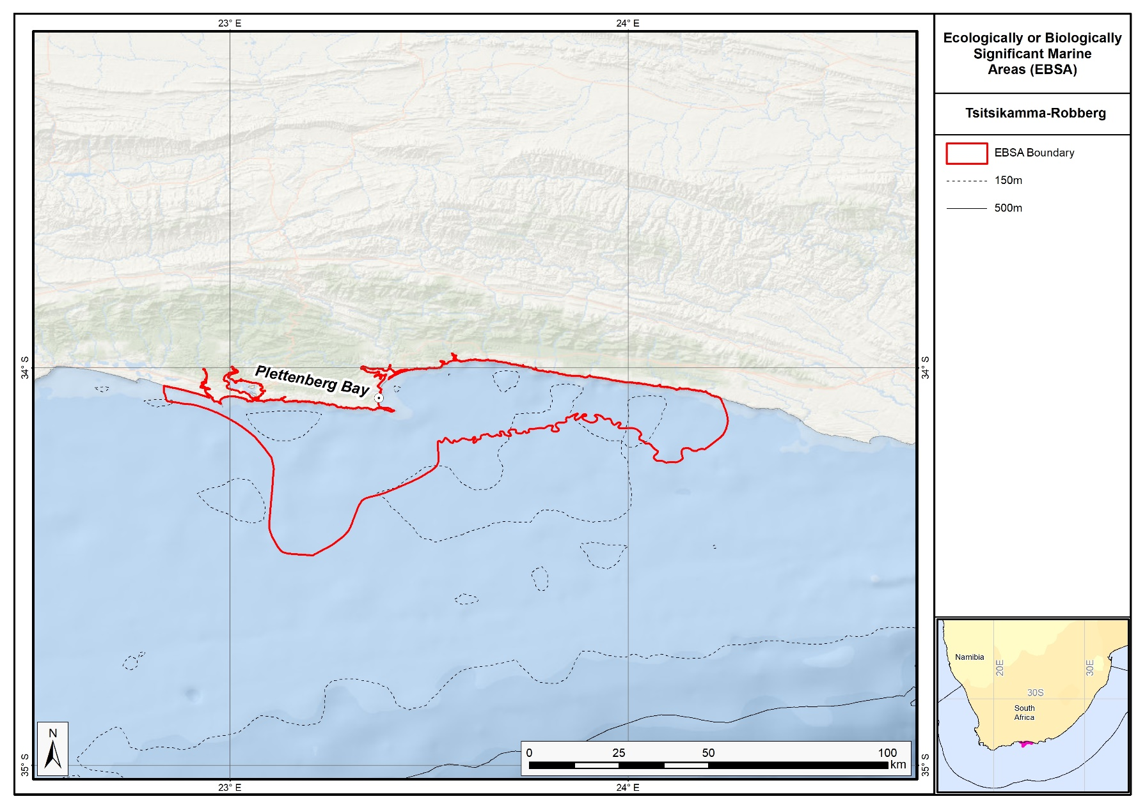
Proposed boundaries of the Tsitsikamma-Robberg EBSA.

Feature description of the proposed area
The features contained within the EBSA are largely benthic, but several of the top predators are associated more with the pelagic environment. The EBSA status of this site is largely underpinned by the inshore reefs, and those in Tsitsikamma MPA have been protected since the 1964, making it the oldest marine reserve in Africa. These reefs comprise numerous fragile and sensitive species that are slow growing, including both habitat-forming reef species, as well as animals such as sparids. As a result of the large, old, no-take reserves, species abundance and diversity in this EBSA’s MPAs are much higher compared to that of the surrounding area. In turn, the area supports key populations of top predators, including Cape fur seals, sharks, seabirds and cetaceans by providing breeding and foraging habitat for them. There are several threatened species in this area, including top predators and species of commercial importance. There are also 19 ecosystem types in the EBSA, including 10 threatened ecosystem types, which by implication support biological communities that are also threatened.

Given the abundant marine life in the area, and the large no-take reserve that serves as a pristine reference site, there is a long history of marine research in this area, and a thriving ecotourism industry, including Blue Flag boats and beaches. The EBSA had a high selection frequency in a national systematic conservation plan indicative that this is a key area in which biodiversity targets need to be met (Sink et al., 2011, 2012, SANBI unpublished results), and it is also recognised as a focus area for protected area expansion in South Africa. The broader area, including the terrestrial side, is similarly recognised for its key ecological value. Most of the EBSA is backed by the terrestrial Garden Route National Park, and it forms part of the much larger Garden Route Biosphere Reserve that was declared by UNESCO in 2017. It also includes the Tsitsikamma-Plettenberg Bay Important Bird and Biodiversity Area, within which at least 300 species of birds have been recorded (Marnewick et al., 2015).

Feature condition and future outlook of the proposed area
A lot of the EBSA is in good ecological condition, but there are smaller portions that are in fair or poor condition based on a national analysis of cumulative threats to the marine realm (Sink et al., 2012, 2019). Notably, the South African government recently opened sections of the previously no-take Tsitsikamma MPA for recreational fishing.

References
Edgar, G.J., Stuart-Smith, R.D., Willis, T.J., Kininmonth, S., Baker, S.C., Banks, S., Barrett, N.S., Becerro, M.A., Bernard, A.T., Berkhout, J., Buxton, C.D., Campbell, S.J., Cooper, A.T., Davey, M., Edgar, S.C., Forsterra, G., Galvan, D.E., Irigoyen, A.J., Kushner, D.J., Moura, R., Parnell, P.E., Shears, N.T., Soler, G., Strain, E.M., Thomson, R.J. 2014. Global conservation outcomes depend on marine protected areas with five key features. Nature, 506: 216-20.
Huisamen, J., Kirkman, S.P., Watson, L.H., Cockcroft, V.G. and Pistorius, P.A., 2011. Recolonisation of the Robberg Peninsula (Plettenberg Bay, South Africa) by Cape fur seals. African Journal of Marine Science, 33(3): 453-461.
Johnson, D.E., Barrio Froján, C., Turner, P.J., Weaver, P., Gunn, V., Dunn, D.C., Halpin, P., Bax, N.J., Dunstan, P.K., 2018. Reviewing the EBSA process: Improving on success. Marine Policy 88, 75-85.
Lockyear, J.F., Hecht, T., Kaiser, H., Teske, P.R. 2006. The distribution and abundance of the endangered Knysna seahorse Hippocampus capensis (Pisces: Syngnathidae) in South African estuaries. African Journal of Aquatic Science, 31: 275-283.
Marnewick, M.D., Retief, E.F., Theron, N.T., Wright, D.R., Andersonm T.A. 2015. Important Bird and Biodiversity Areas of South Africa. Johannesburg: BirdLife South Africa.
Sink, K.J., Attwood, C.G., Lombard, A.T., Grantham, H., Leslie, R., Samaai, T., Kerwath, S., Majiedt, P., Fairweather, T., Hutchings, L., van der Lingen, C., Atkinson, L.J., Wilkinson, S., Holness, S., Wolf, T. 2011. Spatial planning to identify focus areas for offshore biodiversity protection in South Africa. Unpublished Report. Cape Town: South African National Biodiversity Institute.
Sink, K., Holness, S., Harris, L., Majiedt, P., Atkinson, L., Robinson, T., Kirkman, S., Hutchings, L., Leslie, R., Lamberth, S., Kerwath, S., von der Heyden, S., Lombard, A., Attwood, C., Branch, G., Fairweather, T., Taljaard, S., Weerts, S., Cowley, P., Awad, A., Halpern, B., Grantham, H., Wolf, T. 2012. National Biodiversity Assessment 2011: Technical Report. Volume 4: Marine and Coastal Component. South African National Biodiversity Institute, Pretoria.
Sink, K.J., van der Bank, M.G., Majiedt, P.A., Harris, L.R., Atkinson, L., Karenyi, N., Kirkman, S. (eds) 2019. National Biodiversity Assessment 2018 Technical Report Volume 4: Marine Realm. South African National Biodiversity Institute, Pretoria.
Whittington, P.A., Crawford, R.J.M., Martin, A.P., Randall, R.M., Brown, M., Ryan, P.G., Dyer, B.M., Harrison, K.H.B., Huisamen, J., Makhado, A.B., Upfold, L., Waller, L.J., Witteveen, M. 2016. Recent Trends of the Kelp Gull (Larus dominicanus) in South Africa. Waterbirds, 39: 99-113.
Wood, A.D., Brouwer, S.L., Cowley, P.D., Harrison, T.D. 2000. An updated check list of the ichthyofaunal species assemblage of the Tsitsikamma National Park, South Africa. Koedoe, 43: 13.

Other relevant website address or attached documents
Summary of habitat types and threat status for the Tsitsikamma-Robberg EBSA. Data from Sink et al. (2019).
Threat Status | Ecosystem Type | Area (km²) | Area (%)
Endangered | Agulhas Bays - West | 118.8 | 4.5
 | Agulhas Sheltered Rocky Shore | 0.3 | 0.0
Vulnerable | Agulhas Exposed Rocky Shore | 26.0 | 1.0
 | Agulhas Inner Shelf Reef Sand Mosaic | 178.2 | 6.7
 | Agulhas Mid Shelf Reef Complex | 12.1 | 0.5
 | Agulhas Sandy Outer Shelf | 14.8 | 0.6
 | Agulhas Very Exposed Rocky Shore | 0.8 | 0.0
 | Warm Temperate Estuarine Bay | 30.1 | 1.1
 | Warm Temperate Large Temporarily Closed Estuary | 3.2 | 0.1
 | Warm Temperate Predominantly Open Estuary | 15.8 | 0.6
Near Threatened | Agulhas Boulder Shore | 0.1 | 0.0
 | Agulhas Mixed Shore | 9.2 | 0.3
 | Agulhas Sandy Mid Shelf | 1636.0 | 61.9
Least Concern | Agulhas Dissipative-Intermediate Sandy Shore | 8.5 | 0.3
 | Agulhas Inner Shelf Reef Complex | 17.7 | 0.7
 | Agulhas Intermediate Sandy Shore | 2.6 | 0.1
 | Agulhas Outer Shelf Reef Coarse Sediment Mosaic | 566.6 | 21.4
 | Warm Temperate Small Fluvially Dominated Estuary | 0.8 | 0.0
 | Warm Temperate Small Temporarily Closed Estuary | 1.6 | 0.1
Grand Total |  | 2643.2 | 100.0

Assessment of the area against CBD EBSA Criteria
CBD EBSA Criteria  (Annex I to decision IX/20) | Description  (Annex I to decision IX/20) |  | Ranking of criterion relevance
Uniqueness or rarity | Area contains either (i) unique (“the only one of its kind”), rare (occurs only in few locations) or endemic species, populations or communities, and/or (ii) unique, rare or distinct, habitats or ecosystems; and/or (iii) unique or unusual geomorphological or oceanographic features. |  | Medium
Explanation for ranking
The uniqueness of the area is largely driven by the effect of Africa’s oldest MPA, providing a reference site for ecological research. Other rare features include presence of Endangered humpback dolphins, the tombolo at Robberg Peninsula, and some endemic species, such as the Knysna seahorse (Lockyear et al., 2006) and African Black Osytercatcher (Marnewick et al., 2015). The site also had a high selection frequency, meaning that the area is important for meeting biodiversity feature targets.

Special importance for life-history stages of species | Areas that is required for a population to survive and thrive. |  | High
Explanation for ranking
As an IBA, the site supports many breeding bird species, e.g., White-breasted Cormorants, Caspian Terns and White-fronted Plovers, and is also a notably important breeding site (1% or more of the congregatory population threshold) for Kelp Gulls, (Endangered) Cape Cormorants, and (endemic) African Black Oystercatchers (Marnewick et al., 2015). In fact, the Keurbooms Estuary mouth is the largest breeding colony of Kelp gulls on the South African south coast, and one of the largest in the country (Whittington et al., 2015). The EBSA supports a Southern right whale breeding area, and a breeding colony of Cape fur seals at Robberg (Huisamen et al., 2011). During the latter pupping season, white sharks are known to be drawn to the area to forage on the young seals. The EBSA also includes the Keurbooms and Knysna Estuaries, which are two of only three estuaries in which Endangered, endemic Knysna seahorses live (Lockyear et al., 2006).

Importance for threatened, endangered or declining species and/or habitats | Area containing habitat for the survival and recovery of endangered, threatened, declining species or area with significant assemblages of such species. |  | High
Explanation for ranking
One of the key attributes of this EBSA is its importance for threatened species. These include (among others): Critically Endangered Seventy-four Seabream, Critically Endangered Dageraad, Endangered Knysna seahorses, Endangered humpback dolphins, Endangered White Steenbras, Endangered Cape Cormorants, Vulnerable white sharks. Near Threatened Roman Seabream and Near Threatened African Clawless Otters are also present. These species are top predators, iconic species, or commercially important species that have been overexploited outside of the MPAs in this area.

Given that ecosystem types are frequently used as a surrogate for biodiversity, South Africa places key importance on its national ecosystem type map for biodiversity planning and assessment (Sink et al., 2012). Tsitsikamma-Robberg includes two Endangered and eight Vulnerable ecosystem types (Sink et al., 2019). By implication, these habitats each support biological communities that are likely threatened as well.

Vulnerability, fragility, sensitivity, or slow recovery | Areas that contain a relatively high proportion of sensitive habitats, biotopes or species that are functionally fragile (highly susceptible to degradation or depletion by human activity or by natural events) or with slow recovery. |  | High
Explanation for ranking
The area contains vulnerable inshore reefs that include sensitive, fragile and vulnerable habitat-forming species. Further, some of the top predator and some sparid populations are also vulnerable to population impacts because the species are slow growing and late maturing.

Biological productivity | Area containing species, populations or communities with comparatively higher natural biological productivity. |  | Medium
Explanation for ranking
Time-averaged MODIS Aqua data on chlorophyll concentration (NASA Giovanni Portal: https://giovanni.gsfc.nasa.gov) shows that productivity inside Tsitiskamma-Robberg is higher compared to that of the surrounding area, particularly close to the shore. Local productivity is also higher because of the no-take MPAs supporting high abundances of biota, especially fish (Edgar et al., 2014), and thus contributing to more productive biological communities.

Biological diversity |  | Area contains comparatively higher diversity of ecosystems, habitats, communities, or species, or has higher genetic diversity. | High
Explanation for ranking
The focus area includes representation of 19 different ecosystem types, each likely supporting their own biological communities. There is also high diversity of fish and sharks (Wood et al., 2000) in the EBSA, and it includes the Tsitsikamma-Plettenberg Bay Important Bird and Biodiversity Area, within which at least 300 species of birds have been recorded (Marnewick et al., 2015).

Naturalness |  | Area with a comparatively higher degree of naturalness as a result of the lack of or low level of human-induced disturbance or degradation. | Medium
Explanation for ranking
The EBSA focus area is predominantly in good or fair ecological condition as per a national cumulative threat assessment of pressures on South Africa’s marine environment (Sink et al., 2012). This is partly because the area includes three MPAs, the largest of which is an old (proclaimed in 1964) no-take reserve, and the adjacent hinterland (although not part of the EBSA) mostly comprises the Garden Route National Park, and more recently (2017), the Garden Route Biosphere Reserve.

Status of submission
Area to be submitted to the Conference of the Parties for acknowledgement of meeting EBSA criteria once review process is finalized.

COP Decision
Not yet submitted.

End of proposed EBSA revised description

Motivation for Submission
The Robberg-Tsitsikamma area was highlighted in a recent expert and systematic review of gaps in the EBSA network. The area also has high selection frequency in spatial assessments (Sink et al., 2011; Unpublished data linked to Majiedt et al., 2013; Holness et al., 2014) and contains threatened ecosystem types identified in the National Biodiversity Assessment 2011 (Sink et al., 2012). Initial draft EBSA boundaries were determined, and these were then evaluated against the EBSA criteria. Once it was determined that the area would meet EBSA criteria a formal boundary delineation and evaluation process was undertaken. The delineation process included an initial stakeholder review, a technical mapping process and then an expert review workshop where boundary delineation options were discussed. The boundaries were revised a final time to accommodate the latest NBA 2018 assessment results and the review workshop discussion. The delineation processe used a combination of Systematic Conservation Planning and Multi-Criteria Analysis methods. The features used in the analysis were:
- Irreplaceable and near irreplaceable (i.e. very high selection frequency) sites which relate closely to the EBSA criteria of “Uniqueness and rarity” from the offshore prioritisation process (Sink et al., 2011), the Systematic Conservation Planning process undertaken for Majiedt et al. (2013) and the additional unpublished analysis for the broader BCLME region by Holness et al. (2014).
- Delineations and threat status of consitituent ecosystem types in the area were included in the analysis and used to refine the boundary of the EBSA.
- Areas of high relative naturalness identified in the National Biodiversity Assessment 2011 (Sink et al., 2012), the West Coast (Majiedt et al., 2013) and the BCLME spatial assessments (Holness et al., 2014) were included in the analysis. Both pelagic and benthic and coastal condition were incorporated.
- Distributions of known fragile, vulnerable and sensitive habitat-forming species were included (Unpublished SANBI and SAEON data).
The multi-criteria analysis resulted a value surface. The cut-off value used to determine the extent of the EBSA was based on expert input and quantitative analysis of effective inclusion of the above features. This entailed taking an iterative parameter calibration-based approach, whereby the spatial efficiency of the inclusion of the targeted features was evaluated. The approach aimed to identify a cut-off which most efficiently included prioritised features while minimizing the inclusion of impacted areas. The final boundaries shown in the map were validated in a national workshop.

Research Needs
This item will be populated in a workshop to be held in August/September 2018.

Future Process
It is unclear if this EBSA will be subject to detailed attention in the MARISMA EBSA status assessment and management options workplan. This will be decided on in a workshop to be held in August/September 2018.

Cape Point to Cape Agulhas

Proposed EBSA Description

Abstract
The proposed Cape Point to Cape Agulhas EBSA is located at the coastal tip of Africa, wrapping around Cape Point and Cape Agulhas, within South Africa’s EEZ. It extends from the coast to the inner shelf, and includes key islands, two major bays (False Bay and Walker Bay). This EBSA is of key importance for threatened species and habitats, and for supporting life-history stages, notably for some of the threatened species. The threatened habitats include coastal, inshore and inner shelf ecosystem types. The important life-history stages supported by the area are breeding and/or foraging grounds for a myriad of top predators, including sharks, whales, and seabirds, some of which are threatened species, such as the Endangered African penguin. The EBSA also includes some relatively rare features. For example, it contains one of a few locations where surf diatom accumulations occur in South Africa, that in turn fuel sandy shores with heightened productivity. This EBSA is also the place where the Benguela and Agulhas Currents meet, and thus where the Indian and Atlantic Oceans meet.

Introduction
Cape Point to Cape Agulhas is a coastal EBSA at the southernmost tip of Africa that includes both benthic and pelagic features, and key links between the terrestrial and marine realms. The proposed EBSA extends from the dune base at the back of the shore to depths that are mostly shallower than 150 m. The Agulhas and Benguela Currents meet offshore of this EBSA, with the sea surface temperature between Cape Point and Cape Agulhas being generally cooler than that further offshore where the warmer Agulhas current has a greater influence. The area is important for many commercially important fish species (e.g., Watermeyer et al., 2016), and forms part of their spawning grounds. Consequently, it provides key foraging habitat for numerous top predators, including sharks, whales, seals and seabirds (e.g., Crawford et al., 2008; Pichegru et al., 2010; Best et al. 2015). The EBSA also contains important breeding and resting sites for these top predators, both on the mainland, in bays and on several islands that are contained within the EBSA (e.g., Best 2000; Underhill et al., 2006; Kirkman et al., 2013). Cape Point to Cape Agulhas also includes areas of high productivity formed by relatively rare surf diatom accumulations. Given the close proximity of the EBSA to key research institutions, and the rich diversity of key marine species and features in the area, there are many datasets available for the site.

The reason this site was not part of the original list of EBSAs first proposed in the South Eastern Atlantic EBSA Identification Workshop in 2013 (UNEP/CBD/RW/EBSA/SEA/1/4) is because the value of the area was recognised only afterwards in a gap analysis. It is presented as a Type 2 EBSA because it contains “spatially stable features whose individual positions are known, but a number of individual cases are being grouped” (sensu Johnson et al., 2018).

EBSA Region
South-Eastern Atlantic

Location
The proposed Cape Point to Cape Agulhas EBSA is located at the coastal tip of Africa, within South Africa’s EEZ. It starts just south of Camps Bay, wraps around the tip of Cape Point, extends along the shore to the western end of the terrestrial De Mond Nature Reserve in Struisbaai, just past Cape Agulhas. It extends from the dune base to the inner shelf, mostly following the -150m isobath.

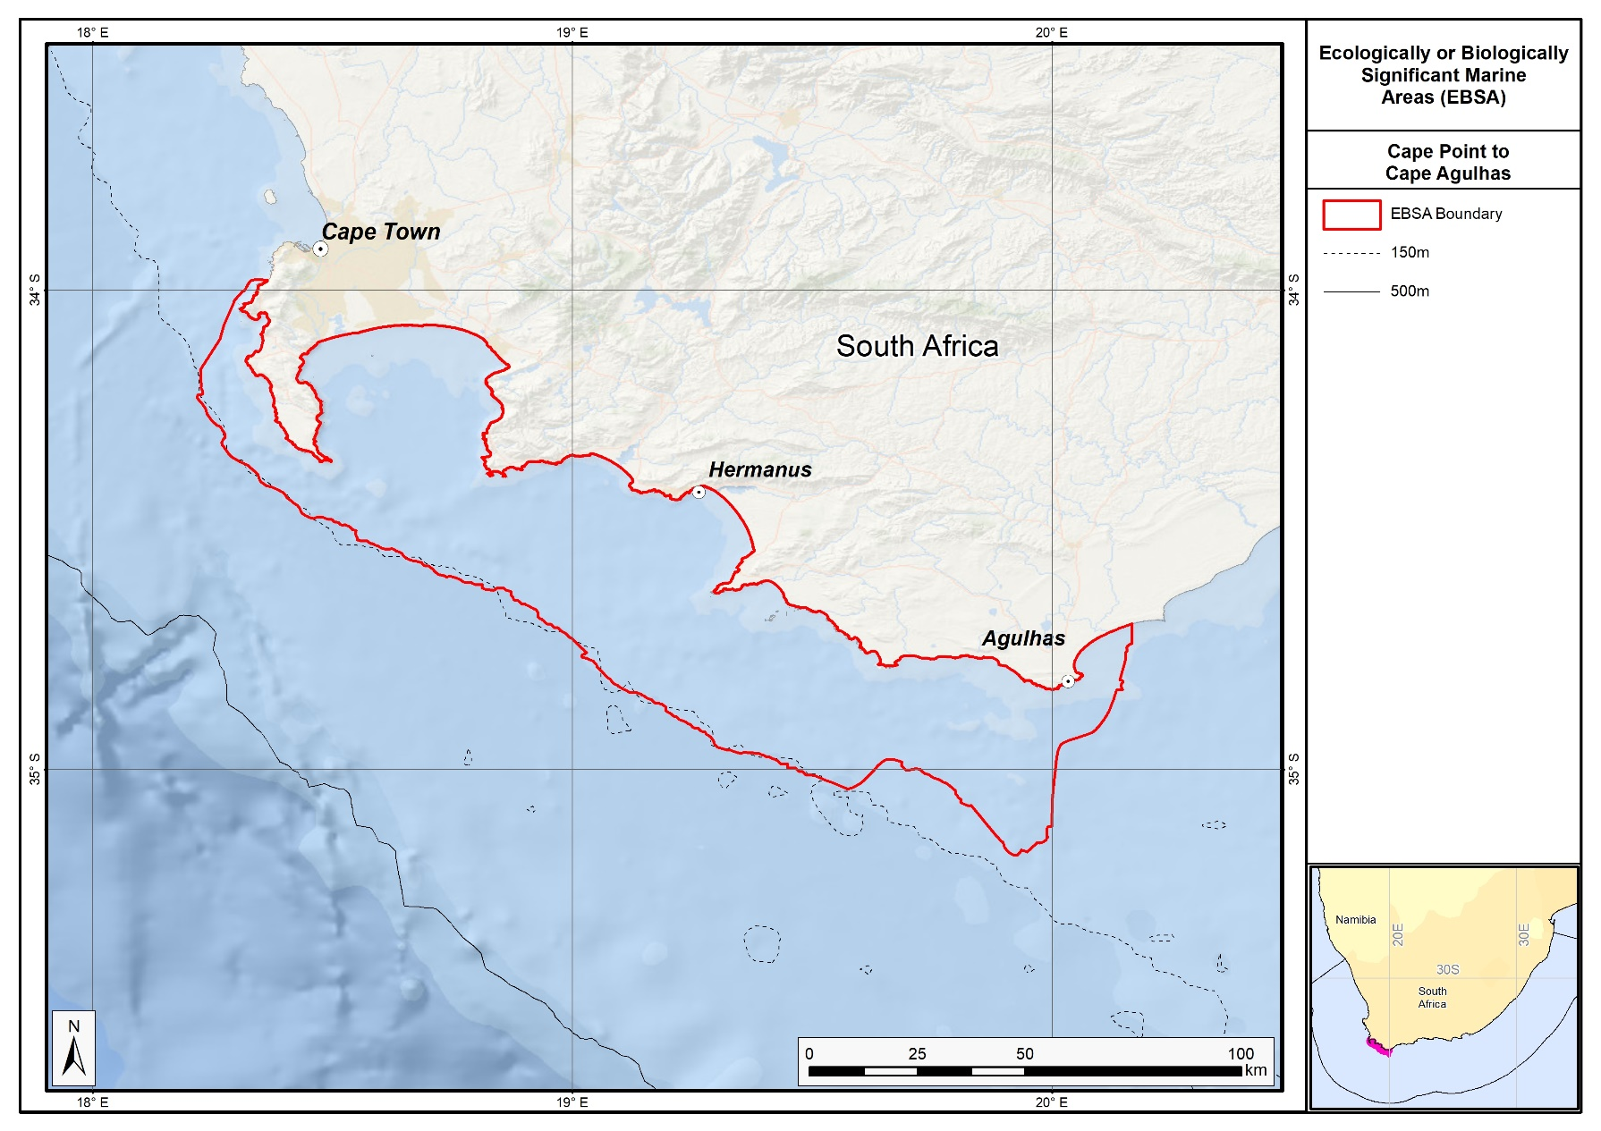
Proposed boundaries of the Cape Point to Cape Agulhas EBSA.

Feature description of the proposed area
Cape Point to Cape Agulhas is important for both benthic and pelagic features. The benthic features include ecosystem types comprising mosaics of sand and reef, kelp beds, and several islands (Seal Island, Dyer Island, Geyser Rock, Quoin Rock), and shore habitats including rocky, sandy, mixed and estuarine shores; the pelagic features include important spawning and foraging grounds for a variety of fish and top predators, and areas of high primary productivity. Benthic-pelagic coupling is also a key feature of this EBSA, particularly important in the two important bay systems that are in the EBSA, and for land-sea connectivity among ecosystem types. Overall, the EBSA’s most key attributes are that it includes many threatened species and 23 threatened ecosystem types, and supports important life-history stages of many species, including some of the threatened taxa.
Of the 32 ecosystem types represented in Cape Point to Cape Agulhas, two thirds (n=23) are threatened, including one Critically Endangered and eight Endangered and 14 Vulnerable types (Sink et al., 2019). By implication, these support biological communities that are also threatened. The EBSA forms part of the spawning grounds for many commercially important fish species (e.g., Watermeyer et al., 2016). Consequently, it provides key foraging habitat for numerous top predators, including sharks, whales, seals and seabirds (e.g., Crawford et al., 2008; Pichegru et al., 2010; Best et al. 2013, Kock et al., 2018), many of which species are also threatened. It also contains important breeding and resting sites for top predators in bays, on the islands and the mainland. For example, it contains island-based (Seal Island, Dyer Island, Geyser Rock) and the only mainland-based (Boulders Beach, Stony Point) colonies of breeding Endangered African penguins (Underhill et al., 2006), and Seal Island, Geyser Rock and Quoin Rock support breeding colonies of Cape fur seals (Kirkman et al., 2013). The EBSA may also include areas where southern right whales give birth to and nurse their calves, and possibly mate (Best 2000).
Secondary attributes of Cape Point to Cape Agulhas support all other EBSA criteria except for Naturalness. The EBSA includes relatively rare surf diatom accumulations that are present at a few sites along the South African south coast, and only several other places, globally (Campbell & Bate., 1988, Campbell 1996). These surf diatom accumulations fuel sandy beach food webs with particularly high productivity. The kelp beds in the adjacent habitat also provide beach-cast kelp wrack, which also creates particularly productive sandy shore systems (e.g., Dugan et al., 2003; Rodil et al., 2018). Cape Point represents a biogeographic break between the warm and cold temperate coastal systems (Sink et al., 2012), and thus diversity at this site is comparatively higher than adjacent sites because it includes representatives from both bioregions. And finally, the reef and hard ground habitats all support fragile species, that are slow growing and sensitive to disturbance.

Feature condition and future outlook of the proposed area
Although the Cape peninsula is protected in a marine protected area, there are numerous threats to the marine environment in this EBSA, particularly within False Bay and Walker Bay. There are several fisheries operating in the area, including those for West coast rock lobster, squid, linefish, and sharks, as well as subsistence and recreational shore and boat-based fishing, kelp harvesting, and bait collecting (Sink et al., 2012). Given the close proximity to the Cape Town harbour, and the numerous smaller ports within the EBSA, shipping is a relatively high pressure here. The coast is under particular pressure from coastal development (outside the many terrestrial nature reserves in the western half of the EBSA), with associated pressures such as waste water discharge; there are also several invasive invertebrates that are primarily associated with rocky shores that have affected native populations (Sink et al., 2012). Global change pressures are affecting the distribution of local fish stocks, which in turn are affecting some of the top predators, including Endangered African penguins, and Endangered Cape gannets (Crawford et al., 2008; Pichegru et al., 2010). A recent assessment of the ecological condition of the marine realm shows that this EBSA is in fair to poor ecological condition (Sink et al., 2019).

References
Best, L.N., Attwood, C.G., da Silva, C., and Lamberth, S.J. 2013. Chondrichthyan occurrence and abundance trends in False Bay, South Africa, spanning a century of catch and survey records. African Zoology, 48: 201-227.
Best, P.B. 2000. Coastal distribution, movements and site fidelity of right whales Eubalaena australis off South Africa, 1969–1998. South African Journal of Marine Science, 22: 43-55.
Campbell, E.E. 1996. The global distribution of surf diatom accumulations. Revista Chilena Historia Natural, 69: 495-501.
Campbell, E.E., Bate, G.C. 1988. The estimation of annual primary production in a high energy surf-zone. Botanica Marina, 31: 337-343.
Crawford, R.J.M., Underhill, L.G., Coetzee, J.C., Fairweather, T., Shannon, L.J., Wolfaardt, A.C. 2008. Influences of the abundance and distribution of prey on African penguins Spheniscus demersus off western South Africa. African Journal of Marine Science, 30: 167-175.
Dugan, J., Hubbard, D.M., McCrary, M.D., Pierson, M.O. 2003. The response of macrofauna communities and shorebirds to macrophyte wrack subsidies on exposed sandy beaches of southern California. Estuarine, Coastal and Shelf Science, 58S: 25-40.
Johnson, D.E., Barrio Froján, C., Turner, P.J., Weaver, P., Gunn, V., Dunn, D.C., Halpin, P., Bax, N.J., Dunstan, P.K., 2018. Reviewing the EBSA process: Improving on success. Marine Policy 88, 75-85.
Kirkman, S.P., Yemane, D., Oosthuizen, W.H., Meÿer, M.A., Kotze, P.G.H., Skrypzeck, H., Vaz Velho, F., Underhill, L.G. 2013. Spatio-temporal shifts of the dynamic Cape fur seal population in southern Africa, based on aerial censuses (1972–2009). Marine Mammal Science, 29: 497–524.
Kock, A.A., Photopoulou, T., Durbach, I., Mauff, K., Meÿer, M., Kotze, D., Griffiths, C.L., O’Riain, M.J. 2018. Summer at the beach: spatio-temporal patterns of white shark occurrence along the inshore areas of False Bay, South Africa. Movement Ecology 6, 7.
Pichegru, L., Ryan, P.G., Crawford, R.J.M., van der Lingen, C.D., Grémillet, D. 2010. Behavioural inertia places a top marine predator at risk from environmental change in the Benguela upwelling system. Marine Biology, 157: 537-544.
Rodil, I.F., Lastra, M., López, J., Mucha, A.P., Fernandes, J.P., Fernandes, S.V., Olabarria, C. 2018. Sandy Beaches as Biogeochemical Hotspots: The Metabolic Role of Macroalgal Wrack on Low-productive Shores. Ecosystems, in press.
Sink, K., Holness, S., Harris, L., Majiedt, P., Atkinson, L., Robinson, T., Kirkman, S., Hutchings, L., Leslie, R., Lamberth, S., Kerwath, S., von der Heyden, S., Lombard, A., Attwood, C., Branch, G., Fairweather, T., Taljaard, S., Weerts, S., Cowley, P., Awad, A., Halpern, B., Grantham, H., Wolf, T. 2012. National Biodiversity Assessment 2011: Technical Report. Volume 4: Marine and Coastal Component. South African National Biodiversity Institute, Pretoria.
Sink, K.J., van der Bank, M.G., Majiedt, P.A., Harris, L.R., Atkinson, L., Karenyi, N., Kirkman, S. (eds) 2019. National Biodiversity Assessment 2018 Technical Report Volume 4: Marine Realm. South African National Biodiversity Institute, Pretoria.
Underhill, L.G., Crawford, R.J.M., Wolfaardt, A.C., Whittington, P.A., Dyer, B.M., Leshoro, T.M., Ruthenberg, M., Upfold, L., Visagie, J. 2006. Regionally coherent trends in colonies of African penguins Spheniscus demersus in the Western Cape, South Africa, 1987–2005. African Journal of Marine Science, 28: 697-704.

Other relevant website address or attached documents
Summary of ecosystem types and threat status for Cape Point to Cape Agulhas. Data from Sink et al. (2019).
Threat Status | Ecosystem Type | Area (km²) | Area (%)
Critically Endangered | Cool Temperate Large Temporarily Closed Estuary | 4.4 | 0.1
Endangered | Agulhas Sheltered Rocky Shore | 0.6 | 0.0
 | Cape Island Shore | 0.1 | 0.0
 | Cape Sheltered Rocky Shore | 0.1 | 0.0
 | Cool Temperate Estuarine Lake | 5.0 | 0.1
 | Cool Temperate Predominantly Open Estuary | 0.4 | 0.0
 | Cool Temperate Small Temporarily Closed Estuary | 2.4 | 0.0
 | Southern Benguela Reflective Sandy Shore | 0.1 | 0.0
 | Warm Temperate Estuarine Lake | 0.9 | 0.0
Vulnerable | Agulhas Exposed Rocky Shore | 22.6 | 0.3
 | Agulhas Inner Shelf Reef Sand Mosaic | 520.8 | 7.7
 | Agulhas Island Shore | 3.4 | 0.1
 | Agulhas Kelp Forest | 11.7 | 0.2
 | Agulhas Outer Shelf Reef Sand Mosaic | 1899.6 | 28.2
 | Agulhas Reflective Sandy Shore | 0.8 | 0.0
 | Agulhas Very Exposed Rocky Shore | 2.5 | 0.0
 | Cape Boulder Shore | 1.0 | 0.0
 | Cape Exposed Rocky Shore | 7.7 | 0.1
 | Cape Kelp Forest | 3.6 | 0.1
 | Cape Mixed Shore | 7.7 | 0.1
 | Cape Rocky Inner Shelf | 188.6 | 2.8
 | Cape Rocky Mid Shelf Mosaic | 335.1 | 5.0
 | False and Walker Bays | 1681.2 | 24.9
Near Threatened | Agulhas Boulder Shore | 0.9 | 0.0
 | Agulhas Dissipative Sandy Shore | 21.9 | 0.3
 | Agulhas Mid Shelf Reef Sand Mosaic | 1970.5 | 29.2
 | Agulhas Mixed Shore | 35.1 | 0.5
 | Cape Very Exposed Rocky Shore | 0.3 | 0.0
 | Southern Benguela Intermediate Sandy Shore | 0.2 | 0.0
Least Concern | Agulhas Dissipative-Intermediate Sandy Shore | 12.3 | 0.2
 | Agulhas Intermediate Sandy Shore | 2.2 | 0.0
 | Southern Benguela Dissipative Sandy Shore | 0.3 | 0.0
 | Southern Benguela Dissipative-Intermediate Sandy Shore | 0.4 | 0.0
N/A | Cool Temperate Micro-estuary | 0.8 | 0.0
Grand Total |  | 6745.5 | 100.0

Assessment of the area against CBD EBSA Criteria
CBD EBSA Criteria  (Annex I to decision IX/20) | Description  (Annex I to decision IX/20) | Ranking of criterion relevance
Uniqueness or rarity | Area contains either (i) unique (“the only one of its kind”), rare (occurs only in few locations) or endemic species, populations or communities, and/or (ii) unique, rare or distinct, habitats or ecosystems; and/or (iii) unique or unusual geomorphological or oceanographic features. | Medium
Explanation for ranking
The EBSA contains three of 14 sites in South Africa where surf diatom accumulations are present (Campbell 1996), and the only mainland colonies of Endangered African penguins (Underhill et al., 2006). False and Walker Bay are also relatively rare geomorphic features in the BCLME. It also encompasses the only coastal area where the Indian and Atlantic Oceans meet.

Special importance for life-history stages of species | Areas that is required for a population to survive and thrive. | High
Explanation for ranking
Cape Point to Cape Agulhas is an important spawning ground for commercially important fish species (e.g., Watermeyer et al., 2016). Consequently, it provides key foraging habitat for numerous top predators, including sharks, whales, seals and seabirds (e.g., Crawford et al., 2008; Pichegru et al., 2010; Best et al. 2013). It also contains important breeding and resting sites for top predators, in bays, on the islands and the mainland. For example, it contains island-based and the only mainland-based colonies of breeding Endangered African penguins (Underhill et al., 2006), and Seal Island, Geyser Rock and Quoin Rock support breeding colonies of Cape fur seals (Kirkman et al., 2013). The EBSA may also include areas where southern right whales give birth to and nurse their calves, and possibly mate (Best 2000).

Importance for threatened, endangered or declining species and/or habitats | Area containing habitat for the survival and recovery of endangered, threatened, declining species or area with significant assemblages of such species. | High
Explanation for ranking
There are a number of threatened species that depend on this EBSA focus area for foraging and/or breeding, including Vulnerable white shark, Endangered Indian Ocean humpback dolphin, Endangered Cape gannet, Endangered African penguin, Endangered Cape cormorant, Endangered bank cormorant, white-breasted cormorant, and Near Threatened crowned cormorant. Importantly, some of these species have high residency within the EBSA, e.g., white sharks have specific locations within False Bay where they have high levels of occurrence (Kock et al., 2018), and are especially resident in inshore areas between Walker Bay and around Cape Agulhas (A. Kock, Unpublished tracking data).

The area includes a very high diversity of threatened ecosystem types. Of the 34 ecosystem types in the EBSA, 23 are threatened, including one Critically Endangered, eight Endangered and 14 Vulnerable ecosystem types (Sink et al., 2019). By implication, the biological communities associated with these ecosystems are also likely to be threatened. There are also a further six ecosystem types in the EBSA that are considered Near Threatened (Sink et al., 2019).

Vulnerability, fragility, sensitivity, or slow recovery | Areas that contain a relatively high proportion of sensitive habitats, biotopes or species that are functionally fragile (highly susceptible to degradation or depletion by human activity or by natural events) or with slow recovery. | Medium
Explanation for ranking
The top predators represented in this EBSA have a slow recovery time following impacts to their respective populations. Further, the reefs and hard grounds contain fragile species that are slow growing, and sensitive to disturbance.

Biological productivity | Area containing species, populations or communities with comparatively higher natural biological productivity. | Medium
Explanation for ranking
The kelp beds and surf diatom accumulations contribute to elevated productivity for coastal ecosystems, notably the sandy shores (Campbell and Bate, 1988, Rodil et al., 2018). As a spawning area for commercially important fish species, productivity across the shelf is also relatively high.

Biological diversity | Area contains comparatively higher diversity of ecosystems, habitats, communities, or species, or has higher genetic diversity. | Medium
Explanation for ranking
The Agulhas and Benguela currents also meet in the broader area surrounding the EBSA. Consequently, Cape Point is a biogeographic break between the warm and cold temperate bioregions, and thus biodiversity in the area is expected to relatively higher here compared to that of surrounding areas. This is additionally true because the conditions range from fully sheltered within the bays, to fully exposed on the open coast, and because it contains 34 different ecosystem types, each likely supporting their own biological communities (Sink et al., 2019). The EBSA is also known to support diverse assemblages of key species (e.g., Best et al., 2013).

Naturalness | Area with a comparatively higher degree of naturalness as a result of the lack of or low level of human-induced disturbance or degradation. | Low
Explanation for ranking
Although there are some areas that are protected or under relatively low pressure within this EBSA, the bays in particular are under high pressure from human activities, and the condition of the ecosystem types across the EBSA as a whole is generally quite poor (Sink et al., 2012, 2019). Global change pressures are also strongly felt in this area, with the knock-on effects observed at the top-predator level (Crawford et al., 2008; Pichegru et al., 2010).

Status of submission
Area to be submitted to the Conference of the Parties for acknowledgement of meeting EBSA criteria once review process is finalized.

COP Decision
Not yet submitted.
End of proposed EBSA revised description

Motivation for Submission
Expert and systematic review of gaps in the EBSA network highlighted the requirements for the Cape Point to Cape Agulhas EBSA. The area had high selection frequency in spatial assessments (Majiedt et al., 2013; Holness et al., 2014) and contained a number of threatened ecosystem types identified in the National Biodiversity Assessment 2011 (Sink et al., 2012). Initial draft EBSA boundaries were determined, and these were then evaluated against the EBSA criteria. Once it was determined that the area would meet EBSA criteria, a formal boundary delineation and evaluation process was undertaken. The delineation process included an initial stakeholder review, a technical mapping process and then an expert review workshop where boundary delineation options were discussed. The boundaries were revised a final time to accommodate the latest NBA 2018 assessment results and the review workshop discussion. The delineation process used a combination of Systematic Conservation Planning and Multi-Criteria Analysis methods. The features used in the analysis were:
- Key physical features (i.e. islands) from the National Biodiversity Assessment 2011 (Sink et al., 2012) and BCC spatial mapping project (Holness et al., 2014) were incorporated. In addition, bays were mapped and included as these have been identified as important features in the new National Biodiversity Assessment 2018 (no reference available yet).
- Delineations and threat status of consitituent ecosystem types in the area were included in the analysis and used to refine the boundary of the EBSA.
- Irreplaceable and near irreplaceable (i.e. very high selection frequency) sites which relate closely to the EBSA criteria of “Uniqueness and rarity” from the Systematic Conservation Planning process undertaken for Majiedt et al. (2013) and the BCLME by Holness et al. (2014).
- Areas of high relative naturalness identified in the National Biodiversity Assessment 2011 (Sink et al., 2012), the West Coast (Majiedt et al., 2013) and the BCLME spatial assessments (Holness et al., 2014) were included in the analysis. Both pelagic and benthic and coastal condition were incorporated.
- Distributions of known fragile, vulnerable and sensitive habitat-forming species were included (Unpublished SANBI and SAEON data).
- Areas important for threatened and special species were included. The priority areas and buffer distances around colonies were from Holness et al. (2014). Note that the full extent of the buffer was not necessarily included in the EBSA. Features included in the analysis were:
  - African Penguin colonies and a 20km buffer.
  - Bank Cormorant, Cape Cormorant, White Breasted Cormorant and Crowned Cormorant colonies and a 40km buffer.
  - Seal Colonies and a 20km buffer.
The multi-criteria analysis resulted in a value surface. The cut-off value used to determine the extent of the EBSA was based on expert input and quantitative analysis of effective inclusion of the above features. This entailed taking an iterative parameter calibration-based approach whereby the spatial efficiency of the inclusion of the targeted features was evaluated. The approach aimed to identify a cut-off which most efficiently included prioritised features while minimizing the inclusion of impacted areas. The final boundaries shown in the map were validated in a national workshop.

Research Needs
This item will be populated in a workshop to be held in August/September 2018.

Future Process
It is unclear if this EBSA will be subject to detailed attention in the MARISMA EBSA status assessment and management options workplan. This will be decided on in a workshop to be held in August/September 2018.

Transboundary EBSAs

Revised EBSAs

Namibe (Formerly Kunene-Tigres)

Revised EBSA Description

General Information

Summary
Namibe is a trans-boundary area shared by Namibia and Angola. The EBSA is a modification, and extension of the original Kunene-Tigres EBSA. The Kunene River, its mouth and associated wetland influence the salinity, sediment and productivity within the Tigres Island-Bay complex about 50 km north of the river mouth. This link, underpinning elevated local productivity, is a regionally unique feature. However, the original EBSA delineation also included but overlooked the presence of shelf-incising canyons and seamounts in EBSA footprint, which also contribute to elevated productivity are foraging habitat. New information since the initial description has facilitated a northward extension of the EBSA to include adjacent canyons and seamounts, as well as the full extent of the coastline of Iona National Park. In short, Namibe comprises a highly diverse collection of species and habitats in very close proximity, many of which are also threatened, with unique and other features that promote high productivity. In turn this drives importance of the area for supporting the life-histories of key species, such as providing foraging, breeding and resting habitats for seals, fish, turtles, and migratory and resident birds.

Introduction of the area
Adjacent to the arid, mostly uninhabited, and remote 100 km of the southern Angolan coastline is an area of limited geographic but notable ecological prominence. Tigres Island and adjacent bay are a remnant of the pre-1970s peninsula formed by sediment discharged from the Kunene River. These features form a rare coastal wetland that plays an important role in the life cycles of many marine and terrestrial fauna (Simmons et al., 2006, Paterson 2007). The predominantly sandy island, measuring ~6 km at its widest point and ~22 km in length, has withstood the weathering effects of the Atlantic since the breaching of the isthmus in 1973, and has become an important site for a number of migratory and resident aquatic fauna (Morant 1996b, Simmons et al., 2006, Dyer 2007, Meÿer 2007). Approximately 50 km south of Tigres Island is an ecologically significant natural marine-freshwater feature: the Kunene River mouth. Although discharge volumes are erratic, this sub-tropical, perennial river may discharge up to 30 million m³ of fresh water per day into the sea. This has pronounced physicochemical influences on the adjacent marine habitat (sublittoral to littoral coastal region) to an extent of ~100 km from the river mouth, mostly northwards, but also southwards during certain times of the year and during abnormal climatic events, such as Benguela Niños (Simmons et al., 1993, Shillington 2003). A lagoon extends 2 km south from the river mouth (Simmons et al., 1993). These features provide foraging, roosting and breeding habitat for a range of fauna, including sea- and shorebirds (Braine 1990, Simmons et al., 1993, Anderson et al., 2001, Dyer 2007, Simmons 2010), marine and freshwater reptiles (Griffin & Channing 1991, Simmons et al., 1993, Griffin 1994, Carter & Bickerton 1996, Griffin 2002), crustaceans (Carter & Bickerton 1996), marine and freshwater fish species (Simmons et al., 1993, Hay et al., 1997, Fishpool & Evans 2001, Holtzhausen 2003), as well as resident (Meÿer 2007) and transient marine mammals (Paterson 2007). In this region the presence of the Cape Fur Seal (Arctocephalus pusillus) is verified. This species is strongly associated with the cooler waters of the Benguela Current ecosystem and, therefore, its distribution extends to the western coast of southern Africa to the south of Angola. A. pusillus are most common in southern Angola, where there is a large colony in Tigres Bay (Morais et al., 2006). Weir (2013) found that this was the most common marine mammal species in the Benguela region but rarely seen in the northern-most regions. This confirms the link between the northern Angolan section of the EBSA and the Namibian sections.

The revised boundary for this EBSA now includes the full extent of the coastline of the adjacent Iona National Park, which is an Important Bird and Biodiversity Area that similarly supports migratory and resident birds in this area. Further, since the original description, a regional map of marine ecosystems has become available for Namibia and Angola (Holness et al., 2014). It was then noted that the original Kunene-Tigres EBSA contained seamounts and canyons that were also likely contributing to the elevated productivity that underpins the key foraging areas for the species noted above. Therefore, the EBSA was extended northward to include adjacent seamounts and canyons that were in close proximity to Tigres Island and adjacent to the Iona National Park IBA. The southern boundary was also refined to improve precision based on the new habitat map. The habitats that are influenced by the Kunene River, i.e., those formed from terrigenous sediments flowing out of the river, are now included in their full extent. Furthermore, the real extent of the Kunene Estuary, on which this whole EBSA depends, is now included to improve precision over the much smaller representation of the estuary in the original boundary. Namibe is thus proposed as a Type 2 EBSA (sensu Johnson et al. 2018) because it comprises a collection of features and ecosystems that are connected by the same ecological processes.

Description of the location

EBSA Region
South-Eastern Atlantic

Description of location
The delineated area extends along the shore approximately 170 km north of the Kunene mouth into southern Angola (to the northern boundary of Iona National Park at Curoca River), and 40 km south of the Kunene mouth into northern Namibia. The maximum offshore extent is approximately 100 km, although the Namibian section extends only 40 km offshore. The EBSA includes the Tigres Bay lagoon and approximately 12 km of the Kunene estuary. Namibe is well within the national jurisdictions of the two neighbouring countries it straddles (i.e., Angola and Namibia), with >80 % of the area falling within Angolan jurisdiction. In Namibia, this EBSA borders the Skeleton Coast National Park; and in Angola it borders the Iona National Park. It has a total area of approximately 15,000km².

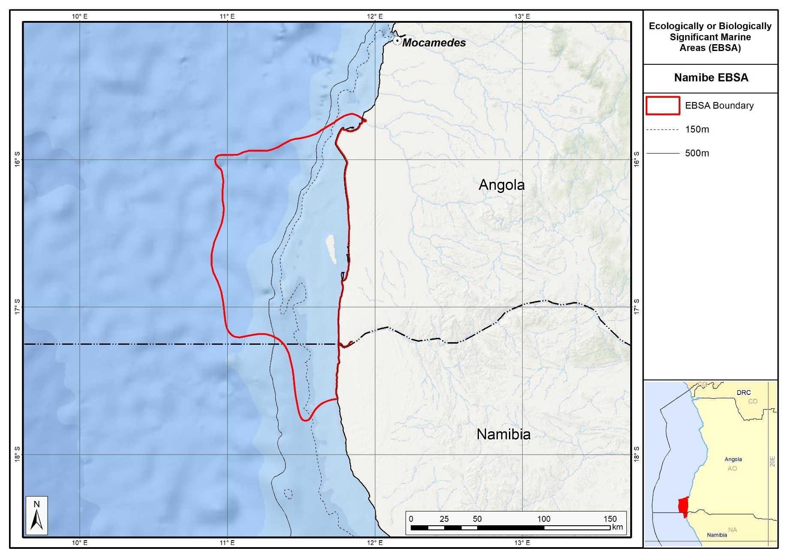
Revised boundary of the Namibe EBSA.

Feature description of the area
Namibe comprises a rich diversity of features, species and habitats. The southern portion includes the Kunene estuary and surrounding river-influenced ecosystems, with the bulk of the influence from the river (freshwater, sediment and nutrients) transported north, connecting to Tigres Island and Tigres Bay in Angola. The surrounding ecosystems also include canyons and seamounts that contribute to the productivity and diversity in the EBSA. Tigres Bay is approximately 11 km at its widest point (northern region of Tigres Bay) and ~8.5 km at its narrowest point (southern limit of Tigres Island from the mainland), with a longitudinal extent of ~60 km.

Surveys of the area have recorded 26 bird species with abundances of around 13000 individuals (Simmons et al., 1993, Simmons et al., 2006, Simmons 2010). Several bird species breed on Tigres Island or along the bay (including globally threatened Cape Cormorants and Damara Terns, and locally threatened Great White Pelicans and Caspian Terns; Simmons et al., 2006; Dyer 2007; Simmons 2010) and Cape fur seals breed on the island (Meÿer 2007). The Kunene River mouth and adjacent marine habitat supports a lower bird density (~4000 individuals) than does Tigres Bay, but a higher species richness, and serves as a refuelling and resting area for Palearctic migrant bird species (Simmons et al., 1993). At least 119 bird species have been recorded at the Kunene River mouth (Paterson 2007), and there are records of 381 species in the EBSA area, of which 2 are Critically Endangered, 3 are Endangered, and 9 are Vulnerable (OBIS, 2017). Iona National Park in Angola is an Important Bird and Biodiversity Area. Furthermore, the Kunene-Namib area is known to support the largest density of green turtles in Namibia (Griffin & Channing 1991; Simmons et al., 2006), with olive ridleys also present. In addition, there are many species of fish, sharks and cetaceans in the area, some of which are threatened, that breed and/or forage in this EBSA (Hay et al., 1997, Holtzhausen 2003, Paterson 2007).

Habitat heterogeneity is high, with 15 habitats present in the EBSA. These include representation of two threatened habitat types: the Endangered Kunene Outer Shelf, and Vulnerable Kunene Shelf Edge. These threat statuses were determined by assessing the weighted cumulative impacts of various pressures (e.g., extractive resource use, pollution, development and others) on each habitat type for Namibia and Angola (Table in the Other relevant website address or attached documents section; Holness et al., 2014).

Feature conditions and future outlook of the proposed area
Due to the remoteness of the Namibe focus area, limited human impacts (apart from current mining/exploration) on the marine and coastal areas have resulted in this area being relatively pristine. However, threats to the pristine nature of this ecologically important area include industrial interests upstream of the Kunene River mouth (including proposals to dam the river for power generation) and recent increases in fishing, mining and tourism interests on both sides of the Kunene River mouth (Simmons et al., 1993, Paterson 2007). The Namibian portions of the area are generally in good condition, although most of the Angolan area is in fair condition, primarily due to the high intensity of artisanal and commercial fishing taking place there (Holness et al., 2014). Consequently, 63 % of the overall area has been identified as being in fair condition, and 25 % in good condition.

References
Anderson M.D., Anderson R.A., Anderson S.L., Anderson T.A., Bader U., Heinrich D., Hofmeyer J.H., Kolberg C., Kolberg H., Komen L., Paterson B., Paterson J., Sinclair K., Sinclair W., van Zijl D., van Zijl, H. 2001. Notes on the birds and other animals recorded at the Kunene River mouth from 6-8 January 2001. Bird Numbers, 10: 52-56.
Barnard P. Curtis, B. 1998. Sites of special ecological importance. In: Biological Diversity in Namibia: a Country Study. Barnard, P. (ed.) 1998. Namibian National Biodiversity Task Force, Windhoek. Pages: 74-75.
Bethune S. 1998. Wetland habitats. In: Biological Diversity in Namibia: a Country Study. Barnard, P. (ed.). Namibian National Biodiversity Task Force. Windhoek. Pages 60-66.
Braine S. 1990. Records of birds of the Kunene River estuary. Lanioturdus, 25: 38–44.
Carter R., Bickerton, I.B. 1996. Chapter 5 Aquatic Fauna. In: Environmental Study of the Kunene River Mouth. Morant, P. D. ed.). CSIR Report EMAS - C96023. CSIR, Stellenbosch.
Carr T., Carr, N. 1991. Surveys of the Sea Turtles of Angola. Biological Conservation, 58: 19-29.
De Moor F.C., Barber-James H.M., Harrison, A.D., Lugo-Ortiz, C.R. 2000. The macro-invertebrates of the Kunene River from the Ruacana Falls to the river mouth and assessment of the conservation status of the river. African Journal of Aquatic Sciences, 25: 105-122.
Dentlinger, L. 2005. Namibia, Angola eye reviving Kunene hydropower plans. The Namibian. Wednesday, August 17. Dyer B.M. 2007. Report on top-predator survey of southern Angola including Ilha dos Tigres, 20-29 November 2005. In: Kirkman, S.P. (Ed.), Final Report of the BCLME (Benguela Current Large Marine Ecosystem) Project on Top Predators as Biological Indicators of Ecosystem Change in the BCLME. Avian Demography Unit, Cape Town, pp. 303–306.
Fishpool L.D.C., Evans, M.I. (eds.) 2001. Important Bird Areas in Africa and associated islands: Priority sites for conservation. Newbury and Cambridge, UK: Pisces Publications and BirdLife International. BirdLife Conservation Series No. 11.
Fretey, J. 2001. Biogeography and conservation of marine turtles of the Atlantic coast of Africa. CMS Technical Series Publication No. 6, UNEP/CMS Secretariat, Bonn, Germany: 429 pp.
Griffin, M. 1994. Report on the Reptiles of the Kunene Mouth. In: Tyldesley, P. (Comp) Report on an Integrated Scientific Data Collecting Expedition to the Mouth of the Kunene River 19/04/94 – 23/04/94. NNF report.
Griffin, M. 2002. Annotated checklist and provisional conservation status of Namibian reptiles. Technical Reports of Scientific Services No 1, Ministry of Environment and Tourism, Windhoek: 168 pp.
Griffin, M., Channing, A. 1991. Wetland: associated reptiles and amphibians of Namibia – a national review. Madoqua, 17: 221-225.
Hay, C.J., van Zyl, B.J., van der Bank F.H., Ferreira J.T., Steyn, G.J. 1997. A survey of the fishes of the Kunene River, Namibia. Madoqua, 19: 129-141.
Holness S., Kirkman S., Samaai T., Wolf T., Sink K., Majiedt P., Nsiangango S., Kainge P., Kilongo K., Kathena J., Harris L., Lagabrielle E., Kirchner C., Chalmers R., Lombard, M. 2014. Spatial Biodiversity Assessment and Spatial Management, including Marine Protected Areas. Final report for the Benguela Current Commission project BEH 09-01.
Holtzhausen, H. 2003. Fish of the Kunene River mouth. BCLME Orange-Kunene estuaries workshop. 21-23 October 2003, Swakopmund, Namibia.
Kolberg H. & Simmons R.E. 1998. Wetlands. In: Biological Diversity in Namibia: a Country Study. Barnard, P. (ed.). 1998. Namibian National Biodiversity Task Force. Windhoek. Pages 47-48.
Johnson, D.E., Barrio Froján, C., Turner, P.J., Weaver, P., Gunn, V., Dunn, D.C., Halpin, P., Bax, N.J., Dunstan, P.K., 2018. Reviewing the EBSA process: Improving on success. Marine Policy 88, 75-85.
Lutjeharms, J.R.E., Meeuwis, J.M. 1987. The extent and variability of the South East Atlantic upwelling. South African Journal of Marine Science, 5: 51-62.
Meÿer, M.A. 2007. The first aerial survey of Cape Fur Seal numbers at Baia dos Tigres, southern Angola. In: Kirkman, S.P. (Ed.), Final Report of the BCLME (Benguela Current Large Marine Ecosystem) Project on Top Predators as Biological Indicators of Ecosystem Change in the BCLME. Avian Demography Unit, Cape Town, pp. 307.
Morant, P.D. 1996a. Chapter 1 Introduction. In: Morant, P. D. 1996 (ed.) Environmental Study of the Kunene River Mouth. CSIR Report EMAS-C96023. CSIR Stellenbosch.
Morant, P.D. 1996b. Chapter 6 Avifauna of the Kunene River Mouth. In: Morant, P. D. 1996 (ed.) Environmental Study of the Kunene River Mouth. CSIR Report EMAS-C96023. CSIR Stellenbosch.
OBIS. 2017. Summary statistics of biodiversity records in the Kunene-Tigres EBSA. (Available: Ocean Biogeographic Information System. Intergovernmental Oceanographic Commission of UNESCO. www.iobis.org. Accessed: 2017-07-27).
Paterson, J.R.B. 2007. The Kunene River Mouth: Managing a unique environment. MSc Thesis, Unversity of KwaZulu Natal, Pietermaritzburg, South Africa: 124 pp.
Ryan, P.G., Cooper, J., Stutterheim, C. J. 1984. Waders (Charadrii) and other coastal birds of the Skeleton Coast, South West Africa. Madoqua, 14: 71-78.
Shillington, F. 2003. Oceanography. In: Namibia’s Marine Environment. Molloy, F. and Reinikainen, T. (eds.). Directorate of Environmental Affairs of the Ministry of Environment and Tourism, Namibia. Windhoek: 162 pp.
Simmons, R.E. 2010. First breeding records for Damara Terns and density of other shorebirds along Angola’s Namib Desert coast. Ostrich, 81: 19-23.
Simmons, R.E., Braby R, Braby, S.J. 1993. Ecological studies of the Kunene River mouth: avifauna, herpetofauna, water quality, flow rates, geomorphology and implications of the Epupa Dam. Madoqua, 18: 163-180.
Simmons, R.E., Sakko A., Paterson J. & A. Nzuzi 2006. Birds and Conservation Significance of the Namib Desert's least known coastal wetlands: Baia and Ilha dos Tigres, Angola. African journal of marine science, 28: 713-717.
Simmons, R.E., Brown, C.J., Kemper, J. 2015. Birds to watch in Namibia: red, rare and endemic species. Ministry of Environment and Tourism and Namibia Nature Foundation, Windhoek, Namibia.
Schneider, G.I.C., Miller, R.McG. 1992. Diamonds. Ministry of Mines and Energy Geological Survey Namibia. Economic Geology Series open file report.

Assessment of the area against CBD EBSA criteria
C1: Uniqueness or rarity High
Justification
The Namibe area is unique in the sense that it is the only sheltered, predominantly marine, sandy bay with a link to a perennial river for a 1500 km stretch along the Namibian coast and a 200 km stretch along the Angolan coast (Simmons et al., 2006). Being both geographically and biologically isolated, this area is ranked amongst the most threatened in Namibia (Simmons et al. 1993, Carter and Bickerton 1996, Barnard and Curtis 1998, Bethune 1998, De Moor et al., 2000) and supports reptilian fauna unique to Southern Africa (Kolberg & Simmons 1998). Furthermore, the Kunene wetland is globally unique as it is the only freshwater input area that is located adjacent to an upwelling cell, viz. the Kunene upwelling cell, and wedged within the longitudinal range of a warm-cold water frontal system, i.e., the Angola-Benguela frontal system (Lutjeharms & Meeuwis 1987, Paterson 2007).

C2: Special importance for life-history stages of species High
Justification
The Namibe wetlands serve as resting grounds for Palearctic migratory birds that use the area to build up energy reserves during their seasonal migrations (Simmons et al., 1993). The area (particularly Tigres Island) also serves as the breeding site for several bird species (Simmons et al., 2006, Simmons 2010). In addition to a colony of Cape fur seals, a number of other marine mammals (in particular Heaviside’s dolphins, long-finned pilot whales, bottlenose dolphins, beaked whales and Atlantic humpback dolphins) have also been recorded in the general area (Dyer 2007, Paterson 2007). However, little research has been done on cetaceans there, and they are currently considered to be only transient visitors to the area (Paterson 2007). Namibe is very important for green turtles, with high densities of these animals known to occur in the area, which also represents the southern-most distribution of the species along the African west coast (Carr & Carr 1991, Griffin and Channing 1991, Carter & Bickerton 1996, Branch 1998, Griffin 2002, Fretey 2001, Paterson 2007). Furthermore, Namibe is an important spawning area for many marine fish species found along the northern and central Namibian coast (Hay et al., 1997, Holtzhausen 2003).

C3: Importance for threatened, endangered or declining species and/or habitats Medium
Justification
The EBSA contains portions of two threatened habitats, assessed by determining the weighted cumulative impacts of various pressures (e.g., extractive resource use, pollution, development and others) on each habitat type for Namibia and Angola (Table in the Other relevant website address or attached documents section; Holness et al., 2014): the Endangered Kunene Outer Shelf, and Vulnerable Kunene Shelf Edge. Further, the Kunene-Tigres area (including the island, the bay, the river mouth and adjacent marine environment) supports threatened and/or regionally endemic bird species – in particular the Great White Pelican: Pelecanus onocrotalus, Cape Cormorant: Phalacrocorax capensis, Lesser Flamingo: Phoeniconaias minor, African Black Oystercatcher: Haematopus moquini, Hartlaub’s Gull: Chroicocephalus hartlaubii, Caspian Tern: Hydroprogne caspia and Damara Tern: Sternula balaenarum (Barnard & Curtis 1998, Anderson et al., 2001, Simmons et al., 2006, Simmons et al., 2015). Cetaceans that are endemic to the region (e.g., Heaviside’s dolphin: Cephalorhynchus heavisidii), or are threatened (e.g., the Vulnerable sperm whale, Physeter microcephalus; OBIS 2017) also make use of this area during their life cycles (Paterson 2007). Other threatened species in the area include the fish and condricthian species: Squatina oculata and Squatina aculeate (Critically Endangered); Argyrosomus hololepidotus, Rostroraja alba, and Sphyrna lewini (Endangered); and Thunnus obesus, Mustelus mustelus, Rhinobatos albomaculatus, Oxynotus centrina, Oreochromis macrochir, and Centrophorus squamosus (Vulnerable; OBIS, 2017). The resident edible freshwater prawn: Macrobrachium vollenhovenii is also believed to be geographically, ecophysiologically and morphologically distinct here due to the physical characteristics of the Kunene River mouth (Carter and Bickerton 1996, Patterson 2007). Large aggregations of green turtles, Chelonia mydas, found in the area further support the significance of the area in relation to this EBSA criterion; Vulnerable olive ridley turtles, Lepidochelys olivacea, are also present. This criterion is ranked as medium because the cetaceans listed are probably non-resident here, and there are other areas along the Namibian coast that are considered more important in terms of supporting threatened and endemic bird species.

C4: Vulnerability, fragility, sensitivity, or slow recovery Medium
Justification
The EBSA is largely underpinned by the influence of the Kunene River. Consequently, there is a moderate level of vulnerability and sensitivity to disturbance because changes to the freshwater outflow could result in significant changes to the ecosystems it influences by altering sediment delivery, salinity and nutrient concentrations. The vulnerability of the site to changes in productivity is, in part, buffered by the numerous other features that also contribute to productivity in the area, including the upwelling cell and the seamounts and canyons. The Kunene wetlands are believed to be vulnerable to environmental change mainly as a result of anthropogenic stress from activities such as fishing, mining and industrial development (Schneider & Miller 1992; Simmons et al., 1993; De Moor et al., 2000; Paterson 2007). The species at the site include turtles, cetaceans, sharks, seals and birds that are sensitive to delines in population abundance, and would be slow to recover from impacts.

Historically, dams constructed along the upper reaches of the Kunene River (six in total) have not had significant negative impacts on the flow characteristics of the river and naturalness of the adjacent wetland (Paterson 2007). This may be linked to the fact that the six dams have never been in operation at the same time due to structural damages sustained during the historic civil unrest in the region. This, however, may change as there is a proposal for a new hydroelectric dam to be built in the vicinity of the Epupa Falls (Dentlinger 2005), and potential still exists for the renovation of the existing six dams (Paterson 2007). Limited fishing occurs in the area that poses threats to vulnerable species such green turtles (which are often targeted by small military contingents near the Kunene River mouth) and marine mammals, which can get entangled in gillnets used by the fishers on the Angolan side of the border (Paterson 2007). On the Namibian side, diamond mining poses a threat to the area; prospecting taking place some 10 km south of the Kunene River mouth (Schneider & Miller 1992; Paterson 2007). There has also been a proposal for a deepwater harbour at one of two locations (viz. Cape Fria or Angra Fria), which are located roughly 160 and 130 km south of the Kunene River mouth, respectively (Paterson 2007). There have also been calls for the investigation of aquaculture viability at the Kunene River mouth, focusing on the edible freshwater prawn that is resident to the area (Paterson 2007). Furthermore, limited tourism interests are already established on the Namibian side and with tourism gaining momentum on the Angolan side, this industry could also pose a threat to the naturalness of the area if not properly regulated (Simmons et al., 2006, Paterson 2007).

C5: Biological productivity High
Justification
The Namibe area is considered to be productive due to its unique geographical location. It is situated within the moderately strong Kunene Upwelling Cell, within the longitudinal range of the Angola-Benguela frontal system (Lutjeharms & Meeuwis 1987, Paterson 2007), and at the mouth of one of only two perennial rivers in Namibia. The nutrients carried by the Benguela Current are supplemented by nutrient inputs from the Kunene River, providing a rich food supply that supports a diverse fish community in the area (Paterson 2007). In addition, the EBSA contains ecosystems that are characteristically associated with relatively higher productivity, including wetlands, seamounts and canyons. Jointly, this collection of productive features results in a site of high productivity that in turn provides foraging areas for several species, including seals, birds and turtles that breed or rest in the coastal areas (e.g., Simmons et al., 2006; Dyer 2007; Simmons 2010), as well as supporting many fish species that spawn in the area (Paterson 2007).

C6: Biological diversity High
Justification
Habitat heterogeneity in Namibe is high, with 15 distinct habitat types present in the EBSA (Holness et al., 2014). The Namibe wetlands also support a high diversity of species, including terrestrial, freshwater and marine fauna (Paterson 2007). Over and above freshwater and marine reptiles (e.g., Nile soft-shelled terrapin, Nile crocodile, green turtle and Nile monitor), and cetaceans, the area also supports a large colony of Cape fur seals (Griffin & Channing 1991, Simmons et al., 1993, Carter & Bickerton 1996, Patterson 2007). The Kunene river mouth is also one of Namibia’s most diverse bird areas, with a total of at least 119 bird species (including 8 resident waders, 22 palearctic waders, 32 wetland-, 19 marine- and 38 non-wetland bird species; Ryan et al., 1984, Braine 1990, Simmons et al., 1993, Anderson et al., 2001, Paterson 2007). In terms of ichthyofauna, 65 freshwater fish species (five of which are endemic to the area) and 19 marine fish species have been recorded in Namibe (Hay et al., 1997, Holtzhausen 2003, Paterson 2007).

C7: Naturalness Medium
Justification
In Namibia, human impacts on the Namibe area have been limited due to its remoteness. However, historic and current fishing activities, combined with dam construction, mining and prospecting activities in and around the area have had some impacts on the local naturalness (Simmons et al., 1993, De Moor et al., 2000, Paterson 2007). Much of the Angolan area was identified as being in fair condition by Holness et al. (2014) largely due to the high intensity of artisanal and commercial fishing. Consequently, overall 63 % of the area is in fair condition and 25 % in good condition.

Other relevant website address or attached documents
Summary of habitat types and threat status for Namibe. Data from Holness et al. (2014).
Threat Status | Ecosystem Type | Area km² | Area (%)
Endangered | Cunene Outer Shelf | 919.6 | 6%
Endangered Total |  | 919.6 | 6%
Vulnerable | Cunene Shelf Edge | 601.9 | 4%
 | Tombua Estuarine Shore | 3.8 | 0%
 | Tombua Inshore | 56.6 | 0%
 | Tombua Mixed Shore | 0.5 | 0%
 | Tombua Reflective Sandy Beach | 22.1 | 0%
 | Tombua Sheltered Rocky Shore | 2.4 | 0%
Vulnerable Total |  | 687.2 | 5%
Least Threatened | Cunene Dissipative-Intermediate Sandy Beach | 11.6 | 0%
 | Cunene Estuarine Shore | 6.2 | 0%
 | Cunene Inner Shelf | 2,220.9 | 15%
 | Cunene Inshore | 655.8 | 4%
 | Cunene Intermediate Sandy Beach | 56.6 | 0%
 | Cunene Island | 860.6 | 6%
 | Cunene Lagoon Coast | 5.1 | 0%
 | Cunene Low-energy Reflective Sandy Beach | 14.3 | 0%
 | Cunene Lower Slope | 3,720.9 | 25%
 | Cunene Mixed Shore | 28.5 | 0%
 | Cunene Reflective Sandy Beach | 57.6 | 0%
 | Cunene Shelf | 2,443.9 | 16%
 | Cunene Upper Slope | 3,112.2 | 21%
 | Namibe Shelf | 148.4 | 1%
 | Namibe Shelf Edge | 61.4 | 0%
 | Namibe Upper Slope | 25.9 | 0%
 | Tombua Intermediate Sandy Beach | 5.7 | 0%
 | Tombua Low-energy Reflective Sandy Beach | 12.8 | 0%
Least Threatened Total |  | 13,448.6 | 89%
Grand Total |  | 15,055.4 | 100%

Status of submission
The Kunene – Tigres EBSA was recognized as an area meeting EBSA criteria that were considered by the Conference of the Parties. The revised name, description and boundaries still need to be submitted to COP for approval.

COP Decision
dec-COP-12-DEC-22

End of proposed EBSA revised description

Motivation for Revisions
Revisions to the Namibian portion of the EBSA are largely a slight refinement of the boundaries, editing and formatting of the description, updates on references, and addition of some quantitative data from the from the BCC spatial mapping project (Holness et al., 2014). The original EBSA description was revised and updated with the latest research and biodiversity information from OBIS. The changes in Angola are more significant and are linked to the extension of the boundary to match that of the terrestrial Iona National Park and include significant offshore features such as canyons and seamounts. The overall motivation for the EBSA and the criteria ranks remain largely the same. The proposed name change from Kunene-Tigres to Namibe reflects the change in overall geographical footprint of the EBSA.
The delineation process used a combination of Systematic Conservation Planning (SCP) and Multi-Criteria Analysis methods. The features used in the analysis were:
- Threatened Benthic and Coastal Ecosystems. The analysis focussed on the inclusion of the most threatened ecosystem types found in the area. These types are highlighted in the table in the Other relevant website address or attached documents section. Key threatened ecosystem types were the endangered Cunene Outer Shelf, and numerous vulnerable types including Cunene Shelf Edge, Tombua Estuarine Shore, Tombua Inshore, Tombua Mixed Shore, Tombua Reflective Sandy Beach and Tombua Sheltered Rocky Shore. Delineations and ecosystem threat status from Holness et al. (2014).
- Areas of high relative naturalness identified in the SCP undertaken for the BCLME by Holness et al. (2014).
- Key physical features such as canyons, areas in proximity to islands, and some small seamounts from the BCC spatial mapping project (Holness et al., 2014), GEBCO data, and global benthic geomorphology mapping (www.bluehabitats.org, Harris et al., 2014).
- Irreplaceable and near irreplaceable (i.e. very high selection frequency) sites, as well as primary and secondary focus areas identified in the SCP undertaken for the BCLME by Holness et al. (2014).
- Some additional manual editing of the northern boundary of the EBSA was undertaken to align with the boundaries of Iona National Park.
The revised boundaries of the EBSA were validated at a series of national (in both Angola and Namibia) and regional (BCC) meetings.

Research Needs
Given the remote nature of the area, it remains largely poorly understood (except for the Kunene Estuary). Much further baseline research and ongoing monitoring is needed to ensure that the key features of the EBSA are well managed. Further research will be necessary to support the appropriate zoning and management of any additional marine protection in southern Angola.

Future Process
It is currently unclear whether this EBSA will be the focus for status assessment and detailed transboundary management planning. Key immediate issues are expanding marine protection in southern Angola.

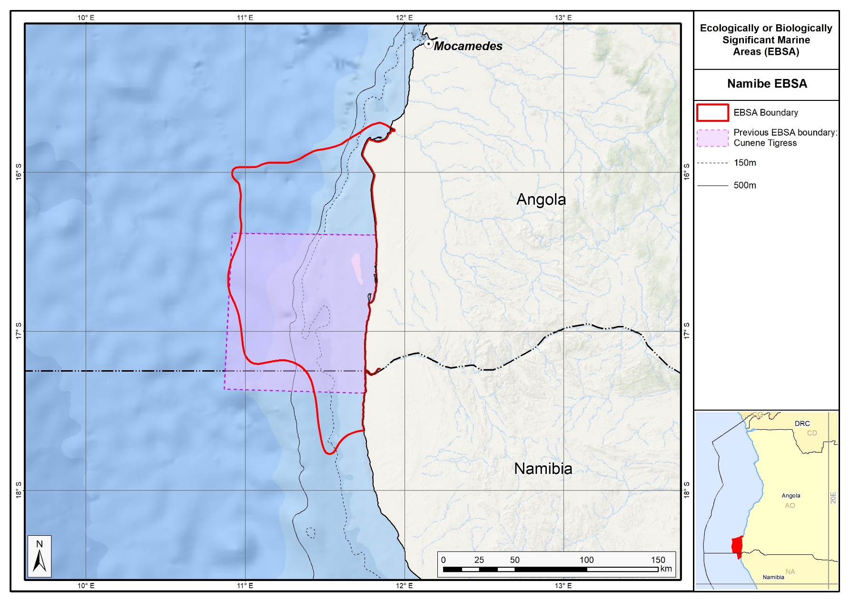
The revised Namibe EBSA in relation to the original Cunene-Tigres EBSA.

Orange Seamount and Canyon Complex (formerly Orange Shelf Edge)

Revised EBSA Description

General Information

Summary
The Orange Seamount and Canyon Complex, occurs at the western continental margin of South Africa and Namibia, spanning the border between the two countries. On the Namibian side, it includes Tripp Seamount and a shelf-indenting canyon. The EBSA comprises shelf and shelf-edge habitat with hard and unconsolidated substrates, including at least eleven ecosystem types. According to recent threat status assessments of coastal and marine habitat in South Africa and Namibia, three ecosystem types represented in the EBSA are threatened, one of which is Endangered and another two that are Vulnerable. However, the area is one of few places where these threatened ecosystem types are in relatively natural/pristine condition. Based on an analysis of long-term trawl-survey data, the Orange Seamount and Canyon Complex is a persistent hotspot of demersal fish biodiversity, which may be a result of the local habitat heterogeneity. In summary, this area is highly relevant in terms of the following EBSA criteria: ‘Importance for threatened, endangered or declining species and/or habitats’, ‘Biological diversity’ and ‘Naturalness’.

Introduction of the area
The area occurs at the outer shelf and shelf edge of the western continental margin of South Africa and Namibia, spanning the border between the two countries. It includes hard and unconsolidated (sand) shelf and shelf edge benthic habitat at depths of approximately 350-1200 m on the South African side (Sink et al., 2012, 2019). On the Namibian side, it includes Tripp seamount and a shelf-indenting submarine canyon, providing a heterogeneous habitat (Holness et al., 2014). The pelagic environment in the area is characterized by medium productivity, cold to moderate Atlantic temperatures (SST mean = 18.3 °C) and moderate chlorophyll levels related to the eastern limit of the Benguela upwelling on the outer shelf (Lagabrielle 2009).
Since the original description and delineation, the boundary of this EBSA has been revised largely because of new evidence that has emerged after South Eastern Atlantic Workshop to identify EBSAs in 2013 (UNEP/CBD/RW/EBSA/SEA/1/4). A new map of Namibian Ecosystem Types has been generated, and the new boundary builds on existing (SA) and new (Namibia) spatial assessment and prioritisation (Holness et al., 2014; Sink et al., 2019). These new datasets have facilitated more precision in the boundary definition such that the EBSA now better represents the underlying features that make this site regionally significant for threatened species and habitats and diverse assesmblages, in a highly natural area.

Description of the location

EBSA Region
South-Eastern Atlantic

Description of location
The area occurs at the outer shelf and shelf edge of the western continental margin of South Africa and Namibia, spanning the border between the two countries. It is entirely within the national jurisdiction of the two countries.

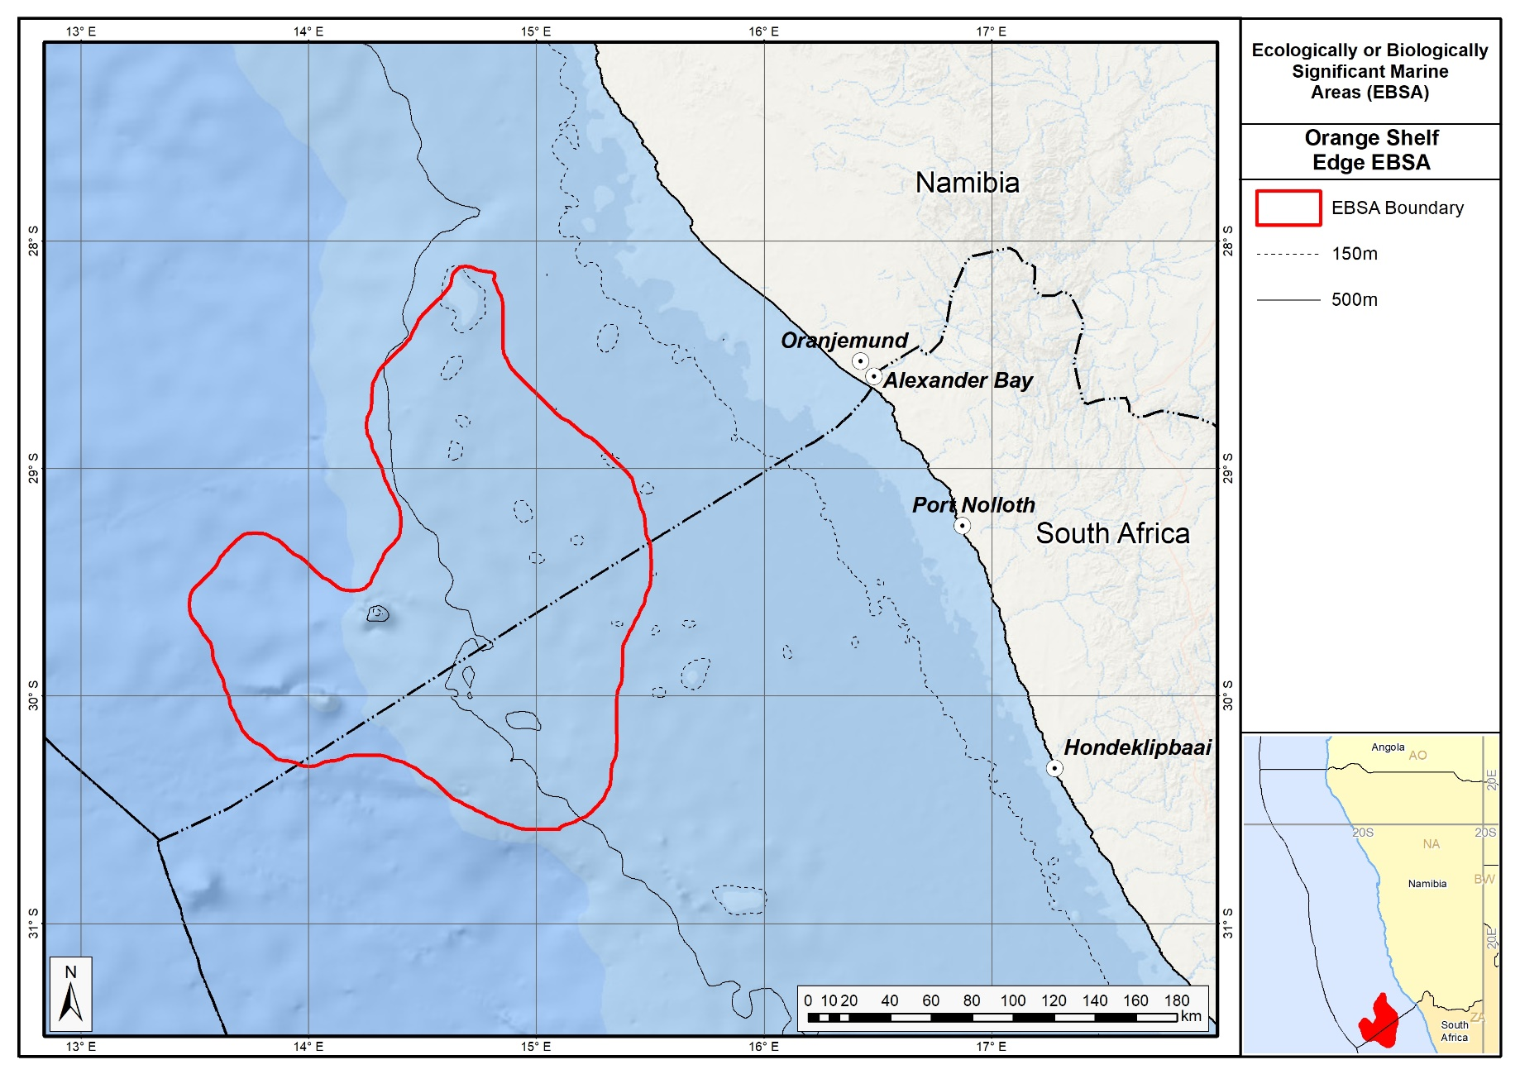
Revised delineation of the Orange Seamount and Canyon Complex EBSA.

Area Details

Feature description of the area
The area includes a high diversity of shelf and shelf-edge habitat with hard or unconsolidated (sand) substrates (Sink et al., 2012; Holness et al., 2014). It includes eleven ecosystem types that have been identified for South Africa and Namibia (Sink et al., 2019; Holness et al., 2014). On the Namibian side, it includes Tripp seamount and a shelf-indenting canyon. The pelagic environment of the area is characterized by medium productivity, cold to moderate temperatures, and moderate chlorophyll levels related to the eastern limit of the Benguela upwelling on the outer shelf (Lagabrielle 2009).
The area has been subjected to annual demersal fish trawl surveys conducted by the Department of Agriculture, Forestry and Fisheries of South Africa (see Atkinson et al., 2011 for details), and under the Nansen Programme in Namibia (see Jonsen and Kathena 2012 for details). Based on spatial modeling of nearly 30 years of distribution and abundance data from these surveys, Kirkman et al., (2013) identified a persistent hotspot of species richness for demersal fish species that coincides with part of the area. This may be related to the local habitat heterogeneity, including the presence of a shelf-indenting submarine canyon and the close proximity of a seamount. Generally, however, seamounts and canyons in the region have been poorly studied (Sink et al., 2011).

Feature conditions and future outlook of the proposed area
Sink et al., (2012, 2019) estimated the threat status of coastal and marine habitats in South Africa by assessing the cumulative impacts of various pressures (e.g., extractive resource use, pollution and others) on each ecosystem type. This analysis was extended to Namibia by Holness et al. (2014). The EBSA has a lot of natural habitat, although there are some portions that have been moderately modified, largely because this area has been subjected to relatively little extractive resource use (e.g., fishing, mining) pressure, and is relatively remote from sources of pollution. Overall the assessments of Sink et al. (2012) and Holness et al. (2014) classified 78 % of the Orange Seamount and Canyon Complex area as being in good condition, with an additional 13 % being in fair condition.
Previously, the Orange Seamount and Canyon Complex area was identified by Majiedt et al. (2013) as one of six marine ‘primary focus areas’ for spatial protection in South Africa, with the good condition of threatened habitats and the relative absence of anthropogenic pressures as the major drivers of this selection. This has resulted in two portions of the EBSA currently being proclaimed as marine protected areas. On the Namibian side, the assessment of Holness et al. (2014) identified the Namibian portions of the EBSA as being of high priority for place-based conservation measures. Tripp seamount on the Namibian side of the border is the location of a productive pelagic pole-and-line tuna fishery (FAO 2007). Although no research is currently planned for this area, it is recommended for this EBSA, particularly towards informing appropriate spatial management of this site.

References
Atkinson L.J., Leslie, R.W., Field, J.G., Jarre, A. 2011. Changes in demersal fish assemblages on the west coast of South Africa, 1986–2009. African Journal of Marine Science, 33: 157–170
Clark, M.R., Tittensor, D., Rogers, A.D., Brewin, P., Schlacher, T., Rowden, A., Stocks, K., Consalvey, M. 2006. Seamounts, deep-sea corals and fisheries: vulnerability of deep-sea corals to fishing on seamounts beyond areas of national jurisdiction. UNEP-WCMC, Cambridge, UK.
Coleman, F.C., Scanlon, K.M., Koenig, C.C. 2011. Groupers on the edge: Shelf edge spawning habitat in and around marine reserves of the northeastern Gulf of Mexico. Professional Geographer, 63: 456-474.
Dearden, P., Topelko, K.N. 2005. Establishing criteria for the identification of ecologically and biologically significant areas on the high seas. Background paper prepared for Fisheries and Oceans Canada. Marine protected Areas Research Group, 50 pp.
De Leo, F.C., Smith, C.R., Rowden, A.A., Bowden, D.A., Clark, M.R. 2010. Submarine canyons: hotspots of benthic biomass and productivity in the deep sea. Proceedings of the Royal Society B, 277: 2783-2792.
FAO. 2007. Namibia: Country Profiles. Food and Agricultural Organisation (FAO) Country Profiles. http://www.fao.org/fi/website/FIRetrieveAction.do?dom=countrysector&xml=FICP_NA.xml&lang=en. (accessed 17 April 2012).
FAO. 2009. Appendix F: International Guidelines for the Management of Deep-sea Fisheries in the High Seas. In: Report of the Technical Consultation on International Guidelines for the Management of Deepsea Fisheries in the High Seas. Rome, 4–8 February and 25-29 August 2008. FAO Fisheries and Aquaculture Report No. 881. Rome, Italy: Food and Agriculture Organization of the United Nations. pp. 39-51.
Gjerde, K.M., Breide, C. 2003. Towards a Strategy for High Seas Marine Protected Areas: Proceedings of the IUCN, WCPA and WWF Experts Workshop on High Seas Marine Protected Areas, 15-17 January 2003, Malaga, Spain.
Holness S., Kirkman S., Samaai T., Wolf T., Sink K., Majiedt P., Nsiangango S., Kainge P., Kilongo K., Kathena J., Harris L., Lagabrielle E., Kirchner C., Chalmers R., Lombard M. 2014. Spatial Biodiversity Assessment and Spatial Management, including Marine Protected Areas. Final report for the Benguela Current Commission project BEH 09-01.
Hutchings, L., van der Lingen, C.D. Shannon, L.J., Crawford, R.J.M., Verheye, H.M.S., Bartholomae, C.H., van der Plas, A.K., Louw, D., Kreiner, A., Ostrowski, M., Fidel, Q., Barlow, R.G., Lamont, T., Cotzee, J., Shillington, F., Veitch, J., Currie, J.C., Monteiro, P.P.S. 2009. The Benguela Current: An ecosystem of four components. Progress in Oceanography, 83: 15 – 32.
Johnsen, E., Kathena, J. 2012. A robust method for generating separate catch time-series for each of the hake species caught in the Namibian trawl fishery. African Journal of Marine Science, 34: 43–53.
Johnson, D.E., Barrio Froján, C., Turner, P.J., Weaver, P., Gunn, V., Dunn, D.C., Halpin, P., Bax, N.J., Dunstan, P.K., 2018. Reviewing the EBSA process: Improving on success. Marine Policy 88, 75-85.
Kirkman, S.P., Yemane, D., Kathena, J., Mafwila, S., Nsiangango, S., Samaai, T., Axelsen, B., Singh, L. 2013. Identifying and characterizing demersal biodiversity hotspots in the BCLME: Relevance in the light of global changes. ICES Journal of Marine Science, 70: 943–954.
Lagabrielle E. 2009. Preliminary report: National Pelagic Bioregionalisation of South Africa. Cape Town: South African National Biodiversity Institute.
Majiedt, P., Holness, S., Sink, K., Oosthuizen, A., Chadwick, P. 2013. Systematic Marine Biodiversity Plan for the West Coast of South Africa. South African National Biodiversity Institute, Cape Town.
McClain, C.R. Barry, J.P. 2010. Habitat heterogeneity, disturbance, and productivity work in concert to regulate biodiversity in deep submarine canyons. Ecology, 91: 964-76.
Moore, S.E., Watkins, W.A., Daher, M.A., Davies, J.R., Dahlheim, M.E., 2002. Blue whale habitat associations in the Northwest Pacific: analysis of remotely sensed data using a Geographic Information System. Oceanography, 15:, 20–25.
Morato, T., Varkey, D.A., Damaso, C., Machete, M., Santos, M., Prieto, R., Santos, R.S. and Pitcher, T.J. 2008. Evidence of a seamount effect on aggregating visitors. Marine Ecology Progress Series, 357: 23-32.
OBIS. 2017. Summary statistics of biodiversity records in the Orange Shelf EBSA. (Available: Ocean Biogeographic Information System. Intergovernmental Oceanographic Commission of UNESCO. www.iobis.org. Accessed: 2017-07-27).
Piatt, J.F., Wetzel, J., Bell, K., DeGange, A.R., Balogh, G.R., Drew, G.S., Geernaert, T., Ladd, C., Byrd G.V. 2006. Predictable hotspots and foraging habitat of the endangered shorttailed albatross (Phoebastria albatrus) in the North Pacific: Implications for conservation. Deep-Sea Research II, 53: 387-398.
Pitcher, T.J., Morato, T., Hart, P.J.B., Clark, M.R., Haggan, N., Santos, R.S. (Eds.). 2007. Seamounts: Ecology, Fisheries & Conservation. Blackwell Publishing, Oxford, UK.
Sink KJ, Attwood CG, Lombard AT, Grantham H, Leslie R, Samaai T, Kerwath S, Majiedt P, Fairweather T, Hutchings L, van der Lingen C, Atkinson LJ, Wilkinson S, Holness S, Wolf T. 2011. Spatial planning to identify focus areas for offshore biodiversity protection in South Africa. Unpublished Report. Cape Town: South African National Biodiversity Institute.
Sink, K., Holness, S., Harris, L., Majiedt, P., Atkinson, L., Robinson, T., Kirkman, S., Hutchings, L., Leslie, R., Lamberth, S., Kerwath, S., von der Heyden, S., Lombard, A., Attwood, C., Branch, G., Fairweather, T., Taljaard, S., Weerts, S., Cowley, P., Awad, A., Halpern, B., Grantham, H., Wolf T. 2012. National Biodiversity Assessment 2012: Technical Report. Volume 4: Marine and Coastal Component. South African National Biodiversity Institute, Pretoria.
Sink, K.J., van der Bank, M.G., Majiedt, P.A., Harris, L.R., Atkinson, L., Karenyi, N., Kirkman, S. (eds) 2019. National Biodiversity Assessment 2018 Technical Report Volume 4: Marine Realm. South African National Biodiversity Institute, Pretoria.
Springer, A.M., McRoy, C.P., Flint, M.V. 1996. The Bering Sea green belt: shelf-edge processes and ecosystem production. Fisheries Oceanography, 5: 205-223.
Sydeman, W.J., Brodeur, R.D., Grimes, C.B., Bychkov, A.S., McKinnell, S. 2006. Marine habitat “hotspots” and their use by migratory species and top predators in the North Pacific Ocean: Introduction. Deep-Sea Research Part II, 53: 247-249.

Assessment of the area against CBD EBSA criteria
C1: Uniqueness or rarity Low
Justification
Neither the benthic nor pelagic habitat types that are known to occur in the area are unique to the area (Sink et al., 2011).
C2: Special importance for life-history stages of species Medium
Justification
Elsewhere it has been shown that seamounts, shelf breaks and submarine canyons (all of which occur in the area) constitute important foraging habitats for pelagic-feeding vertebrates such as seabirds, cetaceans and large fish species, including migratory species, which exploit elevated primary production and high standing stocks of zooplankton, fish, and other organisms at these features (Dearden and Topelko 2005, Sydeman et al., 2006, Morato et al., 2008). Generally, however, seamounts and canyons in the region have been poorly studied (Sink et al., 2011).
C3: Importance for threatened, endangered or declining species and/or habitats High
Justification
Threat status assessments of ecosystem types by Sink et al. (2012, 2019) and Holness et al., (2014) highlighted several threatened habitat types that are represented in the EBSA. Threatened ecosystem types include the Endangered Namaqua Shelf Edge and Vulnerable Southern Benguela Rocky Shelf Edge and Southern Benguela Sandy Shelf Edge. This implies that, although there are sufficient areas of intact biodiversity of these habitats to meet the conservation targets, there has been habitat degradation and some loss of ecosystem processes. The importance of the area for the conserving the threatened habitat types represented in the Orange Seamount and Canyon Complex was emphasized by Majiedt et al. (2013) and Holness et al. (2014).
C4: Vulnerability, fragility, sensitivity, or slow recovery Medium
Justification
The threatened status of three ecosystem types (Sink et al., 2012, 2019) implies that degradation and some loss of ecosystem processes has been associated with these ecosystem types in other areas, and therefore that they are vulnerable to the effects of human activities. Seamounts, submarine canyons and the shelf break, all of which occur in the area, are all vulnerable and sensitive ecosystems (FAO 2009). Seamount communities are particularly vulnerable to human activities (e.g. trawling) due to intrinsic biological factors that are characteristic of seamount-associated species (e.g. slow growth rate, late maturation), with the likelihood of very long time scales of recovery if damaged (Gjerde & Breide, 2003, Clark et al., 2006).
C5: Biological productivity Medium
Justification
The area is at the eastern limit of the Benguela upwelling region (Hutchings et al., 2009), where the pelagic environment is characterized by medium productivity, and moderate chlorophyll levels (Lagabrielle 2009). However, shelf edge environments (e.g. Springer et al., 1996, Piatt et al., 2006, Coleman et al., 2011), seamounts (e.g. Moore et al., 2002, Pitcher et al., 2011) and submarine canyons (e.g. de Leo et al., 2010, McClain and Barry 2010), all of which occur in the proposed area, are associated with elevated productivity and biomass levels, spanning several trophic levels. Tripp seamount on the Namibian side of the border supports a productive pole-and-line tuna fishery (FAO 2007).
C6: Biological diversity High
Justification
Based on spatial modelling of 20-30 years of distribution and abundance data from demersal trawl surveys in Namibian and South African waters, Kirkman et al. (2013) identified the area as a persistent hotspot of species richness for demersal fish species. This may be linked to the habitat heterogeneity of the area, including the shelf edge, the presence of a shelf-indenting submarine canyon and the close proximity of a seamount. Further, 487 species have been recorded in the area (OBIS 2017). Diversity of habitat types is also high, with 11 habitat types occurring in the area (Sink et al., 2012; Holness et al., 2014).
C7: Naturalness High
Justification
The area on the South African side is one of the few areas where the threatened habitat types are in good condition (relatively natural/pristine), largely because it has been subjected to relatively low levels of anthropogenic pressures (Sink et al., 2011, 2019). The importance of the area for the conservation of the threatened habitat types represented there has therefore been emphasized by Majiedt et al., (2013). Although there are impacted areas, much of the Namibian portion of the area is also in good condition (Holness et al., 2014).

Other relevant website address or attached documents
Summary of habitat types and threat status for the Orange Seamount and Canyon Complex. Data from Sink et al., 2019 and Holness et al., 2014.
Threat Status | Ecosystem Type | Area (km²) | Area (%)
Endangered | Namaqua Shelf Edge | 3065.9 | 10.5
Vulnerable | Southern Benguela Rocky Shelf Edge | 751.7 | 2.6
 | Southern Benguela Sandy Shelf Edge | 1780.6 | 6.1
Least Concern | Southeast Atlantic Lower Slope | 139.9 | 0.5
 | Southeast Atlantic Mid Slope | 993.1 | 3.4
 | Southeast Atlantic Upper Slope | 2133.3 | 7.3
 | Southern Benguela Sandy Outer Shelf | 3003.1 | 10.3
 | Namaqua Outer Shelf | 8702.9 | 29.7
 | Namib Lower Slope | 4315.1 | 14.7
 | Namib Seamount | 393.1 | 1.3
 | Namib Upper Slope | 3988.7 | 13.6
Grand Total |  | 29267.4 | 100.0

Status of submission
The Orange Shelf Edge EBSA (now Orange Seamount and Canyon Complex) was recognized as meeting EBSA criteria by the Conference of the Parties. The revised boundaries and description still need to be submitted to COP for approval.

COP Decision
dec-COP-12-DEC-22

End of proposed EBSA revised description.

Motivation for Revisions
Only slight revision of the EBSA description was done since no new research has been carried on this area since its original adoption in 2014. Small additions, such as biodiversity information from OBIS and updated South African assessments were made, but none of these edits were significant enough to drive a change in the EBSA criteria rankings. A supplementary table of the ecosystem types represented in the EBSA and their associated threat status was also included.
The biggest change to the EBSA was a significant refinement of the EBSA delineation. This was done to focus more closely the EBSA on the key biodiversity features that underpin its EBSA status. The delineation process included an initial stakeholder workshop, a technical mapping process and then an expert review workshop where boundary delineation options were finalised. The delineation process used a combination of Systematic Conservation Planning (SCP) and Multi-Criteria Analysis methods. The features used in the analysis were:
- Threatened Benthic and Coastal Ecosystems. The analysis focussed on the inclusion of the most threatened ecosystem types found in the area. These types are highlighted in the table in the Other relevant website address or attached documents section. Additional weight was given to the priority shelf edge habitats which are core to the EBSA description.
- Areas of highest fish diversity from Kirkman et al. (2013) were included.
- Areas of high relative naturalness identified in the SCP undertaken for the BCLME by Holness et al. (2014).
- Key physical features such as seamounts and canyons from the BCC spatial mapping project (Holness et al., 2014), GEBCO data, and global benthic geomorphology mapping (www.bluehabitats.org, Harris et al., 2014).
- Irreplaceable and near irreplaceable (i.e. very high selection frequency) sites, as well as primary and secondary focus areas identified in the SCP undertaken for the BCLME by Holness et al. (2014).
The multi-criteria analysis resulted in a value surface. The cut-off value (used to determine the extent of the EBSA) was based on expert input and quantitative analysis of effective inclusion of the above features. This entailed taking an iterative parameter calibration-based approach whereby the spatial efficiency of the inclusion of the targeted features was evaluated. The approach aimed to identify a cut-off which most efficiently included prioritised features while minimizing the inclusion of impacted areas. The final boundaries shown in the map below were validated in a series of national (in both South African and Namibia) and regional (BCC) meetings.

Research Needs
Much further baseline research and ongoing monitoring is needed to ensure that the key features of the EBSA are well managed. This is particularly important as the EBSA is adjacent to Namibia’s Kudu gas field. The area is subject to ongoing oil and gas exploration.

Future Process
It is likely that this EBSA will be the focus for status assessment and detailed transboundary management planning.

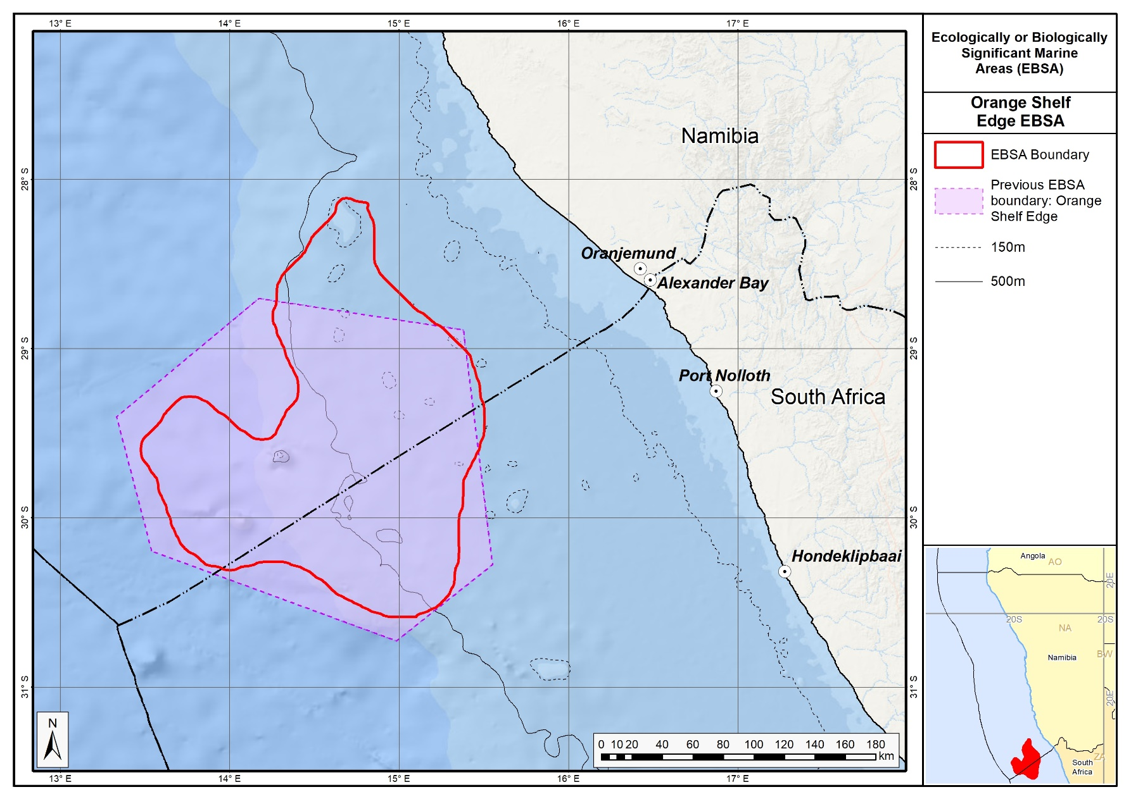
The revised Orange Shelf EBSA in relation to its original boundary.

Orange Cone

Revised EBSA Description

General Information

Summary
The Orange Cone is a transboundary area between Namibia and South Africa that spans the mouth of the Orange River (South Africa and Namibia’s major river in terms of run-off to the marine environment). The estuary is biodiversity-rich but modified, and the coastal area includes 10 threatened ecosystem types: two Critically Endangered, four Endangered and four Vulnerable types. The marine environment experiences slow, but variable currents and weaker winds, making it potentially favourable for reproduction of pelagic species. Furthermore, given the proven importance of river outflow for fish recruitment at the Thukela Banks (a comparable shallow, fine-sediment environment on the South African east coast), a similar ecological dependence for the inshore Orange Cone is likely. Evidence supporting this hypothesis is growing but has not yet been consolidated. Comparable estuarine/inshore habitats are not encountered for 300 km south (Olifants River) and over 1300 km north (Kunene) of this system. The Orange River Mouth is a transboundary Ramsar site between Namibia and South Africa. The river mouth also falls within the Tsau//Khaeb (Sperrgebiet) National Park in Namibia, is under consideration as a protected area by South Africa, and is also an Important Bird and Biodiversity Area. Although there are substantially impacted areas especially on the coast and in the estuary, much of the area remains in a natural state. In summary, this area is highly relevant in terms of: ‘Uniqueness or rarity’, ‘Importance for threatened, endangered or declining species and/or habitats’ and ‘Special importance for life history stages of species’.

Introduction of the area
The Orange Cone spans the coastal boundary between South Africa and Namibia. The Orange River estuary extends approximately 10 km inland of the sea in a hydrological sense, although estuarine-dependent species migrate much further upstream. The estuary is substantially modified but under rehabilitation. Boundaries of the marine area that is ecologically coupled to the estuary are not accurately known, but could be extensive: seasonally and inter-annually, the marine habitat affected by freshwater outflow varies from a few kilometres to hundreds of kilometres in the longshore direction during floods, particularly southwards (Shillington et al., 1990). This area is located 50 km north and south of the Orange River, extending 30 - 45 km offshore, and includes the full extent of the estuary. There are 16 marine and coastal ecosystem types represented in the area (Sink et al., 2012, 2019; Holness et al., 2014). The associated pelagic environment is characterized by upwelling, giving rise to cold waters with high productivity/chlorophyll levels (Lagabrielle 2009). However, the winds in the area are weaker compared to that to the north or south of the river mouth, leading to less local upwelling (Boyd, 1988).

Description of the location

EBSA Region
South-Eastern Atlantic

Description of location
The Orange River estuary is located at 29°S and forms the boundary between South Africa and Namibia. The northern and southern boundaries of the Orange Cone EBSA are located 50 km north and south of the Orange River, respectively, with the eastern boundary extending 30 – 45 km offshore, and includes the full extent of the estuary. However, the broader area has characteristics of the Orange Cone marine environment as far as 100 km offshore. This EBSA straddles coastal and marine areas within the national jurisdictions of South Africa and Namibia.

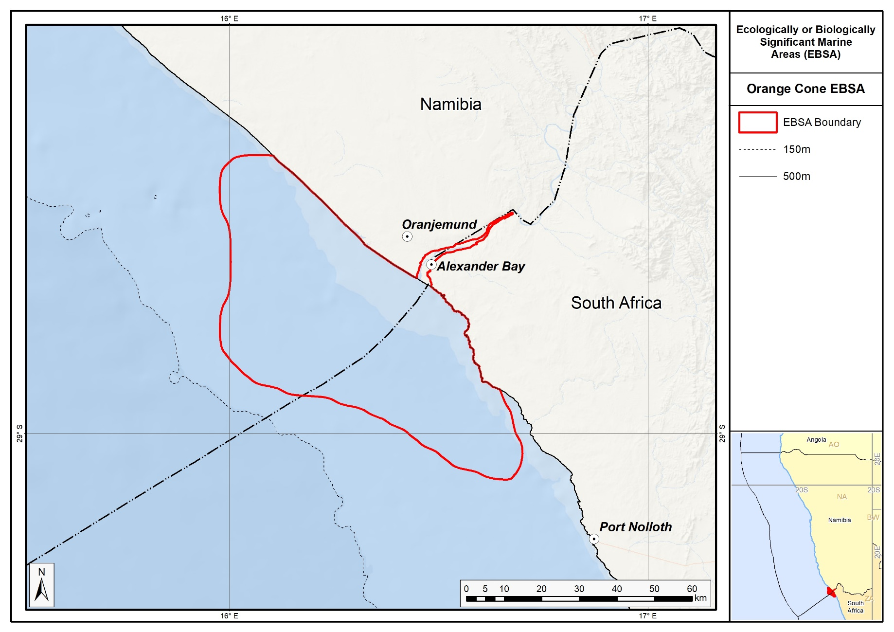
Revised delineation of the Orange Cone EBSA.

Area Details

Feature description of the area
There are 16 ecosystem types represented in this EBSA (Sink et el., 2012, 2019; Holness et al., 2014). The associated pelagic environment is characterized by upwelling, giving rise to cold waters with high productivity (Lagabrielle 2009). However, the winds in the Orange Cone are weaker than those north or south of the area, leading to some stratification (Boyd 1988). Moreover, currents in the inshore region, and indeed over much of the Orange Cone area, have slower speeds than those occurring further north or south, and movements in both upper and lower layers are dominated by diurnal and/or inertial motions (Iita et al., 2001, Largier and Boyd, 2001).

The river and estuary have received substantial research attention over the last decade; the adjacent marine environment much less so, apart from some research during the Large Marine Ecosystem (LME) project from 1995-2000. However, given the proven role of the Thukela River outflow for the recruitment of fish stocks in the adjacent marine area on the South African east coast (Turpie and Lamberth 2010), it is hypothesized that the Orange River plays a similar role on the South African west coast. Although not formally described, evidence is mounting to support this hypothesis, because there are seemingly many relationships between Orange River flow volumes and demersal, pelagic and nearshore fish biomass (S.J. Lamberth, pers.com, unpublished). For example, the sole fishery collapse was associated with a change in local sediment particle size, because it altered burying difficulty and exposure to predators. Also, anchovy (mostly juveniles) appear to be positively correlated with the size of the plume, because the plume probably serves as a turbidity refuge. Furthermore, the conditions in the area are consistent with the criteria proposed for supporting pelagic species’ reproduction (Parrish et al., 1983).

Because of a previous lack of research, the boundaries of the marine zone that is ecologically coupled to the estuary were not accurately known, but were thought to be extensive. For example, geological research suggests that the sediment from the Orange River travels as far north as southern Angola (1750 km north of the mouth), and comprises >80 % of the dune sand along the Skeleton Coast in Namibia (Garzanti et al., 2014). A particular challenge to determining the river’s extent of influence is that the marine habitat affected by freshwater outflow varies greatly both seasonally and inter-annually, from a few to hundreds of kilometres in the longshore direction (mainly southwards) during floods (Shillington et al., 1990). Submarine delta deposits off the mouth of the Orange River extend 26 km offshore, and 112 km alongshore (Rodgers & Rau 2006). The terrigenous material exiting the Orange River has a heterogeneously integrated catchment signal (Hermann et al., 2016) that is generally confined to about 50 km from the shore (Rodgers & Rau 2006). Since the original description of this EBSA, recent work on marine sediments and delineation of muddy sediment associated habitats have allowed a far more precise delineation of the Orange Cone (Karenyi, 2014; Karenyi et al., 2016). It is largely these new data which were used to refine the Orange Cone EBSA boundary, which was noted in the original description as being an approximation that needed further research so it could be properly delineated.

In terms of uniqueness of habitat (i.e., refuge for estuarine-dependent or partially dependent fish, and birds), approximately similar estuarine and adjacent inshore habitats are not encountered for over 300 km further south to the Olifants River and over 1300 km further north, until the Kunene River (Lamberth et al., 2008, van Niekerk et al., 2008). The fact that the estuary is a declared Ramsar site (Ramsar 2013; note that the adjacent Namibian and South African Ramsar sites were joined into a transboundary site) and an Important Bird and Biodiversity Area (IBA; BirdLife International 2013) is an important recognition of its importance to birds as well as other species. Altogether, 206 species have been recorded in the EBSA, including 4 threatened fish and condricthian species (OBIS 2017).

Feature conditions and future outlook of the proposed area
The impact of reduced and altered flow at the estuary mouth and into the marine environment has had a negative impact on the estuarine habitat, including the salt marsh, which was exacerbated by inappropriate developments associated with mining at the site (van Niekerk and Turpie 2012). The impact of these changes on the marine offshore environment is not yet known. Both the flow regime (as it will reach the mouth and the marine area) and rehabilitation of the estuary and salt marsh area need to be addressed. However, an estuary management plan is in an advanced stage, and protected area status for the estuary is well advanced as well (van Niekerk and Turpie 2012). Regarding the marine and coastal habitats and biodiversity of the area, the coastline and inshore area to 30 m depth is under considerable threat from mining impacts and is currently unprotected (Sink et al., 2012).

Ecosystem threat status has been estimated in South Africa (Sink et al., 2012, 2019) and Namibia (Holness et al., 2014; Table in the Other relevant website address or attached documents section) by assessing the weighted cumulative impacts of various pressures (e.g., extractive resource use, pollution, development and others) on each ecosystem type. These include 2 Critically Endangered, four Endangered and four Vulnerable ecosystem types, and another one ecosystem type that is Vulnerable. The Critically Endangered status implies that very little (<= 20%) of the total area of the habitats assessed are in natural/pristine condition, and it is expected that important components of biodiversity pattern have been lost and that ecological processes heavily modified. However, within the area, much of these habitat types were assessed to be in fair ecological condition, although there are some portions that are also in poor ecological condition.

References
Anderson, M.D., Kolberg H., Anderson P.C., Dini J., Abrahams A. 2003. Waterbird populations at the Orange River mouth from 1980 – 2001: a re-assessment of its Ramsar status. Ostrich, 74: 1-14.
BirdLife International. 2013. Important Bird Areas: ZA023 Orange River mouth wetlands. URL: www.birdlife.org/datazone/sitefactsheet.php?id=7098 [accessed on 22 April 2013]
BirdLife International (2018) Important Bird Areas factsheet: Orange River Mouth Wetlands. Downloaded from http://www.birdlife.org on 30/08/2018.
Boyd, A. J. 1988. The Oceanography of the Namibian Shelf. PhD Thesis University of Cape Town. 190 pp.
Currie H., Grobler K., Kemper, J. 2008. Concept note, background document and management proposal for the declaration of Marine Protected Areas on and around the Namibian islands and adjacent coastal areas.
Crawford, R.J.M., Randall, R.M., Whittington, P.A., Waller, L., Dyer, B.M., Allan, D.G., Fox, C., Martin, A.P., Upfold, L., Visagie, J., Bachoo, S., Bowker, M., Downs, C.T., Fox, R., Huisamen, J., Makhado, A.B., Oosthuizen, W.H., Ryan, P.G., Taylor R.H., Turpie, J.K. 2013. South Africa's coastal-breeding white-breasted cormorants: population trends, breeding season and movements, and diet. African Journal of Marine Science, 35: 473-490.
Crawford, R.J.M., Randall, R.M., Cook, T.R., Ryan, P.G., Dyer, B.M., Fox, R., Geldenhuys, D., Huisamen, J., McGeorge, C., Smith, M.K., Upfold, L., Visagie, J., Waller, L.I., Whittington, P.A., Wilke, C.G., Makhado, A.B. 2016. Cape cormorants decrease, move east and adapt foraging strategies following eastward displacement of their main prey. African Journal of Marine Science, 38: 373-383.
Garzanti, E., Vermeesch, P., Andò, S., Lustrino, M., Padoan, M., Vezzoli, G. 2014. Ultra-long distance littoral transport of Orange sand and provenance of the Skeleton Coast Erg (Namibia), Marine Geology, 357: 25-36.
Herrmann, N., Boom, A., Carr, A.S., Chase, B.M., Granger, R., Hahn, A., Zabel, M., Schefuß, E. 2016. Sources, transport and deposition of terrestrial organic material: A case study from southwestern Africa. Quaternary Science Reviews, 149: 215-229.
Holness S., Kirkman S., Samaai T., Wolf T., Sink K., Majiedt P., Nsiangango S., Kainge P., Kilongo K., Kathena J., Harris L., Lagabrielle E., Kirchner C., Chalmers R., Lombard M. 2014. Spatial Biodiversity Assessment and Spatial Management, including Marine Protected Areas. Final report for the Benguela Current Commission project BEH 09-01.
Hutchings, L., Beckley, L.E., Griffiths, M.H., Roberts, M.J., Sundby, S., van der Lingen, C. 2002. Spawning on the edge: spawning grounds and nursery areas around the southern African coastline. Marine and Freshwater Research, 53: 307-318.
Iita, A., Boyd, A.J., Bartholomae, C.H. 2001. A snapshot of the circulation and hydrology of the southern and central shelf regions of the Benguela Current in winter 1999. South African Journal of Science, 97: 213–217.
Jansen, T., Kristensen, K., Kainge, P., Durholtz, D., Strømme, T., Thygesen, U.H., Wilhelm, M.R., Kathena, J., Fairweather, T.P., Paulus, S., Degel, H., Lipinski, M.R., Beyer, J.E. 2016. Migration, distribution and population (stock) structure of shallow-water hake (Merluccius capensis) in the Benguela Current Large Marine Ecosystem inferred using a geostatistical population model. Fisheries Research, 179: 156–167.
Johnson, D.E., Barrio Froján, C., Turner, P.J., Weaver, P., Gunn, V., Dunn, D.C., Halpin, P., Bax, N.J., Dunstan, P.K., 2018. Reviewing the EBSA process: Improving on success. Marine Policy 88, 75-85.
Karenyi, N. 2014. Patterns and Drivers of Benthic Macrofauna to Support Systematic Conservation Planning for Marine Unconsolidated Sediment. Nelson Mandela Metropolitan University, Port Elizabeth.
Karenyi, N., Sink, K., Nel, R. 2016. Defining seascapes for marine unconsolidated shelf sediments in an eastern boundary upwelling region: The southern Benguela as a case study. Estuarine, Coastal and Shelf Science, 169: 195-206.
Lagabrielle E. 2009. Preliminary report: National Pelagic Bioregionalisation of South Africa. Cape Town: South African National Biodiversity Institute.
Lamberth, S.J., Van Niekerk, L., Hutchings, K. 2008. Comparison of, and the effects of altered freshwater inflow on, fish assemblages of two contrasting South African estuaries: the cool-temperate Olifants and the warm-temperate Breede. African Journal of Science, 30: 331–336.
Mann BQ. 2000. Status Reports for Key Linefish Species. Durban: Oceanographic Research Institute Special Publication
OBIS. 2017. Summary statistics of biodiversity records in the Orange Cone EBSA. (Available: Ocean Biogeographic Information System. Intergovernmental Oceanographic Commission of UNESCO. www.iobis.org. Accessed: 2017-07-27).
Parrish, R.H., A. Bakun, D.M. Husby, and C.S. Nelson. 1983. Comparative climatology of selected environmental processes in relation to eastern boundary current pelagic fish reproduction. p. 731-778. In: G.D. Sharp and J. Csirke (eds.) Proceedings of the Expert Consultation to Examine Changes in Abundance and Species Composition of Neritic Fish Resources. FAO Fish. Rep. 291(3), 1224 pp.
Ramsar. 2013. Orange River Mouth, Ramsar site no. 526. The annotated Ramsar list: South Africa. URL: www.ramsar.org/cda/en/ramsar-documents-list-anno-southafrica/main/ramsar [accessed on 22 April 2013]
Rodgers, J., Rau, A.J. 2006. Surficial sediments of the wave-dominated Orange River Delta and the adjacent continental margin off south-western Africa. African Journal of Marine Science, 28: 511-524.
Shillington, F.A., Brundrit, G.B., Lutjeharms, J.R.E., Boyd, A.J., Agenbag, J.J., Shannon, L.V. 1990. The coastal current circulation during the Orange River flood 1988. Transaction of the Royal Society of South Africa, 47: 308-329.
Sink, K., Holness, S., Harris, L., Majiedt, P., Atkinson, L., Robinson, T., Kirkman, S., Hutchings, L., Leslie, R., Lamberth, S., Kerwath, S., von der Heyden, S., Lombard, A., Attwood, C., Branch, G., Fairweather, T., Taljaard, S., Weerts, S., Cowley, P., Awad, A., Halpern, B., Grantham, H., Wolf, T. 2012. National Biodiversity Assessment 2011: Technical Report. Volume 4: Marine and Coastal Component. South African National Biodiversity Institute, Pretoria.
Sink, K.J., van der Bank, M.G., Majiedt, P.A., Harris, L.R., Atkinson, L., Karenyi, N., Kirkman, S. (eds) 2019. National Biodiversity Assessment 2018 Technical Report Volume 4: Marine Realm. South African National Biodiversity Institute, Pretoria.
Turpie, J., Lamberth, S.J. 2010. Characteristics and value of the Thukela Banks crustacean and linefish fisheries, and the potential impacts of changes in river flow. African Journal of Marine Science, 32: 613-624.
van Niekerk, L., Neto, D.S., Boyd, A.J., Holtzhausen, H. 2008. BCLME Project BEHP/BAC/03/04: Baseline Surveying of Species and Biodiversity in Estuarine Habitats. Benguela Environment Fisheries Interaction & Training Programme and Instituto Nacional de Investigacao Pesqueira. 152 pp.
Van Niekerk, L. and Turpie, J.K. (eds). 2012. South African National Biodiversity Assessment 2011: Technical Report. Volume 3: Estuary Component. CSIR Report Number CSIR/NRE/ECOS/ER/2011/0045/B. Council for Scientific and Industrial Research, Stellenbosch.

Assessment of the area against CBD EBSA criteria
C1: Uniqueness or rarity High
Justification
In terms of habitat uniqueness (i.e., refugia for estuarine-dependent or partially estuarine-dependent fish and birds, and freshwater outflow to the marine environment), approximately similar estuarine and adjacent inshore habitat are not encountered for over 300 km further south to the Olifants River, and over 1300 km further north, until the Kunene River (van Niekerk et al., 2008, Lamberth et al., 2008). The marine area is fed by the estuarine outflow, and also has its own oceanographic characteristics in terms of inertial currents and stratification, thus being largely “sheltered” from Benguela System forcing (Boyd 1988, Largier and Boyd 2001) that influences the whole Benguela region.

C2: Special importance for life-history stages of species High
Justification
A total of 33 fish species from 17 families have been captured from the Orange River estuary (van Niekerk et al., 2008). Out of these species, 34 % showed some degree of estuarine (i.e., euryhaline) dependence, 24 % were marine and the remaining 42 % were freshwater species. The high diversity and abundance of estuarine-dependant and marine species suggests that this is an extremely important estuarine nursery area, especially for Kob species (van Niekerk and Turpie 2012), and not just a freshwater conduit as previously thought (van Niekerk et al., 2008). Certainly, oceanographic conditions in the area are consistent with the criteria proposed by Parrish et al. (1983) for the reproduction of pelagic species, and the system is also hypothesised to play a similar role to that of the comparable Thukela River/Thukela Banks (on the South African east coast) where the freshwater outflow is proven to support recruitment of fish stocks (Turpie and Lamberth 2010). Evidence is continually mounting to confirm the role of the Orange Cone in supporting key life-history stages. For example, the area is the northern margin of the important west coast nursery ground for pelagic fish species with periodic spawning (Hutchings et al., 2002). The Orange Cone is also an important recruitment/nursery area and one of three primary population components for shallow water hake (Jansen et al., 2016). Furthermore, northern sections of the Orange Cone, particularly a coastal reef called “Mittag”, are important for the Namibian commercial rock lobster fishery (Currie et al., 2008).

The estuary and wetland area are also an important stopover site for migrating shorebirds and other waterbirds, and provides breeding habitat for birds such as White-breasted Cormorants (Crawford et al., 2013) and Cape Cormorants. However, due to the destruction of breeding islands by the 1988 flood, the latter have not bred there since (H. Kolberg pers. obs). The value of the site is recognised internationally with both Ramsar and IBA status. In fact, the Orange River Mouth Wetlands are said to be the sixth most important coastal wetlands for birds, supporting as many as 26000 individuals of 56 species (BirdLife International, 2018).

South of the Kunene River (over 1300 km to the north of the Orange River), the only permanently open estuaries on the west coast of the sub-region include the Orange, Olifants and Berg Rivers (Lamberth et al., 2008). Migration up and down the west coast of southern Africa by marine and estuarine species, e.g., Angolan dusky kob, and west coast steenbras, may be dependent on the availability of warm water refugia offered by these estuary mouths and their plumes, especially during upwelling months (Lamberth et al., 2008).

C3: Importance for threatened, endangered or declining species and/or habitats High
Justification
The area is also an important nursery for coastal fish species, such as kob (van Niekerk and Turpie 2012) which are overexploited (Mann 2000). The estuary includes important breeding habitat for Endangered Cape Cormorants (Crawford et al., 2016), and also contains Endangered Ludwig’s bustard and Vulnerable Damara Terns (Birdlife International, 2018). Four fish and condricthian species recorded in the EBSA are threatened, including the Endangered Rostroraja albai and Mustelus mustelus, and Vulnerable Galeorhinus galeus and Squalus acanthias (OBIS 2017).

Ten of the 16 ecosystem types represented in this EBSA are threatened, including two Critically Endangered, four Endangered and four Vulnerable ecosystem types (Holness et al., 2014; Sink et al., 2019). Because habitat types are generally a very good surrogate for species-level biodiversity patterns, the implication, therefore, is that the species and biological communities that are associated with and unique to these habitats are similarly declining and threatened.

C4: Vulnerability, fragility, sensitivity, or slow recovery Medium
Justification
The estuarine salt marsh area is vulnerable and has been slow to show recovery despite rehabilitation efforts (van Niekerk and Turpie 2012). There has also been a marked decline in certain fish stocks that were previously exploited in the region (Lamberth et al., 2008). Mining and habitat modification are thought to have had an impact with respect to these changes.

C5: Biological productivity Medium
Justification
Winds in the Orange Cone are weaker than those which occur to the north or south of the area, leading to some stratification (Boyd 1988). This, and the effect of the fresh water inflow, may serve to concentrate productivity within the area.

C6: Biological diversity Medium
Justification
Altogether, 206 species have been recorded in the Orange Cone EBSA (OBIS 2017). A high diversity of fish species (33 species from 17 families) has been captured from the Orange River estuary (van Niekerk et al., 2008), including freshwater, marine and estuarine-dependent species. The marine area served as the conduit supporting the estuary’s biodiversity for migratory marine and estuarine-dependent species, as well as marine pelagic and demersal species, including their juvenile stages. Furthermore, the fact that the estuary is a declared Ramsar site (Ramsar 2013) and an IBA (BirdLife International 2013) are important recognitions of its importance to birds and other species. There are 16 ecosystem types represented in this EBSA (Holness et al., 2014; Sink et al., 2019).

C7: Naturalness Medium
Justification
The estuary and nearshore are impacted, including notable infestation by alien plants around the estuary that persist in spite of rehabilitation efforts. Nevertheless, the estuary still provides many ecological services such as recruitment. There are significant impacts from coastal diamond mining in Namibia and, to a lesser extent, in South Africa (Sink et al., 2012; Holness et al., 2014). Although data are sparse, the area has been shown to be largely in fair condition (Sink et al., 2012; Holness et al., 2014), but there have been long-term declines in fish catch.

Other relevant website address or attached documents
Summary of habitat types and threat status for the Orange Cone [data sources: Sink et al. (2019) and Holness et al. (2014)].
Threat Status | Ecosystem Type | Area (km²) | Area (%)
Critically Endangered | Namaqua Intermediate Sandy Beach | 29.7 | 0.9
 | Namaqua Reflective Sandy Beach | 3.1 | 0.1
Endangered | Cool Temperate Large Fluvially Dominated Estuary | 26.7 | 0.8
 | Orange Cone Inner Shelf Mud Reef Mosaic | 338.8 | 10.7
 | Orange Cone Muddy Mid Shelf | 858.0 | 27.2
 | Southern Benguela Reflective Sandy Shore | 0.2 | 0.0
Vulnerable | Namaqua Exposed Rocky Shore | 4.2 | 0.1
 | Namaqua Kelp Forest | 0.3 | 0.0
 | Namaqua Mixed Shore | 2.5 | 0.1
 | Namaqua Inshore | 322.9 | 10.2
Near Threatened | Southern Benguela Intermediate Sandy Shore | 0.6 | 0.0
Least Concern | Namaqua Sandy Mid Shelf | 0.5 | 0.0
 | Southern Benguela Dissipative Sandy Shore | 1.8 | 0.1
 | Southern Benguela Dissipative-Intermediate Sandy Shore | 0.1 | 0.0
 | Namaqua Estuarine Shore | 4.3 | 0.1
 | Namaqua Inner Shelf | 1560.1 | 49.5
Grand Total |  | 3153.8 | 100.0

Status of submission
The Orange Cone EBSA was recognized as meeting EBSA criteria by the Conference of the Parties. The revised boundaries and description still need to be submitted to COP for approval.

COP Decision
dec-COP-12-DEC-22

End of proposed EBSA revised description.

Motivation for Revisions
Some updates were made to the description and references. One criterion rank, Importance for threatened species and habitats, was upgraded from Medium to High based on additional data and extension of the EBSA to include the Orange River Estuary, which is an important Ramsar site. Small additions, such as biodiversity information from OBIS were also made. A supplementary table of the habitats represented in the EBSA and their associated threat status were also included (in Other relevant website address or attached documents section).
The biggest change to the EBSA was a significant refinement of the EBSA delineation. This was done to more closely focus the EBSA on the key biodiversity features that underpin its EBSA status. The delineation process included an initial stakeholder workshop, a technical mapping process and then an expert review workshop where boundary delineation options were finalised. The delineation process used a combination of Systematic Conservation Planning (SCP) and Multi-Criteria Analysis methods. The features used in the analysis were:
- Threatened Benthic and Coastal Ecosystems. The analysis focussed on the inclusion of the most threatened ecosystem types found in the area. These types are highlighted in the table in the Other relevant website address or attached documents section.
- The key muddy habitat types associated with the Orange Cone were identified based on data from new studies by Karenyi (2014) and Karenyi et al. (2016).
- Irreplaceable and near irreplaceable (i.e. very high selection frequency) sites, as well as primary and secondary focus areas identified in the SCP undertaken for the BCLME by Holness et al. (2014).
- Areas of high relative naturalness identified in the SCP undertaken for the BCLME by Holness et al. (2014).
- The Orange River Estuary Ramsar site was included.
The multi-criteria analysis resulted in a value surface. The cut-off value (used to determine the extent of the EBSA) was based on expert input and quantitative analysis of effective inclusion of the above features. This entailed taking an iterative parameter calibration-based approach whereby the spatial efficiency of the inclusion of the targeted features was evaluated. The approach aimed to identify a cut-off which most efficiently included prioritised features while minimizing the inclusion of impacted areas. The final boundaries shown in the map below were validated in a series of national (in both South African and Namibia) and regional (BCC) meetings.

Research Needs
Much further baseline research and ongoing monitoring is needed to ensure that the key features of the EBSA are well managed. Many issues link to the management of the Orange River Mouth, as well as diamond mining along the coast and in marine areas of both countries. Other research into the fluvial fan and plume is also recommended to better understand land-sea connectivity processes, and the effect that freshwater flow reduction could have on marine systems.

Future Process
It is likely that this EBSA will be the focus for status assessment and detailed transboundary management planning.

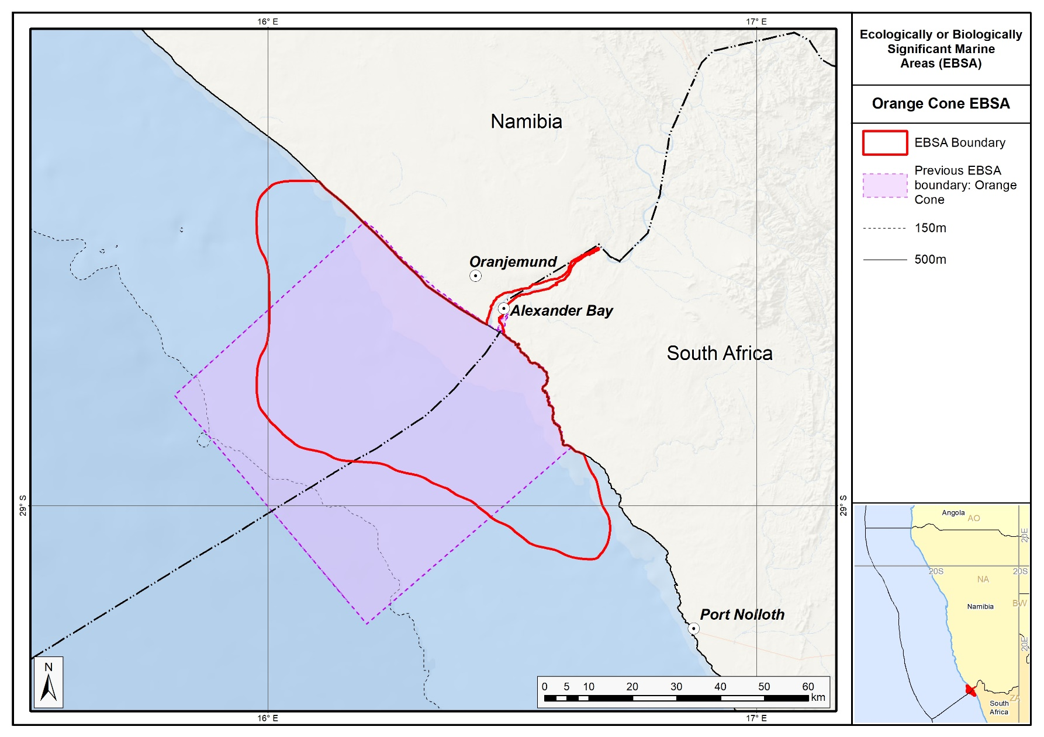
The revised Orange Cone EBSA boundary in relation to its original delineation.

